PERFORMANCE

Inputs

Input_short: file containing 17 lines
Input_large: file containing 1,011,297 lines

Output:

----------------------------------------------------------------------------------------------------
Call: psexpV1
The function took 0.0003859996795654297 seconds to complete file ./input_short
The function took 13.416962146759033 seconds to complete file ./input_large
----------------------------------------------------------------------------------------------------
Call: psexpV2
The function took 0.00644683837890625 seconds to complete file ./input_short
The function took 639.8281652927399 seconds to complete file ./input_large
----------------------------------------------------------------------------------------------------
Call: psexpV3
The function took 0.0062634944915771484 seconds to complete file ./input_short
The function took 568.7677512168884 seconds to complete file ./input_large
----------------------------------------------------------------------------------------------------
Call: psexpV4
The function took 0.0004253387451171875 seconds to complete file ./input_short
The function took 839.4797215461731 seconds to complete file ./input_large
----------------------------------------------------------------------------------------------------
Call: psexpV5
The function took 0.008693695068359375 seconds to complete file ./input_short
The function took 23.590721368789673 seconds to complete file ./input_large
#!/usr/bin/env python2
# -*- coding: utf-8 -*-

'''
Filename: benchmark.py
Description: timer manager
Version: 0.0
Author: JI
Date: 28/01/2018
Licence: Apache License version 2.0
'''

import parser_sexpressionV1 as psexpV1
import parser_sexpressionV2 as psexpV2
import parser_sexpressionV3 as psexpV3
import parser_sexpressionV4 as psexpV4
import parser_sexpressionV5 as psexpV5
import time, sys
import cProfile

class MyTimer():

def __init__(self, fname):
self.start = time.time()
self.fname = fname

def __enter__(self):
return self

def __exit__(self, exc_type, exc_val, exc_tb):
end = time.time()
runtime = end - self.start
msg = 'The function took {time} seconds to complete file {fname}'
print(msg.format(time=runtime, fname=self.fname))

def timeit(fun, fileinput, fileoutput):
cprof = "cprof_" + fun
cprof = fileoutput.replace(".main()", ".cprof")
n = 100
print("-"*n)
print('Call: {}'.format(fun))
cProfile.run(fun + '("' + fileinput + '", "' + fileoutput + '")', cprof)

if __name__ == '__main__':

fileinput1 = "./input_short"
fileinput2 = "./input_large"
fileoutput = "./output"

timeit("psexpV1.main", fileinput1, fileoutput)
with MyTimer(fileinput1):
psexpV1.main(fileinput1, fileoutput)
with MyTimer(fileinput2):
psexpV1.main(fileinput2, fileoutput)

timeit("psexpV2.main", fileinput1, fileoutput)
with MyTimer(fileinput1):
psexpV2.main(fileinput1, fileoutput)
with MyTimer(fileinput2):
psexpV2.main(fileinput2, fileoutput)

timeit("psexpV3.main", fileinput1, fileoutput)
with MyTimer(fileinput1):
psexpV3.main(fileinput1, fileoutput)
with MyTimer(fileinput2):
psexpV3.main(fileinput2, fileoutput)

timeit("psexpV4.main", fileinput1, fileoutput)
with MyTimer(fileinput1):
psexpV4.main(fileinput1, fileoutput)
with MyTimer(fileinput2):
psexpV4.main(fileinput2, fileoutput)

timeit("psexpV5.main", fileinput1, fileoutput)
with MyTimer(fileinput1):
psexpV5.main(fileinput1, fileoutput)
with MyTimer(fileinput2):
psexpV5.main(fileinput2, fileoutput)

sys.exit(0)

#!/usr/bin/env python
# -*- coding: utf-8 -*-

import sys
import os
from future.utils import viewitems

'''
Filename: parser_sexpressionV1.py
Description: parse s-expressions reading character by character
Version: 0.1
Author: JI
Date: 28/01/2018
Licence: Apache License version 2.0
Input: the input consists of a sequence of test cases in the form of integer/tree pairs.
Each test case consists of an integer followed by one or more spaces followed by
a binary tree formatted as an S-expression as described above.
All binary tree S-expressions will be valid, but expressions may be spread over
several lines and may contain spaces. There will be one or more test cases in an
input file, and input is terminated by end-of-file.
Output: there should be one line of output for each test case (integer/tree pair) in the
input file. For each pair I,T (I represents the integer, T represents the tree)
the output is the string yes if there is a root-to-leaf path in T whose sum is I
and no if there is no path in T whose sum is I.
format: (integer()())...
'''

def flatten(dictionary):
for key, value in viewitems(dictionary):
if isinstance(value, dict):
# recurse
for res in flatten(value):
yield res
else:
yield len(dictionary.keys()), value

def GetKeyFromDictByValue(self, dictionary, value_to_find):
for key, value in flatten(dictionary):
if (value == value_to_find) and (key == 1):
return key

def walkdown(tree, nodes, total=0):
if len(nodes) == 0: return tree

node_name = nodes[0]
i = int(node_name)
if tree and node_name in tree:
tree[node_name] = walkdown(tree[node_name], nodes[1:], tree[node_name]['sum'])
else:
tree[node_name] = {'sum': int(total) + i}
return tree

def main(fileinput, fileoutput):

if not os.path.isfile(fileinput):
print("Error. I could not find the read file %s" %(fileinput))
sys.exit(1)

with open(fileinput, 'r') as f:
content = ''.join(line.strip() for line in f)

content = content.replace(" ", "")

with open(fileoutput, 'w') as f:
f.write('')

node_name = ''
parent_names = []
ref = []
tree = {}
counter = 0
k = 0
while k < len(content):
ch = content[k]
if ch == '(':
if counter == 0:
ref = int(node_name)
else:
parent_names.append(node_name)
tree = walkdown(tree, parent_names)
node_name = ''
counter +=1
elif ch == ')':
counter -=1
if counter == 0:
node_name = ''
res = 'yes' if GetKeyFromDictByValue(None, tree, ref) == 1 else 'no'
with open(fileoutput, 'a') as f:
#print res
f.write(res + '\n')
tree = {}
else:
node_name = parent_names.pop()
else:
node_name = node_name + ch

k +=1

if __name__ == '__main__':

fileinput = './input_short'
fileoutput = './output'

main(fileinput, fileoutput)

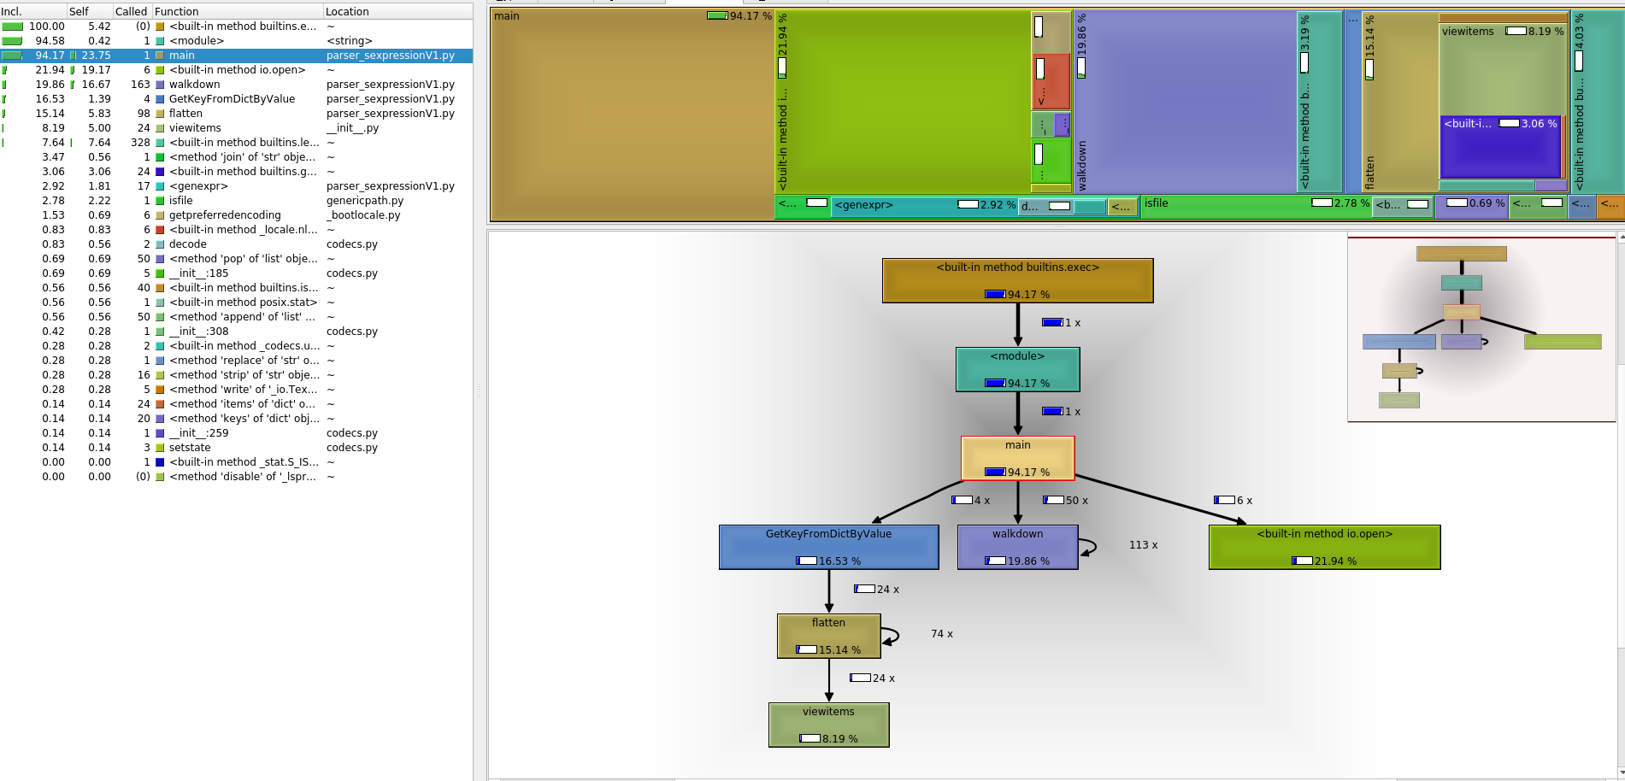

#!/usr/bin/env python
# -*- coding: utf-8 -*-

import regex
import os, sys

'''
Filename: parser_sexpressionV2.py
Description: parse s-expressions using regular expressions
Version: 0.2
Author: JI
Date: 28/01/2018
Licence: Apache License version 2.0
Input: the input consists of a sequence of test cases in the form of integer/tree pairs.
Each test case consists of an integer followed by one or more spaces followed by
a binary tree formatted as an S-expression as described above.
All binary tree S-expressions will be valid, but expressions may be spread over
several lines and may contain spaces. There will be one or more test cases in an
input file, and input is terminated by end-of-file.
Output: there should be one line of output for each test case (integer/tree pair) in the
input file. For each pair I,T (I represents the integer, T represents the tree)
the output is the string yes if there is a root-to-leaf path in T whose sum is I
and no if there is no path in T whose sum is I.
format: (integer()())...
'''

term_regex = r'''(?mx)
\s*(?:
(?P<brackl>\()|
(?P<brackr>\))|
(?P<num>\-?\d+\.\d+|\-?\d+)|
(?P<sq>"[^"]*")|
(?P<s>[^(^)\s]+)
)'''

def parse_sexp(sexp):
stack = []
out = []

for termtypes in regex.finditer(term_regex, sexp):
term, value = [(t,v) for t,v in termtypes.groupdict().items() if v][0]

if term == 'brackl':
stack.append(out)
out = []
elif term == 'brackr':
assert stack, "Trouble with nesting of brackets"
tmpout, out = out, stack.pop(-1)
out.append(tmpout)
elif term == 'num':
v = float(value)
if v.is_integer(): v = int(v)
out.append(v)
elif term == 'sq':
out.append(value[1:-1])
elif term == 's':
out.append(value)
else:
raise NotImplementedError("Error: %r" % (term, value))
assert not stack, "Trouble with nesting of brackets"
return out[0]

def unwrap_list(lst, output = [], node=0):
if type(lst) == type([]):
if len(lst) == 3:
if lst[1]:
unwrap_list(lst[1], output, node + lst[0])
if lst[2]:
unwrap_list(lst[2], output, node + lst[0])
if not lst[1] and not lst[2]:
output.append(node + lst[0])

def main(fileinput, fileoutput):

if not os.path.isfile(fileinput):
print("Error. I could not find the read file %s" %(fileinput))
sys.exit(1)

with open(fileinput, 'r') as f:
content = ''.join(line.strip() for line in f)

content = content.replace(" ", "")

with open(fileoutput, 'w') as f:
f.write('')

patternNum = r'(\d+)'
patternSexp = '\(((?>[^()]+)|(?R))*\)'

r = regex.match(patternNum, content)
if r:
ref = int(r.group())
r = regex.search(patternSexp, content, flags=0)
while r:
result = []
l = r.span()

parsed = parse_sexp(content[l[0]:l[1]])

unwrap_list(parsed, result)
res = 'yes' if ref in result else 'no'
with open(fileoutput, 'a') as f:
#print res
f.write(res + '\n')
content = content[l[1]:]
r = regex.match(patternNum, content)
if r:
ref = int(r.group())
r = regex.search(patternSexp, content, flags=0)
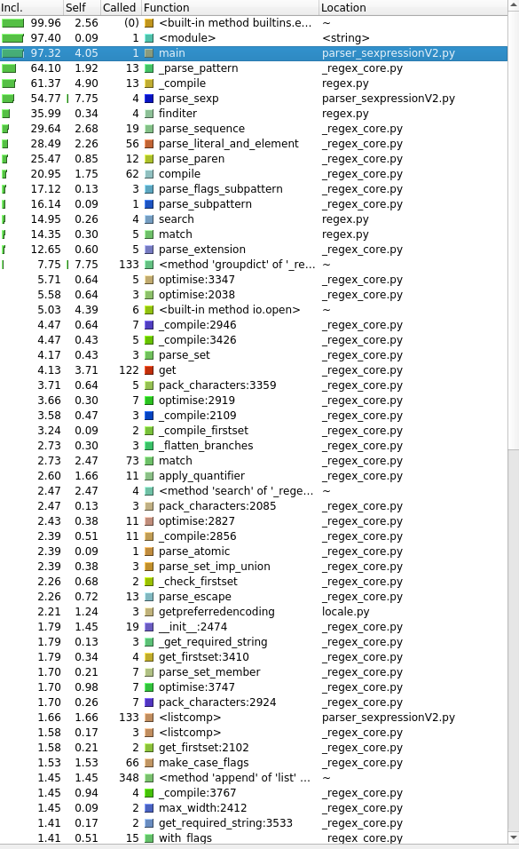
if __name__ == '__main__':

fileinput = './input_short'
fileoutput = './output'

main(fileinput, fileoutput)



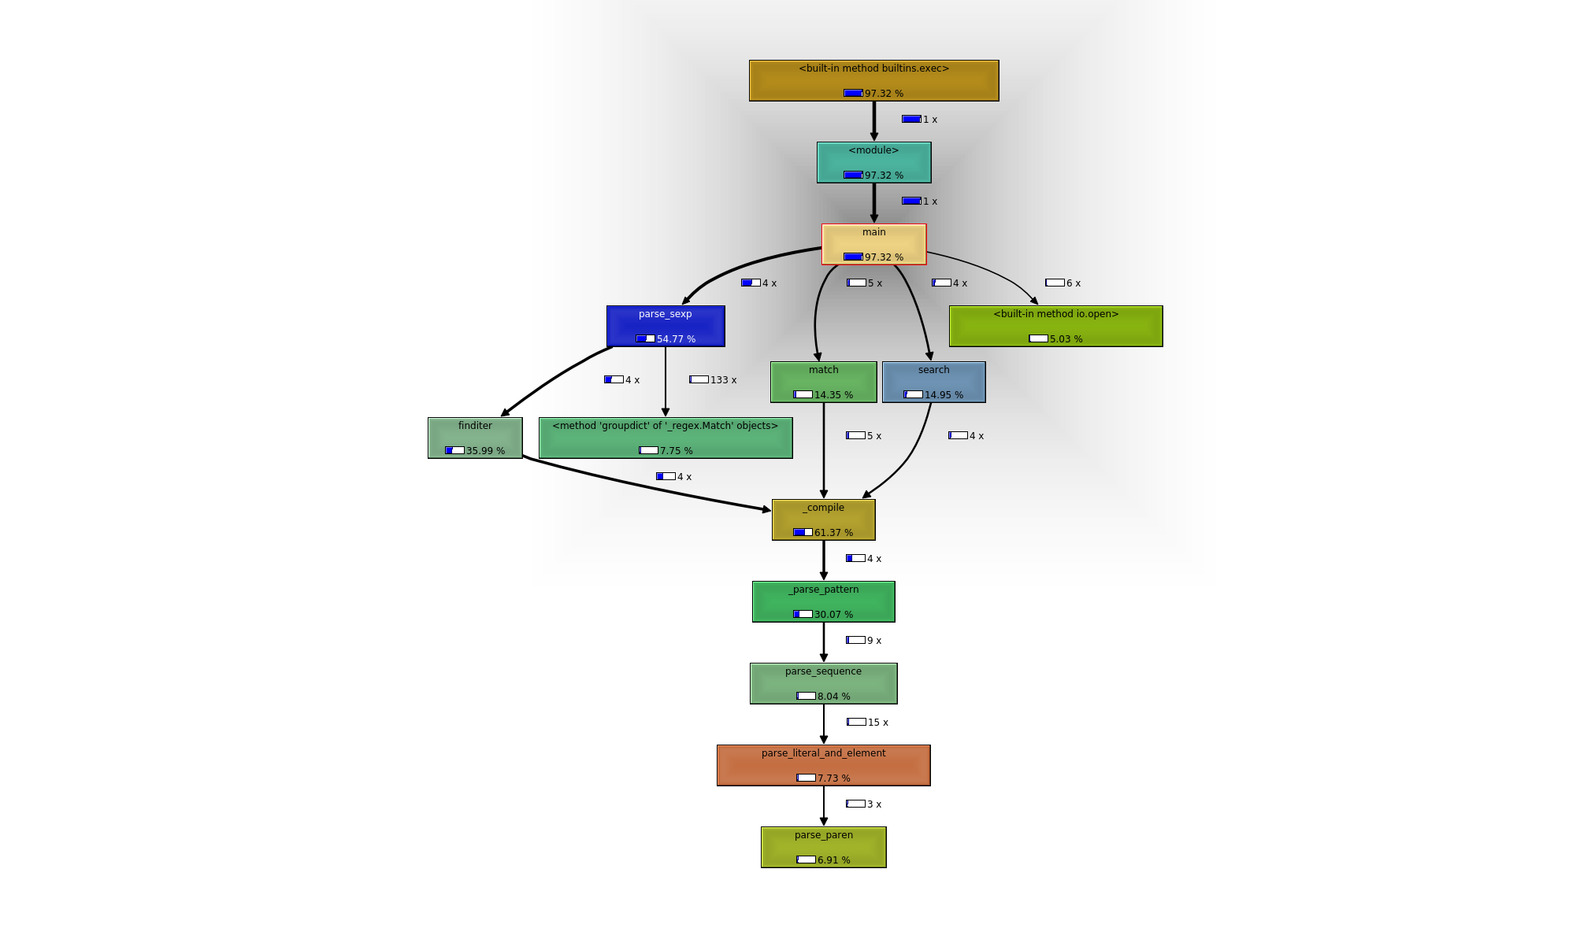

#!/usr/bin/env python
# -*- coding: utf-8 -*-

import regex
import os, sys
from string import whitespace

'''
Filename: parser_sexpressionV3.py
Description: parse s-expressions using regular expressions
Version: 0.3
Author: JI
Date: 28/01/2018
Licence: Apache License version 2.0
Input: the input consists of a sequence of test cases in the form of integer/tree pairs.
Each test case consists of an integer followed by one or more spaces followed by
a binary tree formatted as an S-expression as described above.
All binary tree S-expressions will be valid, but expressions may be spread over
several lines and may contain spaces. There will be one or more test cases in an
input file, and input is terminated by end-of-file.
Output: there should be one line of output for each test case (integer/tree pair) in the
input file. For each pair I,T (I represents the integer, T represents the tree)
the output is the string yes if there is a root-to-leaf path in T whose sum is I
and no if there is no path in T whose sum is I.
format: (integer()())...
'''

atom_end = set('()"\'') | set(whitespace)

def parse(sexp):
stack, i, length = [[]], 0, len(sexp)
while i < length:
c = sexp[i]

reading = type(stack[-1])
if reading == list:
if c == '(': stack.append([])
elif c == ')':
stack[-2].append(stack.pop())
if stack[-1][0] == ('quote',): stack[-2].append(stack.pop())
elif c == '"': stack.append('')
elif c == "'": stack.append([('quote',)])
elif c in whitespace: pass
else: stack.append((c,))
elif reading == str:
if c == '"':
stack[-2].append(stack.pop())
if stack[-1][0] == ('quote',): stack[-2].append(stack.pop())
elif c == '\\':
i += 1
stack[-1] += sexp[i]
else: stack[-1] += c
elif reading == tuple:
if c in atom_end:
atom = stack.pop()
if atom[0][0].isdigit(): stack[-1].append(eval(atom[0]))
else: stack[-1].append(atom)
if stack[-1][0] == ('quote',): stack[-2].append(stack.pop())
continue
else: stack[-1] = ((stack[-1][0] + c),)
i += 1
return stack.pop()

def unwrap_list(lst, output = [], node=0):
if type(lst) == type([]):
if len(lst) == 3:
if lst[1]:
unwrap_list(lst[1], output, node + lst[0])
if lst[2]:
unwrap_list(lst[2], output, node + lst[0])
if not lst[1] and not lst[2]:
output.append(node + lst[0])

def main(fileinput, fileoutput):

if not os.path.isfile(fileinput):
print("Error. I could not find the read file %s" %(fileinput))
sys.exit(1)

with open(fileinput, 'r') as f:
content = ''.join(line.strip() for line in f)

content = content.replace(" ", "")

with open(fileoutput, 'w') as f:
f.write('')

patternNum = r'(\d+)'
patternSexp = '\(((?>[^()]+)|(?R))*\)'

r = regex.match(patternNum, content)
if r:
ref = int(r.group())
r = regex.search(patternSexp, content, flags=0)
while r:
result = []
l = r.span()

parsed = parse(content[l[0]:l[1]])

unwrap_list(parsed[0], result)

res = 'yes' if ref in result else 'no'
with open(fileoutput, 'a') as f:
#print res
f.write(res + '\n')
content = content[l[1]:]
r = regex.match(patternNum, content)
if r:
ref = int(r.group())
r = regex.search(patternSexp, content, flags=0)

if __name__ == '__main__':

fileinput = './input_short'
fileoutput = './output'

main(fileinput, fileoutput)

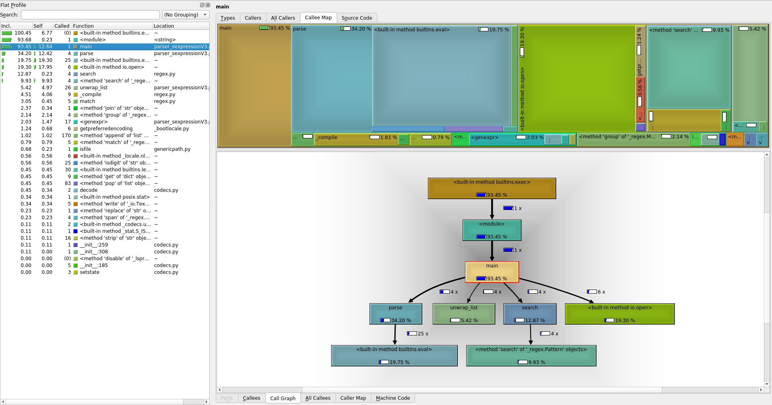
#!/usr/bin/env python
# -*- coding: utf-8 -*-

import regex
import os, sys

'''
Filename: parser_sexpressionV4.py
Description: parse s-expressions converting the structures to arrays
Version: 0.4
Author: JI
Date: 28/01/2018
Licence: Apache License version 2.0
Input: the input consists of a sequence of test cases in the form of integer/tree pairs.
Each test case consists of an integer followed by one or more spaces followed by
a binary tree formatted as an S-expression as described above.
All binary tree S-expressions will be valid, but expressions may be spread over
several lines and may contain spaces. There will be one or more test cases in an
input file, and input is terminated by end-of-file.
Output: there should be one line of output for each test case (integer/tree pair) in the
input file. For each pair I,T (I represents the integer, T represents the tree)
the output is the string yes if there is a root-to-leaf path in T whose sum is I
and no if there is no path in T whose sum is I.
format: (integer()())...
'''

def recursive_bracket_parser(s, i=0, j=0):
res = []
counter = 0

if i < 0: i = 0
if j == 0 or len(s) < j: j = len(s)
if i > j: i = j

while i < j:
if s[i] == '[':
counter +=1
if counter == 1: res.append(i)
elif s[i] == ']':
counter -=1
if counter == 0:
res.append(i+1)
return res
i += 1

return []

def is_sum(tree, num):
if (len(tree) == 0): # 'in' a leaf
return False
if (len(tree[1]) == 0 & len(tree[2]) == 0): # leaf
return num == tree[0]
return (is_sum(tree[1], num-tree[0]) | is_sum(tree[2], num-tree[0]))

def main(fileinput, fileoutput):

if not os.path.isfile(fileinput):
print("Error. I could not find the read file %s" %(fileinput))
sys.exit(1)

with open(fileinput, 'r') as f:
content = ''.join(line.strip() for line in f)

content = content.replace(" ", "")
content = content.replace('(',',[')
content = content.replace(')',']')

with open(fileoutput, 'w') as f:
f.write('')

patternNum = r'(\d+)'
r = regex.match(patternNum, content)
if r:
ref = int(r.group())

s = recursive_bracket_parser(content)

while s:

ltree = eval(content[s[0]:s[1]])

res = 'yes' if is_sum(ltree,ref) else 'no'
with open(fileoutput, 'a') as f:
#print res
f.write(res + '\n')

content = content[s[1]:]

s = []
r = regex.match(patternNum, content)

if r:
ref = int(r.group())
s = recursive_bracket_parser(content)
s = recursive_bracket_parser(content)

if __name__ == '__main__':

fileinput = './input_short'
fileoutput = './output'

main(fileinput, fileoutput)

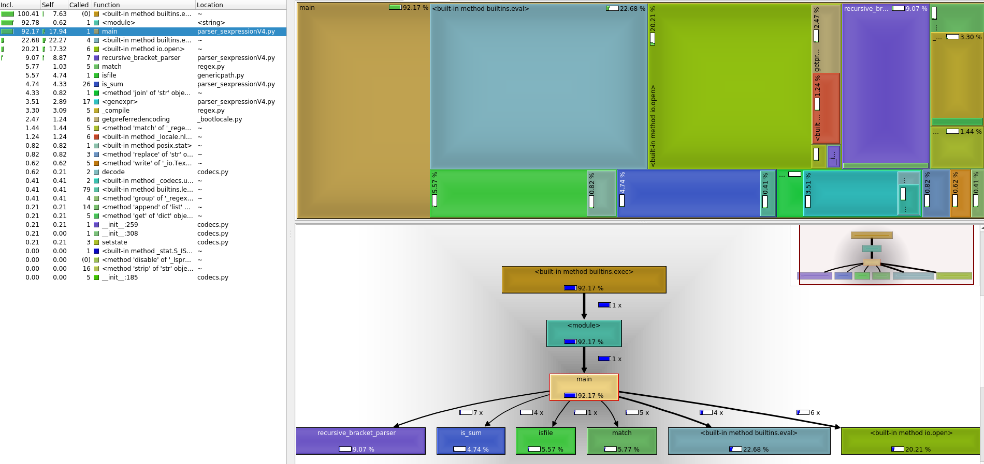
#!/usr/bin/env python
# -*- coding: utf-8 -*-

import sys, os
import itertools
from future.utils import viewitems
from threading import Lock
from multiprocessing.dummy import Pool as ThreadPool

'''
Filename: parser_sexpressionV5.py
Description: multi-threading parse s-expressions after reading each line
Version: 0.5
Author: JI
Date: 28/01/2018
Licence: Apache License version 2.0
Input: the input consists of a sequence of test cases in the form of integer/tree pairs.
Each test case consists of an integer followed by one or more spaces followed by
a binary tree formatted as an S-expression as described above.
All binary tree S-expressions will be valid, but expressions may be spread over
several lines and may contain spaces. There will be one or more test cases in an
input file, and input is terminated by end-of-file.
Output: there should be one line of output for each test case (integer/tree pair) in the
input file. For each pair I,T (I represents the integer, T represents the tree)
the output is the string yes if there is a root-to-leaf path in T whose sum is I
and no if there is no path in T whose sum is I.
format: (integer()())...
'''

lock = Lock()
NUMPROC = 12

def write2file(fpath, text):

lock.acquire() # thread blocks at this line until it can obtain lock
f = open(fpath,'a')
f.write(text + '\n')
f.flush()
f.close()
lock.release()

def log2console(text):
lock.acquire() # thread blocks at this line until it can obtain lock
print('{}'.format(text))
sys.stdout.flush()
lock.release()

def flatten(dictionary):
for key, value in viewitems(dictionary):
if isinstance(value, dict):
# recurse
for res in flatten(value):
yield res
else:
yield len(dictionary.keys()), value

def GetKeyFromDictByValue(self, dictionary, value_to_find):
for key, value in flatten(dictionary):
if (value == value_to_find) and (key == 1):
return key

def walkdown(tree, nodes, total=0):
if len(nodes) == 0: return tree

node_name = nodes[0]
i = int(node_name)
if tree and node_name in tree:
tree[node_name] = walkdown(tree[node_name], nodes[1:], tree[node_name]['sum'])
else:
tree[node_name] = {'sum': int(total) + i}
return tree

def parse_sexpression(args):

content = args[0]
wfile = args[1]

node_name = ''
parent_names = []
ref = []
tree = {}
counter = 0
k = 0
while k < len(content):
ch = content[k]
if ch == '(':
if counter == 0:
ref = int(node_name)
else:
parent_names.append(node_name)
tree = walkdown(tree, parent_names)
node_name = ''
counter +=1
elif ch == ')':
counter -=1
if counter == 0:
node_name = ''
res = 'yes' if GetKeyFromDictByValue(None, tree, ref) == 1 else 'no'
write2file(wfile, res + ': ' + content)
#log2console(res + ': ' + content)
tree = {}
else:
node_name = parent_names.pop()
else:
node_name = node_name + ch

k +=1

def main(fileinput, fileoutput):

with open(fileoutput, 'w') as f:
f.write('')

if not os.path.isfile(fileinput):
print("Error. I could not find the read file %s" %(fileinput))
sys.exit(1)

content = []
sexpr = ''
with open(fileinput, 'r') as f:
for line in f:
line.strip()
line = line.replace(" ", "")
line = line.rstrip("\n\r")
if line:
sexpr = sexpr + line
if sexpr.count("(") == sexpr.count(")"):
content.append(sexpr)
sexpr = ''

pool = ThreadPool(NUMPROC)
pool.map(parse_sexpression, zip(content, itertools.repeat(fileoutput)))

if __name__ == '__main__':

fileinput = './input_short'
fileoutput = './output'

main(fileinput, fileoutput)
