

**ICT 1 PROJECT DOCUMENTATION TASK 1**

**Neha Bisht JC446358**

**Babita JC424959**

**Bhoomi JC458537**

**Table of Contents**

|  |  |  |
| --- | --- | --- |
| S.No | Title | Page |
| 1. | Team Description& individual Classificagtion for ICT-2 | 2 |
| 2. | Project Description | 2 |
| 3. | Project Audit | 4 |
| 4. | Client’s Signed Agreement | 5 |
| 5. | Project Development and Release | 7 |
| 6. | Layout/Prototype | 8 |
| 7. | References | 9 |
| 8. |  |  |

Team Description: -Our team is working on a full fledgedwebsite for an indian startup business of water harvesting and tubewell boring.This company is founded by Rishab Singh who is our ICT client.The company not only deals with the current water problems faced by not onltysmall households but also complex infrastructural projects but tends to provide wide range of products which are used for tube well boring and rain water harvesting. For ICT 2,we have come up with a new team to work together and contributing equally towards our project. The goal of ICT 2 is gauging a bigger picture of website development by associating an admin dashboard and database structural design of all the pages that can be directly accessed by the admin from dashboard. Also, this time we have also extended working on website security for better threat management and safety and privacy of both the admin and users of the website. Before starting implementation of our tasks, being under agile methodology, we followed a work breakdown of each user story and designed the user story board with short term as well as long term tasks into consideration.We are a team of three to complete these tasks.

Individual Contribution:-

Neha Bisht

* Worked on website Templates
* Co-ordination with client.
* Preparing client agreements.
* Admin dashboard designing
* Admin Dashboard Implementation
* Home Page:Design and Development

Babita

* Worked on website layouts
* Create Prototypes
* Described Project Description, Goals and Deliverables
* Our Projects Page: Design and Development
* Our Projects: Database Integration
* Version Control System: Github

Bhoomi

* Our Services Page:Design and Development
* Prototype of all new changes
* Admin dashboard form: Design and Development
* About Us: Layout Improvements
* Contact Us: Layout Improvements
* Our Services: Database Integration

We have divided the requirements according to the planning and designing. All the tasks are completed according to the priorities given from client.

Project Specifications for Beta release

As per the requirements gathered after the implementation of Alpha release and special guidance from Lauras and few suggestions from client Rishab Singh we came up with new ideas while keeping the timelines of developmet in mind.Few of these changes and new scope of requirements are as follows:

1. The company wanted some of the products that they provides to be displayed on Our Projects pageand a platform to sustain user engagement through a contact us form in the same page.
2. The website for the company will enable the users/visitors and targeted clients to get an insight of companies offered services and projects and be a technologically driven method for the client to touch base with client queries on the website.
3. The website directs the users/visitors to different pages that give them a glimpse of what Competent Works is all about. The website as proposed by the client, should user friendly, simple and not too overloading for new users to understand what it actually has to offer.
4. Content management was proposed by the client for About Us and Contact Us page
5. Database connectivity from admin dashboard to enable possibility of data entry from a user friendly platform in form of an admin dash board was proposed by our lecturer Laura. This utility has found a structure till now and we are going to work on integrating database from all the pages in near future.

Justification of Project Specification of Beta release

The website Competent Works aims to provide an overview of the company in the home page and what are the primary services they expertise in and their client’s satisfaction testimonials to show the commitments on the ongoing projects of a company. Highlighting these services a user can have a thought for getting these services for their projects.

Our Services is handled by our team member Bhoomi who has implemented the services offered by the company are listed to detail. The installation processes, site mapping and planning and emerging tube well trends that take less hassle and more comfort while designing for your rainwater harvesting projects also get a place in order to attract the visitors towards the skilled technologies the client has to offer.

Our Projects is a detailed description of the past projects the company excelled in. It will also consist of commitments and people testimonials from the companies the client worked for in the past. Also it consists of company clients and ongoing work and future projects. The products that company is offering and showing the products use in different areas of water harvesting and tube well boring.

About Us/Contact Us: For a better understanding, the company about us page offers why you choose us section and company’s motto with future endeavors.

Project Goals:

Client-Side Goals:

1. Simple and less content but more focused over user interface with proper designing of each page.
2. More visual interaction enabled with image sliders, images and client testimonials.
3. Admin dashboard for user friendly data addition, deletion and modification in the pages.
4. The website should look clean with standard layouts and should have all the pages that we agreed upon.

Development Goals:

1. Standard and neat layouts of all pages
2. Pages should be descriptive enough to be understood by new users/visitors
3. Responsive web pages.
4. Developed pages with integrated database according to the given priority and timelines.
5. Continues follow-ups with client and incorporating any changes in requirement set.
6. Database connectivity of all the pages.

Deliverables with deviations from the Alpha release

1. Online working website with quick access to all the pages.
2. Hassle free enquiry page in Contact Us.
3. Admin dashboard.
4. A clear display of services and projects of the company.
5. Products images with their use in water harvesting.
6. Testimonials of existing client’s.
7. Easy navigation from one page to another.

Justification between major milestones with timeline for beta release

* In this section, we as a team have crafted out the project milestones in terms of the priority of all the tasks and listing the timelines of each of those tasks. As In Alpha release, we have decided to put forward planning requirements, designing of initial prototypes of each web page and identifying a rough template of the website. In the completion of milestone, come up with the static webpage design and development of the web page: Home, Contact Us, About Us, Our Services, and Our Projects.
* In the later milestone Beta release, we have decided to present the ongoing development to the client, error tracking and correction, incorporate any changes in the requirement or identifying any new requirement. Connecting database (MySQL) to the website.

Project Audit:

* Milestone 2: Beta Release
* The starting date of Beta Release: 16thMarch 2018 and ending date will be last week of June. All the webpages will be designed as per the following user stories description by according to the client side.

Beta Release, refer to the document attached below:



<Client Agreement>

Project Development and Release Environment:

Public repositories can use GitHub without any cost, whereas private repositories have pay to use GitHub in their software development process.Repositories can work in a team and they can be either public or private.

Bluehost:Our web hosting provider is Bluehost.

Localhost: XAMPP: It is a cross platform solutions stack containing locally hosted database for development process.

FileZilla: For transferring the files over bluehost, we have used Filezilla as FTP client that successfully transferred the website folder to out web host Bluehost.

Slack: As an ongoing practice for professional communication, we are using Slack that is used for all development related progress, queries and schedule planning of user stories and team meetings. An export file of our conversation history on Slack is attached as here.



Tasks per week from the notebook

We have tried to maintain a streamlined project growth by assigning short tasks to all the team members every week and discussing our issues and doubts while working on them. Some snippets of these tasks are roughly written as a record of who did what and are attached here,

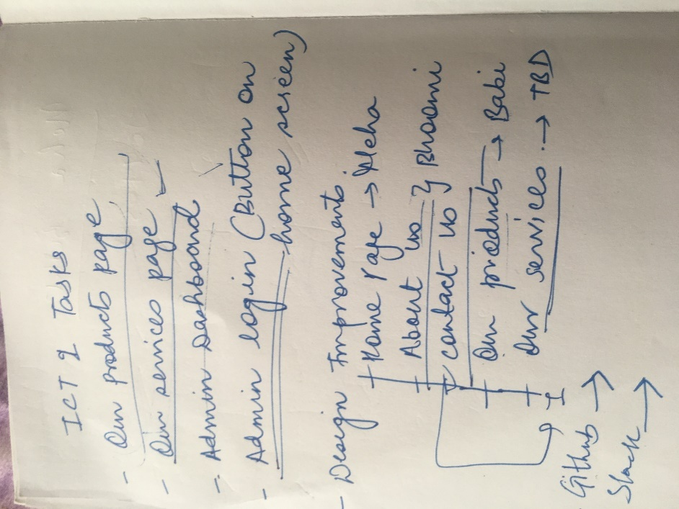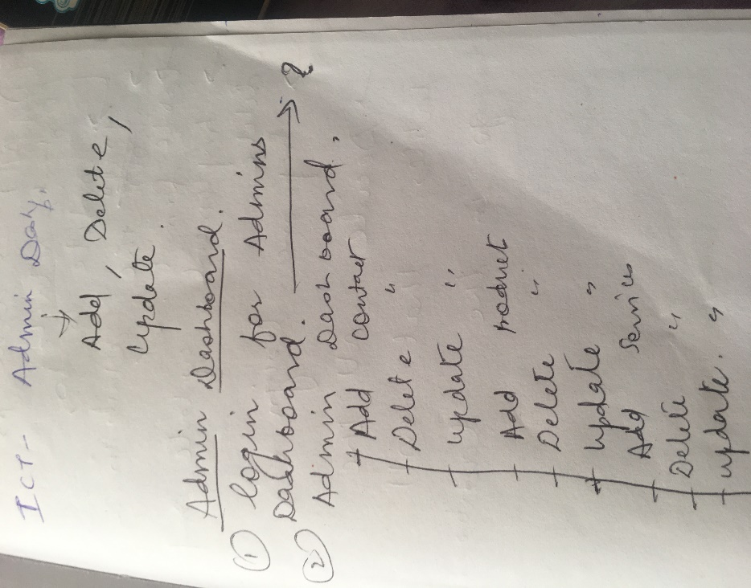

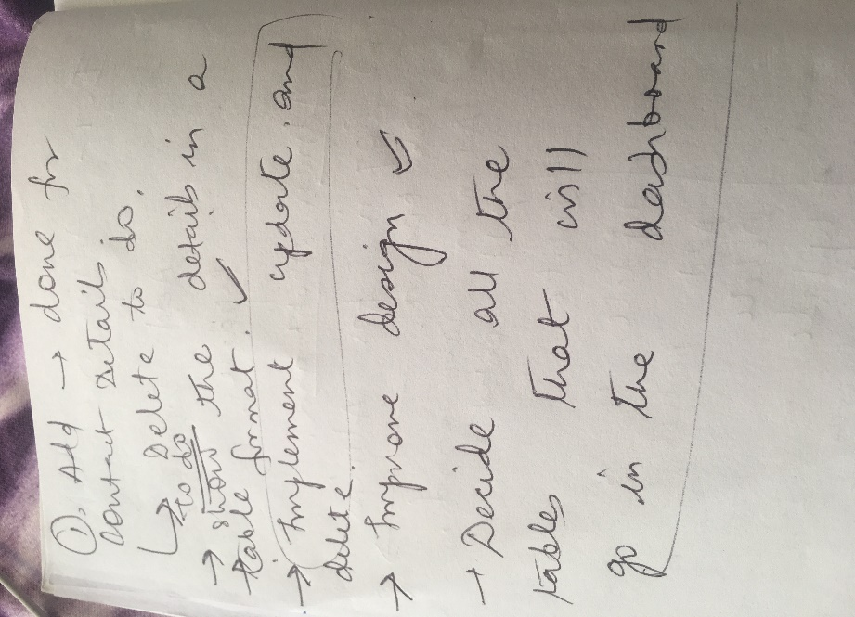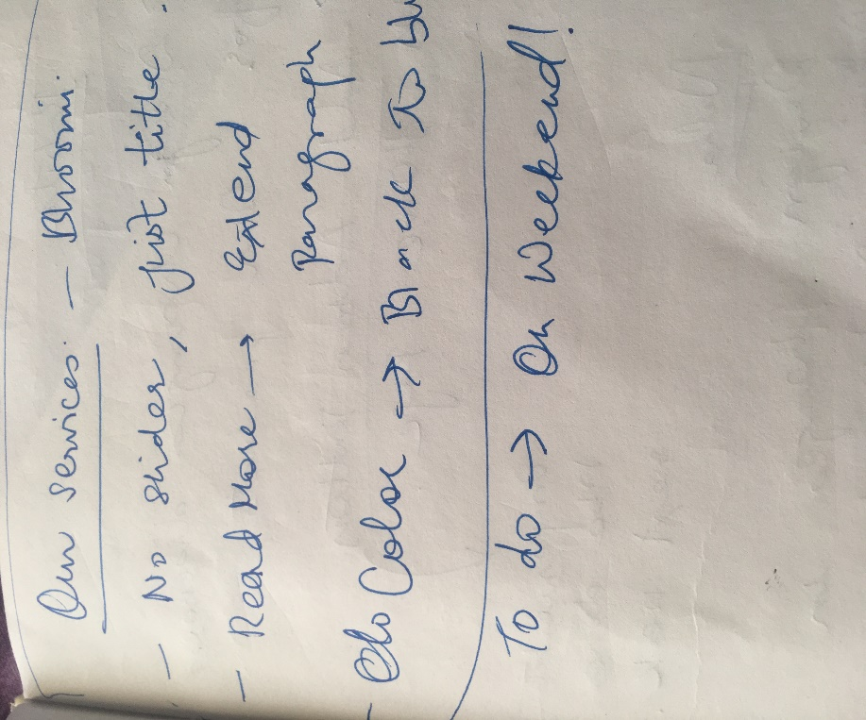

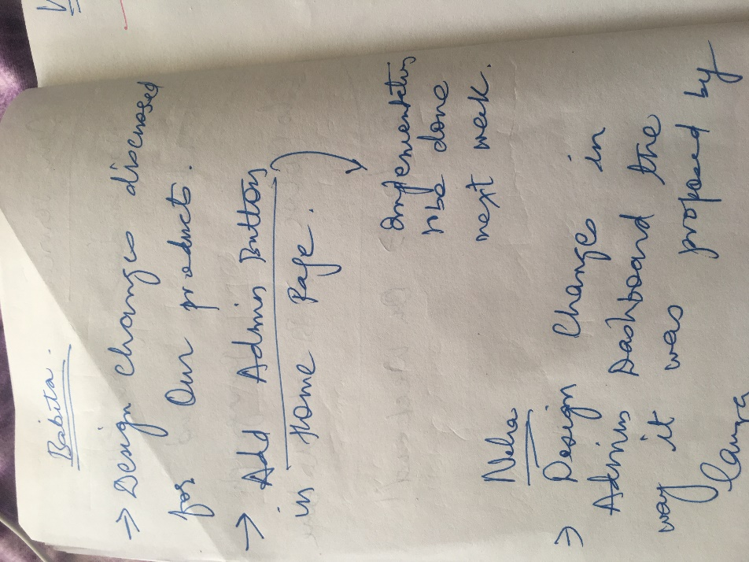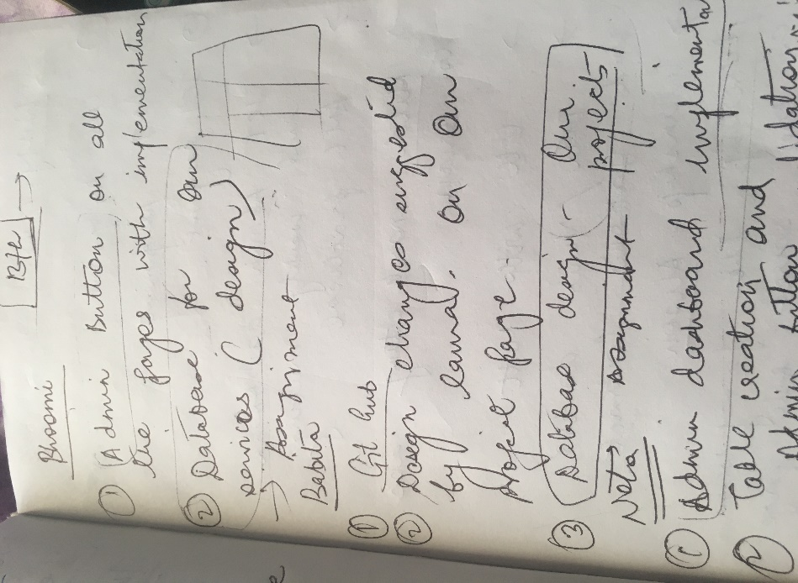

Velocity chart: Sprint 1 & 2

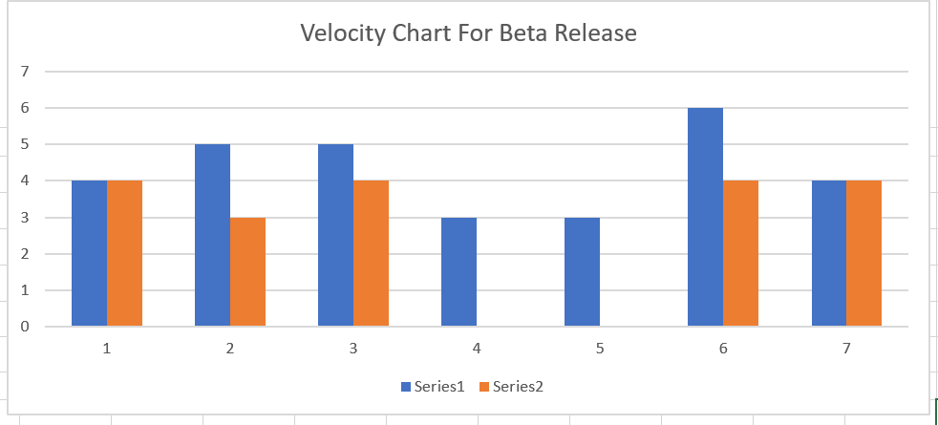

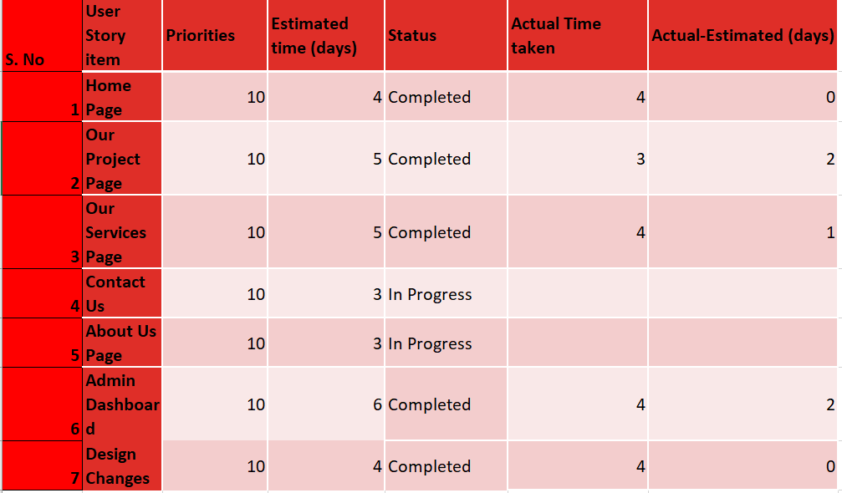

Velocity of the team= (estimated time (days)/actual time (days)) *100

= 30/32*100

=93.75%

*Note: keeping the estimated time completed for two US that are still in progress to be 6 days each.

Burn down chart: Sprint 1 & 2

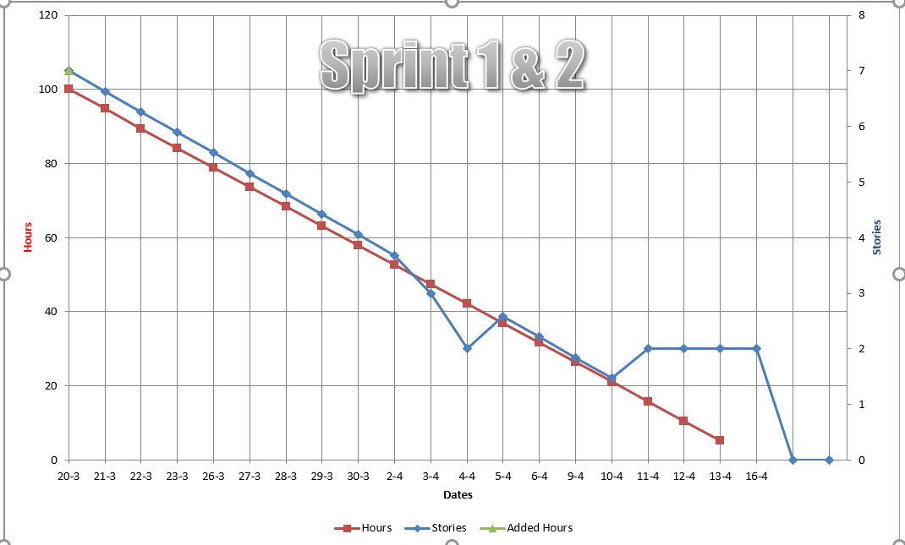

Prototype Changes for Beta release:

1. Our Projects Page

|  |
| --- |
| **Company Logo**  **Image** |

|  |
| --- |
| **Home About Us Contact us Our service Our projects Admin** |

|  |
| --- |
| **Our Projects**    **Project slider**  **Product Description**  **Product Testimonial**      **Footer** |

1. Admin Dashboard

|  |
| --- |
| **Company Logo** |

|  |
| --- |
| **Database Tables**  **Menu Bar**  Data in content Table  Description  Data in Products Table  Description  **Add user contacts**  **Delete User contacts**  **Update User contacts**  **Add Product**  **Delete Product**  **Update Product**  **Add Services**  **Delete services**  **Update services**  **Admin Logout**    **Footer** |

1. Our Services

|  |
| --- |
| **Company Logo**  **Image** |

|  |
| --- |
| **Home About Us Contact us Our service Our projects Admin** |

|  |
| --- |
| **Our Services**  **Description**  **Image**    **Footer** |

1. Contact Us

|  |
| --- |
| **Company Logo**  **Image** |

|  |
| --- |
| **Home About Us Contact us Our service Our projects Admin** |

|  |
| --- |
| **Contact Us**  **Form**  **Google Map**      **Footer** |