**TEAM05NOV16**

**KALYAN JEWELLERS**

**Project Final Stage Report**

**INTRODUCTION**

**PROJECT IDEA AND CONCEPT**

We developed a responsive website for **The Jewellery Store** to make it more convenient for the users to do the online shopping. We have chosen a title for our store website which is “Kalyan Jewellers” The idea behind the development of this website is to provide a wide range of Jewellery instantly through online or in store for the customers. In collections, we have exquisite as well as contemporary jewellery designs that suit with women from all walks of life. Our website exclusively provides visitors to book an appointment that is just a click away. We also have search options for convenient browsing. Store locator makes easier to the users to locate the nearest store. We allow our users to sign up for the free membership and enjoy the discounted jewellery.

**The website encompasses through a some of the below mentioned pages:**

* **Home page**: Gives an overall glimpse of the website and what we have to offer.
* **About us**: What we do and how we help in spreading our mission.
* **Kalyan Stories**: Our Company profile.
* **Collection**: In collections we have the jewellery collections page.
* **Brands**: We have different brands in our store in which we have exquisite range of all types of jewellery.
* **Contact us**: General contact details
* **Registration**: Registration page is for the registered candidates.
* **Search**: We have search option to find the jewellery type.

**Home Page:**

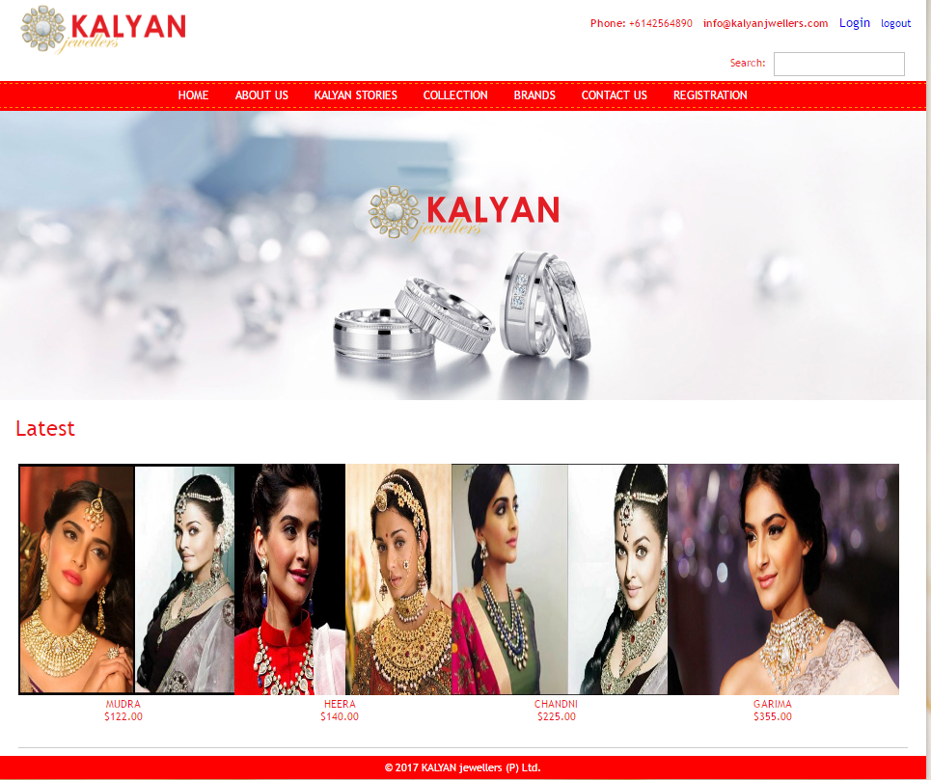

* **Technical Features Of the Website For User friendliness**

Consider any of the followings:

Home, menu bar, icons, logo design

Image colours, font, Jewellery designs.

Usage of media: images, logo, Jewellery designs

* **Strengths Of the Team**

HTML Designing, Communication and Presentation skills, Adaptability to new coding concepts.

* **Weaknesses Of the Team**

Coding.

**Web Site Access: http://10.250.0.9/team05nov16/projectfinalstage/index.php**

**PRIMARY OBJECTIVES OF WEBSITE: -** To provide best jewellery designs to our customer. We developed user friendly website for online booking and for the best designs in all types of jewellery. Compatible website for all devices. Customers can choose from wide range of jewellery. Offers discounts on special occasions and festivals.

**About Us:**

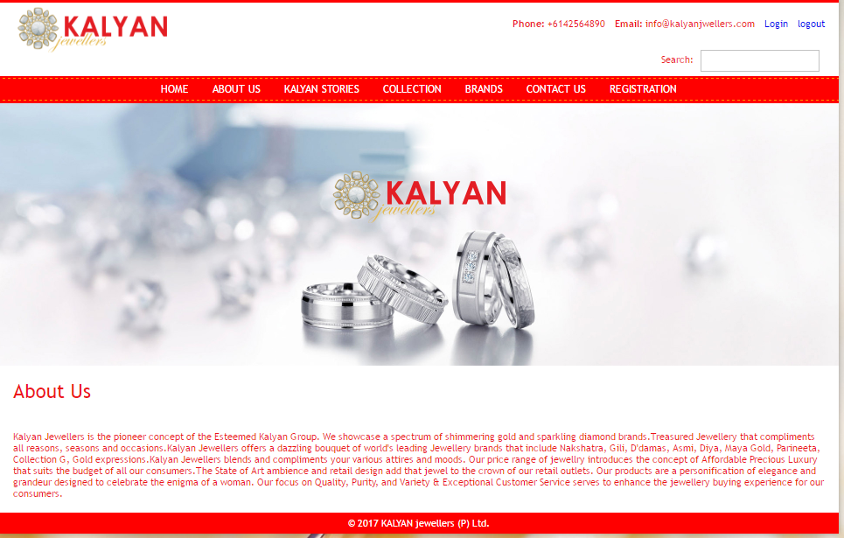

1. **TARGET USERS**

**-**We are targeting on the youngsters who are planning to get married.

**-**We are also targeting on female customers.

**2)**  **SECONDRY USERS**

- Website visitors

**Features of The Website: -** Customers can choose from the wide range of jewellery. Jewellery for all the occasions (Marriages/Gifts).Responsive web pages will fit into wide range of devices.Special offers on festivals and on membership.

**Collection**:

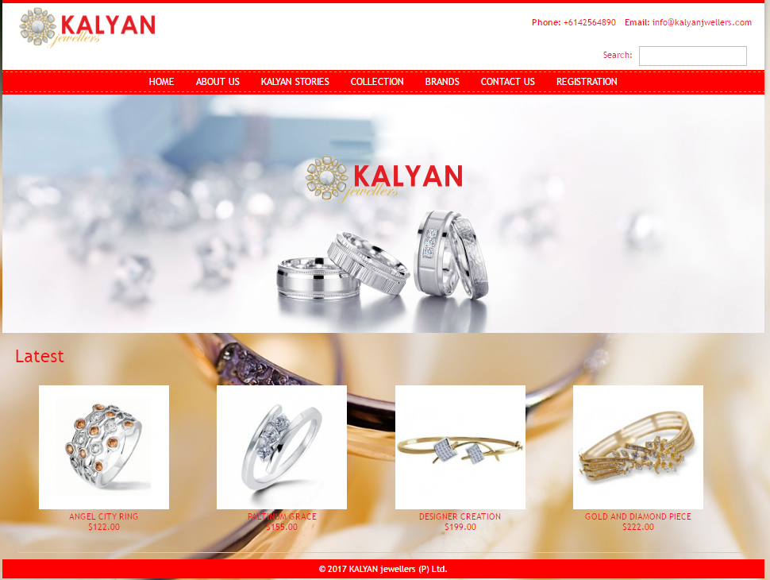

**Technologies in Use**

- **Front end requirements**: HTML5, CSS, JAVASCRIPT.

-**Backend requirements**: PHP, MySQL,

**Brands:**

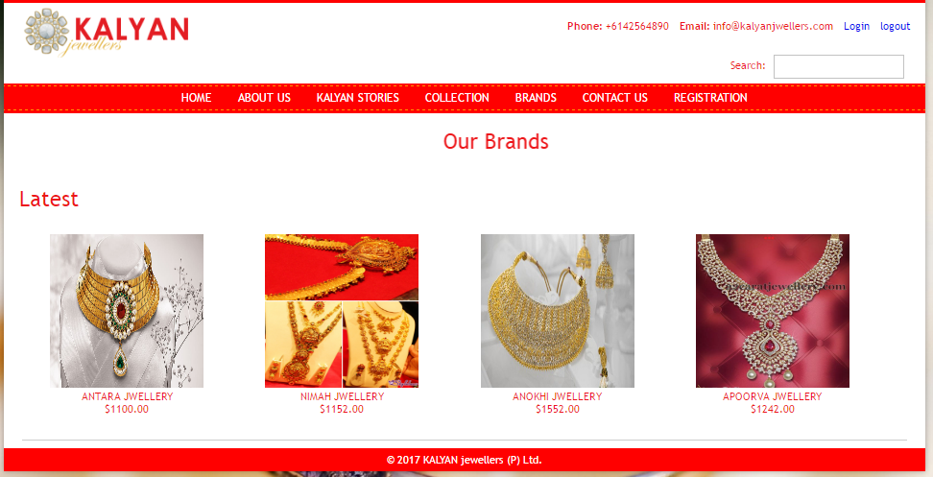

**-Tools:** Photoshop, Paint.

**Registration Page:**

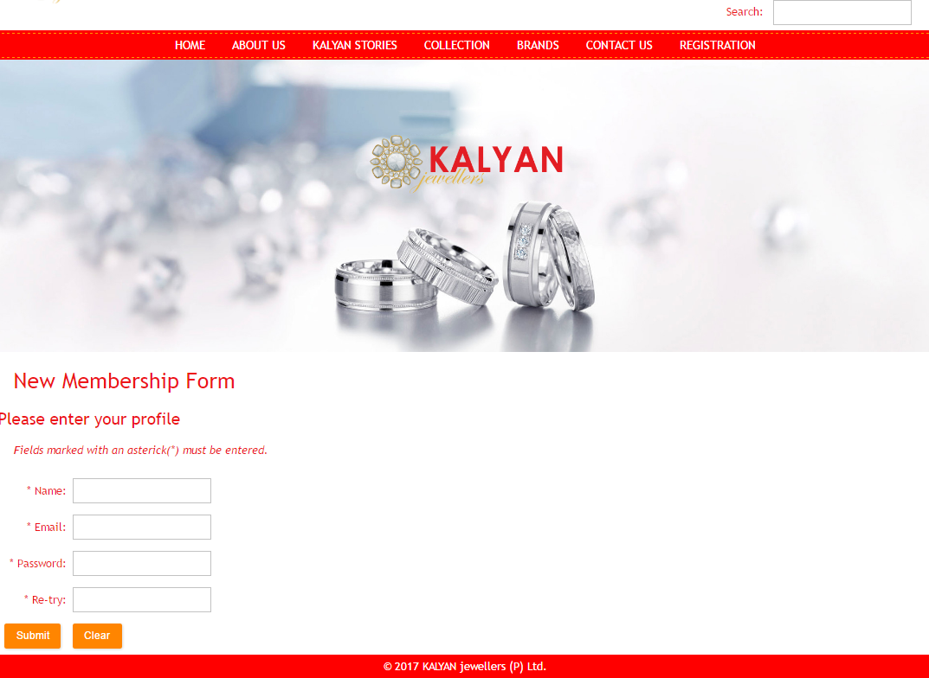

**Responsibilities of Each Team Member & Project Milestone**

**Responsibilities: (Presentation is done together by the team (Inderpreet & Babita)**

**Babita:**

* Designing of the Kalyan logo
* Documentation and Designing
* Designing of Contact Us Page
* Designing of Home Page.
* Responsive and Style CSS File creation.

**Inderpreet:**

* Coding of all the pages
* Database Connectivity
* Registration page
* Contact Us Page

**Schedule:**

**-**Week 6: Blue print & Website Visual Design layout.

**-**Week 7: Designing of all the following pages and assembling their database.

**-**Week 8: Linking the Home, Menu and Offers page to the following subset web pages**.**

**-**Week 9: Database Connectivity

-Week 10: Final Website Completion.