1.select member_id,member_name,city,membership_status

from lms_members

where membership_status='permanent';

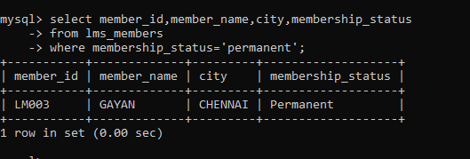

3.select member_id,member_name,book_code

from lms_members,lms_book_details

where book_code='BL000002';

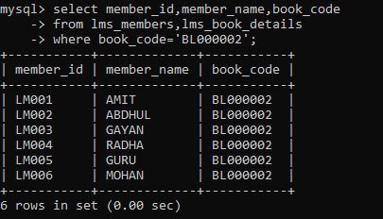

4.select book_code,book_title,author

from lms_book_details

where author like 'P%';

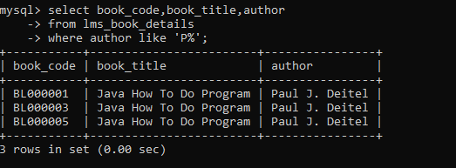

5.select COUNT(CATEGORY) as 'no_of_books'

from LMS_BOOK_DETAILS

where CATEGORY='Java';

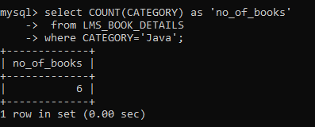

6.SELECT COUNT(CATEGORY) AS NO_OF_BOOKS,CATEGORY

FROM LMS_BOOK_DETAILS

GROUP BY CATEGORY;

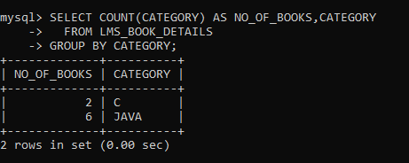

2. SELECT b1.book_code, b2.publication,

b2.price, b3.supplier_name

FROM (SELECT b1.book_code

FROM LMS_BOOK_ISSUE b1

GROUP BY book_code

HAVING COUNT(b1.BOOK_CODE) > 1) b1 JOIN LMS_BOOK_DETAILS b2 ON b1.book_code = b2.book_code JOIN LMS_SUPPLIERS_DETAILS b3 ON b2.supplier_id = b3.supplier_id;

