EMPLOYEE ID-854963

EMPLOYEE NAME-C.PRANUSHA

Question1:

SQL> select department_name,count(employee_id)

2 from departments d,employees e

3 where d.department_id=e.department_id

4 group by department_name

5 having count(employee_id)>=20;

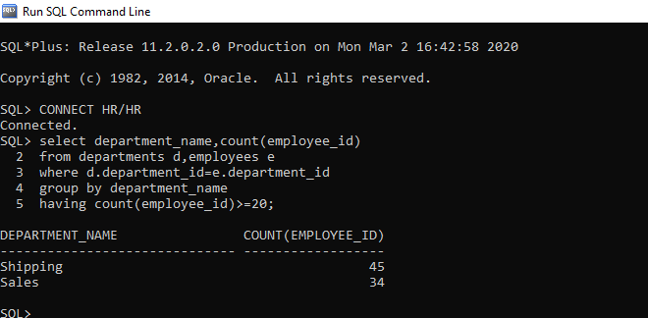

Question2:

SQL> select employee_id,first_name,last_name,salary

2 from employees e1

3 where salary>(select avg(salary)

4 from employees e2

5 where e1.department_id=e2.department_id

6 group by e1.department_id);

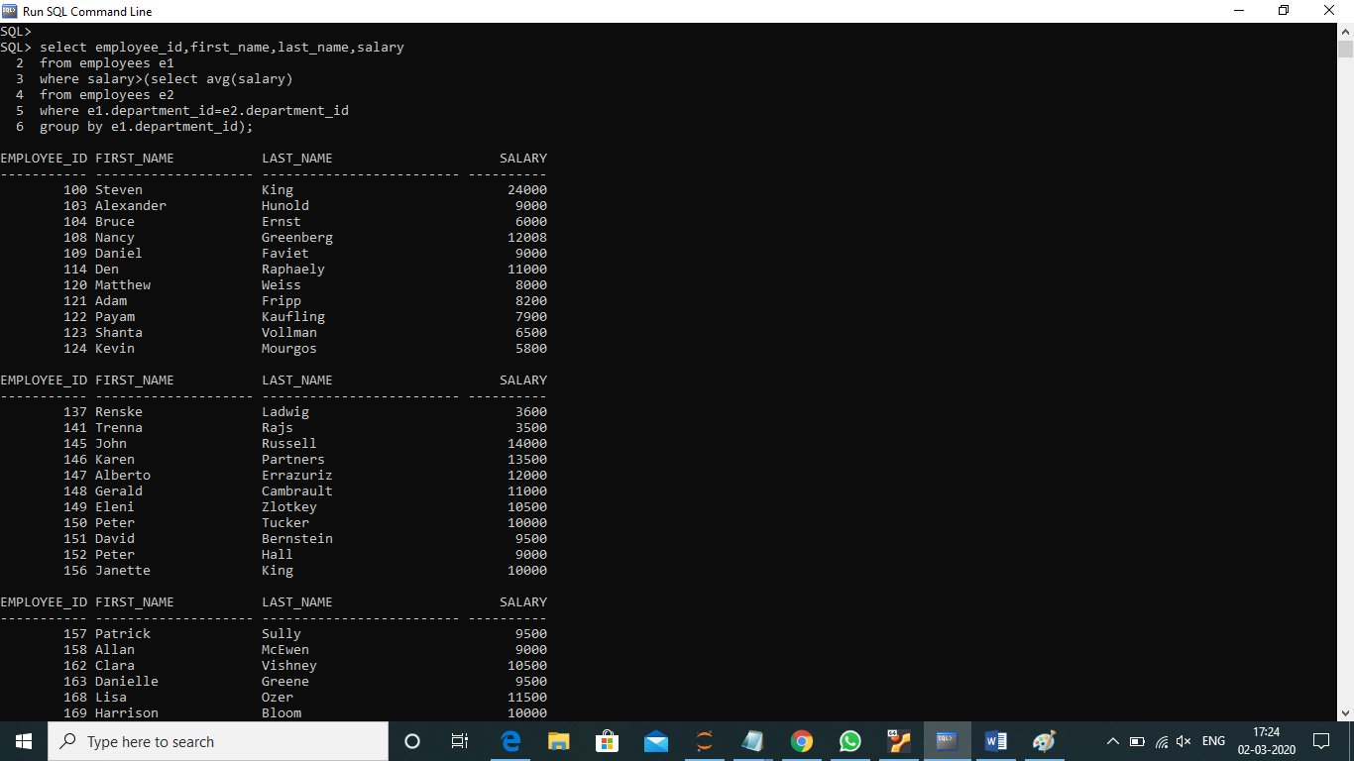

Question3:

SQL> select employee_id,first_name,last_name,

2 first_name ||' '|| last_name as full_name,

3 salary,(salary * (10/100)) as newsalary,

4 (salary- salary*(10/100)) as difference

5 from employees;

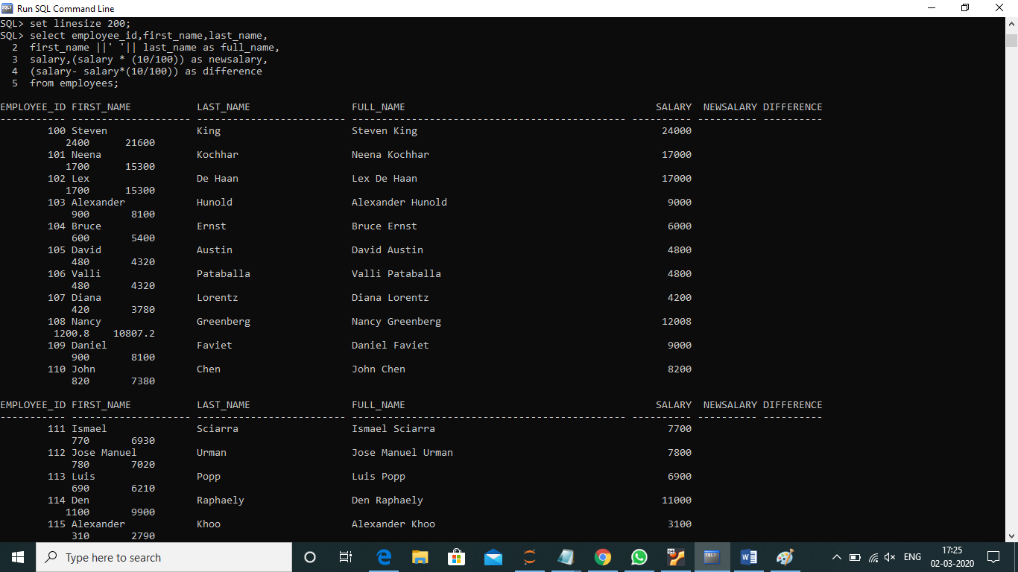

Question4:

SQL> select e1.employee_id,e1.first_name,e1.last_name,e2.first_name as manager_name

2 from employees e1 left outer join employees e2

3 on e1.manager_id=e2.employee_id

4 order by employee_id;

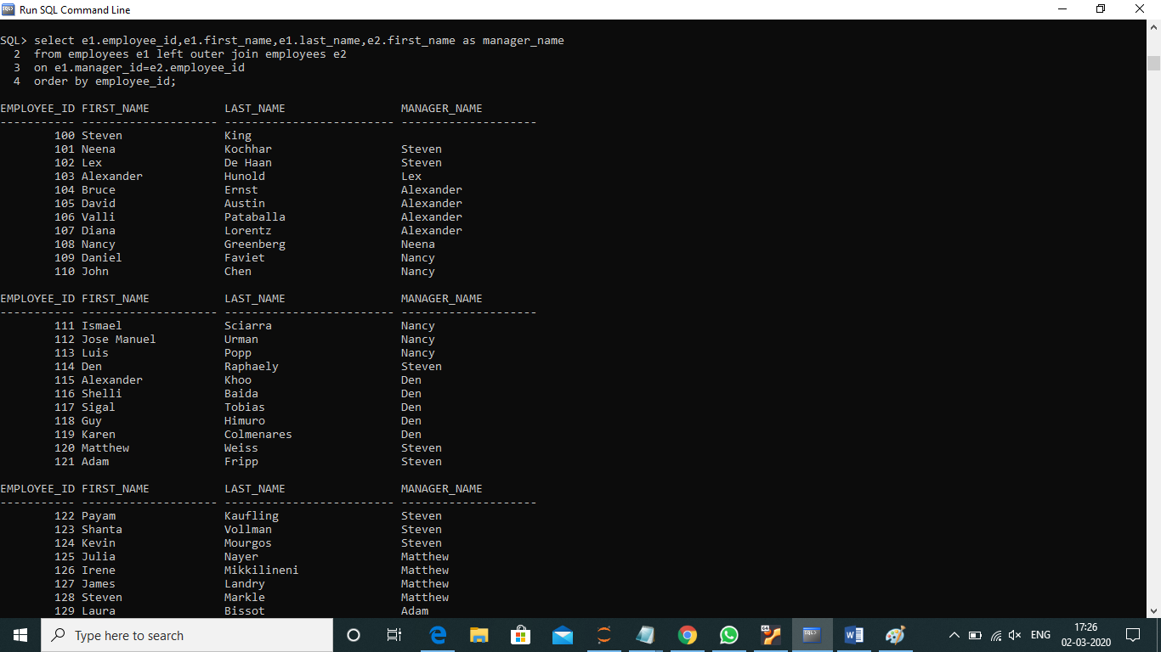

Question5:

SQL> select employee_id,first_name,last_name,salary from employees

2 where rownum<=3

3 order by salary desc;

