1. select MEMBER_ID,

MEMBER_NAME,

CITY,

MEMBERSHIP_STATUS from LMS_MEMBERS

where MEMBERSHIP_STATUS = 'PERMANENT';

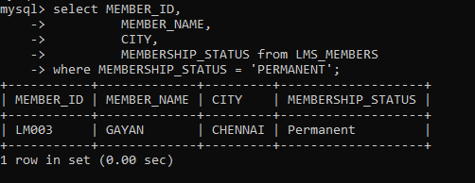

2. SELECT b1.book_code, b2.publication,

b2.price, b3.supplier_name

FROM (SELECT b1.book_code

FROM LMS_BOOK_ISSUE b1

GROUP BY book_code

HAVING COUNT(b1.BOOK_CODE) > 1) b1 JOIN LMS_BOOK_DETAILS b2 ON b1.book_code = b2.book_code JOIN LMS_SUPPLIERS_DETAILS b3 ON b2.supplier_id = b3.supplier_id;

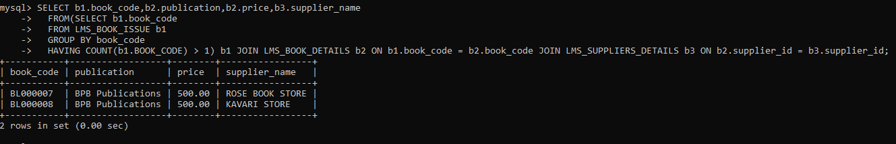

3. select MEMBER_ID ,MEMBER_NAME from LMS_MEMBERS M,LMS_BOOK_DETAILS L

where L.BOOK_CODE='BL000002';

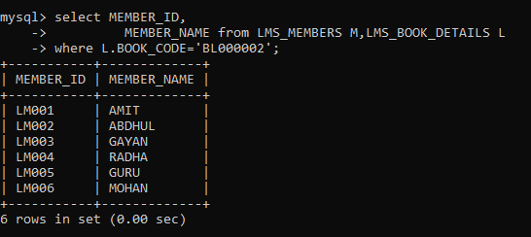

4. select BOOK_CODE,

BOOK_TITLE,

AUTHOR from LMS_BOOK_DETAILS

where AUTHOR like 'P%';

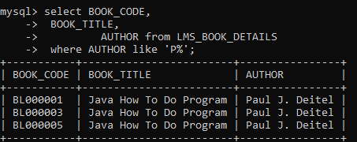

5. select COUNT(*) as NO_OF_BOOKS from LMS_BOOK_DETAILS

where category='JAVA';

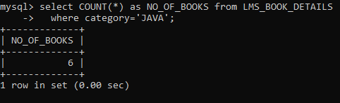

6. select CATEGORY,

COUNT(*) as NO_OF_BOOKS from LMS_BOOK_DETAILS

group by(CATEGORY);

