1.select department_name,count(salary) as no_of_employees

from employees e, departments d

where e.department_id=d.department_id

group by department_name

having count(*)>=20;

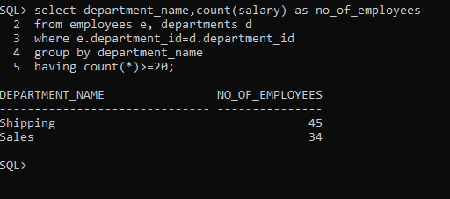

2.select employee_id,first_name,

last_name,salary

from employees where salary>all(select avg(salary) from employees group by department_id);

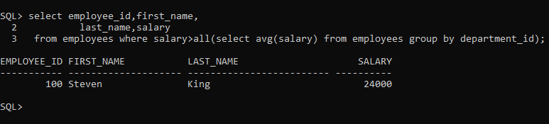

3. select employee_id,first_name,

last_name,salary,

first_name||' '||last_name as full_name,

salary+(salary*10/100) as new_salary,

salary+(salary*10/100)-salary as diff from employees;

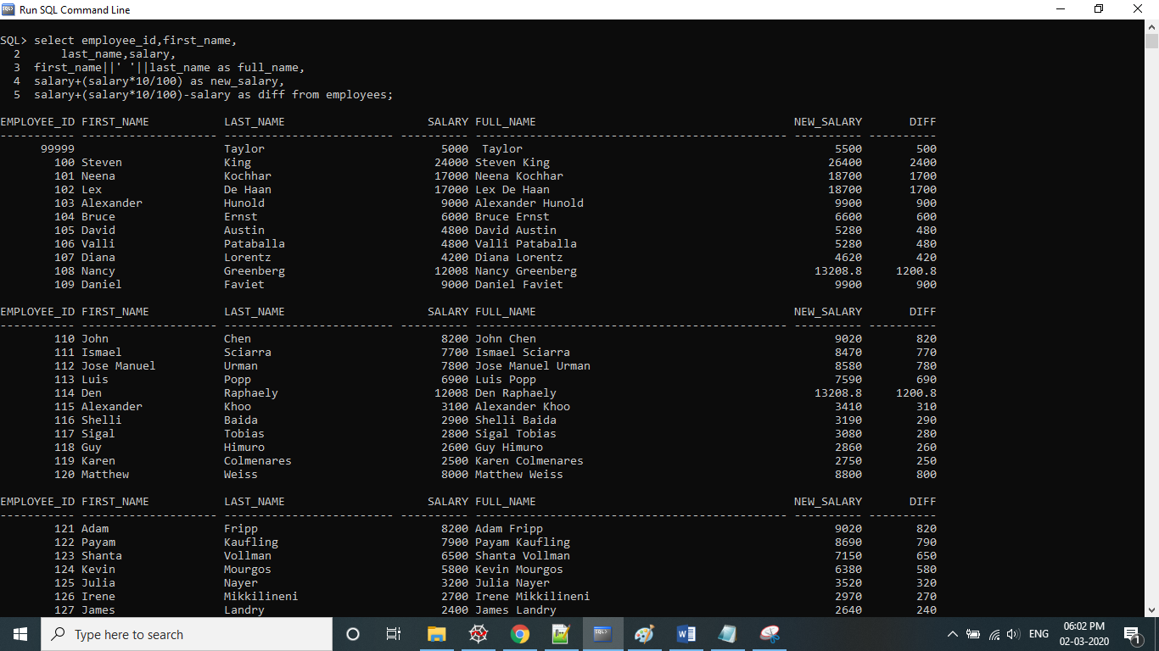

4. select e.employee_id, e.first_name,e.last_name,e.first_name as manager_name

from employees e left outer join employees em

on em.manager_id=em.employee_id

order by employee_id;

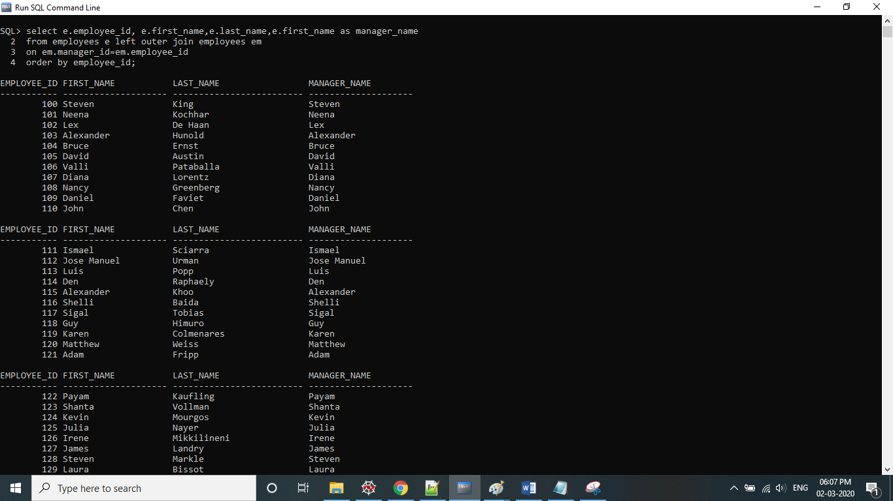

5. select salary, employee_id,first_name

from (select * from employees order by salary desc)

where ROWNUM<=3

order by salary desc;

