1. SELECT MEMBER_ID,MEMBER_NAME,CITY,MEMBERSHIP_STATU

FROM LMS_MEMBERS

WHERE MEMBERSHIP_STATUS='Permanent' ;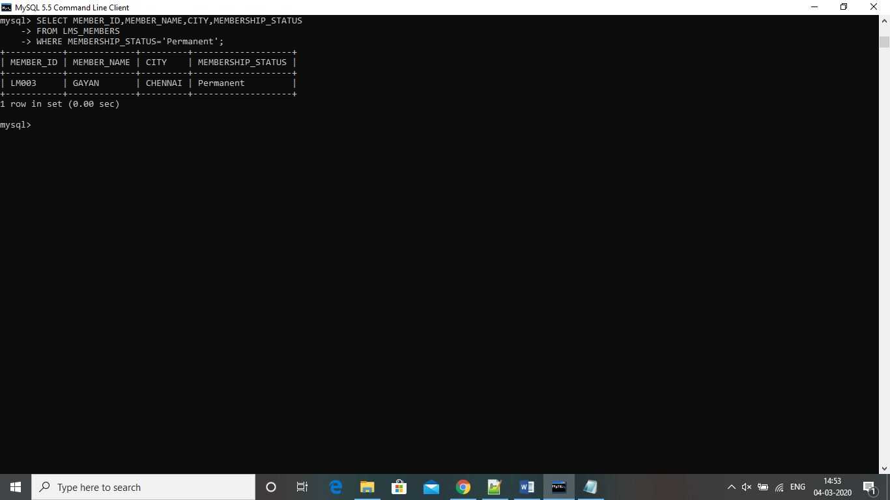

2. SELECT B1.BOOK_CODE,B2.PUBLICATION,B2.PRICE,B3.SUPPLIER_NAME

FROM(SELECT B1.BOOK_CODE

FROM LMS_BOOK_ISSUE B1

GROUP BY BOOK_CODE

HAVING COUNT(B1.BOOK_CODE)> 1) B1 JOIN LMS_BOOK_DETAILS B2

ON B1.BOOK_CODE=B2.BOOK_CODE JOIN LMS_SUPPLIERS_DETAILS B3 ON

B2.SUPPLIER_ID=B3.SUPPLIER_ID;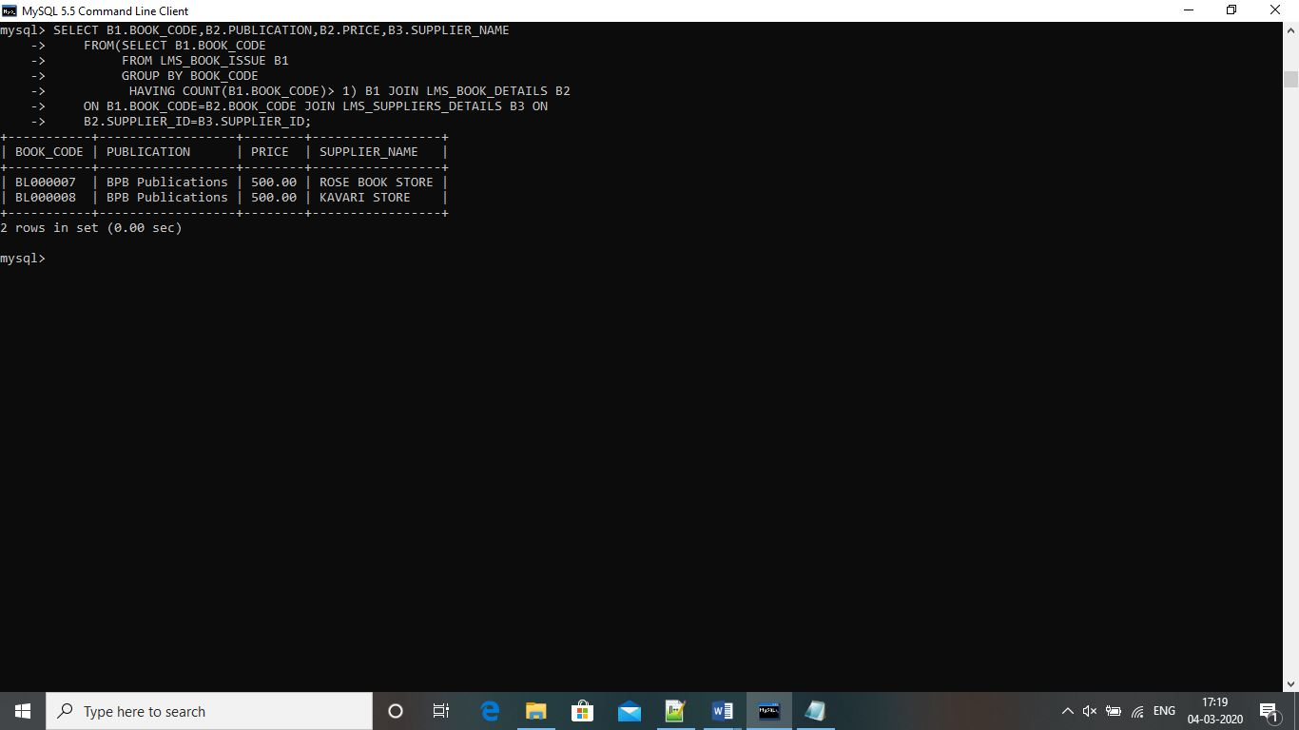

3. SELECT MEMBER_ID,MEMBER_NAME

FROM LMS_MEMBERS

WHERE MEMBER_ID IN (SELECT MEMBER_ID

FROM LMS_BOOK_ISSUE

WHERE BOOK_CODE LIKE 'BL000002') ;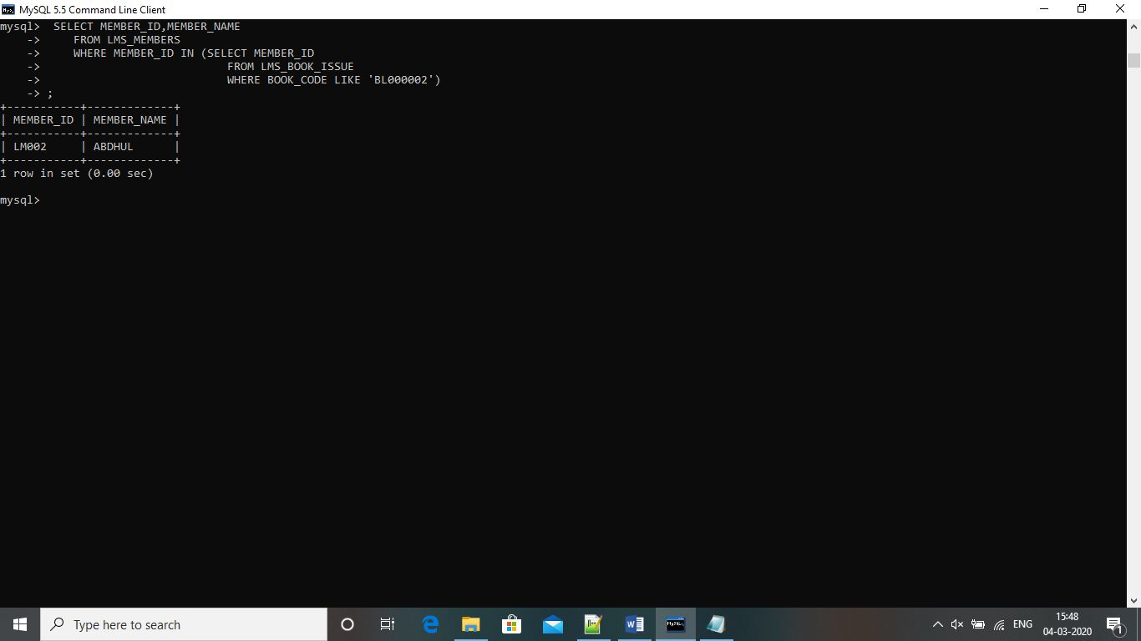

4. SELECT BOOK_CODE,BOOK_TITLE,AUTHOR

FROM LMS_BOOK_DETAILS

WHERE AUTHOR LIKE 'P%' ;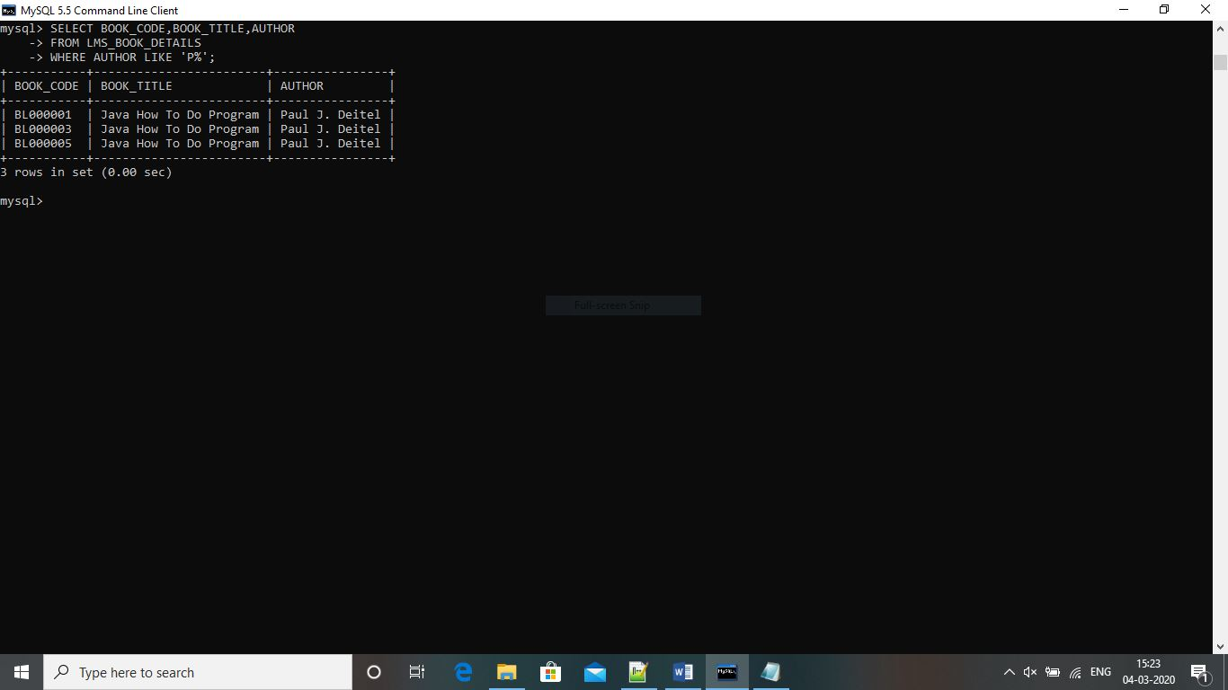

5. SELECT COUNT(CATEGORY) AS NO_OF_BOOKS

FROM LMS_BOOK_DETAILS

WHERE CATEGORY='JAVA' ;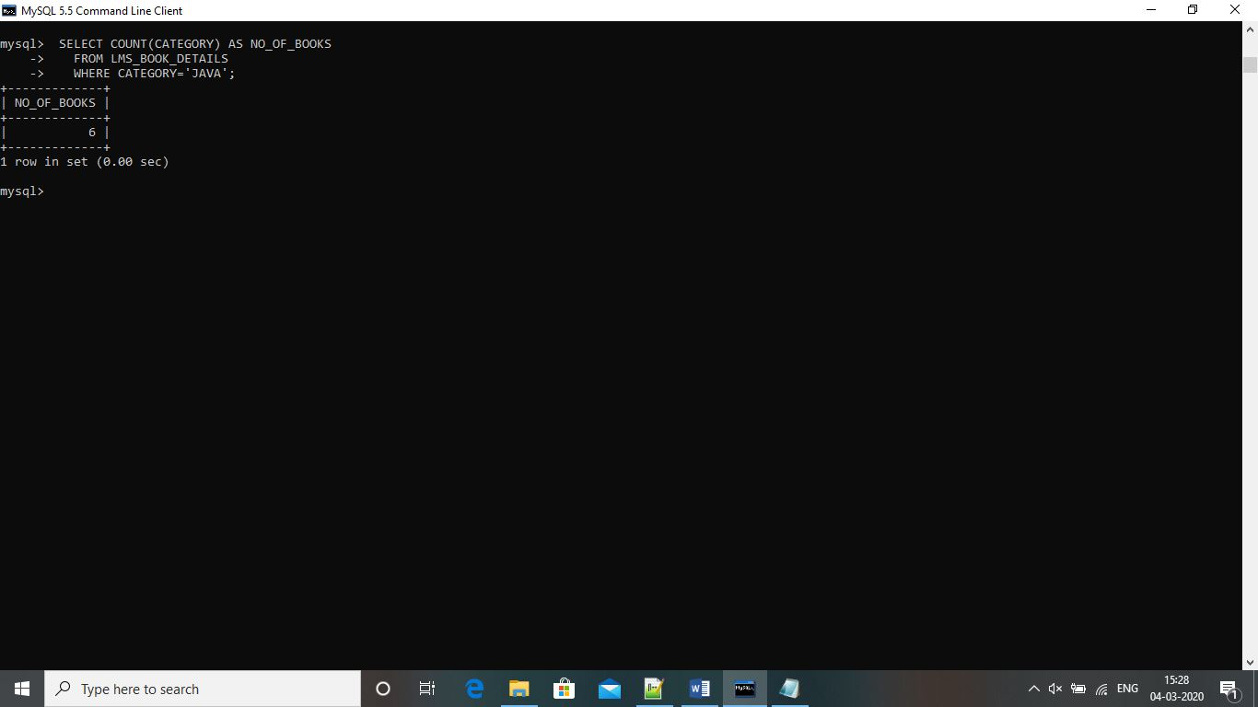

6. SELECT CATEGORY,COUNT(CATEGORY) AS NO_OF_BOOKS

FROM LMS_BOOK_DETAILS

GROUP BY CATEGORY ;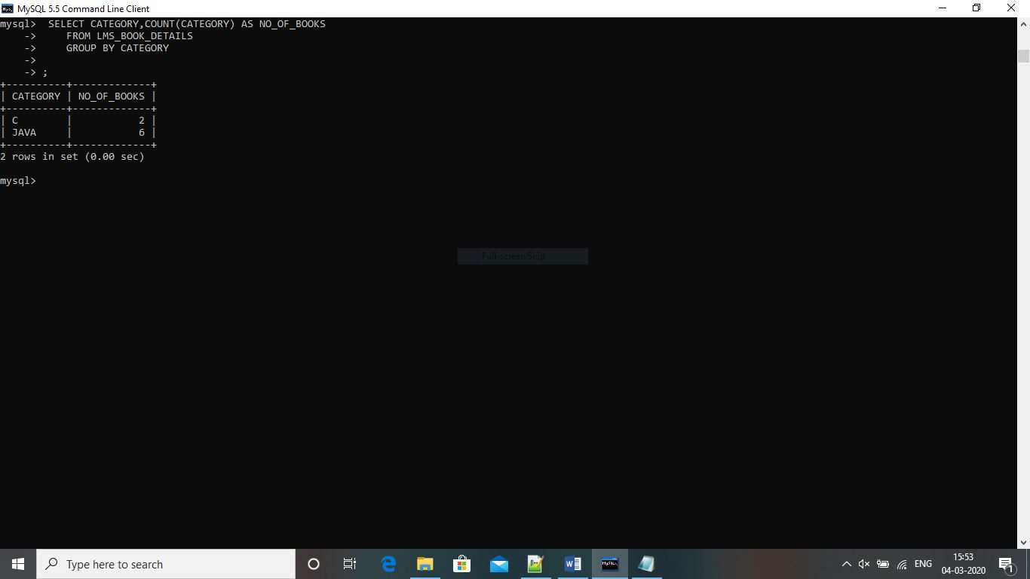

##################################################################################

1. SELECT MEMBER_ID, MEMBER_NAME, BOOK_CODE, BOOK_TITLE

FROM LMS_MEMBERS, LMS_BOOK_DETAILS ;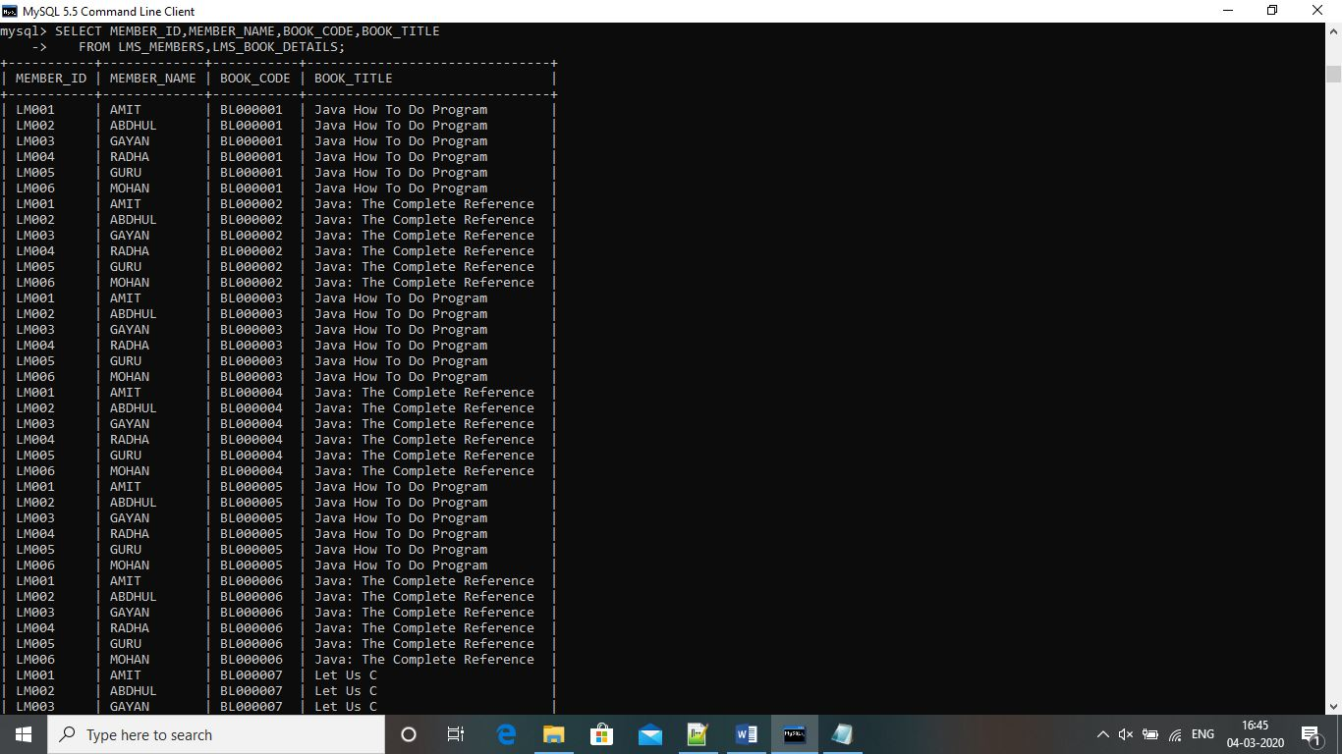

3. SELECT MEMBER_ID, MEMBER_NAME, FINE_RANGE, FINE_AMOUNT

FROM LMS_MEMBERS, LMS_FINE_DETAILS

WHERE FINE_AMOUNT < 100;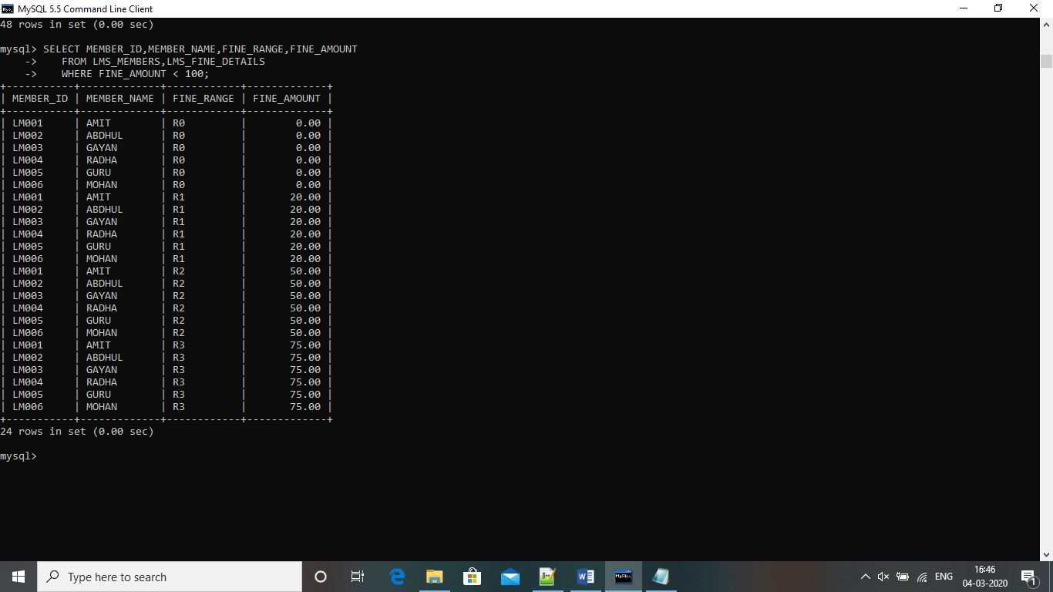

4. SELECT BOOK_CODE, BOOK_TITLE, PUBLICATION, PUBLISH_DATE, BOOK_EDITION, PRICE

FROM LMS_BOOK_DETAILS

ORDER BY PUBLICATION, PUBLISH_DATE, BOOK_EDITION;