1.

select department_name, count(employee_id)

from departments, employees

where departments.department_id=employees.department_id

group by department_name

having count(employee_id) >=20;



2.

select employee_id, first_name, last_name, salary from employees e1

where salary >(select avg(salary) from employees e2

where e1.department_id = e2.department_id

group by e1.department_id);



3.

select first_name,

last_name,

employee_id,

salary,

salary*0.1 as new_salary,

(salary*0.1-(salary)) as difference ,

first_name||' '||last_name as full_name

from employees;

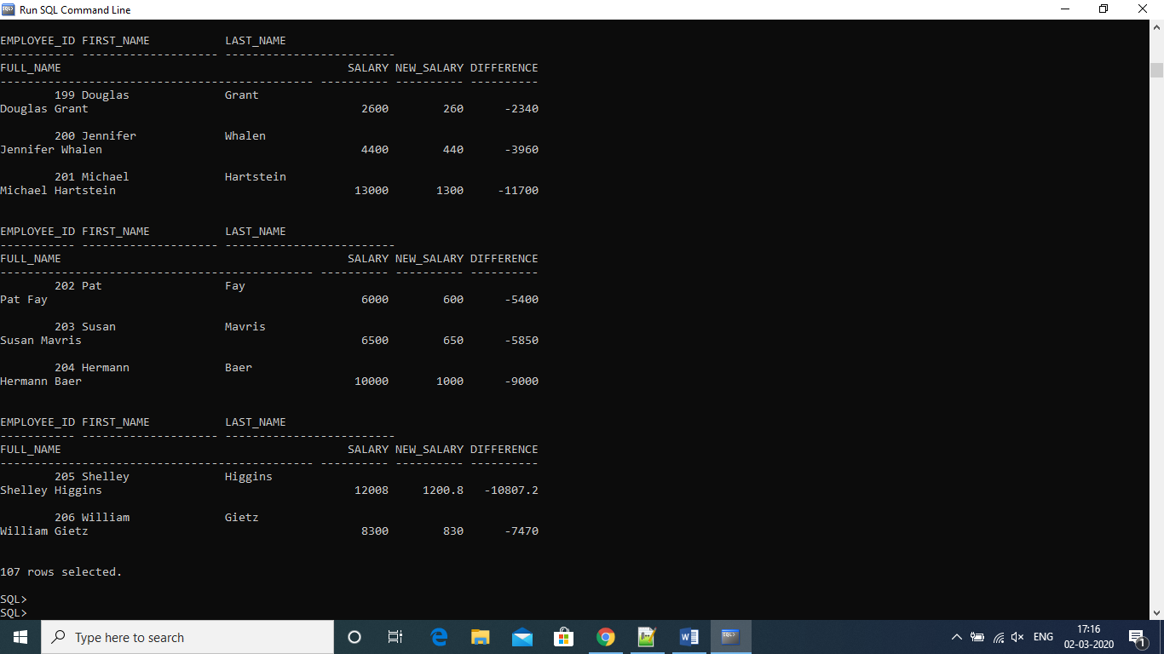

4.

select a.employee_id, a.first_name, a.last_name, b.first_name as manager_name

from employees

a left outer join employees b

on a.manager_id=b.employee_id

order by employee_id;



5.

select employee_id, first_name, salary from employees

where rownum<=3

order by salary desc;

