NAME:P.PAVANKUMAR

(1)SELECT DEPARTMENT_NAME,COUNT(EMPLOYEE_ID)

FROM DEPARTMENTS,EMPLOYEES

WHERE DEPARTMENTS.DEPARTMENT_ID = EMPLOYEES.DEPARTMENT_ID

GROUP BY DEPARTMENT_NAME

HAVING COUNT(EMPLOYEE_ID)>=20;

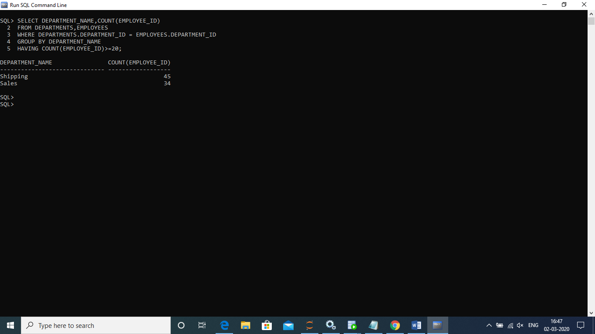

(2)SELECT EMPLOYEE_ID,

FIRST_NAME,

LAST_NAME,SALARY

FROM EMPLOYEES A

WHERE SALARY >(SELECT AVG(SALARY) FROM EMPLOYEES B

WHERE A.DEPARTMENT_ID = B.DEPARTMENT_ID

GROUP BY A.DEPARTMENT_ID);



(3)SELECT EMPLOYEE_ID,

FIRST_NAME,

LAST_NAME,

(FIRST_NAME||' '||LAST_NAME) FULL_NAME,

SALARY,(SALARY*0.1) NEW_SALARY,

(SALARY-(SALARY*0.1)) DIFFERENCE FROM EMPLOYEES;

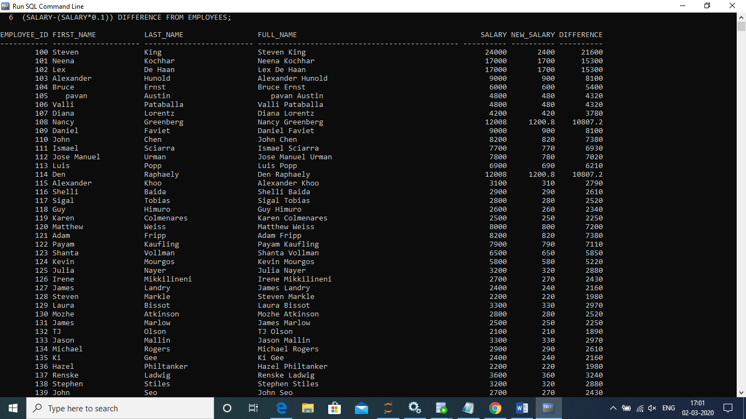

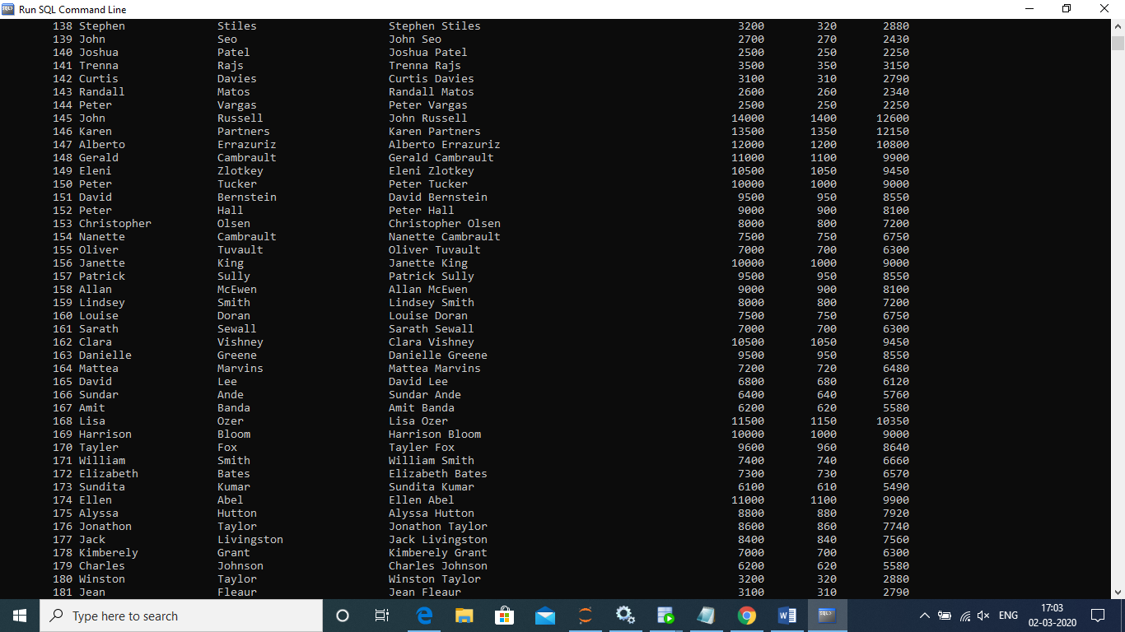

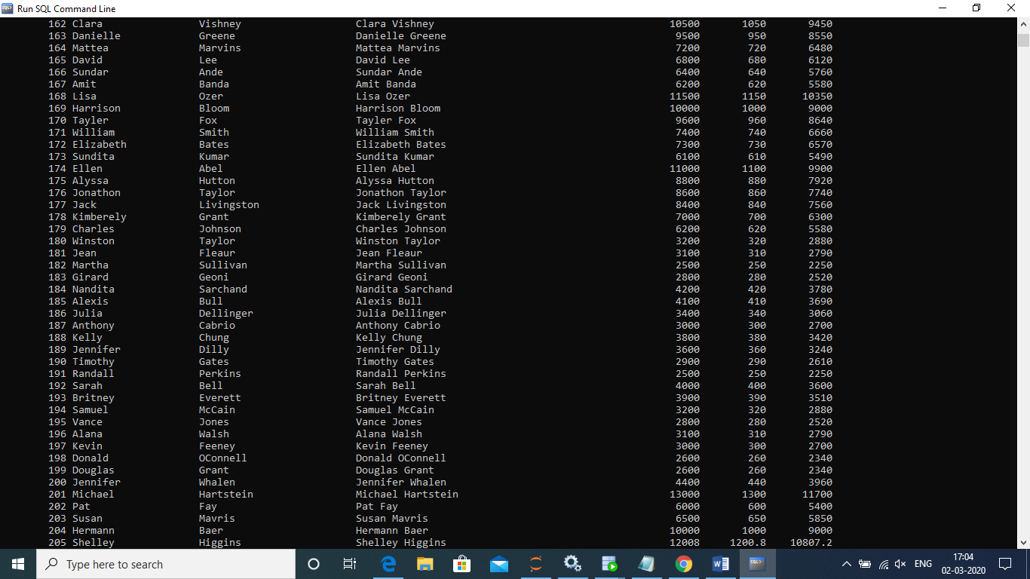

(4)SELECT A.EMPLOYEE_ID,

A.FIRST_NAME,

A.LAST_NAME,

B.FIRST_NAME AS MANAGER_NAME

FROM EMPLOYEES A LEFT OUTER JOIN EMPLOYEES B

ON A.MANAGER_ID = B.MANAGER_ID

ORDER BY EMPLOYEE_ID;





(5)SELECT EMPLOYEE_ID,

FIRST_NAME,SALARY FROM EMPLOYEES

WHERE ROWNUM <=3

ORDER BY SALARY DESC;

