Name: O.Raja Sekhar Reddy

Id: 853787

1.

select a.department_name,count(b.employee_id)

from departments a join employees b on a.department_id=b.department_id

group by a.department_name,b.department_id

having count(b.employee_id)>=20

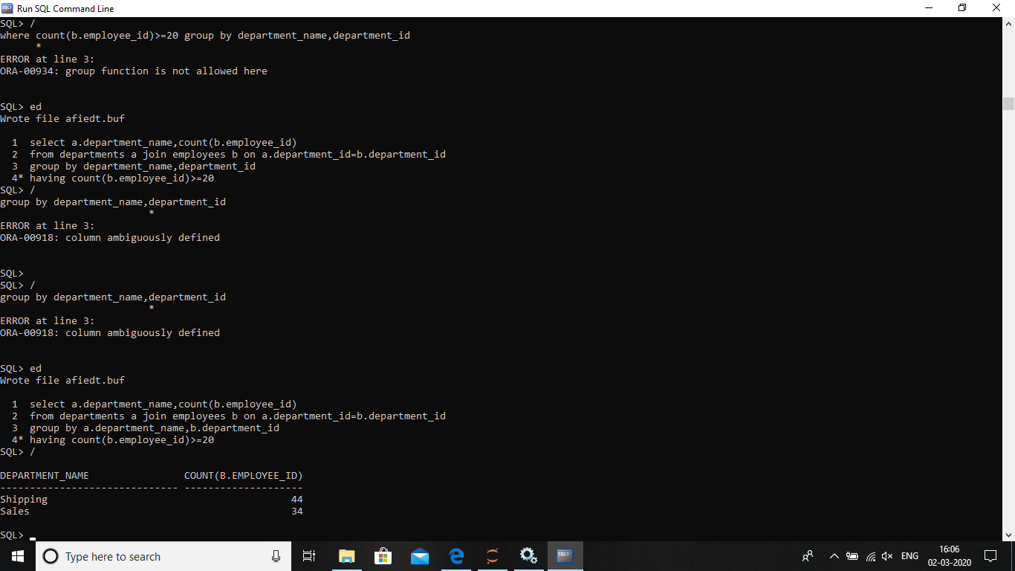

3. select employee_id,first_name,last_name,

(first_name||last_name) as full_name,

salary,

salary*0.1+salary as new_salary,

((salary*0.1)+salary)-salary as difference

from employees

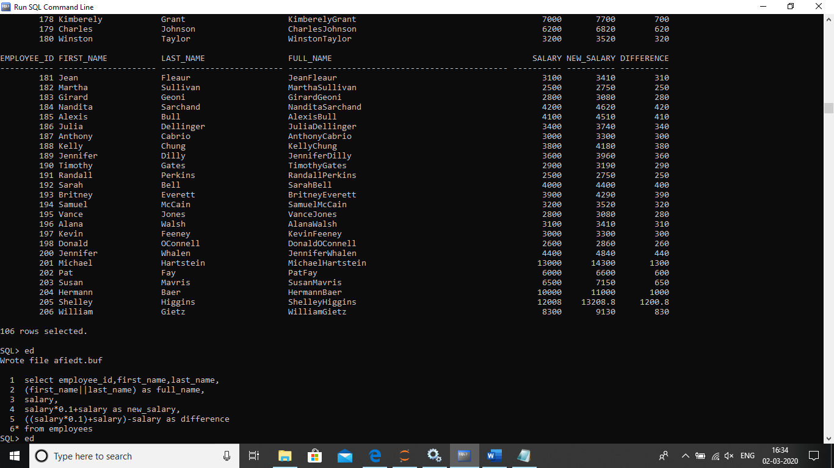

2. select a.employee_id,a.first_name,a.last_name,

a.salary from employees a where salary>(select avg(salary)

from employees b

where a.department_id=b.department_id

group by a.department_id)

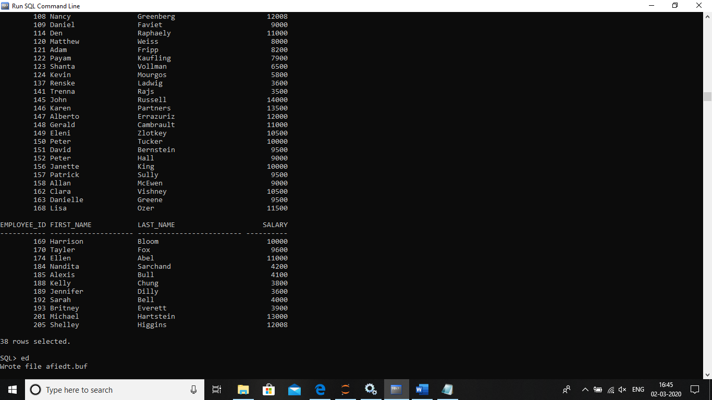

4. select a.employee_id,a.first_name,a.last_name,b.first_name presidentmanager from employees a left outer join employees b

on b.employee_id=a.manager_id

where b.first_name is null

order by employee_id

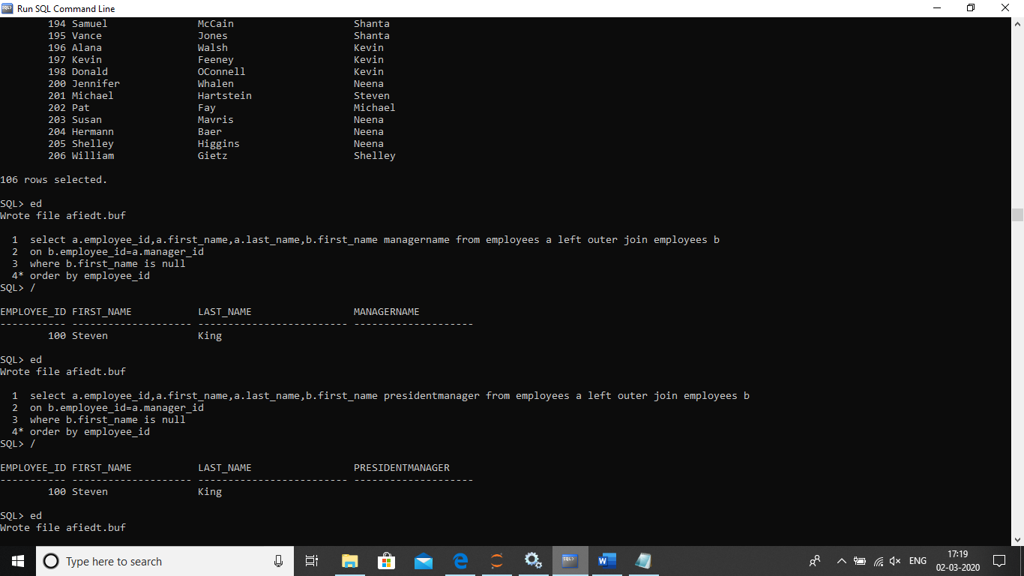

5. select employee_id,first_name,salary from employees

where salary in(select salary from employees

where rownum <=3 order by salary desc)

order by salary desc

