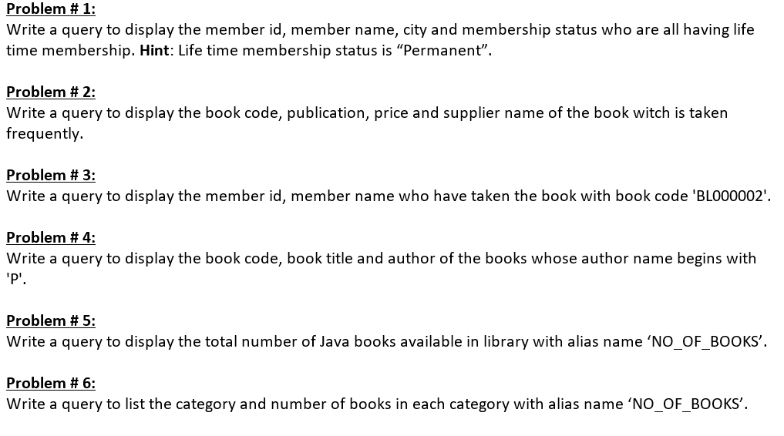1)select member_id,member_name,city,membership_status

from lms_members

where membership_status like"permanent"

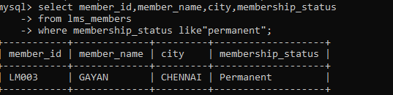

2) SELECT a.book_code,b.publication,b.price,c.supplier_name

FROM(SELECT a.book_code FROM LMS_BOOK_ISSUE a GROUP BY book_code HAVING COUNT(a.BOOK_CODE) > 1)

a JOIN LMS_BOOK_DETAILS b ON a.book_code = b.book_code

JOIN LMS_SUPPLIERS_DETAILS c ON b.supplier_id = c.supplier_id

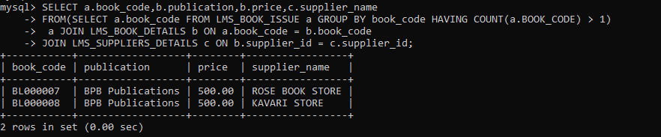

3)select member_id,member_name

from lms_members

where member_id in(select member_id

from lms_book_issue where book_code like "BL000002" )

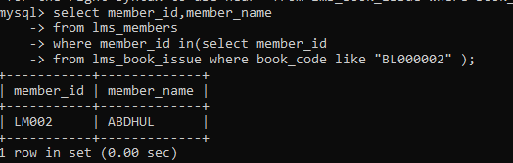

4)

select book_code, book_title,author

from lms_book_details

where author like 'P%'

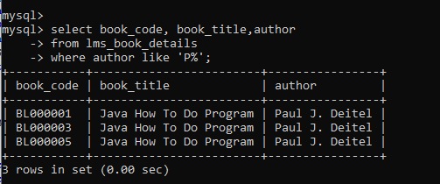

5) select count(*) as no_of_books

from lms_book_details

where category like "java”

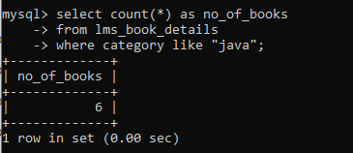

6) select category, count(*) as no_of_books

from lms_book_details

group by category

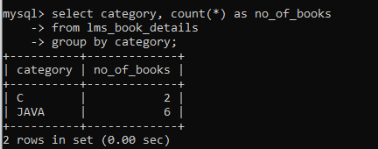

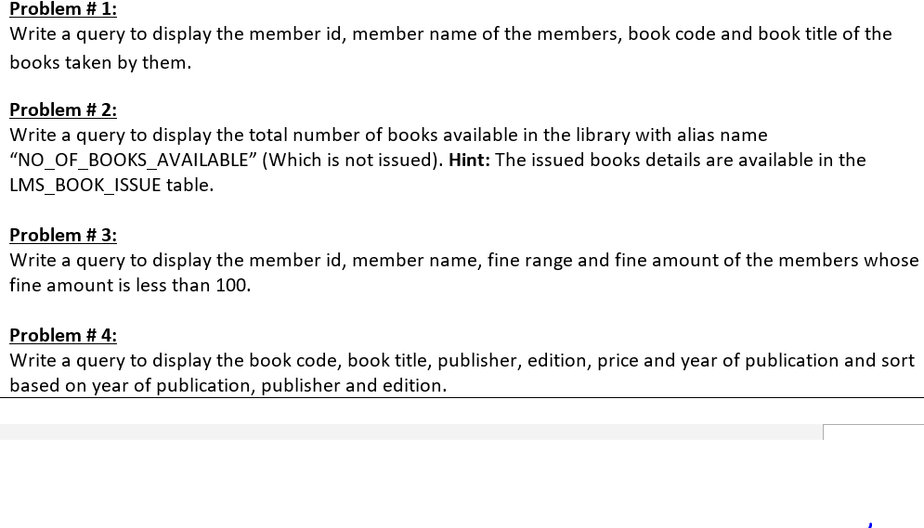

P1) select member_id in(select member_name from lms_members where member_id=a.member_id)

as member_name,book_code in(select book_title from lms_book_details where book_code=a.book_code)

as book_title from lms_book_issue a;

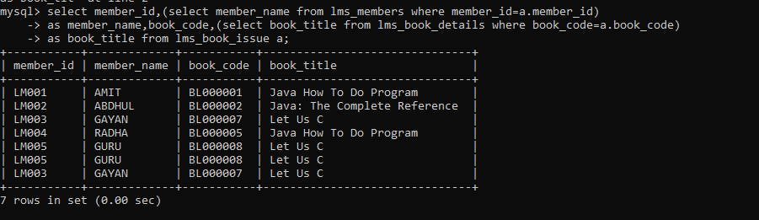

P2)

SELECT COUNT(a.BOOK_CODE)AS NO_OF_BOOKS_AVAILABLE

FROM LMS_BOOK_DETAILS a LEFT JOIN LMS_BOOK_ISSUE b

ON a.BOOK_CODE = b.BOOK_CODE WHERE b.BOOK_CODE IS NULL

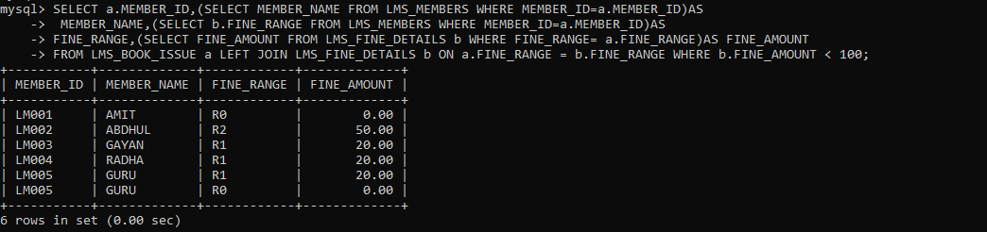

P3) SELECT a.MEMBER_ID,(SELECT MEMBER_NAME FROM LMS_MEMBERS WHERE MEMBER_ID=a.MEMBER_ID)AS

MEMBER_NAME,(SELECT b.FINE_RANGE FROM LMS_MEMBERS WHERE MEMBER_ID=a.MEMBER_ID)AS

FINE_RANGE,(SELECT FINE_AMOUNT FROM LMS_FINE_DETAILS b WHERE FINE_RANGE= a.FINE_RANGE)AS FINE_AMOUNT

FROM LMS_BOOK_ISSUE a LEFT JOIN LMS_FINE_DETAILS b ON a.FINE_RANGE = b.FINE_RANGE WHERE b.FINE_AMOUNT < 100



P4) SELECT BOOK_CODE,BOOK_TITLE,PUBLICATION,BOOK_EDITION,PRICE,YEAR(PUBLISH_DATE)

AS YEAR_OF_PUBLICATION FROM LMS_BOOK_DETAILS ORDER BY YEAR_OF_PUBLICATION

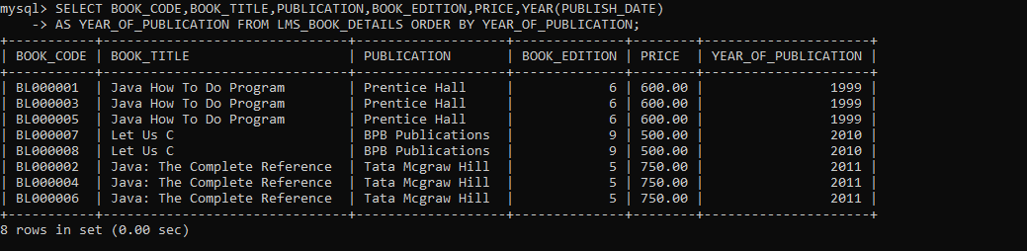

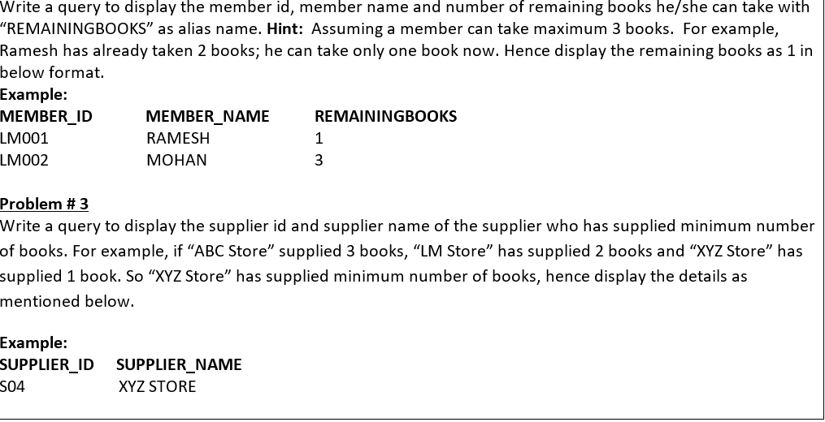

P5) select m.MEMBER_ID,MEMBER_NAME,T.cb as REMAINING_BOOKS from LMS_MEMBERS

m inner join (select a.member_id,COUNT(i.MEMBER_ID) as cb from LMS_MEMBERS

a left outer join LMS_BOOK_ISSUE i on a.MEMBER_ID= i.MEMBER_ID group by a.MEMBER_ID)T on T.MEMBER_ID=m.MEMBER_ID

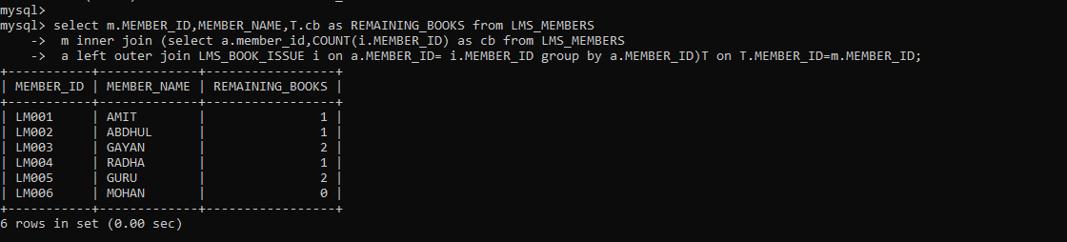

P6)

select S.SUPPLIER_ID,SUPPLIER_NAME

from LMS_BOOK_DETAILS B inner join LMS_SUPPLIERS_DETAILS S on B.SUPPLIER_ID = S.SUPPLIER_ID

where S.SUPPLIER_ID in (select SUPPLIER_ID from LMS_BOOK_DETAILS group by SUPPLIER_ID having

COUNT(SUPPLIER_ID)=(select MIN(cnt) from (select COUNT(*) as cnt from LMS_BOOK_DETAILS group by SUPPLIER_ID)as T));

