Name=C.Sushma Employee_id=854815

**1.** select department_name,count(employee_id) no_of_employees

from departments,employees

where departments.department_id=employees.department_id

group by department_name

having count(employee_id)>=20



**2.** select employee_id,first_name,last_name,salary

from employees e1

where salary>(select avg(salary)

from employees e2

where e1.department_id=e2.department_id

group by e1.department_id)



**3.** select employee_id,first_name,last_name,

first_name||' '||last_name as fullname,salary,

salary*0.1 as newsalary ,(salary*0.1-salary) as difference

from employees

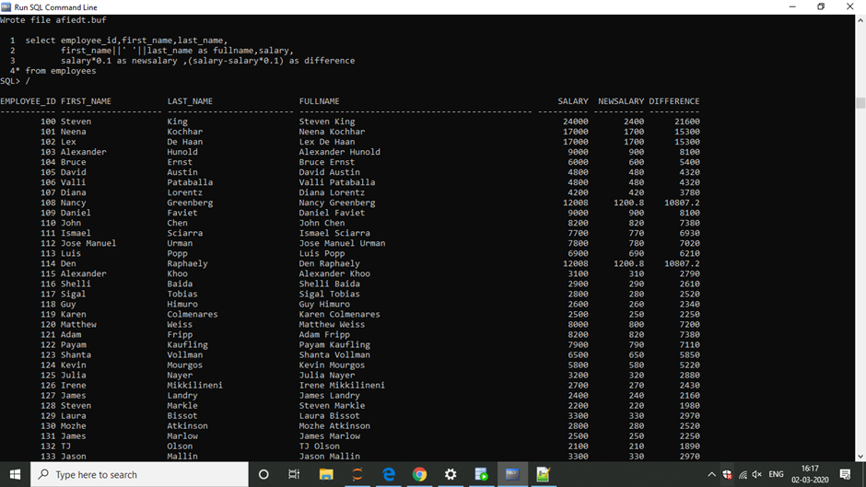

**4.** select a.employee_id,a.first_name,a.last_name,b.first_name as mgrname

from employees a left outer join employees b

on a.manager_id=b.employee_id(+)

where b.first_name is null



**5.** select employee_id,first_name,salary

from(

select *

from employees

order by salary desc)

where rownum<=3

order by salary desc

