1.Departments having more than 20 employees



3. Full_Name and updated salaries

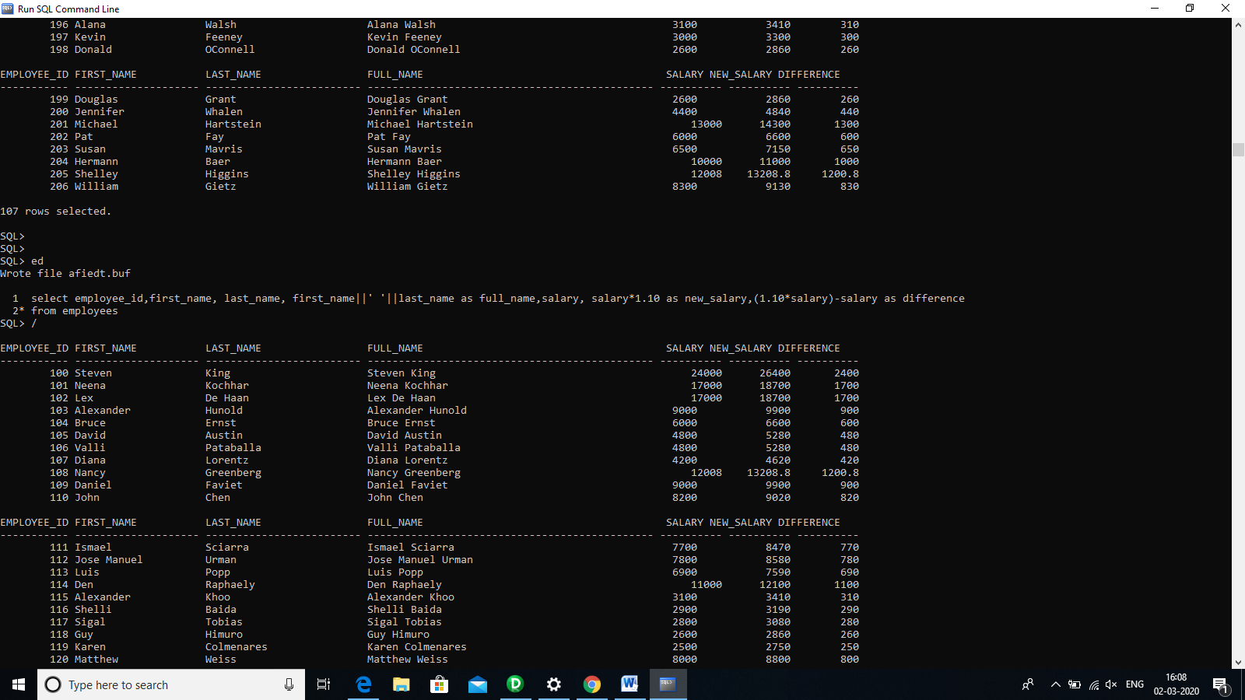

4. Manager_names



2. employee_id,first_name,last_name,salary of employees whose salary > average salary of their department

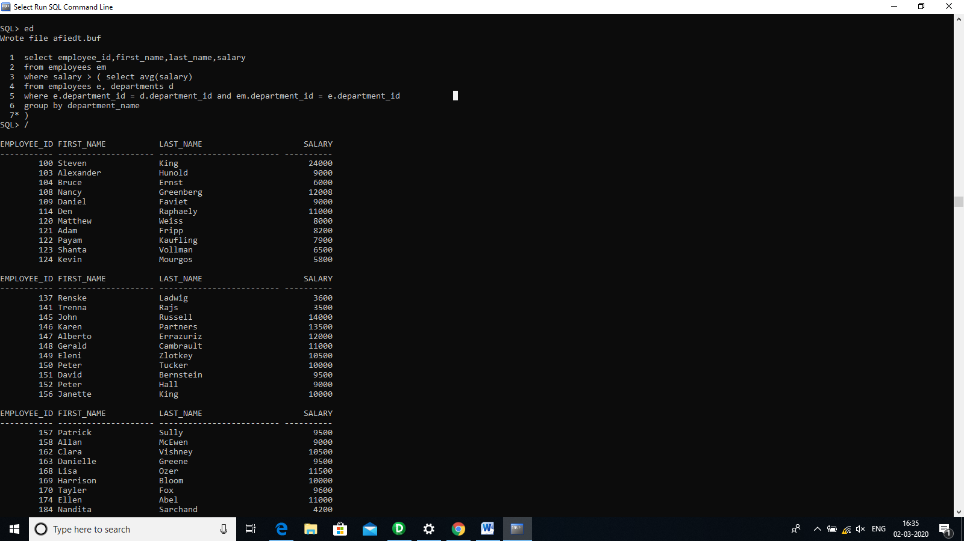

5.Top 3 paid employees

select employee_id,first_name,salary

from employees

order by salary desc

limit 3