Name:M Bhanupriya Id:854834

Q1) select department_name,count(salary) as no_of_employees

from departments d,employees e

where d.department_id=e.department_id

group by department_name

having count(salary)>=20;



Q2) select employee_id,first_name,last_name,salary

from employees e1

where salary>(select avg(salary)

from employees e2

where e1.department_id=e2.department_id

group by e1.department_id);



Q3) select employee_id,first_name,last_name,

first_name||' '||last_name as fullname,salary,

salary*0.1 as newsalary,(salary-salary*0.1) as difference

from employees;

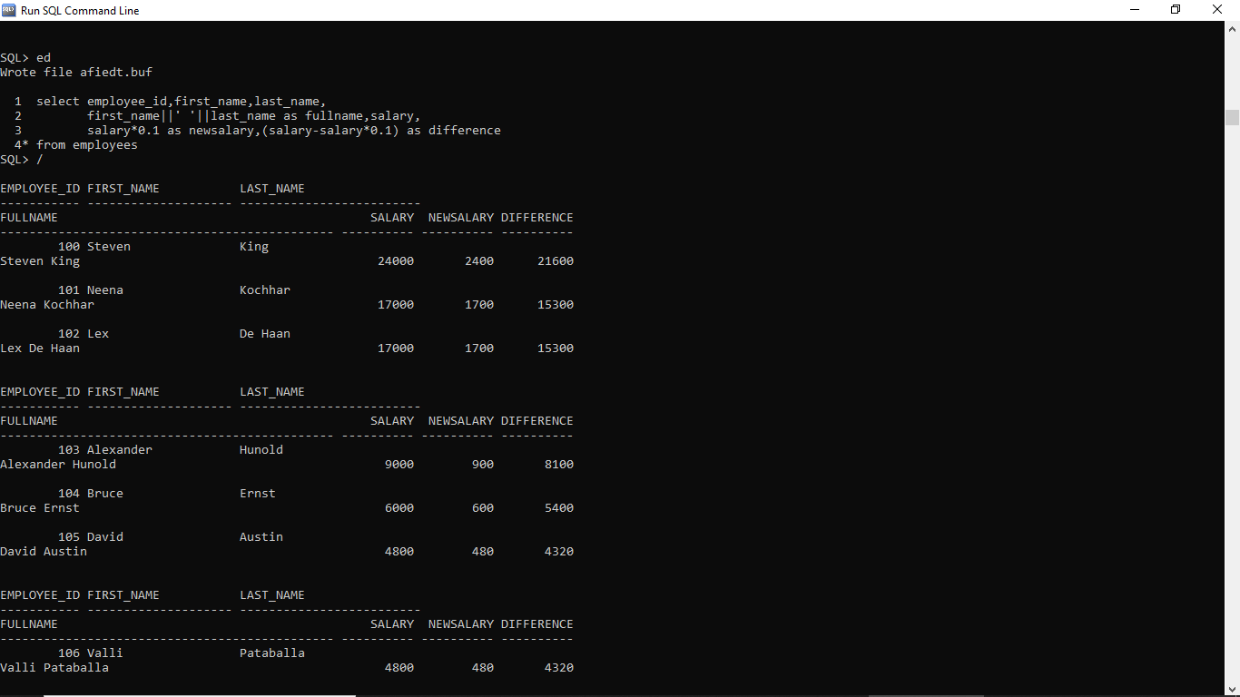

Q4) select a.employee_id,a.first_name,a.last_name,mf.first_name as manager_name

from employees a left outer join employees mf

on a.manager_id=mf.employee_id

order by employee_id;

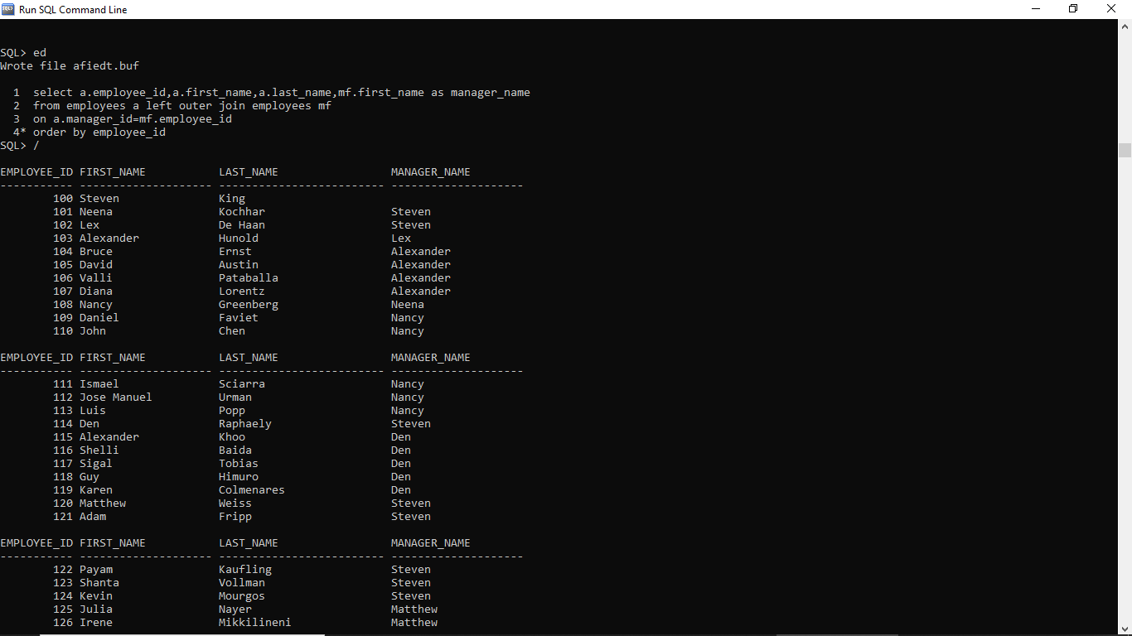

Q5) select employee_id,first_name,salary

from (

select *

from employees

order by Salary desc

)

where rownum <= 3

order by Salary desc;

