1. select department_name,count(salary)as no_of_employees

from employees e, departments d

where d.department_id=e.department_id

group by department_name

having count(*)>=20;



2. select employee_id,first_name,last_name,salary

from employees e1

where salary>(select avg(salary)

from employees e2

where e1.department_id=e2.department_id

group by e1.department_id)

;



3. select employee_id, first_name, last_name,

first_name||' '|| last_name as fullname,salary,

salary * 0.1 as newsalary,(salary-salary * 0.1) as difference

from employees;

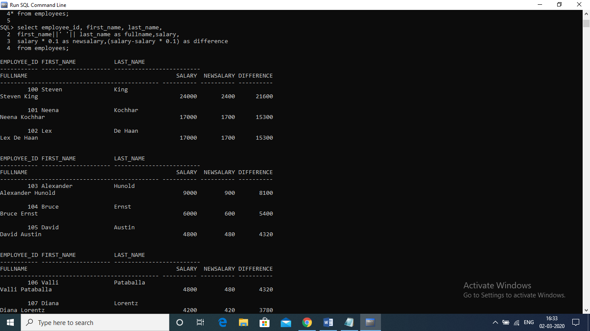

4. select e.employee_id,e.first_name,e.last_name,em.first_name as manager_name

from employees e left outer join employees em

on e.manager_id = em.employee_id

order by employee_id;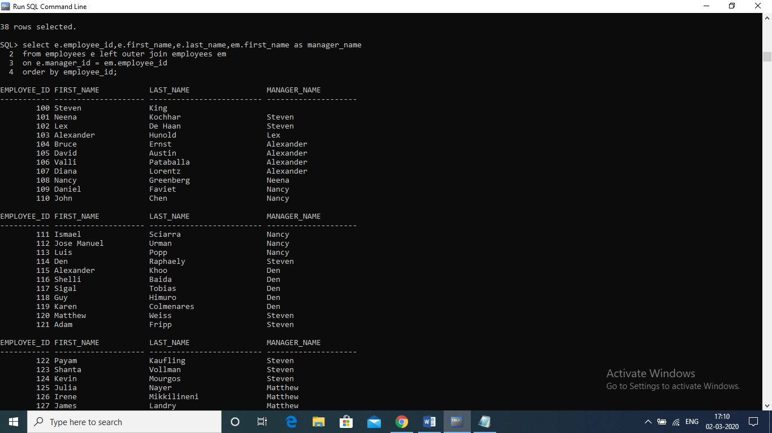

5 .select employee_id,first_name,salary

from employees

where rownum<=3

order by salary desc;