Kiran kumar G

ID : 853765

[Kirankumar.1si16ec411@gmail.com](mailto:Kirankumar.1si16ec411@gmail.com)

Q1 :

Query, result

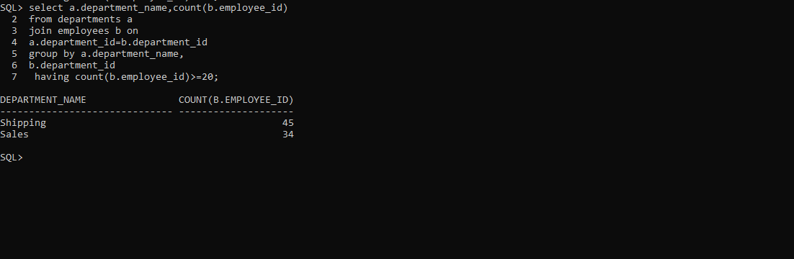

Q2:

Query:

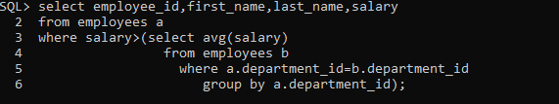

Results:

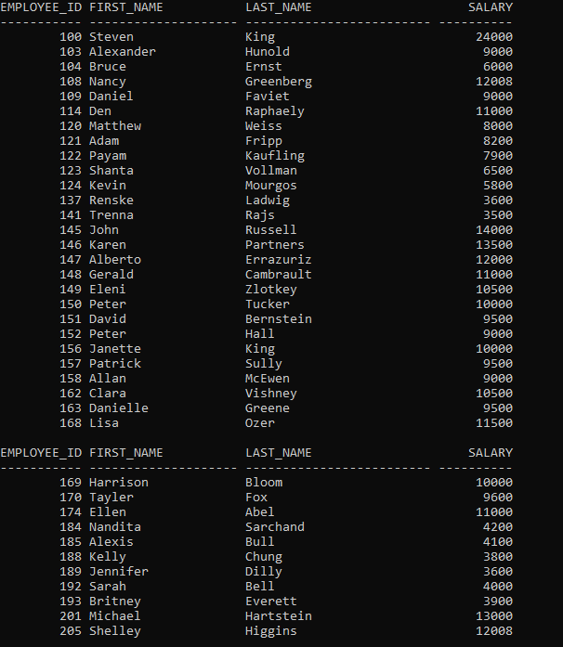

Q3:

Query:

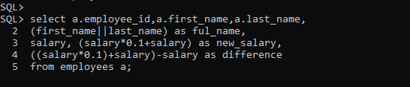

Results:

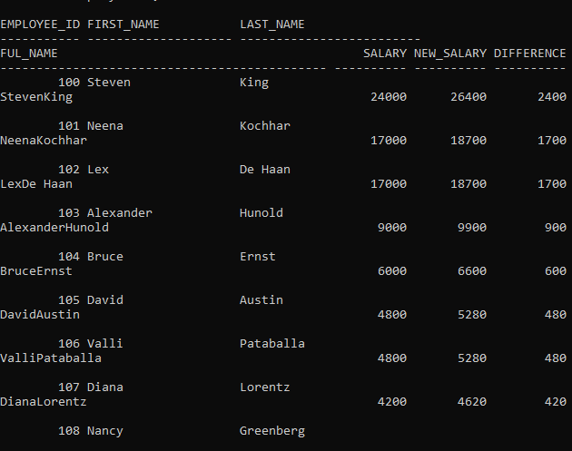

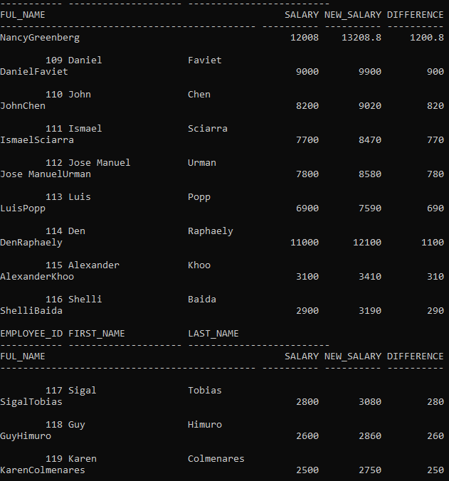

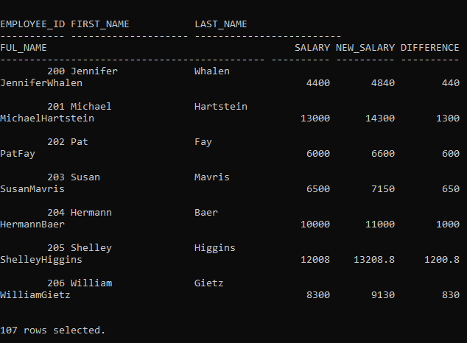

Q4:

Query, results:

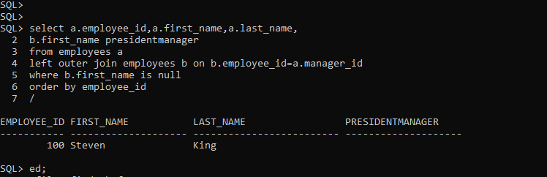

Q5:

Query, results:

