1ST QUERY

SQL> select department_name,count(employee_id)as no_of_employees from departments d,employees e

2 where d.department_id=e.department_id

3 group by department_name

4 having count(employee_id)>=20;

DEPARTMENT_NAME NO_OF_EMPLOYEES

------------------------------ ---------------

Shipping 46

Sales 34

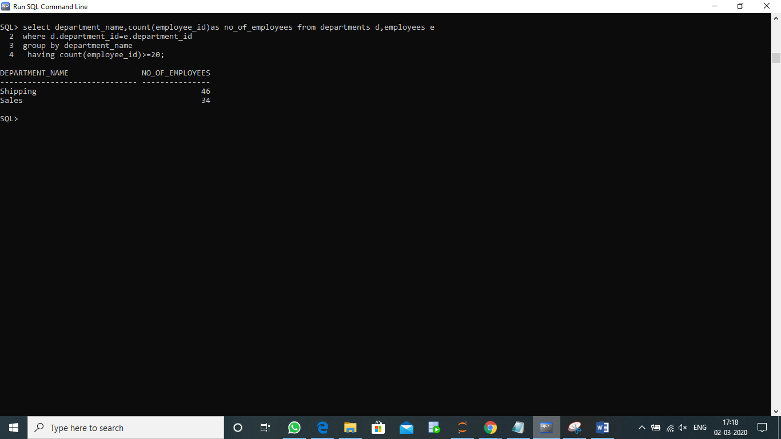

3RD QUERY

SQL> select employee_id,first_name,last_name,concat(first_name,last_name) as full_name,salary,(salary*0.1) as new_salary,(salary-salary*0.1) as difference

2 from employees;

EMPLOYEE_ID FIRST_NAME LAST_NAME

----------- -------------------- -------------------------

FULL_NAME SALARY NEW_SALARY DIFFERENCE

--------------------------------------------- ---------- ---------- ----------

99999 Taylor

Taylor 5000 500 4500

100 Steven King

StevenKing 24000 2400 21600

101 Neena Kochhar

NeenaKochhar 17000 1700 15300

EMPLOYEE_ID FIRST_NAME LAST_NAME

----------- -------------------- -------------------------

FULL_NAME SALARY NEW_SALARY DIFFERENCE

--------------------------------------------- ---------- ---------- ----------

102 Lex De Haan

LexDe Haan 17000 1700 15300

103 Alexander Hunold

AlexanderHunold 9000 900 8100

104 Bruce Ernst

BruceErnst 6000 600 5400

EMPLOYEE_ID FIRST_NAME LAST_NAME

----------- -------------------- -------------------------

FULL_NAME SALARY NEW_SALARY DIFFERENCE

--------------------------------------------- ---------- ---------- ----------

105 David Austin

DavidAustin 4800 480 4320

106 Valli Pataballa

ValliPataballa 4800 480 4320

107 Diana Lorentz

DianaLorentz 4200 420 3780

EMPLOYEE_ID FIRST_NAME LAST_NAME

----------- -------------------- -------------------------

FULL_NAME SALARY NEW_SALARY DIFFERENCE

--------------------------------------------- ---------- ---------- ----------

108 Nancy Greenberg

NancyGreenberg 12008 1200.8 10807.2

109 Daniel Faviet

DanielFaviet 9000 900 8100

110 John Chen

JohnChen 8200 820 7380

EMPLOYEE_ID FIRST_NAME LAST_NAME

----------- -------------------- -------------------------

FULL_NAME SALARY NEW_SALARY DIFFERENCE

--------------------------------------------- ---------- ---------- ----------

111 Ismael Sciarra

IsmaelSciarra 7700 770 6930

112 Jose Manuel Urman

Jose ManuelUrman 7800 780 7020

113 Luis Popp

LuisPopp 6900 690 6210

EMPLOYEE_ID FIRST_NAME LAST_NAME

----------- -------------------- -------------------------

FULL_NAME SALARY NEW_SALARY DIFFERENCE

--------------------------------------------- ---------- ---------- ----------

114 Den Raphaely

DenRaphaely 11000 1100 9900

115 Alexander Khoo

AlexanderKhoo 3100 310 2790

116 Shelli Baida

ShelliBaida 2900 290 2610

EMPLOYEE_ID FIRST_NAME LAST_NAME

----------- -------------------- -------------------------

FULL_NAME SALARY NEW_SALARY DIFFERENCE

--------------------------------------------- ---------- ---------- ----------

117 Sigal Tobias

SigalTobias 2800 280 2520

118 Guy Himuro

GuyHimuro 2600 260 2340

119 Karen Colmenares

KarenColmenares 2500 250 2250

EMPLOYEE_ID FIRST_NAME LAST_NAME

----------- -------------------- -------------------------

FULL_NAME SALARY NEW_SALARY DIFFERENCE

--------------------------------------------- ---------- ---------- ----------

120 Matthew Weiss

MatthewWeiss 8000 800 7200

121 Adam Fripp

AdamFripp 8200 820 7380

122 Payam Kaufling

PayamKaufling 7900 790 7110

EMPLOYEE_ID FIRST_NAME LAST_NAME

----------- -------------------- -------------------------

FULL_NAME SALARY NEW_SALARY DIFFERENCE

--------------------------------------------- ---------- ---------- ----------

123 Shanta Vollman

ShantaVollman 6500 650 5850

124 Kevin Mourgos

KevinMourgos 5800 580 5220

125 Julia Nayer

JuliaNayer 3200 320 2880

EMPLOYEE_ID FIRST_NAME LAST_NAME

----------- -------------------- -------------------------

FULL_NAME SALARY NEW_SALARY DIFFERENCE

--------------------------------------------- ---------- ---------- ----------

126 Irene Mikkilineni

IreneMikkilineni 2700 270 2430

127 James Landry

JamesLandry 2400 240 2160

128 Steven Markle

StevenMarkle 2200 220 1980

EMPLOYEE_ID FIRST_NAME LAST_NAME

----------- -------------------- -------------------------

FULL_NAME SALARY NEW_SALARY DIFFERENCE

--------------------------------------------- ---------- ---------- ----------

129 Laura Bissot

LauraBissot 3300 330 2970

130 Mozhe Atkinson

MozheAtkinson 2800 280 2520

131 James Marlow

JamesMarlow 2500 250 2250

EMPLOYEE_ID FIRST_NAME LAST_NAME

----------- -------------------- -------------------------

FULL_NAME SALARY NEW_SALARY DIFFERENCE

--------------------------------------------- ---------- ---------- ----------

132 TJ Olson

TJOlson 2100 210 1890

133 Jason Mallin

JasonMallin 3300 330 2970

134 Michael Rogers

MichaelRogers 2900 290 2610

EMPLOYEE_ID FIRST_NAME LAST_NAME

----------- -------------------- -------------------------

FULL_NAME SALARY NEW_SALARY DIFFERENCE

--------------------------------------------- ---------- ---------- ----------

135 Ki Gee

KiGee 2400 240 2160

136 Hazel Philtanker

HazelPhiltanker 2200 220 1980

137 Renske Ladwig

RenskeLadwig 3600 360 3240

EMPLOYEE_ID FIRST_NAME LAST_NAME

----------- -------------------- -------------------------

FULL_NAME SALARY NEW_SALARY DIFFERENCE

--------------------------------------------- ---------- ---------- ----------

138 Stephen Stiles

StephenStiles 3200 320 2880

139 John Seo

JohnSeo 2700 270 2430

140 Joshua Patel

JoshuaPatel 2500 250 2250

EMPLOYEE_ID FIRST_NAME LAST_NAME

----------- -------------------- -------------------------

FULL_NAME SALARY NEW_SALARY DIFFERENCE

--------------------------------------------- ---------- ---------- ----------

141 Trenna Rajs

TrennaRajs 3500 350 3150

142 Curtis Davies

CurtisDavies 3100 310 2790

143 Randall Matos

RandallMatos 2600 260 2340

EMPLOYEE_ID FIRST_NAME LAST_NAME

----------- -------------------- -------------------------

FULL_NAME SALARY NEW_SALARY DIFFERENCE

--------------------------------------------- ---------- ---------- ----------

144 Peter Vargas

PeterVargas 2500 250 2250

145 John Russell

JohnRussell 14000 1400 12600

146 Karen Partners

KarenPartners 13500 1350 12150

EMPLOYEE_ID FIRST_NAME LAST_NAME

----------- -------------------- -------------------------

FULL_NAME SALARY NEW_SALARY DIFFERENCE

--------------------------------------------- ---------- ---------- ----------

147 Alberto Errazuriz

AlbertoErrazuriz 12000 1200 10800

148 Gerald Cambrault

GeraldCambrault 11000 1100 9900

149 Eleni Zlotkey

EleniZlotkey 10500 1050 9450

EMPLOYEE_ID FIRST_NAME LAST_NAME

----------- -------------------- -------------------------

FULL_NAME SALARY NEW_SALARY DIFFERENCE

--------------------------------------------- ---------- ---------- ----------

150 Peter Tucker

PeterTucker 10000 1000 9000

151 David Bernstein

DavidBernstein 9500 950 8550

152 Peter Hall

PeterHall 9000 900 8100

EMPLOYEE_ID FIRST_NAME LAST_NAME

----------- -------------------- -------------------------

FULL_NAME SALARY NEW_SALARY DIFFERENCE

--------------------------------------------- ---------- ---------- ----------

153 Christopher Olsen

ChristopherOlsen 8000 800 7200

154 Nanette Cambrault

NanetteCambrault 7500 750 6750

155 Oliver Tuvault

OliverTuvault 7000 700 6300

EMPLOYEE_ID FIRST_NAME LAST_NAME

----------- -------------------- -------------------------

FULL_NAME SALARY NEW_SALARY DIFFERENCE

--------------------------------------------- ---------- ---------- ----------

156 Janette King

JanetteKing 10000 1000 9000

157 Patrick Sully

PatrickSully 9500 950 8550

158 Allan McEwen

AllanMcEwen 9000 900 8100

EMPLOYEE_ID FIRST_NAME LAST_NAME

----------- -------------------- -------------------------

FULL_NAME SALARY NEW_SALARY DIFFERENCE

--------------------------------------------- ---------- ---------- ----------

159 Lindsey Smith

LindseySmith 8000 800 7200

160 Louise Doran

LouiseDoran 7500 750 6750

161 Sarath Sewall

SarathSewall 7000 700 6300

EMPLOYEE_ID FIRST_NAME LAST_NAME

----------- -------------------- -------------------------

FULL_NAME SALARY NEW_SALARY DIFFERENCE

--------------------------------------------- ---------- ---------- ----------

162 Clara Vishney

ClaraVishney 10500 1050 9450

163 Danielle Greene

DanielleGreene 9500 950 8550

164 Mattea Marvins

MatteaMarvins 7200 720 6480

EMPLOYEE_ID FIRST_NAME LAST_NAME

----------- -------------------- -------------------------

FULL_NAME SALARY NEW_SALARY DIFFERENCE

--------------------------------------------- ---------- ---------- ----------

165 David Lee

DavidLee 6800 680 6120

166 Sundar Ande

SundarAnde 6400 640 5760

167 Amit Banda

AmitBanda 6200 620 5580

EMPLOYEE_ID FIRST_NAME LAST_NAME

----------- -------------------- -------------------------

FULL_NAME SALARY NEW_SALARY DIFFERENCE

--------------------------------------------- ---------- ---------- ----------

168 Lisa Ozer

LisaOzer 11500 1150 10350

169 Harrison Bloom

HarrisonBloom 10000 1000 9000

170 Tayler Fox

TaylerFox 9600 960 8640

EMPLOYEE_ID FIRST_NAME LAST_NAME

----------- -------------------- -------------------------

FULL_NAME SALARY NEW_SALARY DIFFERENCE

--------------------------------------------- ---------- ---------- ----------

171 William Smith

WilliamSmith 7400 740 6660

172 Elizabeth Bates

ElizabethBates 7300 730 6570

173 Sundita Kumar

SunditaKumar 6100 610 5490

EMPLOYEE_ID FIRST_NAME LAST_NAME

----------- -------------------- -------------------------

FULL_NAME SALARY NEW_SALARY DIFFERENCE

--------------------------------------------- ---------- ---------- ----------

174 Ellen Abel

EllenAbel 11000 1100 9900

175 Alyssa Hutton

AlyssaHutton 8800 880 7920

176 Jonathon Taylor

JonathonTaylor 8600 860 7740

EMPLOYEE_ID FIRST_NAME LAST_NAME

----------- -------------------- -------------------------

FULL_NAME SALARY NEW_SALARY DIFFERENCE

--------------------------------------------- ---------- ---------- ----------

177 Jack Livingston

JackLivingston 8400 840 7560

178 Kimberely Grant

KimberelyGrant 7000 700 6300

179 Charles Johnson

CharlesJohnson 6200 620 5580

EMPLOYEE_ID FIRST_NAME LAST_NAME

----------- -------------------- -------------------------

FULL_NAME SALARY NEW_SALARY DIFFERENCE

--------------------------------------------- ---------- ---------- ----------

180 Winston Taylor

WinstonTaylor 3200 320 2880

181 Jean Fleaur

JeanFleaur 3100 310 2790

182 Martha Sullivan

MarthaSullivan 2500 250 2250

EMPLOYEE_ID FIRST_NAME LAST_NAME

----------- -------------------- -------------------------

FULL_NAME SALARY NEW_SALARY DIFFERENCE

--------------------------------------------- ---------- ---------- ----------

183 Girard Geoni

GirardGeoni 2800 280 2520

184 Nandita Sarchand

NanditaSarchand 4200 420 3780

185 Alexis Bull

AlexisBull 4100 410 3690

EMPLOYEE_ID FIRST_NAME LAST_NAME

----------- -------------------- -------------------------

FULL_NAME SALARY NEW_SALARY DIFFERENCE

--------------------------------------------- ---------- ---------- ----------

186 Julia Dellinger

JuliaDellinger 3400 340 3060

187 Anthony Cabrio

AnthonyCabrio 3000 300 2700

188 Kelly Chung

KellyChung 3800 380 3420

EMPLOYEE_ID FIRST_NAME LAST_NAME

----------- -------------------- -------------------------

FULL_NAME SALARY NEW_SALARY DIFFERENCE

--------------------------------------------- ---------- ---------- ----------

189 Jennifer Dilly

JenniferDilly 3600 360 3240

190 Timothy Gates

TimothyGates 2900 290 2610

191 Randall Perkins

RandallPerkins 2500 250 2250

EMPLOYEE_ID FIRST_NAME LAST_NAME

----------- -------------------- -------------------------

FULL_NAME SALARY NEW_SALARY DIFFERENCE

--------------------------------------------- ---------- ---------- ----------

192 Sarah Bell

SarahBell 4000 400 3600

193 Britney Everett

BritneyEverett 3900 390 3510

194 Samuel McCain

SamuelMcCain 3200 320 2880

EMPLOYEE_ID FIRST_NAME LAST_NAME

----------- -------------------- -------------------------

FULL_NAME SALARY NEW_SALARY DIFFERENCE

--------------------------------------------- ---------- ---------- ----------

195 Vance Jones

VanceJones 2800 280 2520

196 Alana Walsh

AlanaWalsh 3100 310 2790

197 Kevin Feeney

KevinFeeney 3000 300 2700

EMPLOYEE_ID FIRST_NAME LAST_NAME

----------- -------------------- -------------------------

FULL_NAME SALARY NEW_SALARY DIFFERENCE

--------------------------------------------- ---------- ---------- ----------

198 Donald OConnell

DonaldOConnell 2600 260 2340

199 Douglas Grant

DouglasGrant 2600 260 2340

200 Jennifer Whalen

JenniferWhalen 4400 440 3960

EMPLOYEE_ID FIRST_NAME LAST_NAME

----------- -------------------- -------------------------

FULL_NAME SALARY NEW_SALARY DIFFERENCE

--------------------------------------------- ---------- ---------- ----------

201 Michael Hartstein

MichaelHartstein 13000 1300 11700

202 Pat Fay

PatFay 6000 600 5400

203 Susan Mavris

SusanMavris 6500 650 5850

EMPLOYEE_ID FIRST_NAME LAST_NAME

----------- -------------------- -------------------------

FULL_NAME SALARY NEW_SALARY DIFFERENCE

--------------------------------------------- ---------- ---------- ----------

204 Hermann Baer

HermannBaer 10000 1000 9000

205 Shelley Higgins

ShelleyHiggins 12008 1200.8 10807.2

206 William Gietz

WilliamGietz 8300 830 7470

108 rows selected.

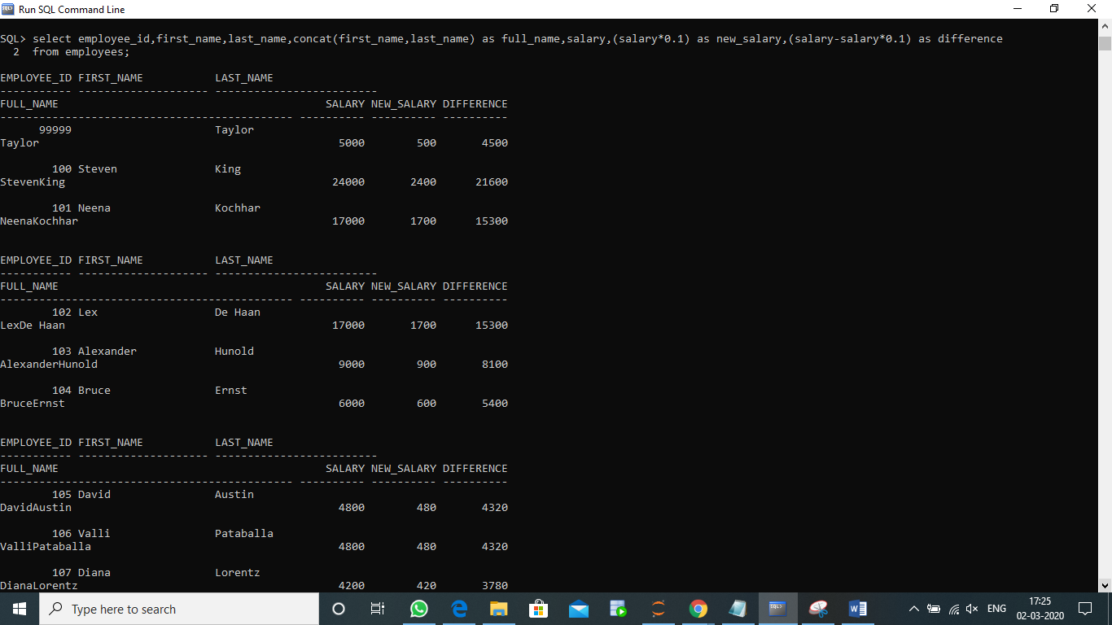

2ND QUERY

SQL> select employee_id,first_name,last_name,salary

2 from employees e1

3 where salary>(select avg(salary)

4 from employees e2

5 where e1.department_id=e2.department_id

6 group by e1.department_id);

EMPLOYEE_ID FIRST_NAME LAST_NAME SALARY

----------- -------------------- ------------------------- ----------

99999 Taylor 5000

100 Steven King 24000

103 Alexander Hunold 9000

104 Bruce Ernst 6000

108 Nancy Greenberg 12008

109 Daniel Faviet 9000

114 Den Raphaely 11000

120 Matthew Weiss 8000

121 Adam Fripp 8200

122 Payam Kaufling 7900

123 Shanta Vollman 6500

EMPLOYEE_ID FIRST_NAME LAST_NAME SALARY

----------- -------------------- ------------------------- ----------

124 Kevin Mourgos 5800

137 Renske Ladwig 3600

145 John Russell 14000

146 Karen Partners 13500

147 Alberto Errazuriz 12000

148 Gerald Cambrault 11000

149 Eleni Zlotkey 10500

150 Peter Tucker 10000

151 David Bernstein 9500

152 Peter Hall 9000

156 Janette King 10000

EMPLOYEE_ID FIRST_NAME LAST_NAME SALARY

----------- -------------------- ------------------------- ----------

157 Patrick Sully 9500

158 Allan McEwen 9000

162 Clara Vishney 10500

163 Danielle Greene 9500

168 Lisa Ozer 11500

169 Harrison Bloom 10000

170 Tayler Fox 9600

174 Ellen Abel 11000

184 Nandita Sarchand 4200

185 Alexis Bull 4100

188 Kelly Chung 3800

EMPLOYEE_ID FIRST_NAME LAST_NAME SALARY

----------- -------------------- ------------------------- ----------

189 Jennifer Dilly 3600

192 Sarah Bell 4000

193 Britney Everett 3900

201 Michael Hartstein 13000

205 Shelley Higgins 12008

38 rows selected.

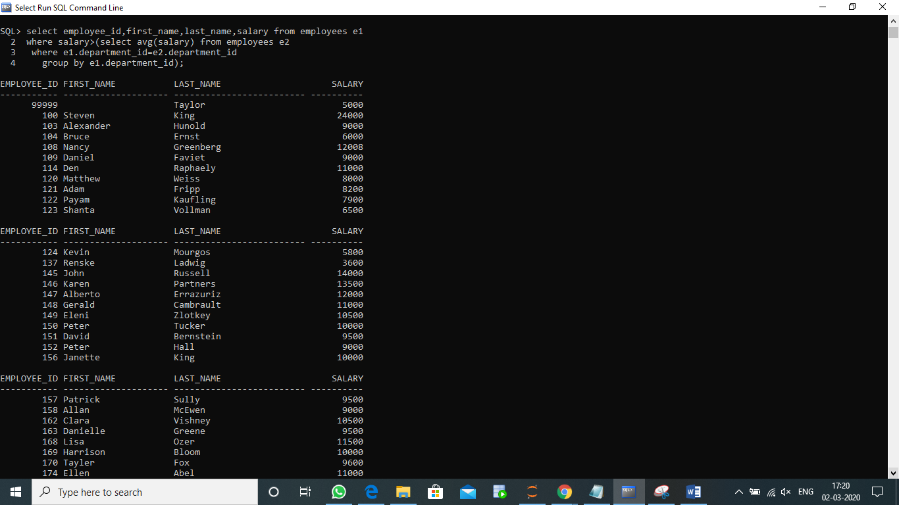

4TH QUERY

SQL> SELECT E.EMPLOYEE_ID,E.FIRST_NAME,E.LAST_NAME,

2 EMP.FIRST_NAME AS MANAGER_NAME

3 FROM EMPLOYEES

4 E LEFT OUTER JOIN EMPLOYEES EMP

5 ON E.MANAGER_ID=EMP.EMPLOYEE_ID

6 ORDER BY EMPLOYEE_ID;

EMPLOYEE_ID FIRST_NAME LAST_NAME MANAGER_NAME

----------- -------------------- ------------------------- --------------------

100 Steven King

101 Neena Kochhar Steven

102 Lex De Haan Steven

103 Alexander Hunold Lex

104 Bruce Ernst Alexander

105 David Austin Alexander

106 Valli Pataballa Alexander

107 Diana Lorentz Alexander

108 Nancy Greenberg Neena

109 Daniel Faviet Nancy

110 John Chen Nancy

EMPLOYEE_ID FIRST_NAME LAST_NAME MANAGER_NAME

----------- -------------------- ------------------------- --------------------

111 Ismael Sciarra Nancy

112 Jose Manuel Urman Nancy

113 Luis Popp Nancy

114 Den Raphaely Steven

115 Alexander Khoo Den

116 Shelli Baida Den

117 Sigal Tobias Den

118 Guy Himuro Den

119 Karen Colmenares Den

120 Matthew Weiss Steven

121 Adam Fripp Steven

EMPLOYEE_ID FIRST_NAME LAST_NAME MANAGER_NAME

----------- -------------------- ------------------------- --------------------

122 Payam Kaufling Steven

123 Shanta Vollman Steven

124 Kevin Mourgos Steven

125 Julia Nayer Matthew

126 Irene Mikkilineni Matthew

127 James Landry Matthew

128 Steven Markle Matthew

129 Laura Bissot Adam

130 Mozhe Atkinson Adam

131 James Marlow Adam

132 TJ Olson Adam

EMPLOYEE_ID FIRST_NAME LAST_NAME MANAGER_NAME

----------- -------------------- ------------------------- --------------------

133 Jason Mallin Payam

134 Michael Rogers Payam

135 Ki Gee Payam

136 Hazel Philtanker Payam

137 Renske Ladwig Shanta

138 Stephen Stiles Shanta

139 John Seo Shanta

140 Joshua Patel Shanta

141 Trenna Rajs Kevin

142 Curtis Davies Kevin

143 Randall Matos Kevin

EMPLOYEE_ID FIRST_NAME LAST_NAME MANAGER_NAME

----------- -------------------- ------------------------- --------------------

144 Peter Vargas Kevin

145 John Russell Steven

146 Karen Partners Steven

147 Alberto Errazuriz Steven

148 Gerald Cambrault Steven

149 Eleni Zlotkey Steven

150 Peter Tucker John

151 David Bernstein John

152 Peter Hall John

153 Christopher Olsen John

154 Nanette Cambrault John

EMPLOYEE_ID FIRST_NAME LAST_NAME MANAGER_NAME

----------- -------------------- ------------------------- --------------------

155 Oliver Tuvault John

156 Janette King Karen

157 Patrick Sully Karen

158 Allan McEwen Karen

159 Lindsey Smith Karen

160 Louise Doran Karen

161 Sarath Sewall Karen

162 Clara Vishney Alberto

163 Danielle Greene Alberto

164 Mattea Marvins Alberto

165 David Lee Alberto

EMPLOYEE_ID FIRST_NAME LAST_NAME MANAGER_NAME

----------- -------------------- ------------------------- --------------------

166 Sundar Ande Alberto

167 Amit Banda Alberto

168 Lisa Ozer Gerald

169 Harrison Bloom Gerald

170 Tayler Fox Gerald

171 William Smith Gerald

172 Elizabeth Bates Gerald

173 Sundita Kumar Gerald

174 Ellen Abel Eleni

175 Alyssa Hutton Eleni

176 Jonathon Taylor Eleni

EMPLOYEE_ID FIRST_NAME LAST_NAME MANAGER_NAME

----------- -------------------- ------------------------- --------------------

177 Jack Livingston Eleni

178 Kimberely Grant Eleni

179 Charles Johnson Eleni

180 Winston Taylor Matthew

181 Jean Fleaur Matthew

182 Martha Sullivan Matthew

183 Girard Geoni Matthew

184 Nandita Sarchand Adam

185 Alexis Bull Adam

186 Julia Dellinger Adam

187 Anthony Cabrio Adam

EMPLOYEE_ID FIRST_NAME LAST_NAME MANAGER_NAME

----------- -------------------- ------------------------- --------------------

188 Kelly Chung Payam

189 Jennifer Dilly Payam

190 Timothy Gates Payam

191 Randall Perkins Payam

192 Sarah Bell Shanta

193 Britney Everett Shanta

194 Samuel McCain Shanta

195 Vance Jones Shanta

196 Alana Walsh Kevin

197 Kevin Feeney Kevin

198 Donald OConnell Kevin

EMPLOYEE_ID FIRST_NAME LAST_NAME MANAGER_NAME

----------- -------------------- ------------------------- --------------------

199 Douglas Grant Kevin

200 Jennifer Whalen Neena

201 Michael Hartstein Steven

202 Pat Fay Michael

203 Susan Mavris Neena

204 Hermann Baer Neena

205 Shelley Higgins Neena

206 William Gietz Shelley

99999 Taylor

108 rows selected. 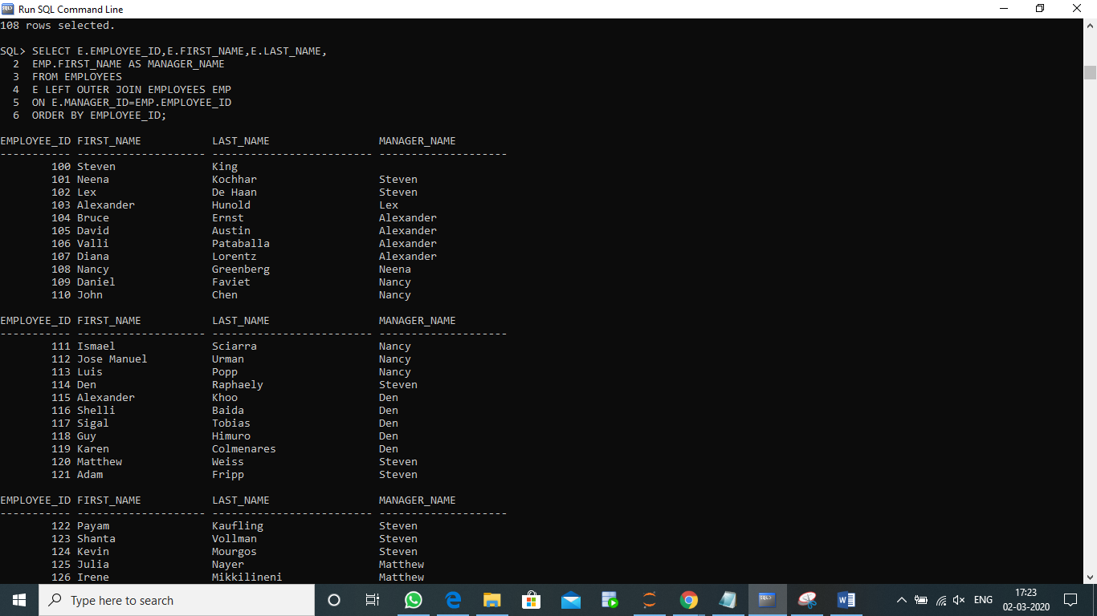

5th query

SQL> SELECT EMPLOYEE_ID,FIRST_NAME,SALARY

2 from employees

3 where rownum<=3

4 order by salary desc;

EMPLOYEE_ID FIRST_NAME SALARY

----------- -------------------- ----------

100 Steven 24000

101 Neena 17000

99999 5000

