select department_name,count(employee_id) as no_of_employees

from departments , employees

where employees.department_id =departments.department_id

group by department_name

having count(employee_id)>=20;

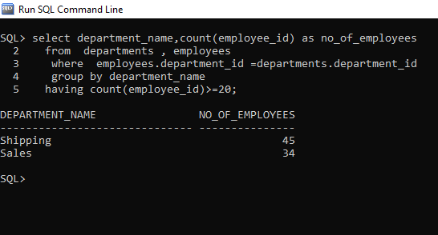

select employee_id,first_name,last_name,salary

from employees e1

where salary > all (select avg(salary) from employees e2

where e1.department_id=e2.department_id

group by department_id)

/

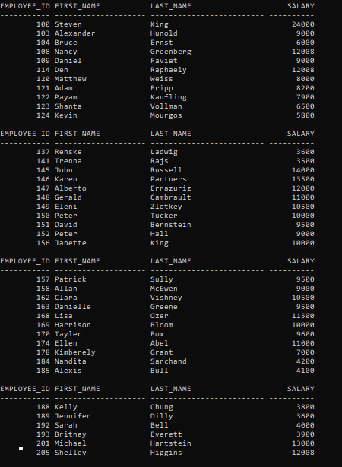

select employee_id,first_name,last_name,salary,(first_name||' '||last_name) as fullname,(salary*(10/100)) as newsal,((salary*(10/100)) -salary) as diff

from employees

/

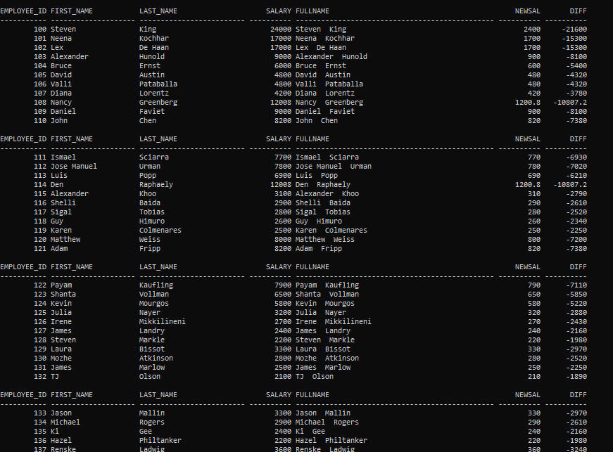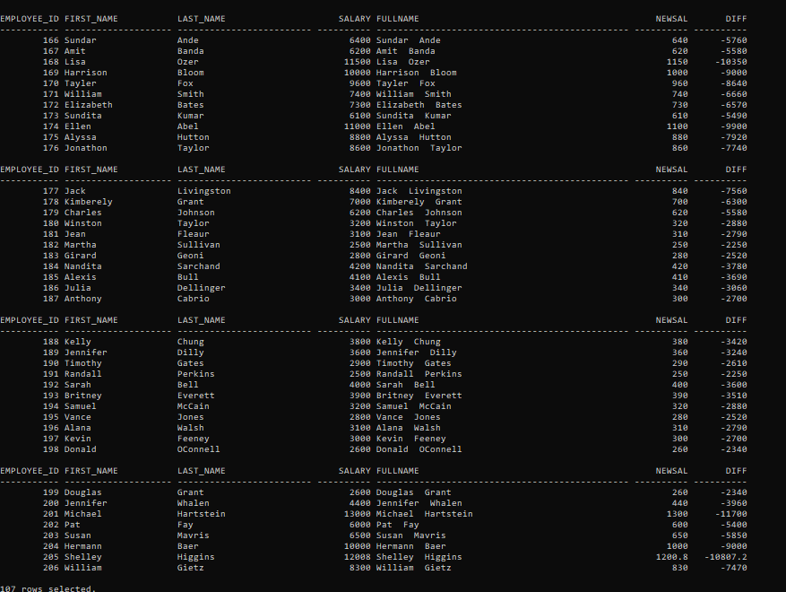

SQL> select e.employee_id,e.first_name,e.last_name,em.first_name as manager

2 from employees e left outer join employees em on

3 e.manager_id=em.employee_id

4 order by employee_id

5 /

EMPLOYEE_ID FIRST_NAME LAST_NAME MANAGER

----------- -------------------- ------------------------- --------------------

100 Steven King

101 Neena Kochhar Steven

102 Lex De Haan Steven

103 Alexander Hunold Lex

104 Bruce Ernst Alexander

105 David Austin Alexander

106 Valli Pataballa Alexander

107 Diana Lorentz Alexander

108 Nancy Greenberg Neena

109 Daniel Faviet Nancy

110 John Chen Nancy

EMPLOYEE_ID FIRST_NAME LAST_NAME MANAGER

----------- -------------------- ------------------------- --------------------

111 Ismael Sciarra Nancy

112 Jose Manuel Urman Nancy

113 Luis Popp Nancy

114 Den Raphaely Steven

115 Alexander Khoo Den

116 Shelli Baida Den

117 Sigal Tobias Den

118 Guy Himuro Den

119 Karen Colmenares Den

120 Matthew Weiss Steven

121 Adam Fripp Steven

EMPLOYEE_ID FIRST_NAME LAST_NAME MANAGER

----------- -------------------- ------------------------- --------------------

122 Payam Kaufling Steven

123 Shanta Vollman Steven

124 Kevin Mourgos Steven

125 Julia Nayer Matthew

126 Irene Mikkilineni Matthew

127 James Landry Matthew

128 Steven Markle Matthew

129 Laura Bissot Adam

130 Mozhe Atkinson Adam

131 James Marlow Adam

132 TJ Olson Adam

EMPLOYEE_ID FIRST_NAME LAST_NAME MANAGER

----------- -------------------- ------------------------- --------------------

133 Jason Mallin Payam

134 Michael Rogers Payam

135 Ki Gee Payam

136 Hazel Philtanker Payam

137 Renske Ladwig Shanta

138 Stephen Stiles Shanta

139 John Seo Shanta

140 Joshua Patel Shanta

141 Trenna Rajs Kevin

142 Curtis Davies Kevin

143 Randall Matos Kevin

EMPLOYEE_ID FIRST_NAME LAST_NAME MANAGER

----------- -------------------- ------------------------- --------------------

144 Peter Vargas Kevin

145 John Russell Steven

146 Karen Partners Steven

147 Alberto Errazuriz Steven

148 Gerald Cambrault Steven

149 Eleni Zlotkey Steven

150 Peter Tucker John

151 David Bernstein John

152 Peter Hall John

153 Christopher Olsen John

154 Nanette Cambrault John

EMPLOYEE_ID FIRST_NAME LAST_NAME MANAGER

----------- -------------------- ------------------------- --------------------

155 Oliver Tuvault John

156 Janette King Karen

157 Patrick Sully Karen

158 Allan McEwen Karen

159 Lindsey Smith Karen

160 Louise Doran Karen

161 Sarath Sewall Karen

162 Clara Vishney Alberto

163 Danielle Greene Alberto

164 Mattea Marvins Alberto

165 David Lee Alberto

EMPLOYEE_ID FIRST_NAME LAST_NAME MANAGER

----------- -------------------- ------------------------- --------------------

166 Sundar Ande Alberto

167 Amit Banda Alberto

168 Lisa Ozer Gerald

169 Harrison Bloom Gerald

170 Tayler Fox Gerald

171 William Smith Gerald

172 Elizabeth Bates Gerald

173 Sundita Kumar Gerald

174 Ellen Abel Eleni

175 Alyssa Hutton Eleni

176 Jonathon Taylor Eleni

EMPLOYEE_ID FIRST_NAME LAST_NAME MANAGER

----------- -------------------- ------------------------- --------------------

177 Jack Livingston Eleni

178 Kimberely Grant Eleni

179 Charles Johnson Eleni

180 Winston Taylor Matthew

181 Jean Fleaur Matthew

182 Martha Sullivan Matthew

183 Girard Geoni Matthew

184 Nandita Sarchand Adam

185 Alexis Bull Adam

186 Julia Dellinger Adam

187 Anthony Cabrio Adam

EMPLOYEE_ID FIRST_NAME LAST_NAME MANAGER

----------- -------------------- ------------------------- --------------------

188 Kelly Chung Payam

189 Jennifer Dilly Payam

190 Timothy Gates Payam

191 Randall Perkins Payam

192 Sarah Bell Shanta

193 Britney Everett Shanta

194 Samuel McCain Shanta

195 Vance Jones Shanta

196 Alana Walsh Kevin

197 Kevin Feeney Kevin

198 Donald OConnell Kevin

EMPLOYEE_ID FIRST_NAME LAST_NAME MANAGER

----------- -------------------- ------------------------- --------------------

199 Douglas Grant Kevin

200 Jennifer Whalen Neena

201 Michael Hartstein Steven

202 Pat Fay Michael

203 Susan Mavris Neena

204 Hermann Baer Neena

205 Shelley Higgins Neena

206 William Gietz Shelley

107 rows selected.

SQL> select employee_id,salary from employees

2 where rownum<4

3 order by salary desc

4 /

EMPLOYEE_ID SALARY

----------- ----------

100 24000

102 17000

101 17000

SQL>