Phanindra Sagar

Emp_ID:853788

3.

select employee_id,first_name,last_name,

(first_name||last_name) as full_name,salary,

salary*0.1+salary as new_salary,

((salary*0.1+salary)-salary) as new_salary_salary

from employees;

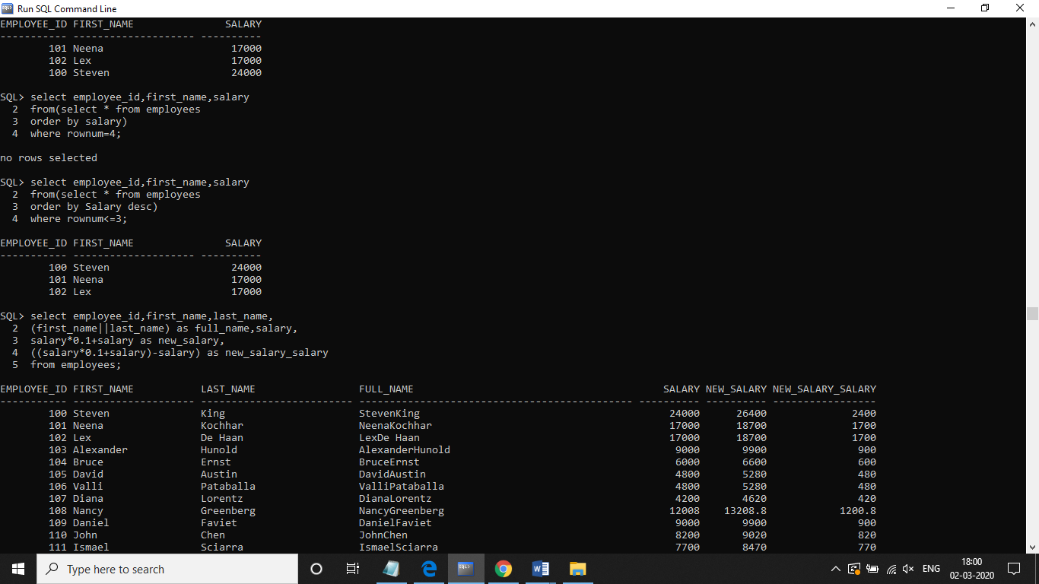

4. select a.employee_id,a.first_name,a.last_name,b.first_name presidentmanager from employees a left outer join employees b

on b.employee_id=a.manager_id

where b.first_name is null

order by employee_id

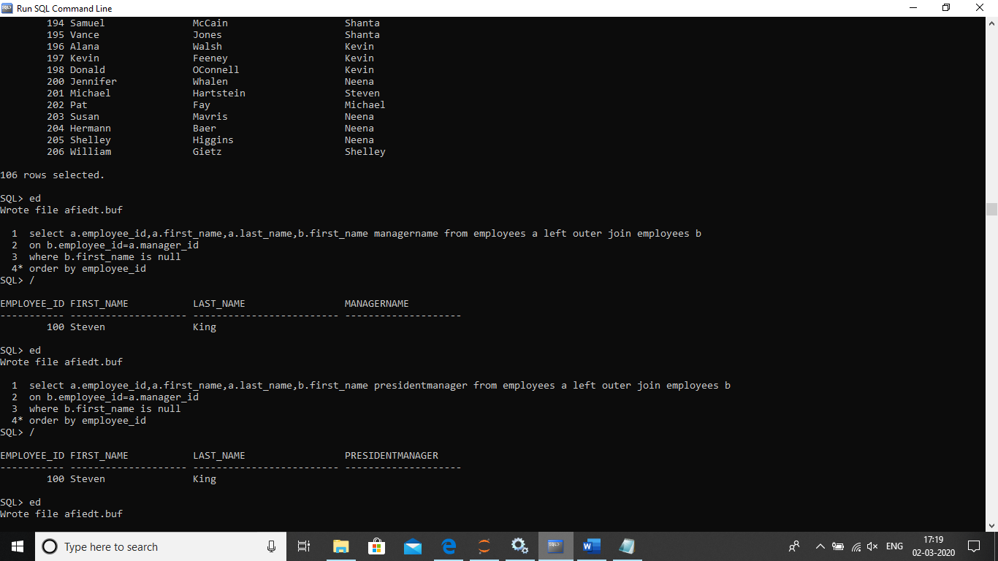

5.

select employee_id,first_name,salary

from(select * from employees

order by Salary desc)

where rownum<=3;



1.

select a.department_name,count(b.employee_id)

from departments a join employees b on a.department_id=b.department_id

group by a.department_name,b.department_id

having count(b.employee_id)>=20

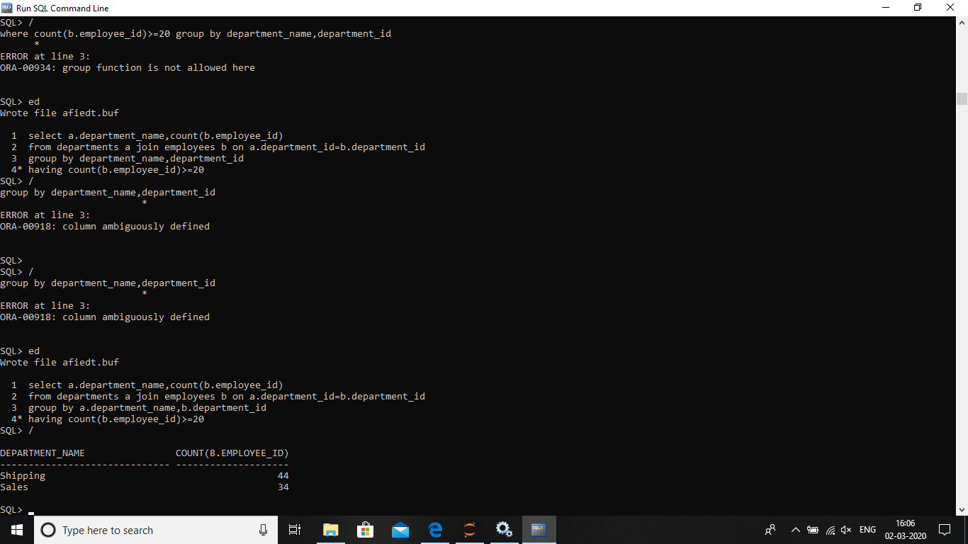

2.

select a.employee_id,a.first_name,a.last_name,

a.salary from employees a where salary>(select avg(salary)

from employees b

where a.department_id=b.department_id

group by a.department_id)

