1. WRITE A QUERY TO DISPLAY DEPARTMENT_NAME,NO_OF_EMPLOYEES WITH DEPARTMENTS HAVING 20 OR MORE DEPARTMENTS

select department_name,count(employee_id)

from departments,employees

where departments.department_id=employees.department_id

group by department_name

having count(employee_id)>=20;

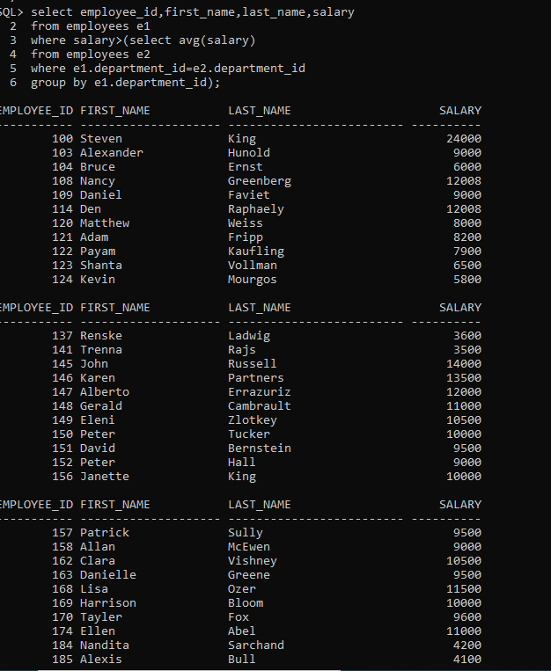

2.WRITE A QUERY TO DISPLAY EMPLOYEE_ID,FIRST_NAME,LAST_NAME,SALARY FROM EMPLOYEES WHOSE SALARY GREATER THAN AVGSSALARY

select employee_id,first_name,last_name,salary

from employees e1

where salary>(select avg(salary)

from employees e2

where e1.department_id=e2.department_id

group by e1.department_id);

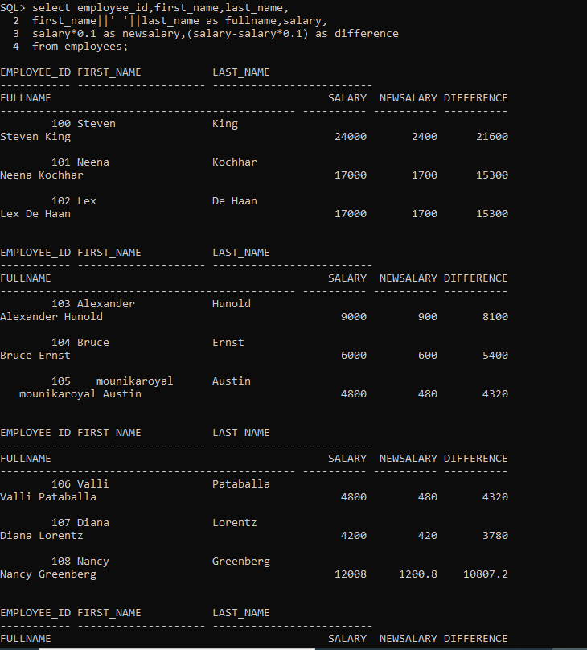

3 WRITE A QUERY TO DISPLAY EMPLOYEE_ID,FIRST_NAME,LAST_NAME,FULL_NAME,SALARY,NEW_SALARY(SALARY*10%),DIFFERENCE(MEW_SALARY-SALARY).

select employee_id,first_name,last_name,

first_name||' '||last_name as fullname,salary,

salary*0.1 as newsalary,(salary-salary*0.1) as difference

from employees;

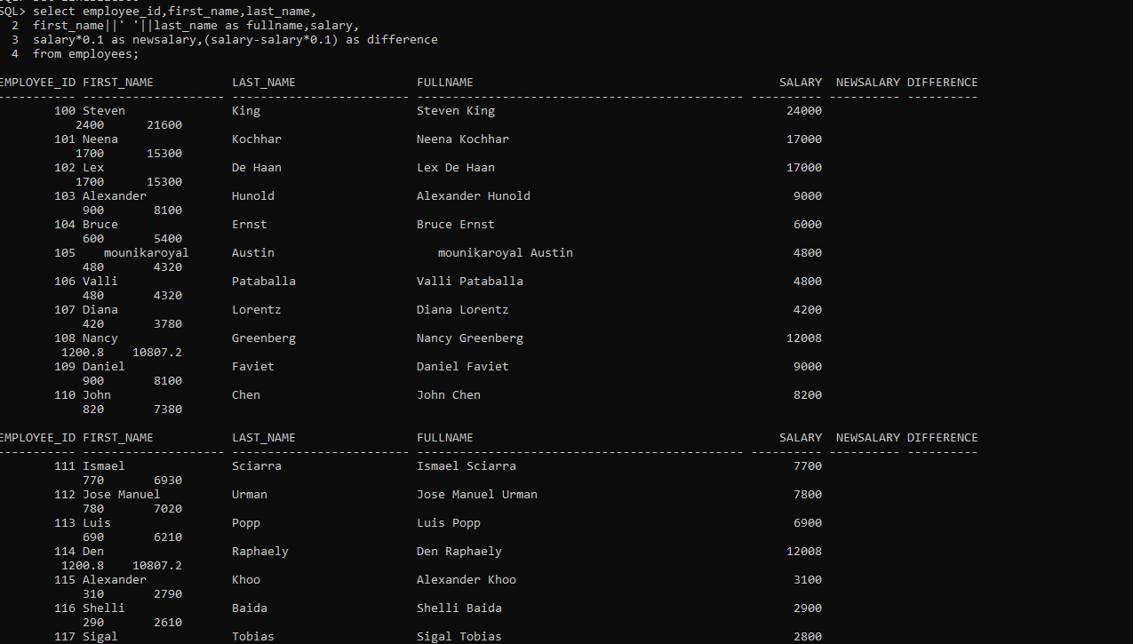

4. DISPLAY EMPLOYEE_ID,FIRST_NAME,LAST_NAME,MANAGER FIRST_NAME WITH PRESIDENT MANAGER _FIRST NAME IS NULL

select e.employee_id,e.first_name,e.last_name,em.first_name as manager_name

2 from employees e left outer join employees em

3 on e.manager_id = em.employee_id

4 order by employee_id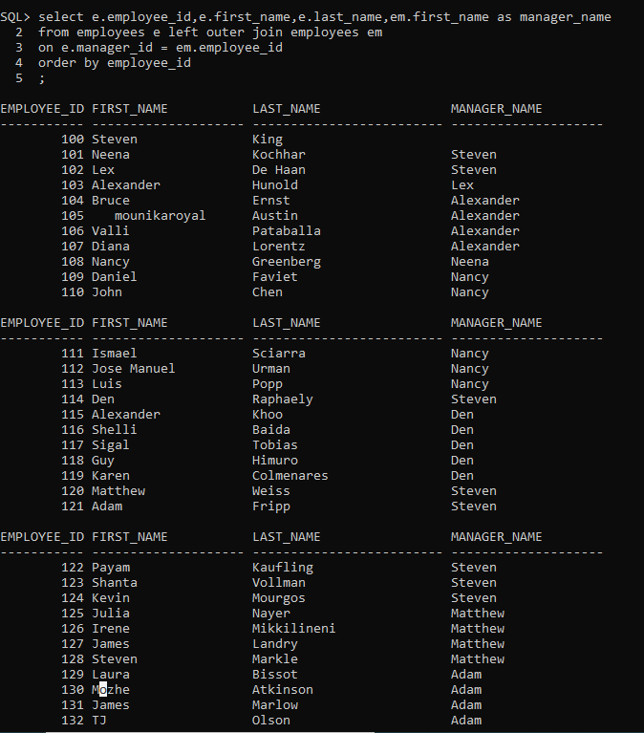

5. DISPLAYTOP3 HIGHEST SALARY EMPLOYEES(EMPLOYEE_ID,FIRST_NAME,SALARY)

Select employee_id,first_name,salary

from employees

WHERE RONUM<=3

order by salary desc;

