**Creating a Docker Image and Creating a Replicated Service on Swarm Cluster - Assessment**

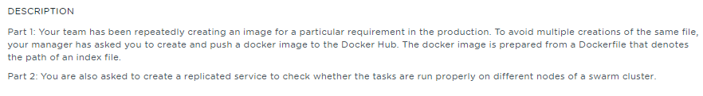

**Table of Contents**

**1.** **Introduction** 1

**1.1.** **Create and Push a Docker image to Docker Hub** 1

**1.1.** **Create replicated service on Swarm cluster** 1

**2.** **References** 1

# **Introduction**

The intent of the project is to create a docker image and create the replicated services to ensure the tasks are running in the available nodes of the swarm cluster. The project is divided into two parts:

## **Create and Push a Docker image to Docker Hub**

The intent of this section is to demonstrate on how to create the Docker image based on the Dockerfile and the base image can be stored in the Docker Hub to avoid creating the images for every new changes.

## **Create replicated service on Swarm cluster**

The intent of this section is to show how to create the replicated services on Swarm cluster and ensure the tasks are running correctly in the available nodes of a Swarm Cluster

# **References**

|  |  |  |
| --- | --- | --- |
| **S.No** | **Components** | **Reference** |
| 1 | Writeup Document | Docker_image_Replicated_service_swarm_writeup.docx |
| 2 | Screenshots Document | Docker_image_Replicated_service_swarm_screenshots.docx |
| 4 | Sources | <https://github.com/babkannan/docker_image_create_replicated_service_swarm_cluster> |