**Build Deployment using Rolling Updates - Assessment**

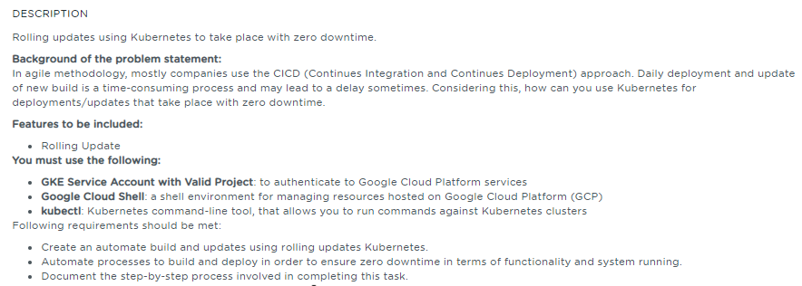

**Table of Contents**

**1.** **Project Abstract** 1

**2.** **References** 1

# **Project Abstract**

The intent of this project is to perform the following activities:

* Automate the build/deployment creation and updation using Rolling updates.
* Automate the build and deploy processes to ensure zero down time in terms of functionality, and process that is running in production.

# **References**

|  |  |  |
| --- | --- | --- |
| **S.No** | **Components** | **Reference** |
| 1 | Screenshots Document | 5.CI_CD_Deployment_using_Rolling_updates_screenshots.docx |
| 2 | Write-up Document | 5.CI_CD_Deployment_using_Rolling_updates_writeup.docx |
| 2 | Sources | <https://github.com/babkannan/k8s-rollingupdates> |