**Deploy Containerized web application in GKE - Assessment**

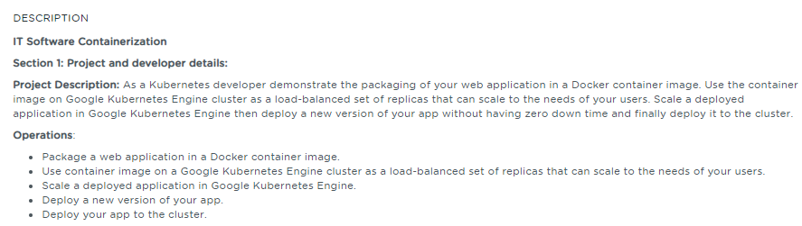

**Table of Contents**

**1.** **Introduction** 1

**2.** **References** 2

# **Introduction**

The intent of this project is to perform the following activities

* Package a web application in a Docker container image,
* Run that container application locally.
* Upload the Docker image to Container Registry
* Create a Google Kubernetes Engine (GKE) cluster
* Deploy the web application as a load-balanced set of replicas that can scale to the needs of your users.
* Expose the web application to the internet
* Deploy a new version of the web application

# **References**

|  |  |  |
| --- | --- | --- |
| **S.No** | **Components** | **Reference** |
| 1 | Screenshots document | Deploy_Containerized_Application_in_GKE_screenshots.docx |
| 2 | Sample Web Application | <https://github.com/babkannan/k8s_deploy_containerized_app_gke> |