**Health Monitoring Using Kubernetes - Assessment**

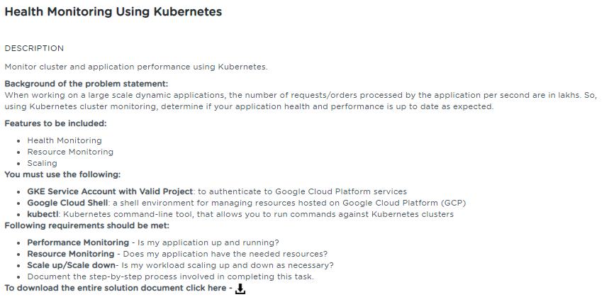

**Table of Contents**

**1.** **Project Abstract** 1

**2.** **Sources** 1

**3.** **References** 1

# **Project Abstract**

The intent of this project is to automate the alert allocation for an analyst on a regular interval of time using the Kubernetes Scheduler.

# **Sources**

The Source files are available in the public Git repo. Please refer the References section for the Public repository of the GitHub.

# **References**

|  |  |  |
| --- | --- | --- |
| **S.No** | **Components** | **Reference** |
| 1 | Write-up Document | 3.Health_Monitoring_using_k8s_writeup.docx |
| 2 | Screenshots | 3.Health_Monitoring_using_k8s_screenshots.docx |
| 3 | Sources |  |