**Job Scheduling Using Kubernetes Cluster - Assessment**

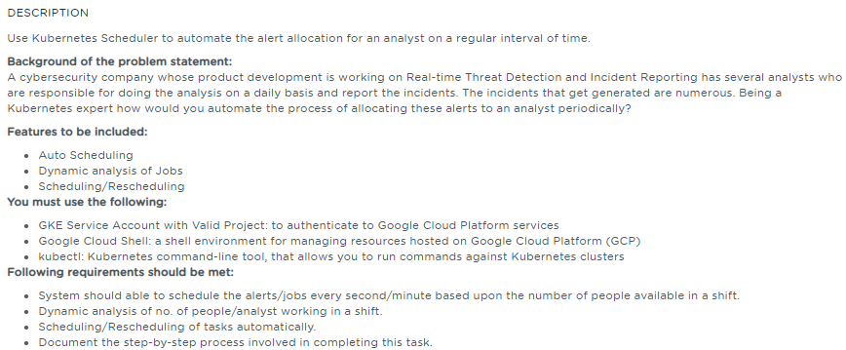

**Table of Contents**

**1.** **Project Abstract** 1

**2.** **Sources** 1

**3.** **References** 1

# **Project Abstract**

The intent of this project is to automate the alert allocation for an analyst on a regular interval of time using the Kubernetes Scheduler.

# **Sources**

The Source files are available in the public Git repo. Please refer the References section for the Public repository of the Github. Cronjob file (yml) file is being used for job scheduling in the Kubernetes cluster

# **References**

|  |  |  |
| --- | --- | --- |
| **S.No** | **Components** | **Reference** |
| 1 | Write-up Document | 1.Job_Scheduling_using_k8s_Cluster_writeup.docx |
| 2 | Screenshots | 1.Job_Scheduling_using_k8s_Cluster_screenshots.docx |
| 3 | Sources |  |