**Setup MYSQL Database Using Ansible – Practice Assessment**

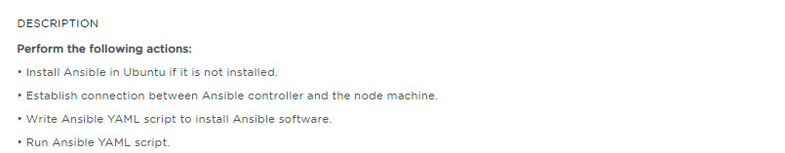

# Source Code

A YAML file (mysqldb.yml) is being used to setup the MySQL using Ansible. Sources are available under the Public Git repo <https://github.com/babkannan/git-github-assessment-project>

# References

* MySQL setup using Ansible Write-up Reference document **- MySQL_Database_Using_Ansible_PracticeAssessment_writeup.docx**

MySQL setup using Ansible Screenshots Reference document **MySQL_Database_Using_Ansible_PracticeAssessment_screenshots.docx**