**Setup MYSQL Database Using Ansible – Practice Assessment**



# Overview

This section will guide you to Setup MYSQL database using Ansible

This lab has four sub-sections:

* Install Ansible in Ubuntu
* Establish connectivity between Ansible controller and node machine
* Write Ansible YAML script to install MYSQL database service
* Run Ansible YAML script
* Check for the MySQL Database connection

# Install Ansible on Ubuntu

Install Ansible software on Ubuntu system as shown below in the snapshot:

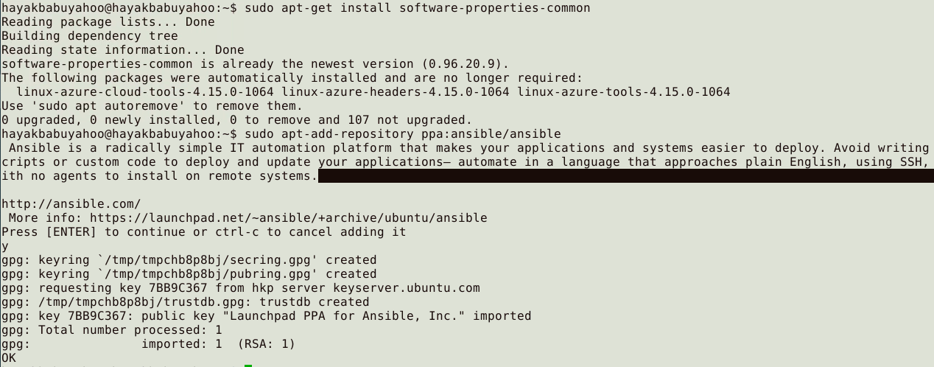

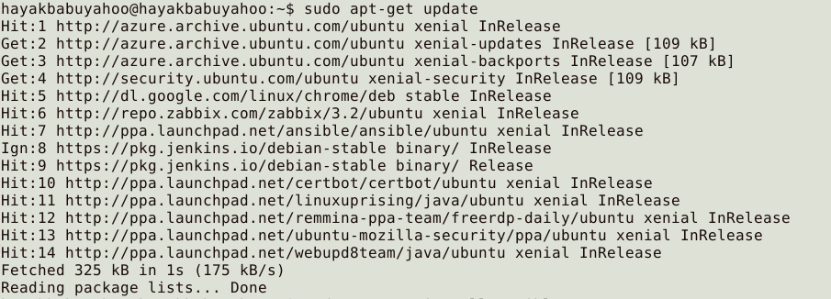

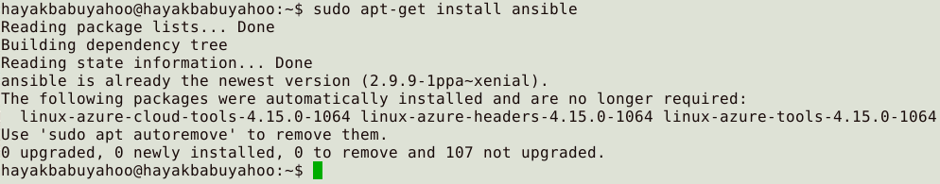

Establish SSH key pair in linux system to have SSH connectivity with localhost as shown below in the snapshot:

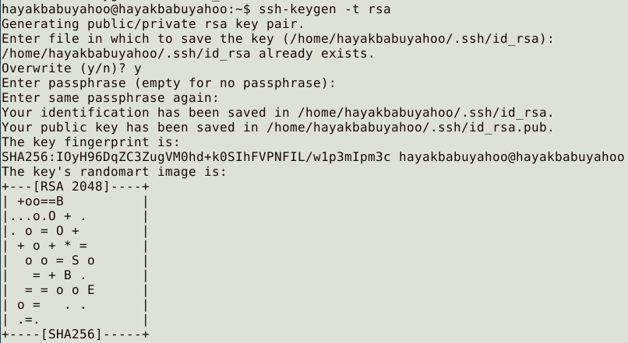

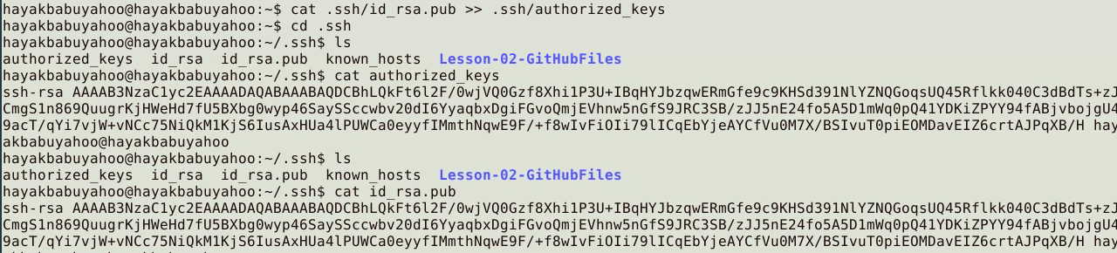

Now, add the host “localhost” with the ssh port in ansible host file /etc/ansible/hosts as shown below in the snapshot:

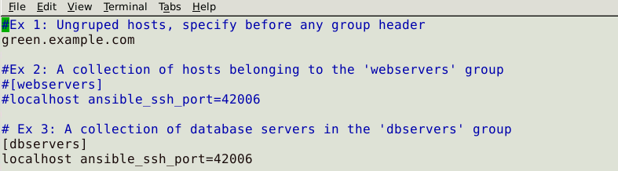

# Establish connectivity between Ansible controller and node machine

Establish connectivity between Ansible controller and node machine, execute the below command to validate host inventory file as shown below in the snapshot:

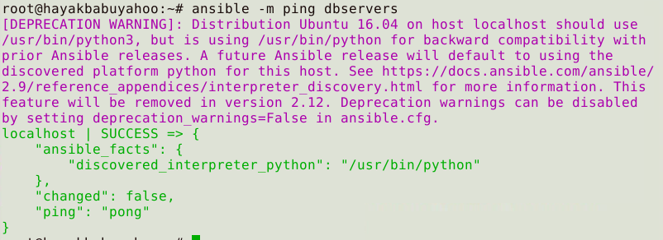

# Write Ansible YAML script to install MYSQL database service

Once connectivity is established, add the following code in the mysqldb.yml file and proceed with execution as shown below in the snapshot: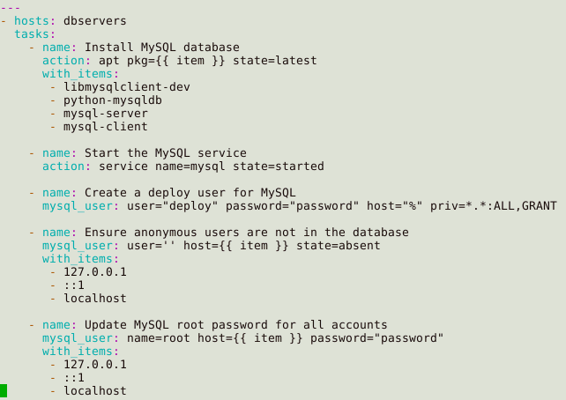

# Run Ansible YAML script

Run mysqldb.yml file using below command as shown in the below snapshot:

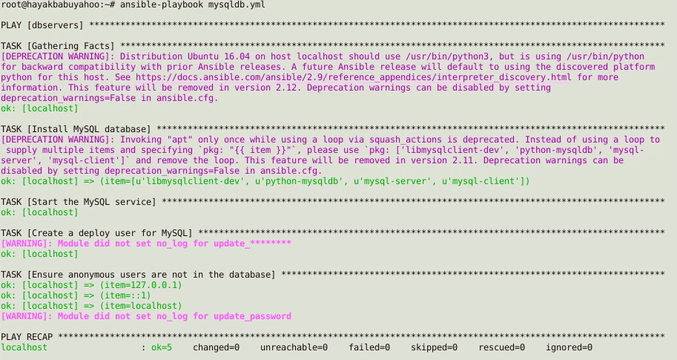

Validate installation using the command as shown below in the snapshot:

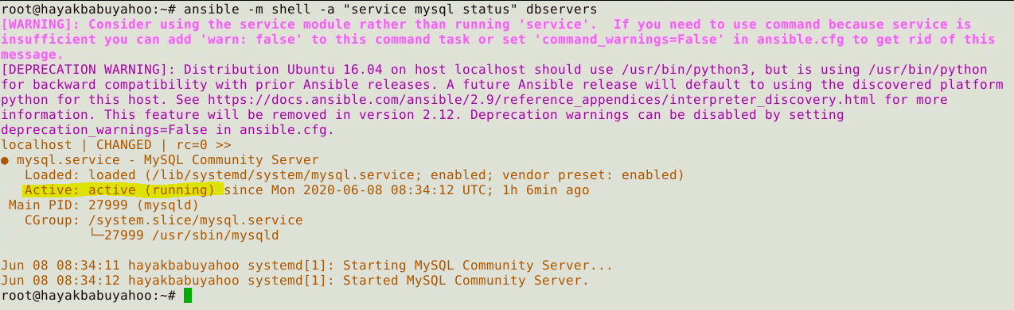

# Check for the MySQL Database

Check for the MySQL database connection as shown in the below snapshot:

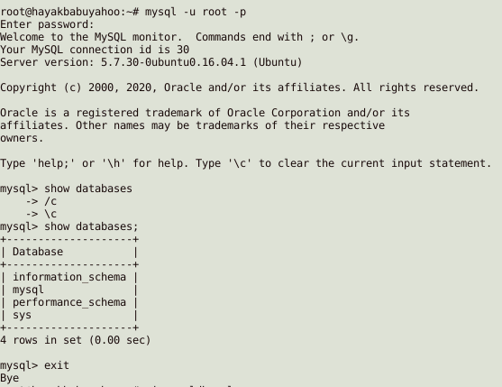

# References

* Sources Reference document **- MySQL_Database_Using_Ansible_PracticeAssessment_writeup.docx**
* Screenshots Reference document - **MySQL_Database_Using_Ansible_PracticeAssessment_sources.docx**