Angular 17 Features:

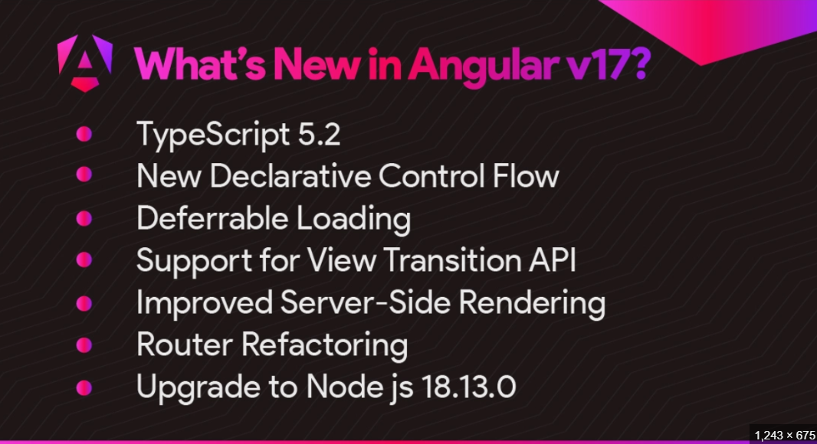

Best URL for Upgrade the Angular 16 to 17 :

<https://daily.dev/blog/angular-17-everything-you-need-to-know-in-one-place>

1-: Declarative control flow

2-: Built-in Control Flow Performance

3-: Deferrable Views

4-: Standalone Components

5-: Enhanced Server-Side Rendering (SSR )

6-: Dependency Injection Debugging

8-: TypeScript 5.2 Support

9-: Improved Routing and Lazy Loading

10-: Material 3 Support