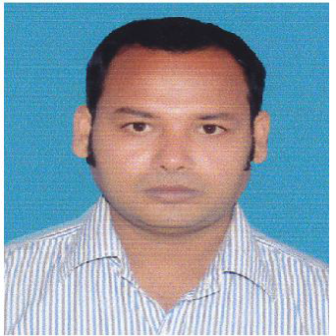

Mohammad Alamgir Hasan

**Date of Birth:** 01, January,1989

**Present Address:** Nahar Nibash,34/4/A/10, North Bashaboo, Dhaka--1214

**Cell:** 01671319520, **email:** alamgirhasanbablu89@gmail.com

|  |  |
| --- | --- |
| Career Objective | I am a fresher in the corporate culture, but ready to accept the challenges, utilizing my technical skills, would like to work with a highly esteemed company which gives me a platform to use my expertise and skills for mutual growth and benefit of company and myself. |
| Skills | • Programming Languages : C , C++, PHP and Java  • Database Technologies : MySQL, MS SQL Server 2012  • Web Technologies : HTML, CSS, Javascript  •Mobile Apps Development : Android  •Networking : Basic Network Configuration and troubleshooting  •System Administration : Redhat Linux System Administration  •Hardware : PC troubleshooting and maintenance |
| Education | * M.Sc in Information Technology Enrolled   Dhaka University   * B.Sc (Hons) in Computer Science & Engineering, 2015 Result-3.08   Dhaka City College, National University   * HSC in Science, 2008 Result-3.20   Chittagong Board   * Dakhil in Science, 2003 Result-3.92   Madrasha Board |
| Training | * Aptis (English Language test by British council) * Microsoft SQL Server 2012, LEADS * Android Application Development, BITM, BASIS * Web Design & Application Development, IAC, BUET * Red Hat Certified Engineer (RHCE), IBCS-PRIMAX * Cisco Certified Network Associate (CCNA),AIUB |
| References | **Dewan Abdul Moyez Choudhury Md. Latifur Rahman**  Manager (Accounts and Admin) Assistant Secretary,  Fashion Linkers Ltd. Finance Division, Ministry of Finance  Malibagh, Dhaka. Bangladesh Secretariat, Dhaka  email: [hasnath_chy@live.com](mailto:hasnath_chy@live.com) Cell# 01715986589  Cell: 01715225989 |

**Date**: ____________________

**Place**: Dhaka **(Mohammad Alamgir Hasan)**