Create a react project with dynamic components that can be added, removed and reorganized on the page. The two components are provided to you in the Figma file.

<https://www.figma.com/file/DYUxqyrUUwlNUZLqrbywHZ/Test?type=design&node-id=0-1&mode=design&t=neq9uq5J1rokAblZ-0>

On clicking “add component” one should be able to add either of the two components on the page. The text and the images in the components should be editable. A rough video of the functionality is added below.



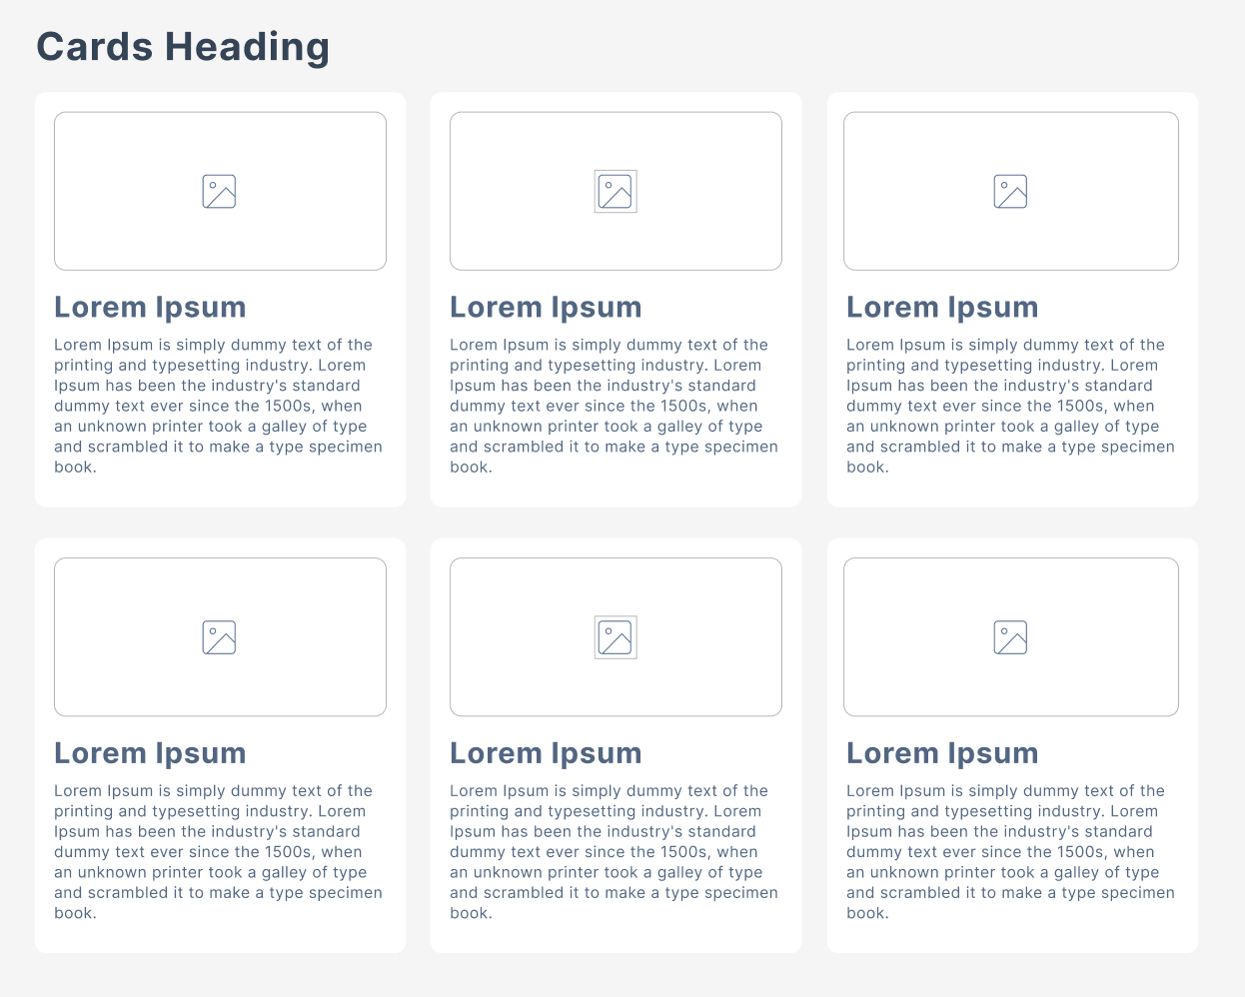

For the cards component please use a placeholder image and the title and description fetched from <https://jsonplaceholder.typicode.com/posts>.

The entire layout with the content should be saved as a JSON object in the context and should be available in other components as well.

Please feel free to use Bootstrap or any other CSS framework of your choice. You can use any React libraries to assist you in your development.

Please make sure:

* Your code is commented
* Your project is divided into reusable components
* Your application maintains naming conventions and folder structures
* Your code is linted and organized.

**The page should be responsive, you can choose any CSS framework.**

Create a React application, push it on a public git repository, and share the repository with us.