**Java Lab Program**

|  |  |  |
| --- | --- | --- |
| **S. No** | **Program** | **Date** |
|  | Printing “Hello World” | **16/04/2021** |
|  | Print ASCII: American Standard Code for Information Interchange Code for any values | **16/04/2021** |
|  | Program To add, multiply, divide and subtract two numbers. Display out.   1. Display, what the two numbers are taken for operations? 2. Display the result by specifying that whether the output is for addition, multiplication, division, or subtraction. | **16/04/2021** |
|  | Print DNA Base Table | **16/04/2021** |
|  | Calculate the GC percent of DNA   * Take a DNA Sequence. * Count A, G, C, T * Calculate GC percentage. | **23/04/2021** |
|  | Calculate frequency of DNA base   * Take a DNA Sequence. * Calculate % percentage of A’s, G’s, C’s and T’s. * Print all the frequencies. * Specify the Maximum Base frequency and Min base frequency. Using max () and Min(). | **23/04/2021** |
|  | Program to print complement of DNA sequence   * Take a DNA Sequence. * Do complement = {'A':'T', 'T':'A', 'G':'C', 'C':'G'} * Print both the input and the complement DNA as output. | **23/04/2021** |
|  | Count repeats in a DNA sequence   * Take a DNA sequence * Get input of the repeat string has to be searched. Eg. aat, cagc etc… * Print DNA sequence, repeat sequence and the no. of time repeats has been made. | **23/04/2021** |
|  | Count no of Gaps DNA sequence   * Take a DNA sequence * Count gaps like “ ” or “-”. * Print DNA sequence, print the no of gap, both in numbers and percentage. |  |
|  |  |  |
|  |  |  |
|  |  |  |
|  |  |  |
|  |  |  |

**Date:- 16/04/2021**

**Program 1: Printing “Hello World”.**

**Code:**

class HelloWorld {

    public static void main(String[] args) {

        System.out.println("Hello World!");

    }

}

**Output**

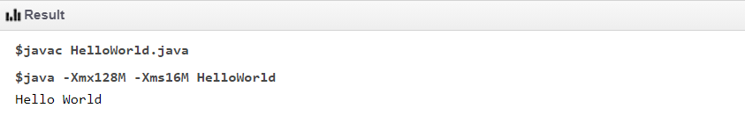

**Program 2:** **Print ASCII: American Standard Code for Information Interchange Code for any values:**

**Code:**

public class PrintAsciiValue {

public static void main(String[] args)

{

char ch1 = 'c';

char ch2 = 'q';

int value1 = ch1;

int value2 = ch2;

System.out.println("ASCII value of " + ch1 + " is: " + value1);

System.out.println("ASCII value of " + ch2 + " is: " + value2);

}

}

**Output**

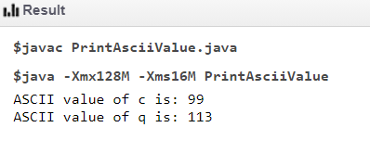

**Program 3: Program To add, multiply, divide and subtract two numbers. Display out.**

1. **Display, what the two numbers are taken for operations?**
2. **Display the result by specifying that whether the output is for addition, multiplication, division, or subtraction.**

**Code:**

public class AddTwoNumbers {

public static void main(String[] args) {

int num1 = 5, num2 = 15, sum, mul, div, sub;

sum = num1 + num2;

mul = num1 * num2;

div = num2 / num1;

sub = num1 - num2;

System.out.println("First numbers: "+num1);

System.out.println("Second numbers: "+num2);

System.out.println("Sum of these numbers: "+sum);

System.out.println("Multiplication of these numbers: "+mul);

System.out.println("Divide of these numbers: "+div);

System.out.println("Subtraction of these numbers: "+sub);

}

}

**Output**

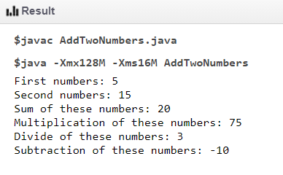

**Program 4: Print DNA Base Table**

**Code:**

public class DNAbaseTable{

public static void main(String []args){

System.out.println(" DNA Base ");

System.out.println("-------------------------------------------");

System.out.println("Code\tDescription\tComplement");

System.out.println("-------------------------------------------");

System.out.println("A\tAdenine\t\t T");

System.out.println("G\tGuanine\t\t c");

System.out.println("T\tThymine\t\t A");

System.out.println("C\tCytosine\t G");

System.out.println("-------------------------------------------");

}

}

**Output**

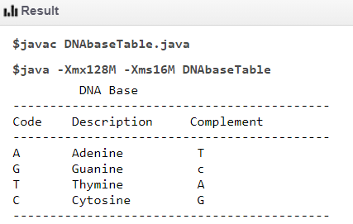

**Program 5:** Calculate the GC percent of DNA Date- 23-04-2021

Take a DNA Sequence.

* + - Count A, G, C, T
    - Calculate GC percentage

public class GC_Percent {

public static void main(String[] args) {

String dna="CATCGATCGTCGGCtgCgtgacTTAACGGAATACgttcagccatcgtctatGCTATGgTCGGtATCG";

dna = dna.toUpperCase();

int len=dna.length();

float A_Count=0, T_Count=0, C_Count=0, G_Count=0;

for(int i=0;i<dna.length();i++){

if (dna.charAt(i)=='A'){

A_Count++;

}

else if(dna.charAt(i)=='T'){

T_Count++;

}

else if(dna.charAt(i)=='C'){

C_Count++;

}

else if(dna.charAt(i)=='G'){

G_Count++;

}

}

System.out.println("INPUT DNA : "+dna);

float GC_percent=((G_Count+C_Count)*100)/len;

System.out.println("A's count = "+A_Count);

System.out.println("T's count = "+T_Count);

System.out.println("C's count = "+C_Count);

System.out.println("G's count = "+G_Count);

System.out.println("PERCENTAGE OF 'GC' = "+GC_percent);

}

}

**Output**

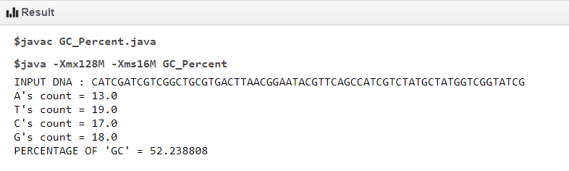

**Program 6: Calculate frequency of DNA base**

* **Take a DNA Sequence.**
* **Calculate % percentage of A’s, G’s, C’s and T’s.**
* **Print all the frequencies.**

**Specify the Maximum Base frequency and Min base frequency. Using max () and Min().**

public class DNA_frequency {

public static void main(String[] args) {

String dna="CATCGATCGTCGGCtgCgtgacTTTACTGTAAACgttagccatcgtctatGCTATGgTCGGtATCG";

dna = dna.toUpperCase();

int len=dna.length();

float A_Count=0, T_Count=0, C_Count=0, G_Count=0;

for(int i=0;i<dna.length();i++){

if (dna.charAt(i)=='A'){

A_Count++;

}

else if(dna.charAt(i)=='T'){

T_Count++;

}

else if(dna.charAt(i)=='C'){

C_Count++;

}

else if(dna.charAt(i)=='G'){

G_Count++;

}

}

float A_percent=(A_Count/len)*100;

float T_percent=(T_Count/len)*100;

float C_percent=(C_Count/len)*100;

float G_percent=(G_Count/len)*100;

System.out.println("The percent of A = "+ A_percent);

System.out.println("The percent of T = "+ T_percent);

System.out.println("The percent of C = "+ C_percent);

System.out.println("The percent of G = "+ G_percent);

System.out.println("\n");

System.out.println("A's frequency = "+A_Count);

System.out.println("T's frequency = "+T_Count);

System.out.println("C's frequency = "+C_Count);

System.out.println("G's frequency = "+G_Count);

float max1=Math.max(A_Count,T_Count);

float max2=Math.max(G_Count,C_Count);

float min1=Math.min(A_Count,T_Count);

float min2=Math.min(G_Count,C_Count);

System.out.println("\n");

System.out.println("The maximum frequency is "+Math.max(max1,max2));

System.out.println("The minimum frequency is "+Math.min(min1,min2));

}

}

**OUTPUT**

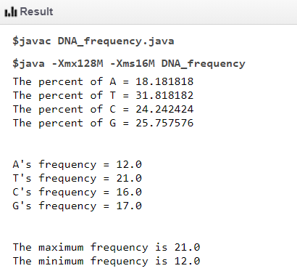

**Program 7: To print complement of DNA sequence**

* **Take a DNA Sequence.**
* **Do complement = {'A':'T', 'T':'A', 'G':'C', 'C':'G'}**
* **Print both the input and the complement DNA as output.**

public class Main

{

public static void main(String[] args) {

String dna = "ttCGATCGTATCGACcattaGtctgTCGtgacgctGatgacTCtCGTAGGCTctgatcgatgctactgcatgTGtagctgTcgcgAtcgTAGcgacGtgcTctgaTAACGCGTCGA";

String DNA = dna.toUpperCase();

String c = DNA;

c = c.replace('T','M');

c = c.replace('A','T');

c = c.replace('M','A');

c = c.replace('C','N');

c = c.replace('G','C');

c = c.replace('N','G');

System.out.println("INPUT : "+DNA);

System.out.println("OUTPOT : "+c);

}

}

**Output**

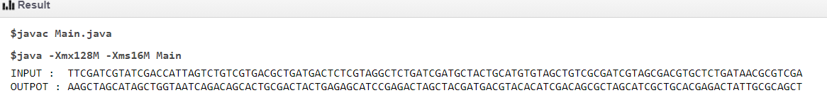

**Program 8: Count repeats in a DNA sequence**

* **Take a DNA sequence**
* **Get input of the repeat string has to be searched. Eg. aat, cagc etc…**
* **Print DNA sequence, repeat sequence and the no. of time repeats has been made**

public class DNA_frequency {

public static void main(String[] args) {

String dna="CAcagcTAACtcCGATCGAACtcTCGGCAACtcgCgtgAACtcacTACgAACtcttcagccatcgtctatGCAACtcTATGgTCGGtcagcATcagGGGCCCAAAtttaacCGcagcgtgtacagcgtgtacagctataccagc";

String DNA = dna.toUpperCase();

//search the dna repeat

String r1,r2;

r1= "AACtc";

r2= "cagc";

String R1= r1.toUpperCase();

String R2= r2.toUpperCase();

float R1_count=0,R2_count=0;

for (int i=0;i<DNA.length();i++)

if (R1.indexOf( DNA.charAt(i) ) >= 0){

R1_count++;

}

else if (R2.indexOf( DNA.charAt(i) ) >= 0){

R2_count++;

}

System.out.println("INPUT DNA : "+DNA);

System.out.println("DNA Repeats : "+R1+", "+R2);

System.out.println(r1+" is repeated "+R1_count+" times");

System.out.println(r2+" is repeated "+R2_count+" times");

}

}

**Output**

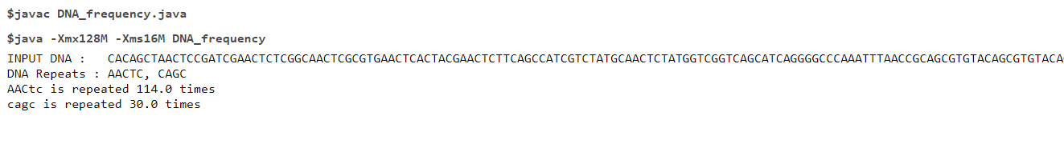

**Program 9: Count no of Gaps DNA sequence**

* **Take a DNA sequence**
* **Count gaps like “ ” or “-”.**
* **Print DNA sequence, print the no of gap, both in numbers and percentage.**

public class MyClass {

public static void main(String args[]) {

String dna = "CGATGCA TGCGATGC_ACGGAT GCTATGCCGT_GACTGCA_GACTGACT_GTAGCTAGTA_ CAGATCG GACGACT ACG_ACGT_GCCC_AT_GCA_GACTGC_GTACGCA_GCAGT GATGCAT_A";

int len = dna.length();

float count=0;

for(int i=0;i<len;i++){

if(dna.charAt(i)==' '|| dna.charAt(i)=='_')

{

count++;

}

}

System.out.println("INPUT DNA : "+dna);

System.out.println("\n");

System.out.println("The number of gaps is "+count);

System.out.println("\n");

System.out.println("The percent of gaps is "+(count/len)*100);

}

}

**OUTPUT**

