RTC INSTITUTE OF TECHNOLOGY
Anandi, Ormanjhi, Ranchi – 835219, Jharkhand
Department of Computer Science & Engineering
───────────────────────────────────────────────────────────────────────────

Assignment No. | 01
Course Name | Data Analysis using Open-Source Tools
Submitted To | Mr. Basudev Mahata, Dept. CSE, RTCIT Ranchi
Name of Student | Bablu Kumar
University Roll No. | 23052440012
College Roll No. | 23011036
Session | 2025-26
Semester | 6th
Batch | 2023-27
Date of Submission | 25/06/26

Assignment 1 — Statistics, Probability & Python Foundations

TASK 1 — Descriptive Statistics, Probability & Combinatorics

Question 1.1 — Descriptive Statistics
Given Marks: 72, 85, 90, 65, 78, 92, 68, 75, 88, 80
n = 10 observations

1. MEAN
Formula:
x_bar = (Sum of all values) / n
Substitution:
x_bar = (72 + 85 + 90 + 65 + 78 + 92 + 68 + 75 + 88 + 80) / 10
Intermediate Calculation:
x_bar = 793 / 10
✅ Final Answer: Mean = 79.3
Explanation: The mean is the arithmetic average. Sum = 793, divided by 10 gives 79.3. The average student scored 79.3 marks.
───────────────────────────────────────────────────────────────────────────
2. MEDIAN
Formula: For n even: Median = (x(n/2) + x(n/2+1)) / 2
Step 1 — Sort in ascending order:
65, 68, 72, 75, 78, 80, 85, 88, 90, 92
Step 2 — n = 10 (even), 5th value = 78, 6th value = 80:
Median = (78 + 80) / 2 = 158 / 2
✅ Final Answer: Median = 79.0
Explanation: The median divides the dataset in half. 50% scored below 79 and 50% scored above 79.
───────────────────────────────────────────────────────────────────────────
3. MODE
Definition: Value appearing most frequently.
Frequency count of each value: All values appear exactly once (frequency = 1).
✅ Final Answer: No Mode exists — all values are unique.
Explanation: Since every mark appears only once, there is no mode. This is a uniform frequency distribution.
───────────────────────────────────────────────────────────────────────────
4. RANGE
Formula:
Range = Maximum - Minimum
Substitution:
Range = 92 - 65
✅ Final Answer: Range = 27
Explanation: The range measures total spread. The 27-mark difference shows moderate variability in the data.
───────────────────────────────────────────────────────────────────────────
5. SAMPLE VARIANCE (n-1)
Formula:
s^2 = Sum[(xi - x_bar)^2] / (n-1)
Given: x_bar = 79.3, n = 10
Step 1 — Calculate each (xi - x_bar)^2:
xi | xi - x_bar | (xi - x_bar)^2
72 | 72-79.3 = -7.3 | 53.29
85 | 85-79.3 = +5.7 | 32.49
90 | 90-79.3 = +10.7 | 114.49
65 | 65-79.3 = -14.3 | 204.49
78 | 78-79.3 = -1.3 | 1.69
92 | 92-79.3 = +12.7 | 161.29
68 | 68-79.3 = -11.3 | 127.69
75 | 75-79.3 = -4.3 | 18.49
88 | 88-79.3 = +8.7 | 75.69
80 | 80-79.3 = +0.7 | 0.49
SUM |  | 790.10

Step 2:
Sum[(xi - x_bar)^2] = 790.10
Step 3:
s^2 = 790.10 / 9 = 87.79
✅ Final Answer: Sample Variance = 87.79
Note: NumPy returns 87.79 (exact: 87.7889) using precise floating-point arithmetic.
Explanation: Bessel's correction (n-1) provides an unbiased estimate of population variance. Higher variance = more spread.
───────────────────────────────────────────────────────────────────────────
6. SAMPLE STANDARD DEVIATION (n-1)
Formula:
s = sqrt(s^2) = sqrt(87.79)
s = 9.37
✅ Final Answer: Sample Standard Deviation = 9.37 (NumPy exact: 9.3696)
Explanation: SD measures average deviation from mean. Students' marks deviate on average ~9.37 marks from 79.3.

Question 1.2 — Probability
Q1 — Fair Coin Tossed Three Times: P(Exactly 2 Heads)
Formula (Binomial):
P(X=k) = C(n,k) * p^k * (1-p)^(n-k)
Given: n=3, k=2, p=0.5
Step 1 — Sample Space (2^3 = 8 outcomes):
S = {HHH, HHT, HTH, HTT, THH, THT, TTH, TTT}
Step 2 — Favourable outcomes (exactly 2 heads):
E = {HHT, HTH, THH} => n(E) = 3
Step 3 — Apply formula:
P(X=2) = C(3,2) * (0.5)^2 * (0.5)^1 = 3 * 0.25 * 0.5 = 3 * 0.125
✅ Final Answer: P(Exactly 2 Heads) = 3/8 = 0.375 = 37.5%
Explanation: 3 of 8 equally likely outcomes have exactly 2 heads. Probability = 3/8 = 37.5%.
───────────────────────────────────────────────────────────────────────────
Q2 — Balls in a Bag
Given: Red=5, Blue=4, Green=3 => Total=12 balls
Formula: P(E) = n(E) / n(S)

Part (a) — P(Red):
P(Red) = 5/12 = 0.4167
✅ Final Answer: P(Red) = 5/12 ≈ 0.4167 = 41.67%

Part (b) — P(Not Green):
P(Green) = 3/12 = 1/4
P(Not Green) = 1 - 3/12 = 9/12 = 3/4
✅ Final Answer: P(Not Green) = 3/4 = 0.75 = 75%
Explanation: Complement rule: P(not A) = 1 - P(A). Non-green = 9 balls. P = 9/12 = 75%.
───────────────────────────────────────────────────────────────────────────
Q3 — Two Dice Rolled: P(Sum > 8)
Total sample space: n(S) = 6 x 6 = 36 outcomes
Favourable outcomes (sum = 9, 10, 11, 12):
Sum | Favourable Outcomes | Count
9 | (3,6),(4,5),(5,4),(6,3) | 4
10 | (4,6),(5,5),(6,4) | 3
11 | (5,6),(6,5) | 2
12 | (6,6) | 1
TOTAL |  | 10

P(Sum > 8) = 10/36 = 5/18 ≈ 0.2778
✅ Final Answer: P(Sum > 8) = 10/36 = 5/18 ≈ 0.2778 = 27.78%
Explanation: 10 of 36 equally likely outcomes have sum > 8. Probability ≈ 27.78%.

Question 1.3 — Permutation & Combination
Problem 1 — Arrange letters of MACHINE (all vowels together)
Word: M-A-C-H-I-N-E | Total letters = 7 (all distinct)
Step 1 — Identify vowels: A, I, E (3 vowels) | Consonants: M, C, H, N (4)
Step 2 — Treat vowels [AIE] as ONE block => 5 units: {[AIE], M, C, H, N}
Step 3 — Arrange 5 units:
5! = 5 x 4 x 3 x 2 x 1 = 120 ways
Step 4 — Arrange 3 vowels within the block:
3! = 3 x 2 x 1 = 6 ways
Step 5 — Total (Multiplication Principle):
Total = 5! x 3! = 120 x 6 = 720
✅ Final Answer: Total arrangements = 720
Explanation: 5! = 120 ways to arrange the 5 units. 3! = 6 internal vowel arrangements. Total = 720.
───────────────────────────────────────────────────────────────────────────
Problem 2 — Committee of 4: Exactly 2 Men from 6, Exactly 2 Women from 5
Formula: C(n,r) = n! / (r! * (n-r)!)
Step 1 — Choose 2 men from 6:
C(6,2) = 6! / (2! x 4!) = (6 x 5) / (2 x 1) = 30/2 = 15
Step 2 — Choose 2 women from 5:
C(5,2) = 5! / (2! x 3!) = (5 x 4) / (2 x 1) = 20/2 = 10
Step 3 — Multiply (independent selections):
Total = C(6,2) x C(5,2) = 15 x 10 = 150
✅ Final Answer: Total number of committees = 150
Explanation: 15 ways to pick 2 men, 10 ways to pick 2 women. By multiplication rule: 15 x 10 = 150.

Question 1.4 — Binomial Distribution
Given: Biased coin P(Head)=0.6, P(Tail)=0.4, n=5 tosses
Formula: P(X=k) = C(n,k) x p^k x (1-p)^(n-k)
───────────────────────────────────────────────────────────────────────────
Part (a) — P(Exactly 3 Heads) = P(X=3)
n=5, k=3, p=0.6, (1-p)=0.4
Step 1:
C(5,3) = 5! / (3! x 2!) = (5 x 4) / (2 x 1) = 10
Step 2:
(0.6)^3 = 0.6 x 0.6 x 0.6 = 0.216
Step 3:
(0.4)^2 = 0.4 x 0.4 = 0.16
Step 4:
P(X=3) = 10 x 0.216 x 0.16 = 10 x 0.03456
✅ Final Answer: P(X=3) = 0.3456 = 34.56%
Explanation: C(5,3)=10 counts all orderings of 3H in 5 tosses. Combined probability = 34.56%.
───────────────────────────────────────────────────────────────────────────
Part (b) — P(At Least 4 Heads) = P(X>=4) = P(X=4) + P(X=5)
Calculate P(X=4):
C(5,4) = 5, (0.6)^4 = 0.1296, (0.4)^1 = 0.4
P(X=4) = 5 x 0.1296 x 0.4 = 5 x 0.05184 = 0.2592
Calculate P(X=5):
C(5,5) = 1, (0.6)^5 = 0.07776, (0.4)^0 = 1
P(X=5) = 1 x 0.07776 x 1 = 0.07776
Final Calculation:
P(X>=4) = P(X=4) + P(X=5) = 0.2592 + 0.07776 = 0.33696
✅ Final Answer: P(X>=4) = 0.3370 = 33.70%
Explanation: Sum the probabilities for 4 and 5 heads. Since p=0.6>0.5, higher heads are common: 33.70%.

TASK 2 — Python, NumPy & Pandas
All code is contained in: Student_Performance_Assignment1.ipynb
Below shows the code and expected outputs for each section.

Task 2.1 — NumPy Statistical Verification
import numpy as np
marks = np.array([72, 85, 90, 65, 78, 92, 68, 75, 88, 80])
print(f"Mean : {np.mean(marks):.4f}")
print(f"Median : {np.median(marks):.4f}")
print(f"Range : {int(np.max(marks)-np.min(marks))}")
print(f"Variance : {np.var(marks, ddof=1):.4f}")
print(f"Std Dev : {np.std(marks, ddof=1):.4f}")
Expected Output:
Mean : 79.3000
Median : 79.0000
Range : 27
Variance : 87.7889 (sample, ddof=1)
Std Dev : 9.3696 (sample, ddof=1)
───────────────────────────────────────────────────────────────────────────
Task 2.2 — Average Salary by Department (groupby)
groupby() Result:
Department | Average Salary (Rs.)
Finance | 78,500.00
IT | 61,250.00
Sales | 50,000.00
HR | 45,000.00

Employees with Experience > 5: Diya, Gaurav, Ishan, Jiya (4 employees)
Top 3 Salaries: Gaurav (Rs.85,000), Jiya (Rs.78,000), Diya (Rs.72,000)

TASK 3 — Hypothesis Testing
Working Hours: 7.5, 8.2, 7.8, 9.0, 8.5, 7.2, 8.8, 9.1, 7.4, 8.0
Company Claim: Average = 8 hours | Significance Level: alpha = 0.05

Task 3.1 — One-Sample t-Test
H0: mu = 8 (Null: Mean working hours = 8)
H1: mu != 8 (Alternative: Mean is not 8, Two-tailed)

Step | Calculation | Result
Sample Mean | x_bar = (7.5+8.2+7.8+9.0+8.5+7.2+8.8+9.1+7.4+8.0)/10 = 81.5/10 | x_bar = 8.15
Sample SD | s = sqrt(4.2050/9) = sqrt(0.4672) | s = 0.6835
Degrees of Freedom | df = n - 1 = 10 - 1 | df = 9
t-Statistic | t = (8.15 - 8.0) / (0.6835/sqrt(10)) = 0.15 / 0.2161 | t = 0.6941
t-Critical | t(0.025, 9) from t-table [two-tailed, alpha=0.05] | t_crit = +/-2.262
p-Value | Computed using SciPy: stats.ttest_1samp() | p = 0.5052
Decision | |t_calc|=0.6941 < t_crit=2.262 | FAIL TO REJECT H0

CONCLUSION: At alpha=0.05, there is insufficient evidence to reject H0. The company's claim that average working hours = 8 is statistically supported. The t-statistic (0.6941) lies well within the acceptance region (-2.262 to +2.262).
───────────────────────────────────────────────────────────────────────────

Task 3.2 — 95% Confidence Interval
Formula: CI = x_bar +/- t(alpha/2, df) * (s/sqrt(n))
Given: x_bar=8.15, s=0.6835, n=10, t_crit=2.262

Margin of Error = 2.262 x (0.6835/sqrt(10)) = 2.262 x 0.2161 = 0.4888
Lower Limit (LL) = 8.15 - 0.4888 = 7.6612
Upper Limit (UL) = 8.15 + 0.4888 = 8.6388
✅ Final Answer: 95% Confidence Interval = (7.66, 8.64) hours
Interpretation: We are 95% confident the true mean lies between 7.66 and 8.64 hours. Since mu_0=8 is inside this interval, it is consistent with failing to reject H0.
───────────────────────────────────────────────────────────────────────────

Task 3.3 — Matplotlib Visualizations
Three professional charts were generated and saved:
File | Chart Type | Description
bar_chart.png | Bar Chart | Department vs Average Salary — shows Finance dept has highest avg salary (Rs.78,500)
scatter_plot.png | Scatter Plot | Experience vs Salary — positive correlation visible with trend line
histogram.png | Histogram | Age Distribution — employees distributed from 26-40, mean age = 31.8 yrs

bar_chart.png
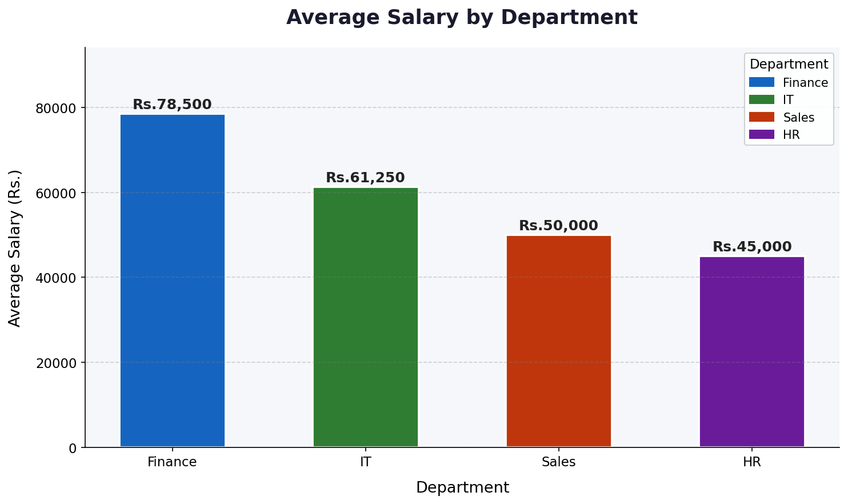

scatter_plot.png
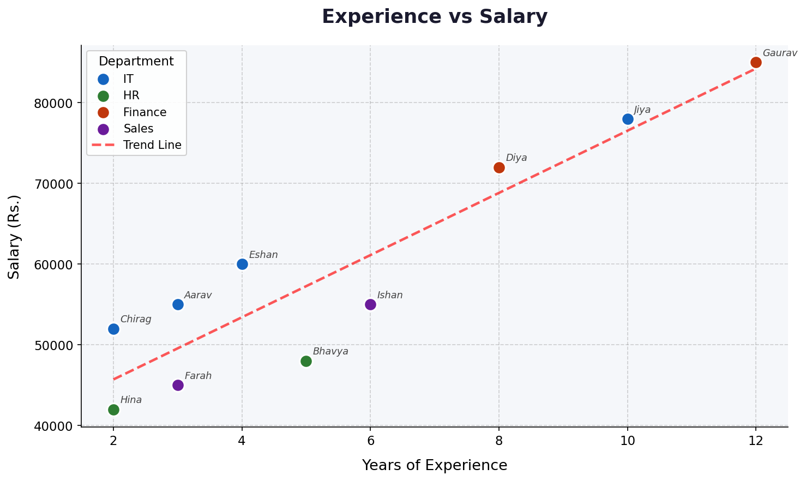

histogram.png
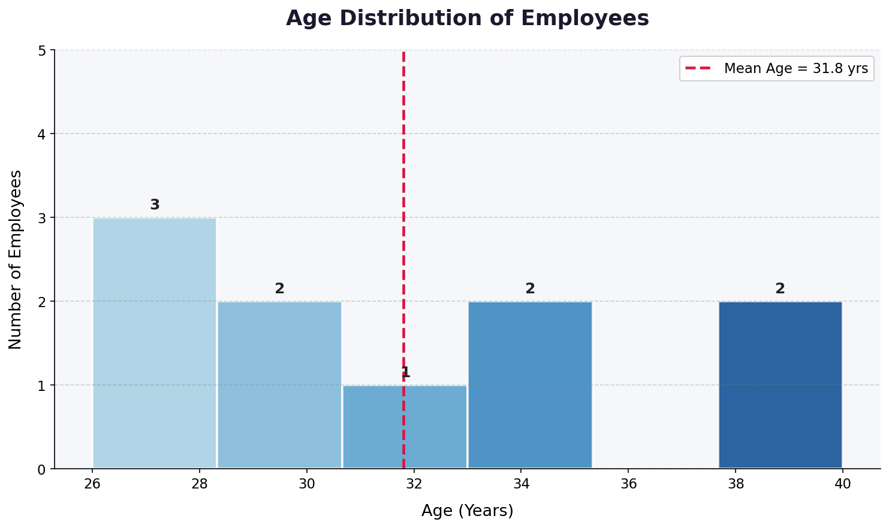

Assignment 1 — Complete Summary
Task | Topic | Key Result | Status
1.1 | Descriptive Statistics | Mean=79.3, Median=79, SD=9.37 | Done
1.2 Q1 | Coin Toss | P(2 Heads)=3/8=0.375 | Done
1.2 Q2 | Balls in Bag | P(Red)=5/12, P(Not Green)=3/4 | Done
1.2 Q3 | Two Dice | P(Sum>8)=5/18=0.2778 | Done
1.3 P1 | MACHINE Vowels | 720 arrangements | Done
1.3 P2 | Committee | C(6,2)xC(5,2)=150 | Done
1.4 (a) | Binomial P(X=3) | 0.3456 (34.56%) | Done
1.4 (b) | Binomial P(X>=4) | 0.3370 (33.70%) | Done
2.1 | NumPy Stats | All verified | Done
2.2 | Pandas Ops | 8 operations completed | Done
3.1 | Hypothesis Test | Fail to Reject H0 | Done
3.2 | Confidence Interval | (7.66, 8.64) hours | Done
3.3 | Matplotlib Charts | 3 charts saved as PNG | Done

Student: Bablu Kumar | Roll No.: 23052440012 | Date: 25/06/26

