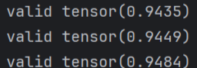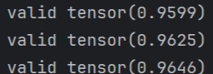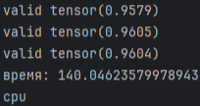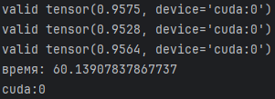

Epochs: 100

Adam:

Seed 0: tensor(0.9564, device='cuda:0')

Seed 1: tensor(0.9557, device='cuda:0')

Seed 2: tensor(0.9587, device='cuda:0')

SGD:

Seed 0: tensor(0.9366, device='cuda:0')

Seed 1: tensor(0.9355, device='cuda:0')

Seed 2: tensor(0.9358, device='cuda:0')