Methods

We fitted a generalized linear mixed regression model to the binary preening data (with leaves vs. without leaves) to test for effects of season (non breeding vs. breeding season), sex (male vs. other), wetness of leaves (dry vs. wet), and time of the day on the probability of preening with vs. without leaves. Season, sex, and wetness of leaves were included as binary categorical predictors and time was treated as a numerical predictor (hour of the day at the preening event, ranging from 6am to 11am). To account for the fact that the observed preening events varied substantially between observation points, we included point ID, ranging from 1 to 30, as a random factor (random intercept) in our model. Statistical significance of coefficients was assessed using likelihood ratio tests.

For a number of variables we had no clear apriori hypotheses, including the species of the birds, the weather variables (rain, sun), and temperature. Therefore, we did not conduct hypothesis tests for these variables and they were not included in the model. Instead, we explored their effects by visualizing their associations with preening.

The statistical analysis was conducted in R. Packages janitor (Firke 2020), tidyverse (Wickham et al. 2019) and patchwork (Lin Pedersen 2020) were used for data cleaning, analysis and plotting. Package lme4 (Bates et al. 2015) was used to fit the model.

Results

The generalized linear mixed model fit showed that effects of season (p< 1e-9 ) and daytime (p<1e-9 ) were statistically significant. The effects of wetness of leaves (p=0.08) and sex (p=0.38) were not statistically significant, but including wetness of leaves improved the model fit (in terms of log-likelihood and deviance).

Preening with leaves occurred predominantly in the non-breeding season and peaked in the early morning hours in all four observed species (Fig. 1A, 1B). Preening without leaves was more evenly distributed across the morning and occurred mainly in the breeding season (Fig. 1B). Both sexes showed the behavior of preening with leaves with similar frequency, which was also confirmed by the mixed model. There were species differences in the preening patterns between the seasons (Fig. 1A). For example, medium ground finches preened predominantly in the non-breeding season and almost exclusively with leaves, whereas warbler finches preened mainly without leaves in the breeding season.

The behaviour of preening with leaves co-occurred with the presence of wet leaves in the non-breeding season and both variables showed the same decreasing daily trend (Fig. 3). Rain was omnipresent in the non-breeding season, which led to frequent wet vegetation (correlation between rain and wet leaves was r=0.77, correlation between season and rain was r=0.70).

The average temperature was cooler in the non-breeding season than in the breeding season (15.4°C vs. 20.8°C), and preening with leaves therefore occurred at cooler mean temperatures.

Sun? Something else missing?

A.
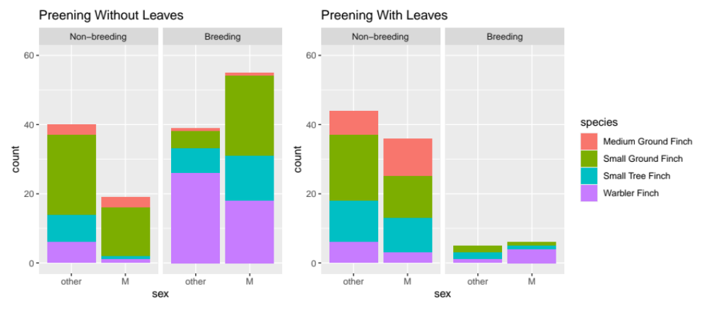
B.
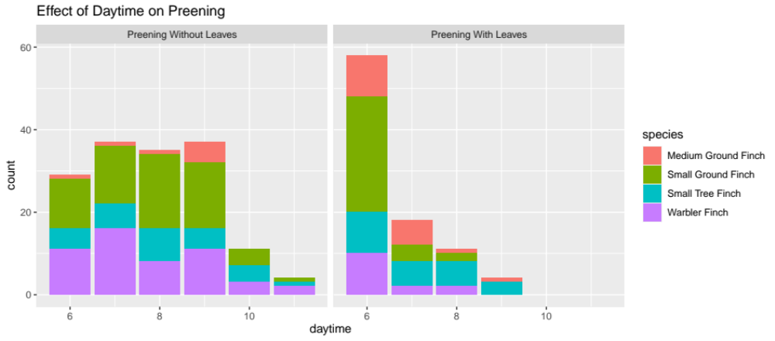

Fig. 1: Preening without vs. with leaves, plotted against season and sex (A.) as well as daytime (B.) for the four observed species.

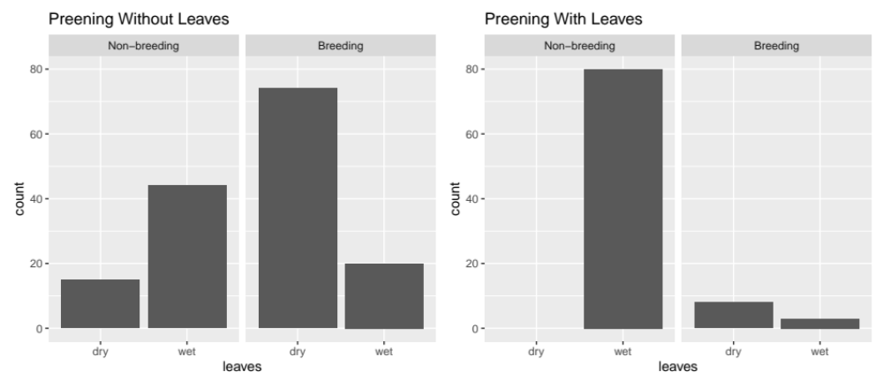
Fig. 2: Preening events with and without leaves, separately for breeding and non-breeding seasons, when leaves were dry vs. wet.

A.
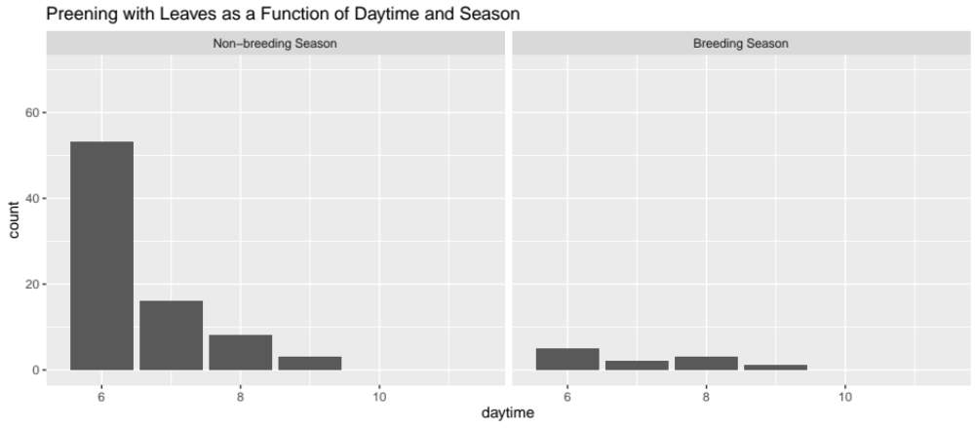
B.
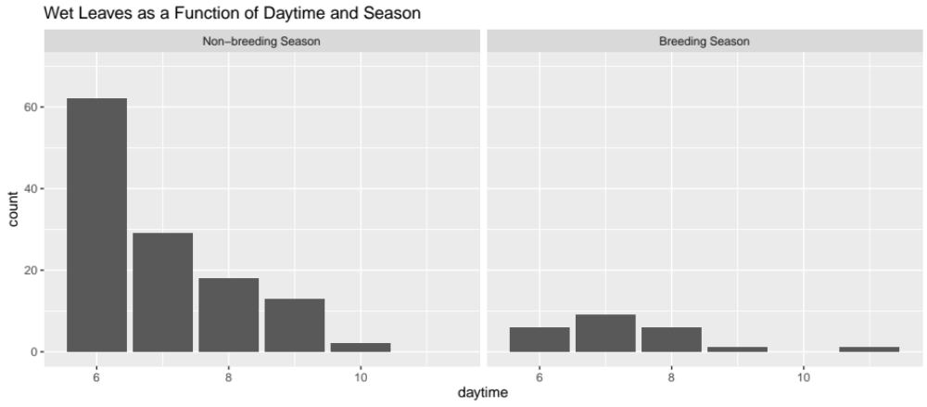
Fig. 3: Preening with leaves (A.) and wet leaves (B.) plotted against daytime, separately for the breeding and non-breeding seasons. In the non-breeding season, these two variables show the same daily trend.

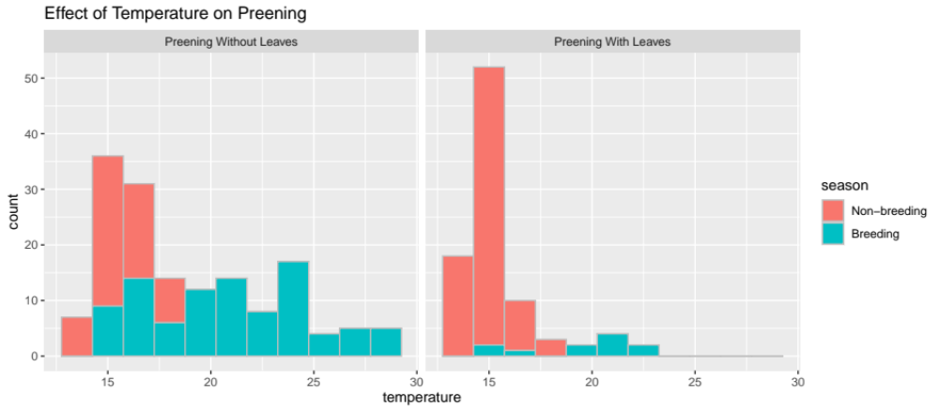
Fig. 4: Temperature for preening events without vs. with leaves, for breeding and non-breeding season.

References

Wickham et al., (2019). Welcome to the Tidyverse. Journal of Open Source Software, 4(43), 1686, https://doi.org/10.21105/joss.01686

Thomas Lin Pedersen (2020). patchwork: The Composer of Plots. R package version 1.0.1.
https://CRAN.R-project.org/package=patchwork

Sam Firke (2020). janitor: Simple Tools for Examining and Cleaning Dirty Data. R package version
2.0.1. https://CRAN.R-project.org/package=janitor

Douglas Bates, Martin Maechler, Ben Bolker, Steve Walker (2015). Fitting Linear Mixed-Effects Models
Using lme4. Journal of Statistical Software, 67(1), 1-48. doi:10.18637/jss.v067.i01.

