Methods

We fitted a generalized linear mixed regression model to the binary preening data (with leaves vs. without leaves) to test for effects of season (non breeding vs. breeding season), sex (male vs. other), wetness of leaves (dry vs. wet), and time of the day. Season, sex, and wetness of leaves were included as binary categorical predictors and time was treated as a numerical predictor (hour of the day at the preening event, ranging from 6am to 11am). To account for the fact that the observed preening events varied substantially between observation points, we included point ID, ranging from 1 to 30, as a random factor (random intercept) in our model. Statistical significance of coefficients was assessed using likelihood ratio tests.

For a number of variables we had no clear apriori hypotheses, including the species of the birds, the weather variables (rain, sun), and temperature. We did not conduct hypothesis tests for these variables and did not include them in the regression model, but we explored their effects by visualizing their associations with preening.

The statistical analysis was conducted in R. Packages janitor (Firke 2020), tidyverse (Wickham et al. 2019) and patchwork (Lin Pedersen 2020) were used for data cleaning, analysis and plotting. Package lme4 (Bates et al. 2015) was used to fit the model. Data and code are available on github (https://github.com/babsifisch/preeningfinches).
[Sabine, you have to say if you want to share the data and code, but I am all for open science. ☺]

Results

Preening with leaves occurred predominantly in the non-breeding season and peaked in the early morning hours in all four observed species (Fig. 1A, 1B). Preening without leaves was more evenly distributed across the morning and occurred mainly in the breeding season (Fig. 1B). The effects of season and daytime on the probability of preening with leaves were statistically significant (p<0.001 for both). Effect size estimates derived from the model for season and daytime were similar with and without inclusion of sex and wetness of leaves as predictors. The estimated probabilities of preening with leaves in the breeding vs. non-breeding season were 0.36 and 0.85 at 6am in the morning. At 10am, they were 0.01 and 0.09, respectively.

Both sexes showed the behavior of preening with leaves with similar frequency (effect of sex was not statistically significant in the model, p=0.16).

There were species differences in the preening patterns between the seasons (Fig. 1A). For example, medium ground finches preened predominantly in the non-breeding season and almost exclusively with leaves, whereas warbler finches preened mainly without leaves in the breeding season.

The behavior of preening with leaves co-occurred with the presence of wet leaves in the non-breeding season and both variables showed the same decreasing daily trend (Fig. 3) However, the effect of wetness of leaves was not statistically significant in the model (p=0.10). Rain was omnipresent in the non-breeding season, which led to frequent wet vegetation (correlation between rain and presence of wet leaves was r=0.77, correlation between season and rain was r=0.70).

The average temperature was 15.4°C (STD=1.12) in the non breeding season and 20.8°C (STD=3.82) in the breeding season. As preening with leaves occurred predominantly in the non-breeding season, it also occurred at cooler temperatures, on average.

A.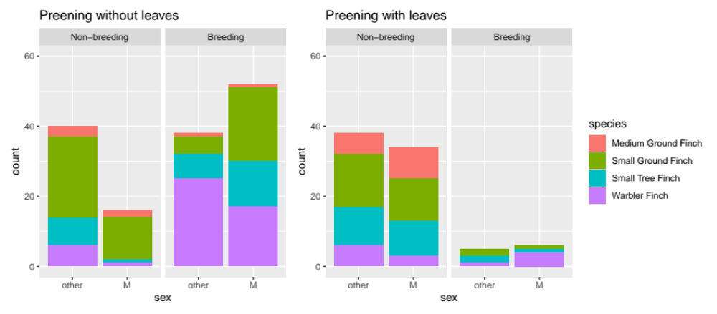
B.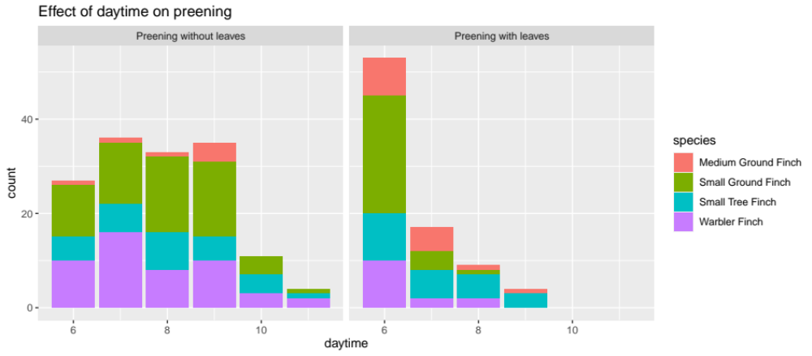
Fig. 1: Preenin events without vs. with leaves, plotted against season and sex (A.) and daytime (B.) for the four observed species.
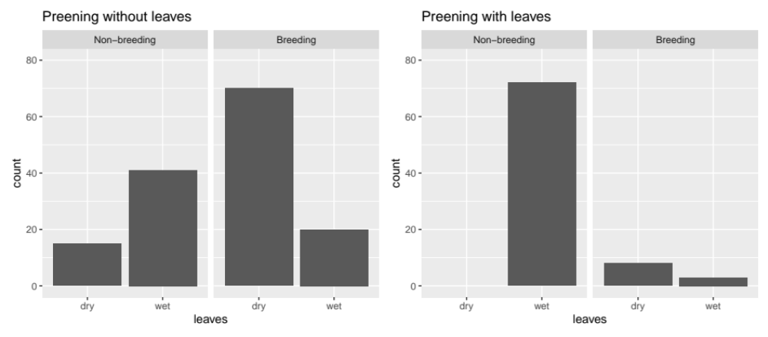

Fig. 2: Preening events with and without leaves, separately for breeding and non-breeding seasons, when leaves were dry vs. wet.

A.
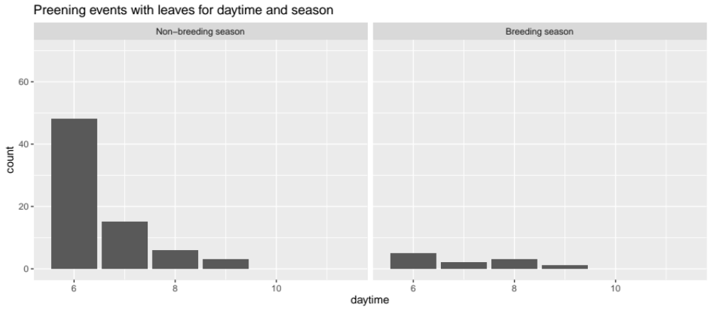
B.
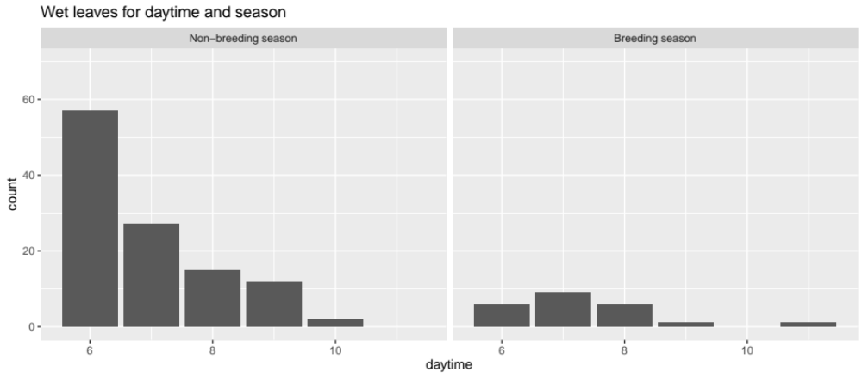
Fig. 3: Numbers of obervations of preening with leaves (A.) and observations of wet leaves (B.) plotted against daytime, separately for the breeding and non-breeding seasons. In the non-breeding season, these two variables show the same daily trend.

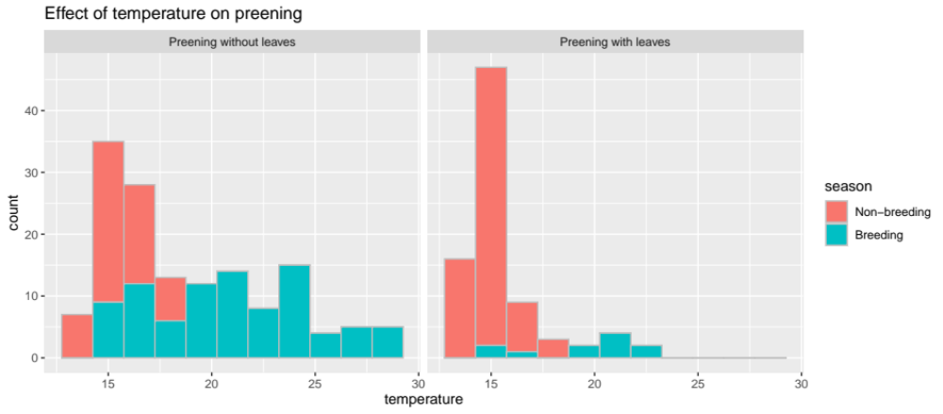
Fig. 4: Temperature distributions for preening events without vs. with leaves, color-coded for the fractions of breeding and non-breeding season.

References

Wickham et al., (2019). Welcome to the Tidyverse. Journal of Open Source Software, 4(43), 1686, https://doi.org/10.21105/joss.01686

Thomas Lin Pedersen (2020). patchwork: The Composer of Plots. R package version 1.0.1.
https://CRAN.R-project.org/package=patchwork

Sam Firke (2020). janitor: Simple Tools for Examining and Cleaning Dirty Data. R package version
2.0.1. https://CRAN.R-project.org/package=janitor

Douglas Bates, Martin Maechler, Ben Bolker, Steve Walker (2015). Fitting Linear Mixed-Effects Models
Using lme4. Journal of Statistical Software, 67(1), 1-48. doi:10.18637/jss.v067.i01.

