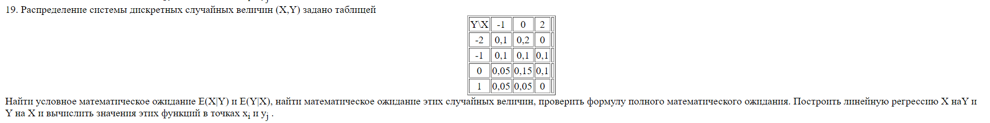

|  |  |  |  |  |
| --- | --- | --- | --- | --- |
| Y\X | -1 | 0 | 2 |  |
| -2 | 0.1 | 0.2 | 0 | 0.3 |
| -1 | 0.1 | 0.1 | 0.1 | 0.3 |
| 0 | 0.05 | 0.15 | 0.1 | 0.3 |
| 1 | 0.05 | 0.05 | 0 | 0.1 |
|  | 0.3 | 0.5 | 0.2 |  |

|  |  |  |  |
| --- | --- | --- | --- |
|  | -1 | 0 | 2 |
| $$p_{i}$$ | 0.3 | 0.5 | 0.2 |

|  |  |  |  |  |
| --- | --- | --- | --- | --- |
|  | -2 | -1 | 0 | 1 |
| $$p_{i}$$ | 0.3 | 0.3 | 0.3 | 0.1 |

|  |  |  |  |  |
| --- | --- | --- | --- | --- |
| Y | -2 | -1 | 0 | 1 |
| $$P\left(y\right)x=-1$$ | 2/6 | 2/6 | 1/6 | 1/6 |
| $$P\left(y\right)x=0$$ | 4/10 | 2/10 | 3/10 | 1/10 |
| $$P\left(y\right)x=2$$ | 0 | 1/2 | 1/2 | 0 |

1. Пусть

|  |  |  |  |
| --- | --- | --- | --- |
|  | -5/6 | -9/10 | -1/2 |
| $$p_{i}$$ | 0.3 | 0.5 | 0.2 |

$$E\left(E\left(y | x\right)\right)=- 0.8= EY$$

Значит формула верная.

$P(x):$

|  |  |  |  |
| --- | --- | --- | --- |
| X | -1 | 0 | 2 |
| $$P\left(x\right)y=-2$$ | 1/3 | 2/3 | 0 |
| $$P\left(x\right)y=-1$$ | 1/3 | 1/3 | 1/3 |
| $$P\left(x\right)y=0$$ | 1/6 | 1/2 | 1/3 |
| $$P\left(x\right)y=1$$ | 1/2 | 1/2 | 0 |

|  |  |  |  |  |
| --- | --- | --- | --- | --- |
|  | -1/3 | 1/3 | 1/2 | -1/2 |
| $$p_{i}$$ | 0.3 | 0.3 | 0.3 | 0.1 |

$EX=\left(E\left(y | x\right)\right)=0.1$

Значит формула верная.

1. Линейная регрессия: $y=g\left(x\right)=ax+b$

$$EX^{2}=1.1$$

$$DX= EX^{2}-(E{X)}^{2}=1.09$$

$$EY^{2}=1.6$$

$$DY= EY^{2}-(E{Y)}^{2}=0.96$$

$$E\left(X,Y\right)=0.05$$

$$k\left(X,Y\right)=E\left(X,Y\right)-E\left(X\right)*E\left(Y\right)=0.05+0.08=0.13$$

$$a=\frac{k\left(X,Y\right)}{DX}=\frac{0.13}{1.09}=0.1193$$