

**AUTOMATED EXTERNAL DEFIBRILLATOR-PHASE 1**

**PROJECT DOCUMENTATION(HARDWARE)**

**PROJECT SCOPE:**

This project is used to develop an “**AUTOMATED EXTERNAL DEFIBRILLATOR**” which

automatically delivers the electric shock to the person who is suffering from abnormalities in heart

beat rhythm by analyzing his/her ECG signal waveform .This project focuses on analyzing six kinds

of abnormalities which are more prone to occur and delivers a electric shock to restore the

malfunctioning of heart thus saving the life of the patient. The main scope of the project is this

device can be handled by any layman as the instructions are provided to him in languages like Hindi

and English. This project also measures the body impedance of the patient and controls the

magnitude of the joules which can be delivered to the patient.

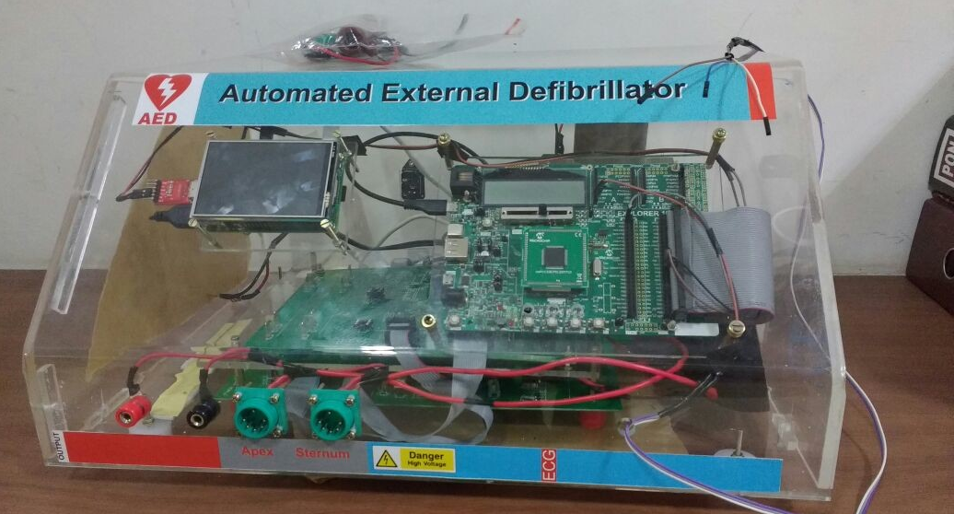

**BLOCK DIAGRAM:**

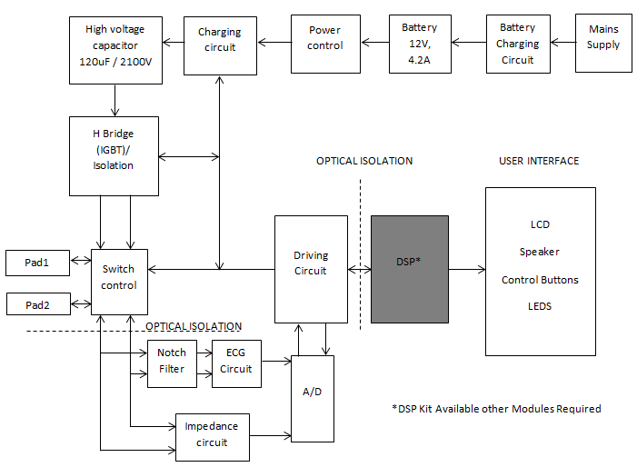

**HARDWARE SCOPE:**

The hardware scope of this project is to develop the following circuits

* High voltage capacitor charger circuit section.
* Discharging circuit section (H-bridge),
* Feedback and Electrode isolation section.
* Impedance measuring section.
* Micro controller section.
* ECG data Acquisition section.
* Graphical Display unit interfacing.

**SOFTWARE SCOPE:**

* Embedded C Firmware development for ECG signal interfacing
* Graphical Display unit interfacing using python.
* Joule selection unit.
* Feedback unit interfacing.
* Audio unit interfacing.

**WORKING PROCEDURE:**

**1. Manual mode:**

To deliver 50J/150J of energy to patient manually

**Procedure:**

1. Switch ON the **AED** unit.

2. Connect **ECG/Electrode** pad to the patient.

3. Click “**MENU”** option,

4. In that, Click “**MANUAL** “option,

5. For 50J/150J shock delivery, click “**CHILD**” or “**ADULT**” options,

6. For No Shock operation, click “**BACK TO HOME**” option.

7. For “**CHILD**” option, the capacitor will charge for **50 J** of energy,

8. After, click “**SHOCK**” option,

9. The **50J** of **Biphasic** Shock delivered to the Patient.

10. For “**ADULT**” option, the capacitor will charge for **150J** of energy,

11. After, click “**SHOCK**” option,

12. The **150J** of **Biphasic** Shock delivered to the Patient.

13. After delivering Shock, the **AED** display unit will go to homepage.

**2. AUTOMATIC mode:**

In AED mode, the Micro controller automatically sense ECG Waveform and Rhythms and sense whether the patient required shock/no shock through algorithms and impedance will also measure to provide required amount of joules and (**BIPHASIC Shock**)delivered to the patient automatically.

**Procedure:**

1. Switch ON the **AED** unit.

2. Connect **ECG/Electrod**e pad to the patient.

3. Click “**AED**” option,

4. In that, Click **“S6”** to **“CONTINUE”** or “**S3”** to “**GO BACK**” options,

5. Click “**S6”** and then click **“CHILD”** or “**ADULT”** options,

6. Click **“CHILD”** option, the Micro controller automatically sense **ECG** Waveform and Rhythms,

7. Then, **ECG** signal Acquisition is under process and it displays **Shock able** or **Non-Shock able**,

8. For **Non-Shock able** Rhythms, the **AED** display unit will go to homepage.

9. For **Shock able** Rhythms, the Micro controller will audio the messages and it automatically charges the capacitor to **50 J** and deliver **Biphasic** shock to the patient.

10. After delivering the shock, the **AED** display unit will go to homepage,

11. Click **“ADULT”** option, the Micro -controller automatically sense **ECG** Waveform and Rhythms,

12. Then, **ECG** signal Acquisition is under process and it displays **Shock able** or **Non-Shock able,**

13. For **Non-Shock able** Rhythms, the **AED** display unit will go to homepage.

14. For **Shock able** Rhythms, the Micro-controller will audio the messages and it automatically charges the capacitor to **150 J** and deliver **Biphasic** shock to the patient.

15. After delivering the shock, the **AED** display unit will go to homepage,

`

**HARDWARE SPECIFICATIONS:**

1. **Non-Rechargeable Battery**  = 12V/ 4.5AH

2. **Capacitor**  = 205uF/2200V DC

3. **Fly back Transformer**

* Primary Inductance = 12uH
* Primary Current = 9.259 A
* Primary Voltage = 12 V
* Primary Turns = 2
* Secondary Inductance = 11mH
* Secondary Current = 0.3 A
* Secondary Voltage = 500 V
* Secondary Turns = 85
* Charging time = 10 sec
* Switching Frequency = 100KHZ
* Max. Duty cycle = 0.45
* Circuit = Discontinuous Fly back mode
* Efficiency = 80%
* Type = EE35 / ETD39

4. **Fly back Converter**

* PWM generation = TL494
* MOSFET = IRF 540
* Gate Driver = IR2110
* Diode = BY255
* Capacitor = 0.01uF/2KV/BOX

5. **Internal Discharge Section**

* Type = HV Reed Relay
* Form = SPST
* Excitation = 12 V through soft switch
* MOSFET = IRF 540

6. **H-Bridge Section**

* Gate Driver = TLP250
* MOSFET = IXBH16N170A
* Isolated Power supply = PE01S1215A

7. **Interfacing Section**

* P40 -> ON_ pin -> To control ON/OFF Relay
* P66 -> CONTROL _ pin -> To control Voltage /Feedback
* P68 -> HV_ON pin -> To control Internal Discharge
* P41 & P43 -> PWM pins -> To control H-bridge section

8. **Micro controller Section**

* Dspic **33EP512GM710** development board
* J18 -> Power Supply through USB
* S3 -> key for Child/Adult Trigger (Manual Mode)
* S6 -> key for Shock Trigger (Manual Mode)
* S5 -> key for Internal Discharge Trigger (Manual Mode)
* J49 -> Connection to Interface Board
* P22 -> ECG Signal Output (Externally)
* P49 -> TX signal to Raspberry Pi (Externally)
* P50 -> RX signal from Raspberry Pi(Externally)

9. **ECG Data Acquisition**

* **AD8232 Heart rate monitor** Development board connected externally through 3 -Electrodes.

10. **Raspberry PI Section**

* For **GUI**  and **Audio** and **UART** communication

11. **Power Supply section**

* **12 V to 5V** converter for Micro controller and Raspberry PI

**HARDWARE SCHEMATIC:**

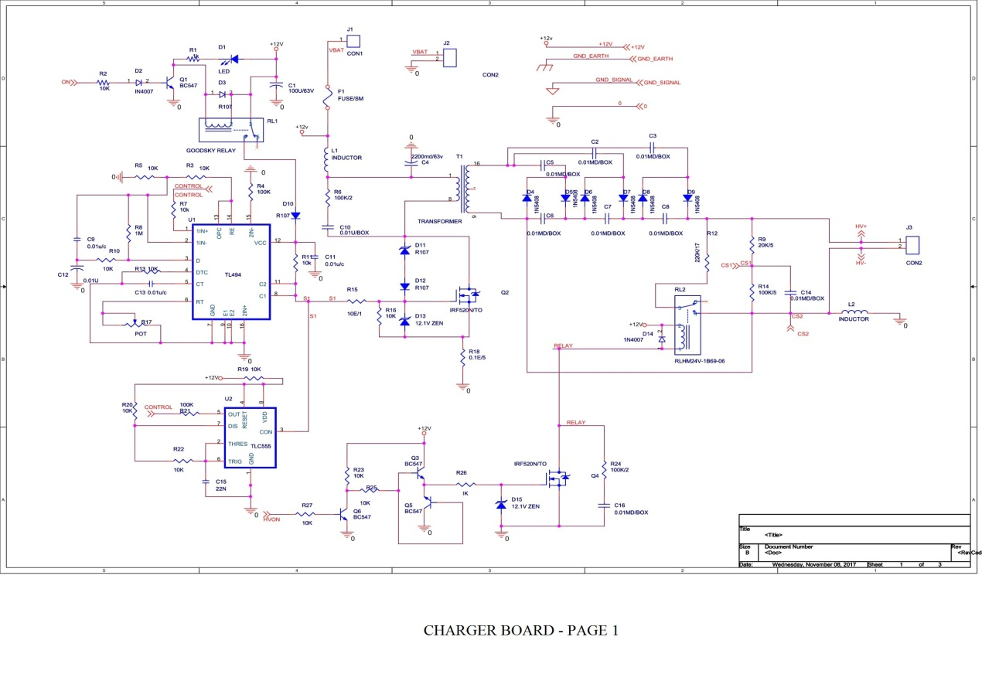

Fig 1: Charging section

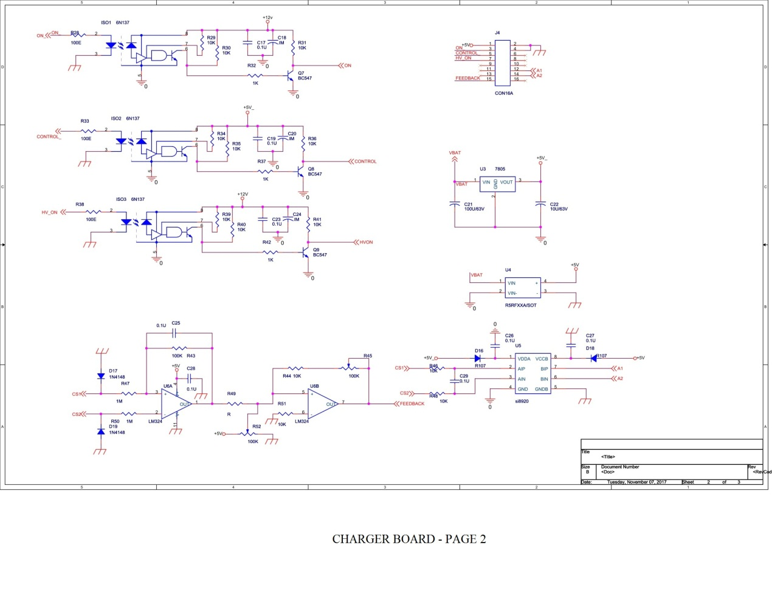

Fig 2 Feedback Section

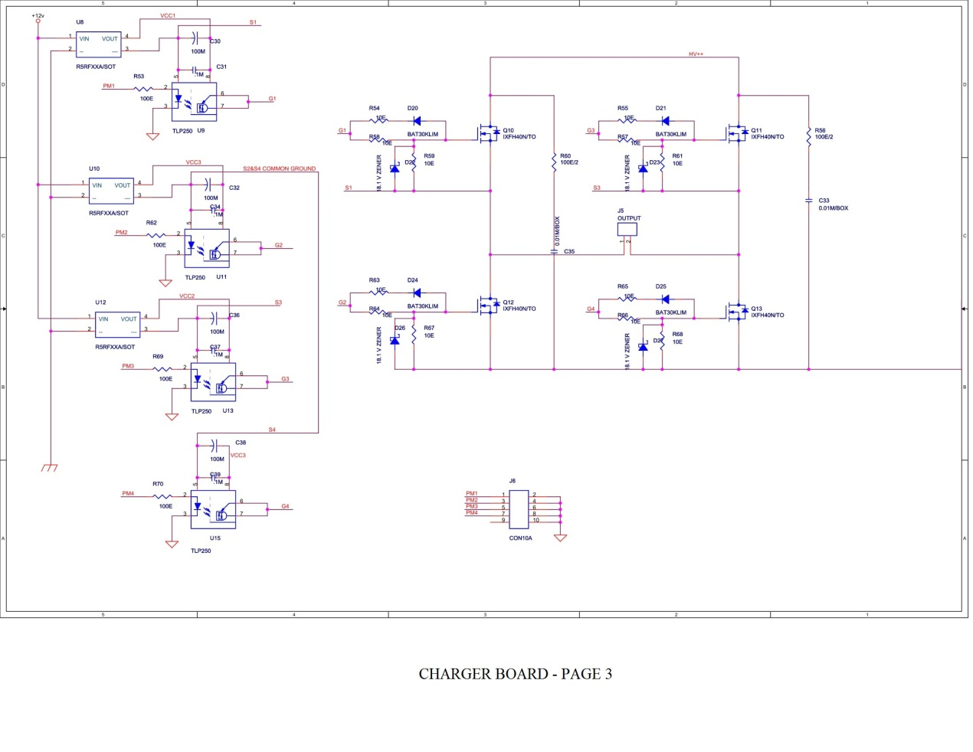

Fig 3 Discharging section

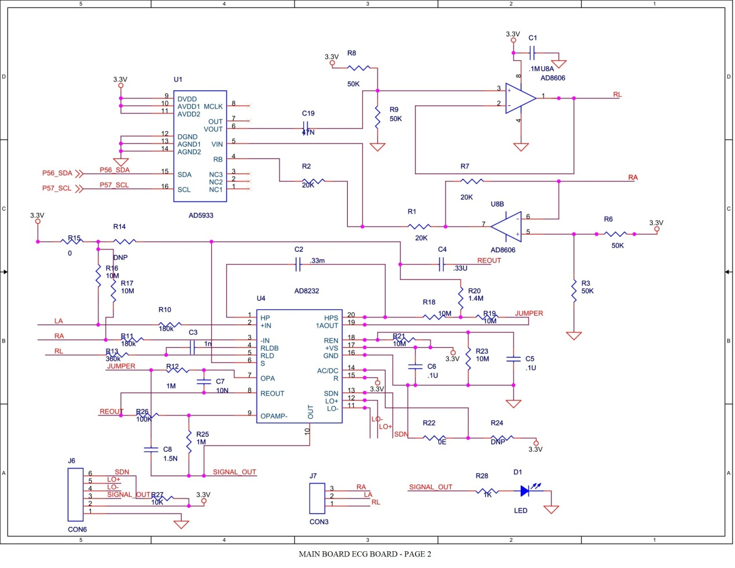

Fig 4 ECG and Impedance acquisition section

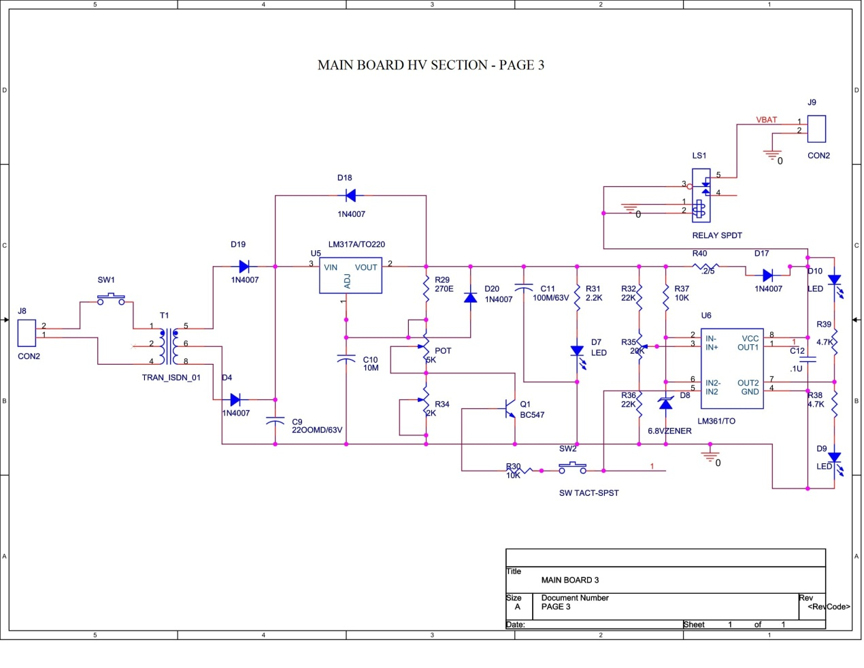

Fig 5 Battery Charging section



Fig 6 Electrode Isolation section



Fig 7 Interfacing section

**FUTURE TASKS:**

* Electrode Isolation circuit not implemented
* Impedance measurement circuit not implemented
* ECG data acquisition using same pad (for shock and ECG ,Impedance) not implemented
* Battery charging circuit not implemented