**Final Year Project (2021 - 2022)**

**Proposal Report**

**Multi-Camera System**

**Project ID:** WA02-a21

**Supervisor:** Professor Albert Wong

**Author (Student ID):** SHARMA Dipankar (20547808), SINGH Dilsher (20545381), JAIN Prabhansh(20581787)

**Date:** 15 September 2021

**Main Objective**

This project aims to increase the accuracy of temperature detection through two color cameras plus two low-resolution thermal cameras at a carefully assessed position for supporting various applications. Mainly involving calibration and synchronization of the cameras, tuning, and optimization of the Image Signal Processing codes, and facilitating multiple cameras outputs to mitigate occlusion complications. Due to limitations with single-camera detectors this particular dual-camera technology will sense temperature and therefore fever with higher efficiency and accuracy, thereby the name FeverSENSE.

**Objective Statements**

* The primary aspect for developing the project is setting up the hardware. The initial step of which is preparing the SD card for the Avnet Ultra96-V2 board followed by connecting the two sets of RGB camera and Thermal Sensor Systems.
* The following step for the project is to collect a dataset that will contain a series of images of unmasked and masked human faces. The dataset will be trained for facial tracking based on certain face landmark features. Due to the existence of a multiple camera system, the algorithm will be trained according to the pose-estimation of a human head based upon the Dlib library on Vitis AI platform.
* The next step is to create a mapping algorithm between the thermal and RGB camera pairs respectively. Each pair will detect core temperature individually. The more accurate output will be selected and used for a threshold program that performs segregation based on readings. The result will be displayed on a monitor and anomalies will be stored in a database.

Table of Contents

**SECTION 1 - INTRODUCTION1**

1.Background and Engineering Problem1

2.Objectives

1. This project aims to increase the accuracy of temperature detection through two color cameras plus two low-resolution thermal cameras at a carefully assessed position for supporting various applications. Mainly involving calibration and synchronization of the cameras, tuning, and optimization of the Image Signal Processing codes, and facilitating multiple cameras outputs to mitigate occlusion complications. Due to limitations with single-camera detectors this particular dual-camera technology will sense temperature and therefore fever with higher efficiency and accuracy, thereby the name FeverSENSE.

2

3. Literature Review2

**SECTION 2 - METHEDOLOGY**5

1. Overview5

1.1 System Description5

1.2 FeverSENSE Block Diagram8

1.3 Component List9

1.4 Helpful ECE Courses10

2. Objective Statements 11

2.1 Dataset Collection11

2.2 Hardware Setup11

2.3 Pose-Estimation of a Human Head11

2.4 Training and Testing the Application on Collected Dataset12

2.5 Creating a Mapping Algorithm12

2.6 Facilitating Multiple Camera Outputs to Mitigate Occlusion Complication12

2.7 Threshold System Installation13

2.8 Display and Store13

**SECTION 3 – PROJECT PLAN**14

1. Gantt Chart 14

2. Budget 15

REFERENCES16

APPENDICES 18

1. Appendix A18

**Section 1- INTRODUCTION**

**1- BACKGROUND AND ENGINEERING PROBLEMS**

The current situation in the area of research is that there are many thermal camera detections in an array of places including shops, restaurants, etc. All around the world, especially with the current situation of the outbreak of the COVID-19 virus, temperature detection has become primarily mandatory mostly in the form of infrared thermometer guns. However, the accuracy of such methods is quite debatable, and this is one of the problems we strive to overcome to give accurate results and save time. With the help of thermal cameras, such issues are solved as this creates automatic thermal detection and records as well. Many of the thermal cameras face the issue of either having misreading or skipping a few people due to positioning as well. Therefore, factors such as the correct angle or the use of multiple cameras will be explored and considered to ensure accuracy for every customer or demographic. All in all, this is an area of research that has come to the focal attention of many people lately.

Thermal cameras have a plethora of use cases at this particular time. For instance, fire detection by helping firefighters detect hotspots originating from unexpected locations; thermal security cameras as they reliably perform well under low light and poorly visible areas to detect bodies and are cheaper to set up than CCTV cameras; remotely piloted drones by enhancing general recon capabilities in dangerous or difficult-to-observe conditions [1].

Since the advent of the COVID crisis, the requirement for sophisticated medical equipment has exponentially grown. To impede the current public health crisis possessing the technical capabilities for detecting potential cases of infection is vital. Therefore, an AI-powered thermal detection system can ease and elevate the capacity and functionality of the traditional approaches. The lack of non-intrusive and fast detection properties in the current system can be repaired with our technology. Besides COVID, this technology can be used for various other purposes unrelated to the medical field. The combination of thermal imaging with identity verification can be used to recognize the presence of people in isolated locations, to assist during autonomous driving, for example, the scenarios where manpower may be inadequate.

Since fever is one of the first signs of the virus, habitual tracking of human core temperature can be a useful resource for early detection and segregation of humans with fever from others, that's a powerful measure to avert the transmission of infectious diseases [2]. The technology we intend to create can detect core temperatures by isolating the specific location of the face and demonstrating the temperature on that position. We are providing a more accurate and effortless way to identify surface skin temperatures by eliminating multiple hassles, specifically in a crowded location where time is of the essence. AI-powered thermal imaging cameras will allow scalable and rapid screening of individuals while eliminating the necessity of queues for individual checks.

According to the European Parliamentary Research Service, Scientific Foresight Unit thermal imaging powered by “AI statistical analysis can achieve accurate temperature screening and high measurement speed of up to 95% “[3]. All in all, the use of temperature detection has come to the foreground for multiple research purposes related to health and various food administration. However, multiple studies in the US have found that Thermal imaging systems are not accurate when used to take the temperature of multiple people at the same time [4]. During the epidemic, the results for such measurements have been mixed. Despite such records, various factors will make it easier to enhance the effectiveness of such measurements and streamline the whole process quicker.

We will integrate a colour camera plus a low-resolution thermal camera. The colour camera will enable accurate face detection and people tracking, and the thermal camera will allow the detection of people with fever. The project involves calibration and synchronization of the cameras, tuning, and optimization of the Image Signal Processing codes, and developing applications to demonstrate the functions of a multi-camera system. We will implement the project on an Avnet Ultra 96 board.

**1.2- OBJECTIVES**

**Main Objective**

This project aims to increase the accuracy of temperature detection through two color cameras plus two low-resolution thermal cameras at a carefully assessed position for supporting various applications. Mainly involving calibration and synchronization of the cameras, tuning, and optimization of the Image Signal Processing codes, and facilitating multiple cameras outputs to mitigate occlusion complications. Due to limitations with single-camera detectors this particular dual-camera technology will sense temperature and therefore fever with higher efficiency and accuracy, thereby the name FeverSENSE.

**Objective Statements**

* The primary aspect for developing the project is setting up the hardware. The initial step of which is preparing the SD card for the Avnet Ultra96-V2 board followed by connecting the two sets of RGB camera and Thermal Sensor Systems.
* The following step for the project is to collect a dataset that will contain a series of images of unmasked and masked human faces. The dataset will be trained for facial tracking based on certain face landmark features. Due to the existence of a multiple camera system, the algorithm will be trained according to the pose-estimation of a human head based upon the Dlib library on Vitis AI platform.
* The next step is to create a mapping algorithm between the thermal and RGB camera pairs respectively. Each pair will detect core temperature individually. The more accurate output will be selected and used for a threshold program that performs segregation based on readings. The result will be displayed on a monitor and anomalies will be stored in a database.

**1.3- LITERATURE REVIEW**

With the increase of viruses and infections in today’s world, measuring fever in public places has become essential. In the previous two years due to the pandemic and more viruses, technology has advanced and has stepped up to help the medical industry. There are several products present in the market which help to measure fever in public places, some of these are very common like an infrared thermometer or a thermal scanner. However, these products could be a problem in crowded places as there might not be the required accuracy or manpower to control these products. Therefore, some solutions solve this problem and we have studied three products that follow the same. The following are discussed below.

**FeverTIR – Fever detection system**

FeverTIR is a product created by VisionTIR which is a company that manufactures industrial non-contact thermal sensing products. VisionTIR has been manufacturing products in this industry for about 20 years and the company is based in Spain [6]. With the rise of Covid-19 and more viruses like the Black Fungus, VisionTIR came up with a product FeverTIR which serves the purpose of non-contact fever detection. This product was much needed in crowded places, like grocery stores or shopping malls.

FeverTIR is combined with a high-precision thermal camera and a visible Full HD coloured camera. This allows the product to capture the temperature of the person using the thermal camera and also capture a full HD image of the person using the coloured camera. The images for the hardware and software of the product are shown below [7].

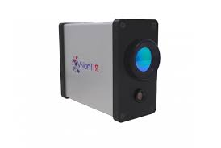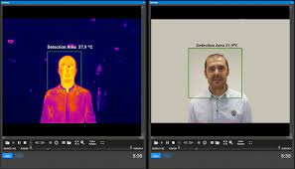

Figure-1 External Hardware of FeverTIR Figure-2 Visual Software of FeverTIR

As you can see from the images above, this product has two cameras embedded into the same body. By this the company claims that this gives them more accuracy to find the core points of the person, in this case of detecting fever it will be the forehead of the person. The system also has an alarm system that triggers when a person crosses a target/threshold temperature, which might confirm that the person has a fever. Moreover, the system also has a recording system in-built with it and lined up in its software [8].

Even though the product is fulfilling the purpose of non-contact fever detection. There are several flaws to be considered. For a temperature to be recorded in the system, a person will have to walk up to the camera and align its face with the box in the center for a temperature to be recorded. This makes it very inconvenient for people and is also very time-consuming, this fails the purpose of it being used in crowded places like an airport. The system is also ideal for only locations where the relative humidity is less than 90% which means this system cannot be ideal for places where the relative humidity is high. Moreover, the system uses the local PC to act as a CPU and GPU, so it depends on the PC for the system to perform well and give ideal results.

**Optris- Fever Screening System**

Another system that serves the purpose of non-contact fever detection, is a product from Optris. Optris is a company which was founded in 2003 and is based in Berlin, Germany. Similar to VisionTIR, this company also manufactures non-contact thermal sensing products. Their fever detection system consists of two infrared cameras (Xi 400 and Pl450i), both of these cameras are in-house created at the camera and are then combined to create the fever screening system [9].

There are two applications to this product; Crowd based screening and individual screening. With the crowd-based screening, the product can detect fever in a crowd but with a minimum range of 4m. Whereas, in the individual screening there can be a minimum range of 1.6m as you can see in the image below.

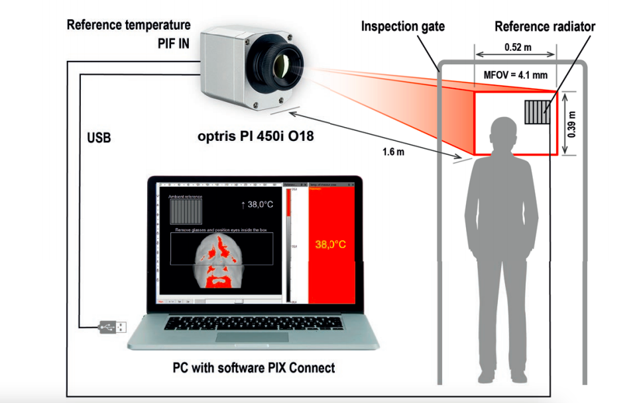

Figure-3 Overview of Opritis System

The Software used for this product is an in-house software called PIX Connect, which can be installed by the user and then can be connected to the fever screening system with a USB cord. Different from FeverTIR, this system does not have a sound alarm but has a visual alarm, which means a constant staff will have to monitor the process throughout [10].

With all this in the system, there are some shortcomings too. This product does not have a coloured camera to help the staff monitor the process better in a crowd screening scenario. The system is directly powered by the PC which means that there is no indirect power, and this clearly tells how the performance of the camera will not be so powerful. The same goes with the software, the computation and GPU are all dependent on the PC/laptop where the software will be installed which is also a big drawback as that can make the whole process have a frame rate drop.

The one common drawback in both systems mentioned above is that both products do not hold their separate GPU and computer. Whereas with our fever detection system we will be using an Avnet Ultra962-V2 board to compute all our readings and calculations. One drawback of the FeverTIR system is that the temperature will only be recorded if a face is aligned with the box provided in the software. We will be eliminating this drawback, by installing two sets of fever detection systems which will be calibrated to get the best of results. Finally, coming to the Opritis system, as there are no thermal cameras in that system, we will be having a total of two thermal cameras combined with two full HD coloured cameras in our system.

As mentioned earlier, there are many drawbacks with the current methods of fever detection which are also evident in the reports referenced. Our unique selling point would be to make use of 2 thermal cameras with 2 coloured cameras positioned at a carefully assessed angle to give the best results to enhance and improve the accuracy. With two cameras and, therefore, 2 Avnet boards, the measurement would be more reliable, and different angles will be measured and constantly checked with other results.

**Section 2- METHODOLOGY**

**2.1- OVERVIEW**

With the rise of viruses and keeping the recent pandemic in mind, we have decided to come up with a solution for measuring one of the most common symptoms: fever. Fever detection systems have become common, but our product will be a non-contact fever detection system, where we will combine a coloured camera and a thermal camera. Both of these cameras will be embedded in an Avnet Ultra 96-V2 board, and this is a powerful computer that will help us to run all our algorithms and recognize if someone has a fever or not. Our system will also consist of multiple face detection, whether with a face mask or without one. So, as we know nowadays, there are almost all public places where we need fever screening to ensure the safety of everyone. Considering that, each of our products will consist of two sets of thermal cameras and coloured cameras to get the maximum efficiency and accuracy.

All of this will then be shown on display, and it can be anything from a laptop screen to television until it supports an HDMI input. Our system will consist of a digital UI where we will be showing a live feedback system for the ease of monitoring temperatures. Every person walking in the range of the camera will be shown on display with a box containing their temperature on top of it. The package will get highlighted if the person is having a fever (>37℃) to make it easier for the staff in charge to monitor all activity.

Adding to all of this, we will be mounting both sets of cameras on a tripod (>=6’) and setting them on an angle so that we can achieve the best accuracy and achieve the perfect height. Furthermore, we will be syncing both sets of cameras to give us the best reading for each temperature, or we can calculate the average of both thermal readings to get a cumulative measurement. This way, there will be less chance of errors. Moreover, we will also have an image capturing feature, which will mean if a person has a fever. The coloured camera will automatically capture a zoomed-in picture of the person’s face.

**COMPONENTS/MODULES**

* Avnet Ultra 96-V2[10]
  + It is a Xilinx Zynq UltraScale+MPSoC, ARM-Based single board computer based on the Linaro 96Boards specifications.
  + It’s features include Micron 2 GB (512M x32) LPDDR4 Memory, Xilinx Zynq UltraScale+ MPSoC ZU3EG A484,PetaLinux environment, Microchip Wi-Fi / Bluetooth,Mini DisplayPort (MiniDP or mDP),1x USB 3.0 Type Micro-B upstream port,2x USB 3.0, 1x USB 2.0 Type A downstream ports,40-pin 96Boards Low-speed expansion header,60-pin 96Boards High-speed expansion header, 85mm x 54mm form factor,Linaro 96Boards Consumer Edition compatible
  + Ultra96-V2 is a unique embedded system and has an essential position in the 96Boards community. It has the potential for extensive applications and adapts to multiple acceleration engines in programmable logic and probable peripherals. It is also an improved version of the original Ultra96 board.

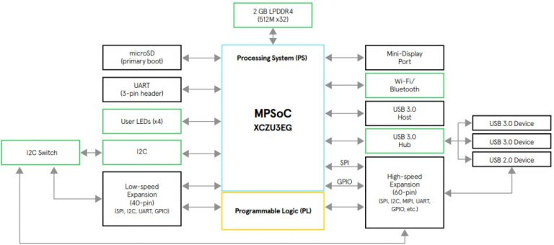

Figure 4 Avnet Ultra962-V2 Platform

* Xilinx Vitis AI [11]
  + The Vitis AI is used in Xilinx manufactured hardware which consists of both the Alveo cards and the edge Devices. It is a development stack for AI inference.
  + These are the following key components of the platform:-
    - AI Model Zoo - Contains pre-optimized ready to deploy models onto the Xilinx hardware.
    - AI Optimizer - This can prune or shape up the model up to 90%.
    - AI Quantizer - It allows quantization, model calibration, and fine-tuning.
    - AI Compiler - Compiles the quantized model to a high-efficient instruction set and data flow.
    - AI Profiler - Allows intensive analysis of the utilization and efficiency of AI inference implementation.
    - AI Library - Consists of optimized and high-level C++ APIs for AI apps from edge to cloud
    - DPU - Prebuilt images, we use u96v2_sbc_base: 1 x B2304 (low RAM usage), 200MHz/400MHz
  + Vitis AI gives a unified set of high-degree C++/Python programming APIs to build AI programs throughout edge-to-cloud platforms, inclusive of DPU for Alveo and DPU for Zynq Ultrascale+ MPSoC and Zynq-7000. As a result, it is advantageous for effortlessly porting AI packages from cloud to edge and vice versa.
  + We will use Vitis AI to create all algorithms and programs that will enable us to do face detection, face landmark detection, and thermal image mapping to the colour camera.
* Better-Digi UWC14 1080p Webcam [12]
  + This is the coloured full HD webcam we will be using in our product and which will be embedded into the Avnet Ultra-96 Board. This camera has recorded in full HD 1080p and also has a stable frame rate of 30fps.
  + It has low latency and has stable video transmission which makes it best for broadcasting or recording live video.
  + To set up the camera we will just have to connect it with a USB 2.0 connector to the Avnet board.
  + It is compatible with Windows XP, Windows 7/8/10, Mac OS, and other Operating Systems.

Figure 5. Better-Digi Webcam

* Tensorflow and Python Libraries [13]
  + Tensorflow is an open-source platform for machine learning that contains a flexible ecosystem of tools, community resources, and libraries. The python library necessary for us is the Dlib which is unique and not mainstream.
  + The major features of Dlib are its high-quality portable code, the machine learning algorithms which contains structural SVM tools, and kernel RLS regression algorithm integral to our project, The Numerical Algorithms is the one that will allow us to create the feature landmark detection and transformation and transposing the image coordinates, The Graphical Model Inference Algorithms, image processing to do thermal and RGB camera mapping, Threading, GUI and Data Compression and Integrity Algorithms.
* Peripherals [14]
  + Monitor - SAMSUNG Odyssey G5 Series 32-Inch WQHD (2560x1440) Gaming Monitor, 144Hz, Curved, 1ms, HDMI, Display Port, FreeSync Premium (LC32G55TQWNXZA)
* M418A/B Thermal Sensor and Processor [15]
  + QFN33-pin packaged processor.
  + Has great timing and handles it strictly.
  + Handles per-pixel calibration.
  + Frees up the external processor to do temperature processing.

Figure 6. C++ SDK MI48 Thermal Camera

**System Block Diagram**

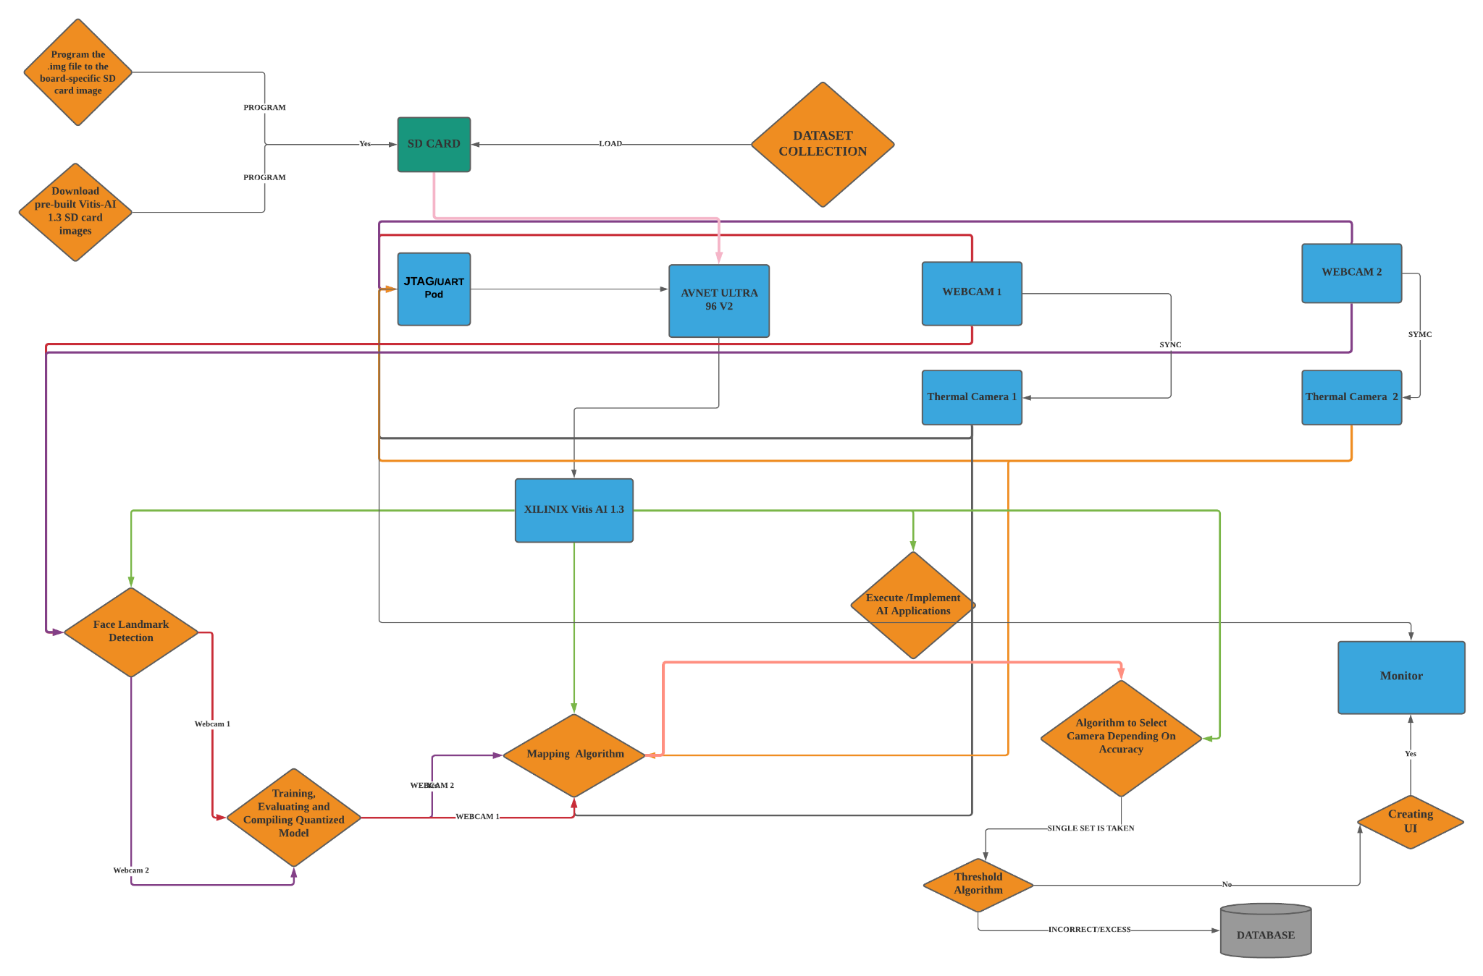

Figure-7 System Block Diagram

**COMPONENT LIST**

|  |  |  |
| --- | --- | --- |
| **COMPONENT NAME** | **MODEL** | **COMPONENT SPECIFICATIONS** |
| **Webcam** | Better-Digi UWC14 1080p Webcam | * Auto Installation * 1080p Resolution * Field of View: 90-degree angle * 2MP sensor Pixels * 360 degree horizontally rotatable |
| **Power Cable** | AES-ACC-U96-4APWR | * Model: VP-1204000 * Input: AC 100-240v, 50/60HZ * Output: DC 12V, 4A * 4.7mm x 1.7mm x 10mm DC plug * 1.2m US AC cable with a C8 socket * 1.2m EU AC cable with a C8 socket * 1.2m UK AC cable with a C8 socket * 1.2m AU AC cable with a C8 socket |
| **FPGA/Embedded System Board** | Avnet Ultra96-V2 | * Xilinx Zynq UltraScale+ MPSoC ZU3EG A484 * Micron 2 GB (512M x32) LPDDR4 Memory * Delkin 16 GB microSD card + adapter * PetaLinux environment available for download * Microchip Wi-Fi / Bluetooth * 1x USB 3.0 Type Micro-B upstream port * 2x USB 3.0, 1x USB 2.0 Type-A downstream ports * 40-pin 96Boards Low-speed expansion header * 60-pin 96Boards High-speed expansion header * 85mm x 54mm form factor * Linaro 96Boards Consumer Edition compatible |
| **Tripod** | Endurax 74” Camera Tripod | * 3-WAY PAN HEADS & LEVEL BUBBLE * 1/4" quick release plate * support 360° panoramic shooting * 90° vertical shooting. |
| **Monitor** | SAMSUNG Odyssey G5 Series 32-Inch WQHD (2560x1440) | * 144Hz * Curved, 1ms, HDMI * Display Port * FreeSync Premium (LC32G55TQWNXZA) |
| **Development Stack** | Xilinx Vitis AI | * AI Model Zoo * AI Optimizer * AI Quantizer * AI Compiler * AI Profiler * AI Library * DPU |
| **Thermal Camera** | Meridian Thermal Imaging Processor (MI48 TiP). | • Support Arm (including Raspbian), Mipsel, X86 |
| **USB Port** | Ultra 96 USB to JTAG/UART Pod | * High-speed MicroUSB 2.0 connection * Female UART header compatible with the Ultra96 UART male header * Female JTAG header compatible with the Ultra96 JTAG male header |

TABLE 1. COMPONENT TABLE

**HELPFUL ECE COURSES**

* **ELEC 3210 - Machine Learning and Information Processing for Robotics**
  + The following course introduced us to the basic concepts of information processing techniques used in robotics. The primary content included the hidden Markov model localization and mapping, kernel methods for regression, the Bayes theorem, classification, support vector machine (SVM), Gaussian process, as well as certain sensors, algorithms, and software platforms that are used in robotics research. This enabled us to understand the mathematics behind the machine learning and deep learning required to create the facial landmark detection systems. [16]
* **ELEC 4240 / COMP 4471 - Deep Learning in Computer Vision** 
  + This was one of the primary courses required to understand the machine learning section since it helped us create and apply the necessary algorithms. It provided us with real-time access to the software and models used in training the quantized model based upon our dataset. We learned the details of convolutional neural networks as well as recurrent neural networks and train deep networks with end-to-end optimization. [16]
* **COMP 2011 - Programming with C++**
  + These courses gave us intensive experience in programming from basic concepts like functions and conditional statements to object-oriented programming that included creating classes and modules and also helped gain an understanding of dynamic programming. [16]

**2.2 OBJECTIVE STATEMENT**

This project aims to increase the accuracy of temperature detection through two color cameras plus two low-resolution thermal cameras at a carefully assessed position for supporting various applications. Mainly involving calibration and synchronization of the cameras, tuning, and optimization of the Image Signal Processing codes, and facilitating multiple cameras outputs to mitigate occlusion complications. Due to limitations with single-camera detectors this particular dual-camera technology will sense temperature and therefore fever with higher efficiency and accuracy, thereby the name FeverSENSE.

* **Dataset Collection**

1. Masked Dataset Collection
   1. Dilsher Singh
   2. Collected training set containing. This dataset consists of Masked CASIA, VGG2, and Kaggle images.
2. Unmasked Dataset Collection
   1. Prabhansh Jain, Dilsher Singh
   2. Collected training set containing images of unmasked people. This dataset consists of Masked CASIA, VGG2, and Kaggle.
3. Labelling and CSV Preparation
   1. Prabhansh Jain
   2. Labelling the images according to masked, We are connecting unmasked and core temperature facial features.

* **Hardware Setup**

1. Preparing the SD Card for Avnet Ultra962-V2
   1. Dipankar Sharma
   2. Download the pre-built Vitis-AI 1.3 SD card images and extract them. Once removed, program the .img file to the board-specific SD card image to a 16Gb or larger SD card.
2. Thermal and Color Cameras Setup
   1. Dipankar Sharma
   2. Connecting and testing the thermal and colour camera range to achieve the best field of view.
   3. Positioning the two sets of thermal and colour cameras in the most optimal angle depending upon the location and purpose.
3. Component Integration
   1. Dipankar Sharma
   2. Integrating all hardware components and testing the output of multiple cameras on the Avnet Ultra962-V2 Board.

* **Pose Estimation of a Human Head**

1. Face Landmark Detection
   1. Prabhansh Jain
   2. Select 2D locations of landmarks of the face through the Dlib face landmark detectors. Proceed to form a 3D location through an arbitrary reference frame of the 2D location. Finally, find the image coordinates using world coordinates and the focal length of the camera.
2. Create an Algorithm in Python for OpenCV Pose
   1. Dilsher Singh
   2. Create the functions solvePnP and solvePnPransac based upon Levenberg-Marquardtthe Optimization
3. Integration of the Class Face Landmark Detection
   1. Prabhansh Jain
   2. Add the class FaceLandmark in the class FaceDetectWithHeadPose, build the head pose estimate application and improve the results using Dlib.

* **Training and Testing the Application on the Collected Dataset**

1. Training
   1. Dipankar Sharma
   2. Use the pre-trained Keras model instead of training a fresh dataset. Through this, we can integrate the new dataset and use the pre-trained model dataset and increase the efficiency.
2. Evaluating Frozen Graph
   1. Dipankar Sharma
   2. Initiate conversion of Keras checkpoint to a Tensorflow compatible frozen graph. Evaluate the frozen graph to calculate the accuracy. Quantize the floating-point frozen graph using the Vitis AI tools and a sample set of data for calibration.
3. Evaluating and Compiling the Quantized Model.
   1. Prabhansh Jain
   2. Evaluation of a Quantized Model is necessary to see the loss of accuracy when we convert from a floating-point model to an 8bit model which has a dynamic range. Finally, for this objective using the Vitis AI compiler, we will optimize, convert the quantized deployment model to a set of micro-instructions and output them into an X model file.
4. Running and Testing with Live Feed
   1. Dilsher Singh
   2. Run the application on the target board using _make_target.sh, check the accuracy and performance. Use live video to check the core feature detection.

* **Creating a Thermal and RGB Camera Mapping Algorithm**

1. Creating Transformation Matrix
   1. Dilsher Singh
   2. We will be using RGB colour camera image coordinates and thermal image coordinates and forming a transformation matrix using image signal processing to create a mapping for each pixel.
2. Creating an Algorithm on Python using the Transformation Matrix
   1. Prabhansh Jain
   2. Using Dlib, OpenCV, and Matplot libraries to form class ThermalCorePoint that will match the core points on the thermal image to the classified features in the AI Program.

* **Facilitating Multiple Camera Outputs to Mitigate Occlusion Complications**

1. Positioning the Camera
   1. Dipankar Sharma
   2. We will position the camera to maximize the accuracy and range by testing different orientations.
2. Detecting the Output
   1. Dipankar Sharma, Prabhansh Jain
   2. Since multiple cameras increase the probability of accurate detection. We will initially read the outputs of the different cameras manually and infer which camera provides a more viable yield depending on its positioning.
3. Creating Algorithm to Select Camera with More Accurate Results
   1. Dilsher Singh, Prabhansh Jain, Dipankar Sharma
   2. We will select the face recognition from the RGB camera and corresponding thermal mapping results whose bounding box has an increased percentage of accuracy and pass the output to the threshold function to perform segregation.

* **Threshold System Installation**

1. Create Threshold Function
   1. Dilsher Singh
   2. Create a threshold function that will not accept any temperature below 33 and display Lo on the UI and temperature above 37.5 will be recorded and alarms will be triggered so that the identified person can be segregated.

* **Display and Store**

1. Displaying the Results on a Screen
   1. Dipankar Sharma, Dilsher Singh
   2. We are creating a UI to display the temperatures of human faces on the bounding boxes.
2. Storing the Results on a Database
   1. Dipankar Sharma, Prabhansh Jain
   2. Creating a CSV file for temperatures that cross a threshold.

**Section 3 - PROJECT PLAN**

**3.1 GANTT CHART (Wk-1 starts 15 Sep)**

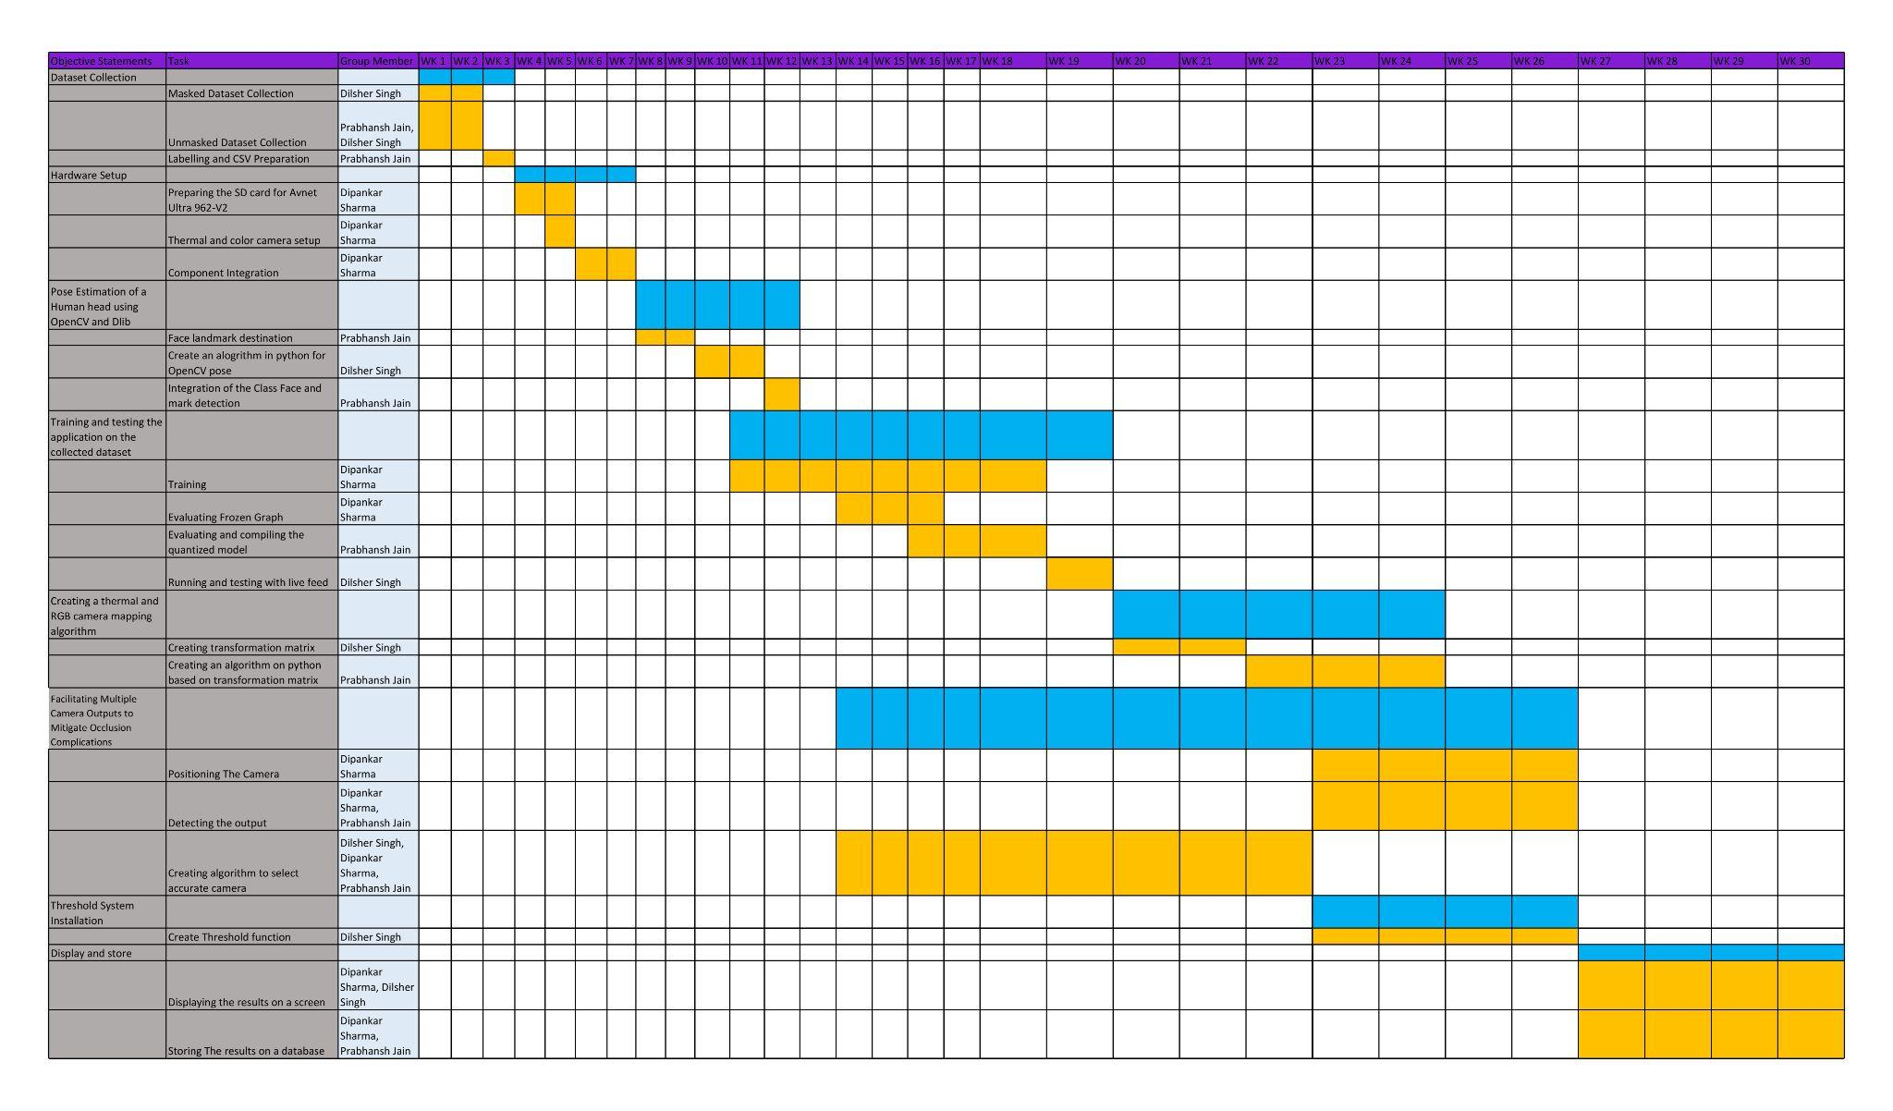

**3.2 BUDGET**

|  |  |  |  |
| --- | --- | --- | --- |
| **COMPONENTS** | **COST IN USD** | **QUANTITY** | **TOTAL COST PER COMPONENT** |
| **AES-ULTRA96-V2-G +**  **ZU3EG Development Board** | **249** | **2** | **498** |
|
| **AES-ACC-U96-4APWR** | **19.99** | **2** | **39.98** |
| **Better-Digi UWC14 1080P Webcam** | **32.09** | **2** | **64.18** |
| **Thermal Camera Meridian MI48** | **Quotation Requested** | **2** | **NA** |
| **Keyboard + Mouse** | **Available from UST** | **1** | **NA** |
| **Endurax 74” Camera Tripod** | **38.6** | **2** | **77.2** |
| **Monitor** | **328** | **1** | **328** |
| **TOTAL COST IN USD** | **1295.39** | | |

TABLE 2. BUDGET TABLE REPRESENTING COMPONENTS, QUANTITY, AND COST

**REFERENCES**

USE IEEE STYLE

1) “Everything you need to know about thermal imaging cameras,” *Everything You Need To Know About Thermal Imaging Cameras | RS Components*. [Online]. Available: https://uk.rs-online.com/web/generalDisplay.html?id=ideas-and-advice%2Fthermal-imaging-cameras-guide. [Accessed: 02-Sep-2021].

2.) “Guidance Note on Monitoring of Body Temperature,” *Infection Control Branch*. [Online]. Available: https://www.chp.gov.hk/files/pdf/guidance_note_on_monitoring_of_body_temperature.pdf. [Accessed: 04-Sep-2021].

3.) M. Kritikos, “AT A GLANCE,” *What if AI could improve thermal imaging, to help fight coronavirus?*, Dec-2020. [Online]. Available: https://www.europarl.europa.eu/RegData/etudes/ATAG/2020/656299/EPRS_ATA(2020)656299_EN.pdf. [Accessed: 04-Sep-2021].

4) Center for Devices and Radiological Health, “Thermal imaging (INFRARED THERMOGRAPHIC systems / THERMAL CAMERAS),” *U.S. Food and Drug Administration*. [Online]. Available: https://www.fda.gov/medical-devices/general-hospital-devices-and-supplies/thermal-imaging-systems-infrared-thermographic-systems-thermal-imaging-cameras. [Accessed: 05-Sep-2021].

5.) “About us,” *VisionTIR*, 17-Jun-2019. [Online]. Available: https://visiontir.com/about-visiontir/. [Accessed: 06-Sep-2021].

6.) “FeverTIR: Fever detection SYSTEM: Body temperature measurement,” *VisionTIR*, 14-Dec-2020. [Online]. Available: https://visiontir.com/products/fevertir-fever-detection-system/. [Accessed: 07-Sep-2021].

7.) C. P. Laffitte, “FeverTIR | Fever detection system,” *VisionTIR*. [Online]. Available: https://visiontir.com/wp-content/uploads/2020/06/FeverTIR_System_data_sheet_EN_v3.0.pdf. [Accessed: 08- Sep- 2021]

8.) "Fever screening systems | Optris GmbH", *Optris.global*, 2021. [Online]. Available: https://www.optris.global/fever-screening-systems. [Accessed: 05- Sep- 2021]

9.) *Company Profile*. Berlin, 2021, p. 16 [Online]. Available: https://www.optris.global/about-optris?file=tl_files/pdf/Downloads/Allg.%20Broschueren/Company%20profile%20optris.pdf. [Accessed: 13- Sep- 2021]

10.) *Hackster.io*. [Online]. Available: https://www.hackster.io/avnet/products/ultra96-v2/specs. [Accessed: 09-Sep-2021].

11)[1]"Everything You Need To Know About Thermal Imaging Cameras | RS Components", *Uk.rs-online.com*, 2021. [Online]. Available: https://uk.rs-online.com/web/generalDisplay.html?id=ideas-and-advice/thermal-imaging-cameras-guide. [Accessed: 09- Sep- 2021].

12) "[UWC14] Webcam with Microphone, USB Computer Camera, 1080P HD Streaming Computer Web Camera", *Better DiGi Official*, 2021. [Online]. Available: https://betterdigishop.com/products/uwc14webcam-with-microphone-usb-computer-camera-1080p-hd-streaming-computer-web-camera. [Accessed: 10- Sep- 2021]

13) "dlib C++ Library", *Dlib.net*, 2021. [Online]. Available: http://dlib.net/. [Accessed: 09- Sep- 2021]

14) "32&quot; G5 Odyssey Gaming Monitor With 1000R Curved Screen - LC32G57TQWNXDC | Samsung US", *Samsung Electronics America*, 2021. [Online]. Available: https://www.samsung.com/us/computing/monitors/gaming/g5-odyssey-gaming-monitor-lc32g57tqwnxdc/. [Accessed: 13- Sep- 2021].

15) "PRODUCTS — Meridian Innovation", *Meridian Innovation*, 2021. [Online]. Available: https://www.meridianinno.com/products. [Accessed: 13- Sep- 2021].

16) "HKUST Course Catalog", HKUST Program & Course Catalog, 2021. [Online]. Available: https://prog-crs.ust.hk/ugcourse/2020-21/ELEC. [Accessed: 12- Sep- 2021].

**Appendices**

Meeting 1

Date: 2/09/2021

Time: 3 pm HKT

Location: Zoom Meeting

Attendees: SINGH Dilsher, JAIN Prabhansh, SHARMA Dipankar

Absent: None

Minutes taken : 40 minutes

* Discussed the possibilities of enhancing accuracy of temperature detection with Prof. Wong.
* With the help of Prof. Wong we came to the conclusion of using 2 thermal cameras instead of one and considering different factors that will help in accuracy.
* Task 1 of dataset collection is in progress by Dilsher and Prabhansh for dataset collection.
* Basics of setup of Task 2 are currently looked by Dipankar Sharma to give headstart for Week 4 when task 1 is completed and task 2 will begin.

**Appendix A**

Table 1 Action Items from the Previous Meeting

|  |  |  |  |
| --- | --- | --- | --- |
| Action Item to Be Completed | By When | By Whom | Status |
| Masked Dataset Collection | 29th Sept | Dilsher Singh | In Progress |
| Unmasked Dataset Collection | 29th Sept | Dilsher Singh, Prabhansh Jain | In Progress |
| Labelling and CSV Preparation | 6th Oct | Prabhansh Jain | In Progress |

Table 1 Action Items for Next Meeting

|  |  |  |
| --- | --- | --- |
| Action Item to Be Completed | By When | By Whom |
| Preparing the SD Card for Avnet Ultra962-V2 | 13th October | Dipankar Sharma |
| Thermal and Color Cameras Setup | 20th October | Dipankar Sharma |

**Next Meeting Date: 16/09/21**