**Device Registration & Commissioning**

1. Ensure device get registered in the platform in the below link

<https://elgi-prod.cloud.thingworx.com/Thingworx/Runtime/index.html?mashup=ELGi.COMP.RegisteredDevices.MU>

1. The Template and Shapes should be attached to local things as given in the registration table and if device is not registered, please check the below link for more details

<https://elgi-prod.cloud.thingworx.com/Thingworx/Runtime/index.html?mashup=ELGI.COMP.AgentRegistrationFailure.MU>

1. Update the Machine details (The below properties) in the PTC composer page,

Machine_varient

Rated_Power

Rated_Pressure

Rated_CFM

Operating_Voltage

Operating_Frequency

TPL_NO

1. Commissioning steps :
   1. Create the Elgi users in the ptc composer
   2. Update home mashup as L3 screen for Country head user
   3. Create the country unit in the org unit if it is not available
   4. Update country head user in the country unit in org unit
   5. Send the commissioning details through API as shown in the below

POST /Thingworx/Things/ELGI.COMP.ThirdPartyIntegrationHelper.Thing/Services/SetOrgStructureAndCustomerDetails HTTP/1.1

Host: elgi-prod.cloud.thingworx.com

Accept: application/json

Content-Type: application/json

appKey: 9afb2c64-fe8c-4ade-bc05-3b0ca287bd48

Content-Length: 1925

{

"input": {

"CRMorCCS": "CRM",

"commissioningDate": "",

"fabNumber": "DQDS040315",

"isCommissioning": true,

"isKeyCustomer": false,

"isRetrofitted": false,

"warrantyStatus": true,

"orgUnitDetails": [

{

"parent_id": "COIMBATORE",

"unitLevel": "DEALER",

"unitName": "CBE Dealer",

"unit_id": "CBE_DEALER"

},

{

"parent_id": "CBE_DEALER",

"unitLevel": "CUSTOMER",

"unitName": "ELGi PVD",

"unit_id": "ELGI_PVD"

},

{

"parent_id": "INDIA",

"unitLevel": "REGION",

"unitName": "South",

"unit_id": "SOUTH"

},

{

"parent_id": "SOUTH",

"unitLevel": "AREA",

"unitName": "Coimbatore",

"unit_id": "COIMBATORE"

}

],

"orgUserDetails": [

{

"email": "elgi_pvd_customer@gmail.com",

"name": "ELGi PVD",

"unit_id": "ELGI_PVD",

"userAction": "ADD"

},

{

"email": "cbe_dealer@gmail.com",

"name": "CBE Dealer",

"unit_id": "CBE_DEALER",

"userAction": "ADD"

},

{

"email": "CBEPilot@elgi.com",

"name": "CBEPilot",

"unit_id": "COIMBATORE",

"userAction": "ADD"

},

{

"email": "SouthPilot@elgi.com",

"name": "SouthPilot",

"unit_id": "SOUTH",

"userAction": "ADD"

},

{

"email": "IndiaPilot@elgi.com",

"name": "IndiaPilot",

"unit_id": "INDIA",

"userAction": "ADD"

}

],

"serviceEngineerDetails": {

"area_id": "COIMBATORE",

"customer_id": "ELGI_PVD",

"dealer_id": "CBE_DEALER",

"email": "CBESEPilot@elgi.com",

"mobileNo": "9898998998988",

"name": "CBESEPilot",

"region_id": "SOUTH"

}

}

}

1. Ensure org unit structure is created as expected and users added in the every unit
   1. Org structure created

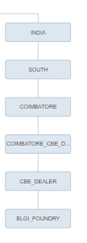

* 1. User group created and users added in the group

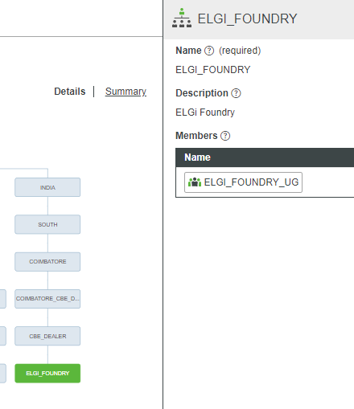

* 1. Dealer/Customer users created

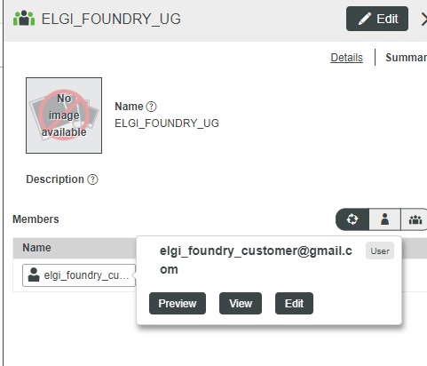

* 1. Visibility added in the asset level

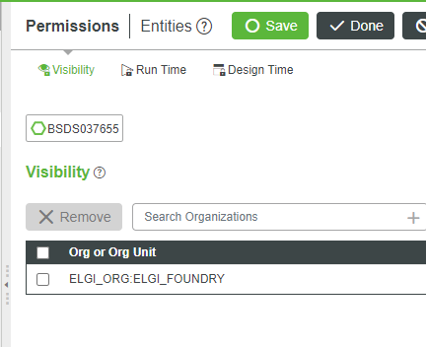

1. Ensure User able to login in the below URL and Mashup & Asset Visibility set accordingly

<https://elgi-prod.cloud.thingworx.com/Thingworx/FormLogin/ELGI_ORG\>