 | AIR UNIVERSITY
 | DEPARTMENT OF COMPUTER ENGINEERING
 | Assignment# 1

Subject: Muhammad Waqas
ID: 240756
Submitted to: Sir Muhammad Naveed Khurshid
Section: BCE-5A

1. Defininations:
Development Life Cycle (SWDLC) | System Development Life Cycle (SysDLC)
The Software Development Life Cycle (SDLC) is a structured process used to plan, design, develop, test, deploy, and maintain software. It ensures a systematic workflow and helps align software development with business goals and user requirements. | The Software Development Life Cycle (SDLC) is a structured process used to plan, design, develop, test, deploy, and maintain software. It ensures a systematic workflow and helps align software development with business goals and user requirements.
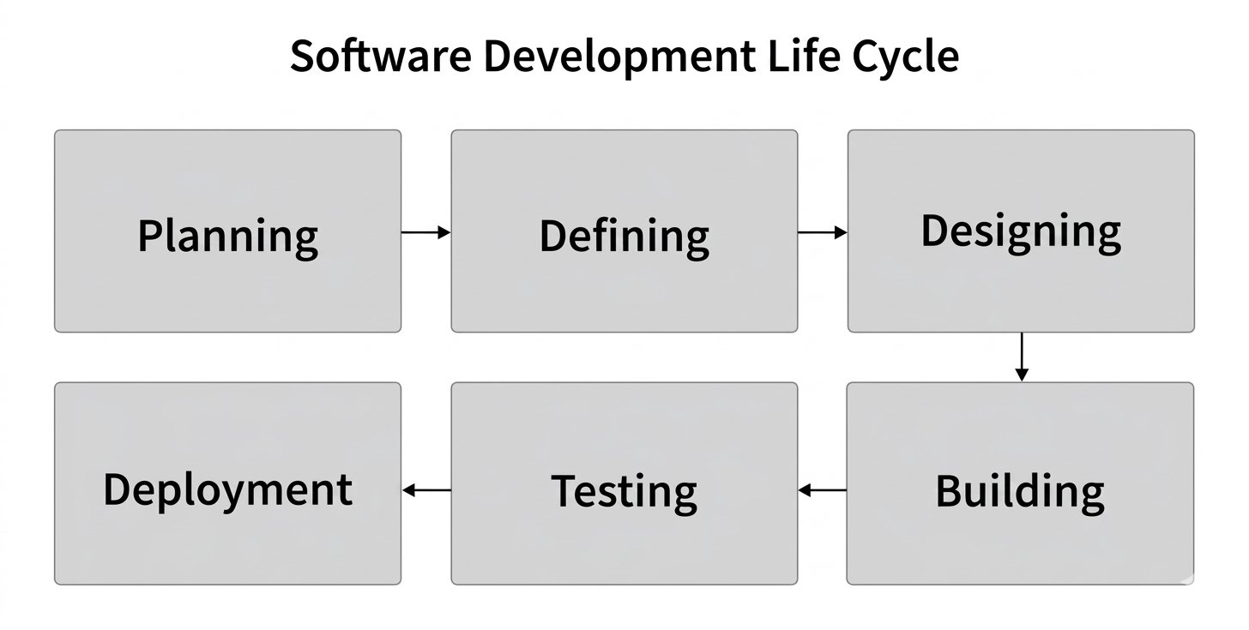 | 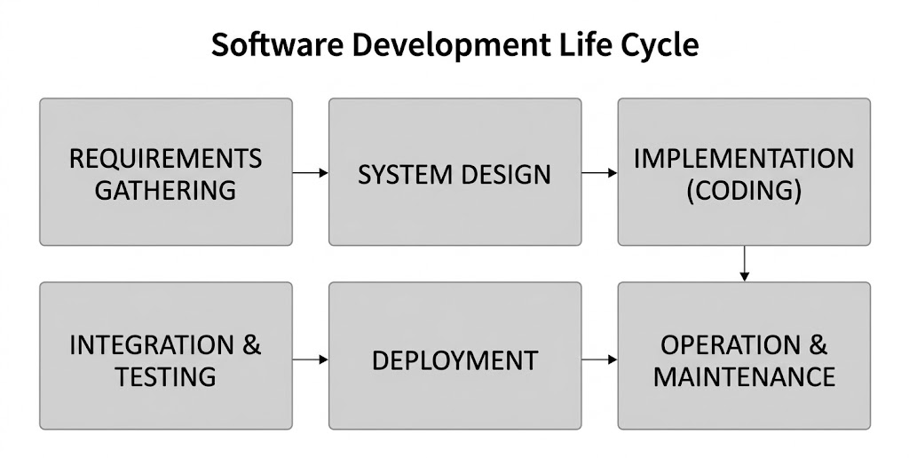

2. Compare their phases in tabular form.
Phase | Software Development Life Cycle | System Development Life Cycle
1.Feasibility and Planning | Evaluates software scope, technical stack feasibility ,code-level risks , sprint timelines , and software developer allocation | Evaluates broad business viability , Total cost of ownership , physical hardware needs , site infrastructure, regulatory compliance , and ROI.
Requirements Analysis | Collects functional software requirements | Analyze end-to-end business work flows, user access roles, physical space rack constrains , network bandwidth , and hardware specs
Architecture and Design | Design high-level software architecture , module interfaces , class diagrams, database ERDs, and REST/GraphQL API contracts | Design Physical network topology, cloud/on-prem server infrastructure, hardware procurement blueprints , and disaster recovery sites.
Implementation/Development | Developers write source code,run test,build microservices,and compile application binaries | Engineers procure Hardware ,install server rackes ,configure firewalls/routers, deploy OS  Environments ,and integrate software builds
Testing and Verification | Focuses on software-centric testing:unit testing integrations testing regression test, automated E2E Tests, and static code ananlysis | Conducted System integration testing(SIT),User acceptance testing9UAT),load/stress testig on physical network gearand site readiness audits.
Deployment | Releasess compiled applications artifacts to target servers or s or environments via CI/CD deployment pipelines. | Cutover execution: physical server deployment, legacy data migration, enterprise network rollout, and operational change management.
Maintenance and Operations | Bug fixing, software patch management, refactoring, feature additions, and framework upgrades. | Ongoing hardware maintenance, firmware updates, network capacity planning, physical security, and end-user training/helpdesk support.

3. Similarities and Differences
Similarities
Structured Methodology | Both frameworks follow systematic, phased approaches to problem-solving, moving logically from problem definition to operational deployment.
Core Engineering Milestones | Both models incorporate mandatory phases for requirements gathering, architectural design, implementation, testing, and post-deployment maintenance.
Quality Assurance Focus | Both emphasize verification and validation at each milestone to prevent defect propagation into production environments.
Iterative & Adaptive Flexibility | Both life cycles can be implemented using traditional linear/waterfall approaches or modern iterative (Agile, DevOps) methodologies.

Differences
Scope and Breadth | WDLC focuses strictly on software components (code, scripts, databases, interfaces). SysDLC covers the total ecosystem, incorporating hardware, network infrastructure, physical security, and human enterprise processes.
Composition | SDLC is typically a subset or constituent component of SysDLC. An enterprise system deployment life cycle often contains multiple software development life cycles running concurrently.
Stakeholders Involved | SDLC primarily involves software engineers, product managers, QA testers, and UX designers. SysDLC involves network architects, systems engineers, procurement officers, business analysts, security specialists, and executive operations managers.
Resource Allocation: | SDLC costs are dominated by software engineering labor and development tooling. SysDLC capital expenditures cover physical hardware acquisition, data center leases, licensing, enterprise training, and site facility costs..

4. Which Model Is More Relevant in Modern Software Engineering?
Software Development Life Cycle is more relevant to modern software engineering practices because most modern projects focus on developing and improving software applications, websites, mobile apps, and cloud-based services.
The main reasons are:
- Frequent Updates: Modern software needs regular updates to fix bugs, improve performance, and introduce new features. Software SDLC supports continuous improvement.
- Agile Development: Modern software teams commonly use Agile methods to develop software in small steps, collect user feedback, and make changes quickly.
- Automation and DevOps: Software SDLC can work with automated testing, continuous integration, and continuous delivery. These practices help teams release software faster and reduce errors.
- User Requirements: Modern software projects often change according to user needs and market trends. Software SDLC allows developers to modify requirements during development.
- Cost and Time Efficiency: Dividing software development into manageable stages helps teams identify problems early and reduce development costs.
- Software Maintenance: Applications require continuous monitoring, security updates, bug fixes, and performance improvements after release. Software SDLC provides a structured approach to these activities.

5. Modern Software Engineering Practices and Real-World Examples
- Agile Development: Companies like Microsoft use Agile practices to develop software in small steps, collect feedback, and improve their products according to user needs.
- Continuous Updates: Google regularly updates Android and its applications to fix bugs, improve security, and introduce new features.
- Automated Testing: Companies like Amazon use automated testing to identify software errors quickly and improve software quality before releasing changes.
- DevOps Practices: Netflix uses DevOps and automation to support frequent software updates and maintain its streaming service.
- System Integration: Hospitals use Systems SDLC to develop complete hospital management systems that connect software, computers, medical equipment, networks, and patient records.

Conclusion:
In simple words, modern software work relies mostly on the Software Development Life Cycle (SDLC). Because of cloud tools like AWS, engineers can easily set up servers and networks directly using code instead of buying physical hardware. While System Development Life Cycle (SysDLC) is still needed for hardware-heavy projects like medical devices or cars, SDLC is much faster and more popular today.
References
https://www.geeksforgeeks.org/software-engineering/software-development-life-cycle-sdlc/
Book: (Global Edition) Ian Sommerville - Software Engineering, 10th Edition-Pearson (2016)
https://www.coursera.org/articles/software-development-life-cycle

