 | AIR UNIVERSITY
 | DEPARTMENT OF COMPUTER ENGINEERING
 | EXPERIMENT NO: 5

Lab Tittle: Threads and Multithreaded Programming
Name: | Muhammad Waqas | Reg No: | 240756
Name: | Muhammad Abuzar | Reg No: | 240736
Objectives: Understanding threads, synchronization using pthreads and multithreading.
LAB ASSESSMENT:

Attributes | Excellent (5) | Good (4) | Average (3) | Satisfactory (2) | Unsatisfactory (1)
Ability to Conduct Experiment
Ability to assimilate the results
Effective use of lab equipment and follows the lab safety rules

Total Marks: Obtained Mark: _____________________

LAB REPORT ASSESSMENT:

Attributes | Excellent (5) | Good (4) | Average (3) | Satisfactory (2) | Unsatisfactory (1)
Data presentation
Experimental results
Conclusion

Total Marks: __________________ Obtained Marks: _______________

DEPARTMENT OF ELECTRICAL & COMPUTER ENGINEERING
OPERATING SYSTEMS LABORATORY
Lab Report: 5
Tittle: Threads and Multithreaded Programming
Name: Muhammad Waqas, Muhammad Abuzar
Reg. No: 240756, 240736
Submitted To: CE- Engr. Mam Javeria Razzaq
Date: 14 Oct, 2026

Lab Experiment No: 5
Task 1:
1. Create an IPC object with your assigned key value and show the status of IPC Message Queue and delete the IPC object at end.
Code
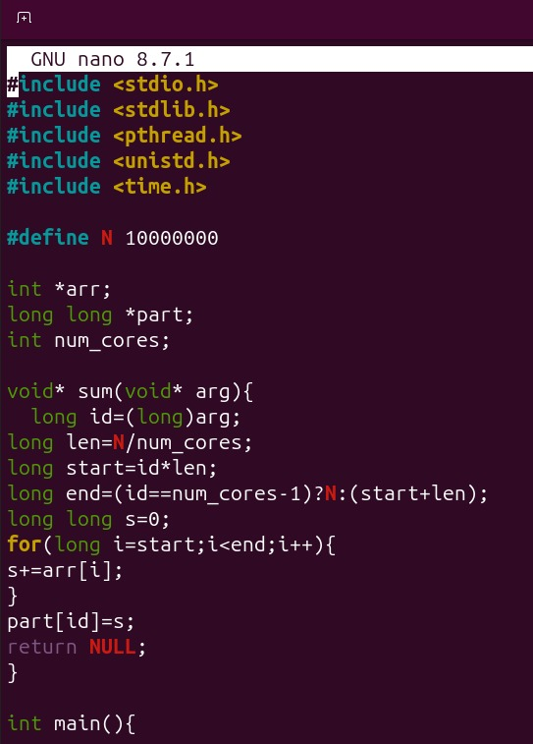
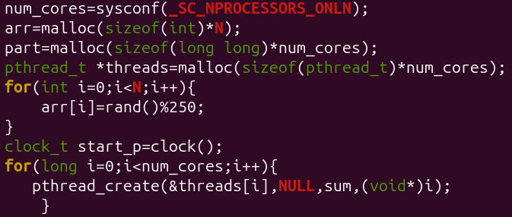
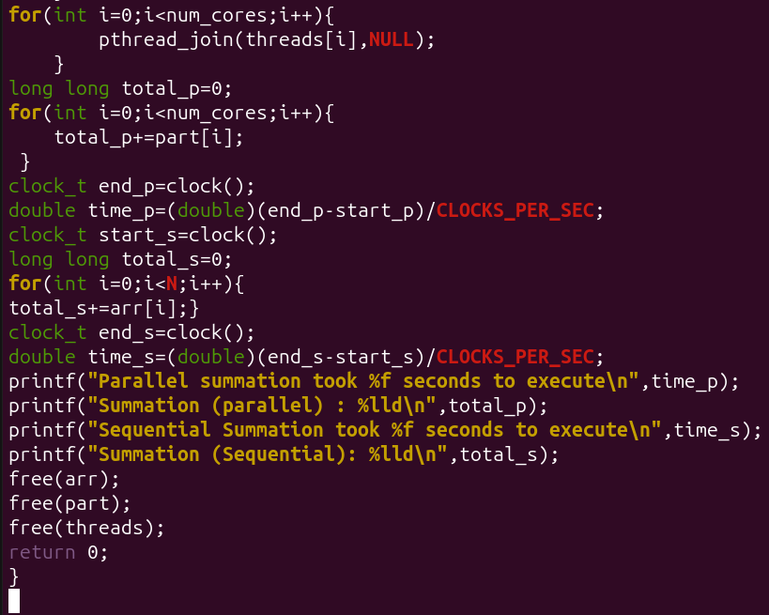
Terminal(Output)
Making folfer lab5 an dthen create Task1.c

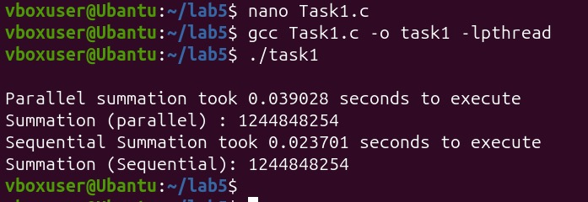

Conclusion:
This program splits a huge array into smaller parts so every processor core can work on a chunk at the same time. Doing the math in parallel helps the computer finish the total sum much faster than adding the numbers one by one. To make sure everything works right, the program also runs a normal single-line loop to check the answer. Comparing both results shows that the math is 100% accurate because both totals end up exact same. It also shows us how much time we save when we use all cores together instead of just one. Overall, it is a basic and clear way to see how multithreading speeds up big tasks on your computer.
.

