 | AIR UNIVERSITY
 | DEPARTMENT OF COMPUTER ENGINEERING
 | EXPERIMENT NO: 2

Lab Tittle: System Call and Operating System Interface
Name: | Muhammad Waqas | Reg No: | 240756
Name: | Muhammad Abuzar | Reg No: | 240736
Objectives: Understanding the concept of System Calls

LAB ASSESSMENT:

Attributes | Excellent (5) | Good (4) | Average (3) | Satisfactory (2) | Unsatisfactory (1)
Ability to Conduct Experiment
Ability to assimilate the results
Effective use of lab equipment and follows the lab safety rules

Total Marks: Obtained Mark: _____________________

LAB REPORT ASSESSMENT:

Attributes | Excellent (5) | Good (4) | Average (3) | Satisfactory (2) | Unsatisfactory (1)
Data presentation
Experimental results
Conclusion

Total Marks: __________________ Obtained Marks: _______________

DEPARTMENT OF ELECTRICAL & COMPUTER ENGINEERING
OPERATING SYSTEMS LABORATORY
Lab Report: 2
Tittle: System call and Operating system interface
Name: Muhammad Waqas, Muhammad Abuzar
Reg. No: 240756, 240736
Submitted To: CE- Engr. Mam Javeria Razzaq
Date: 19 Sep, 2026

Experiment No: 1
Task 1:
Process Identification
Write a program using:
getpid()
getppid()
Display: ● Current PID ● Parent PID
Code
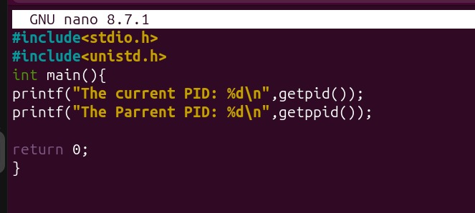

Terminal(Output)
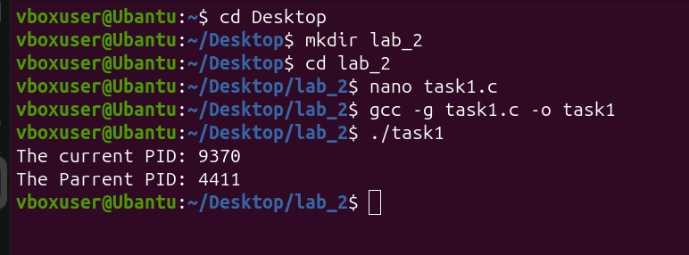

Task 2
Process Creation Use: fork()
Display:
● Parent PID
● Child PID
● Parent's PID from child

Code
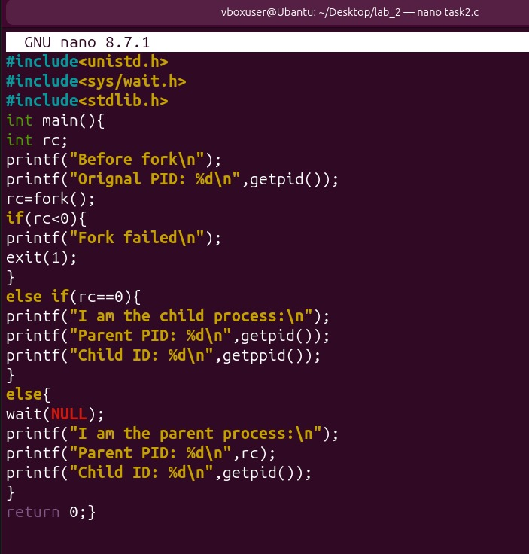

Terminal(Output)
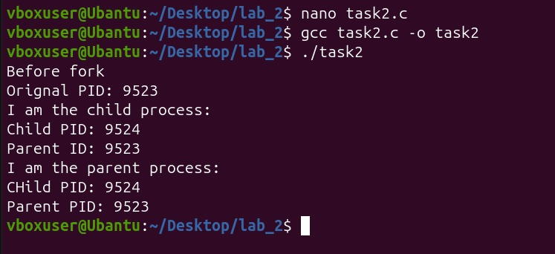

Task 3
Process Synchronization Use:
fork() wait() sleep() exit() The child should sleep for 3 seconds and terminate. The parent should wait for it.
Code
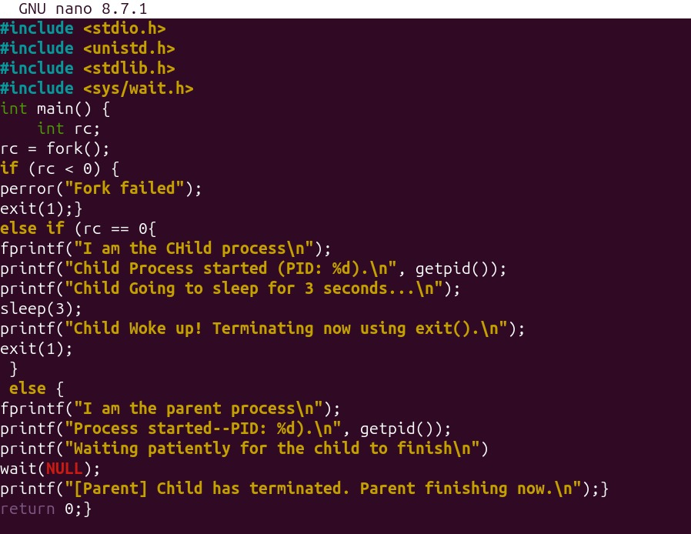

Terminal(Output)
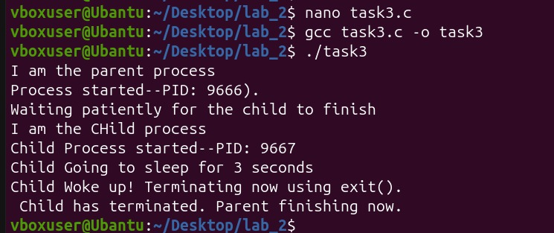

Task 4
File System Calls Use: open() write() close() open() read() close()
Create: data.txt Write a message and then read it back
Code
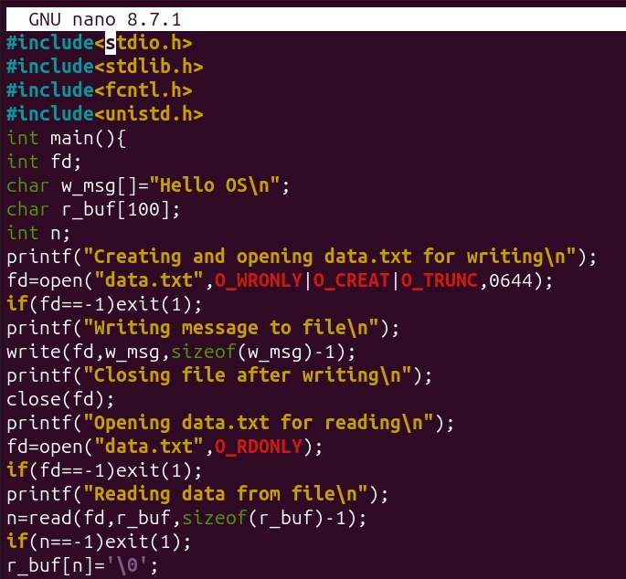
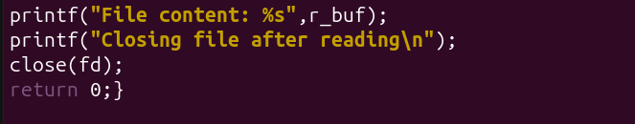
Terminal(Output)
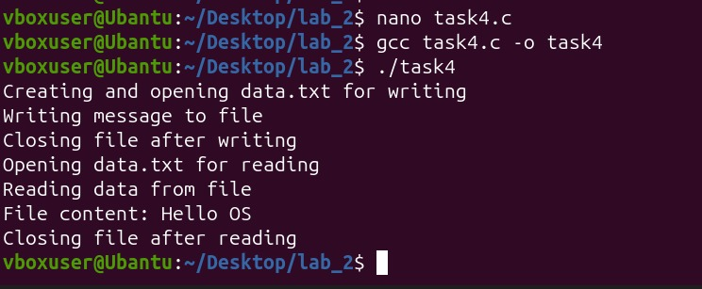

Txt File
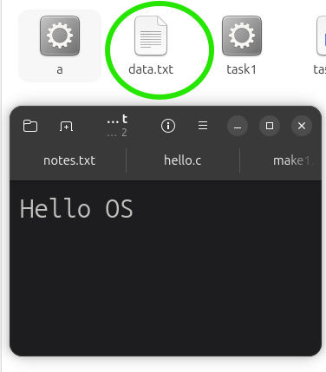

Post Lab Task:
Task 2: Child Process Performing File Operations
Write a C program that performs the following:
1. The parent process creates a child using fork().
2. The child process displays: Its PID using getpid(). Its parent's PID using getppid().
3. The child creates a file named: data.txt using open().
4. The child writes the following message into the file using write():
This file is created using Linux system calls.
5. The child closes the file using close(). 6. The child terminates using exit().
7. The parent waits for the child using wait().
8. After the child terminates, the parent displays: Child completed the file operation. Parent process continues.

Code:
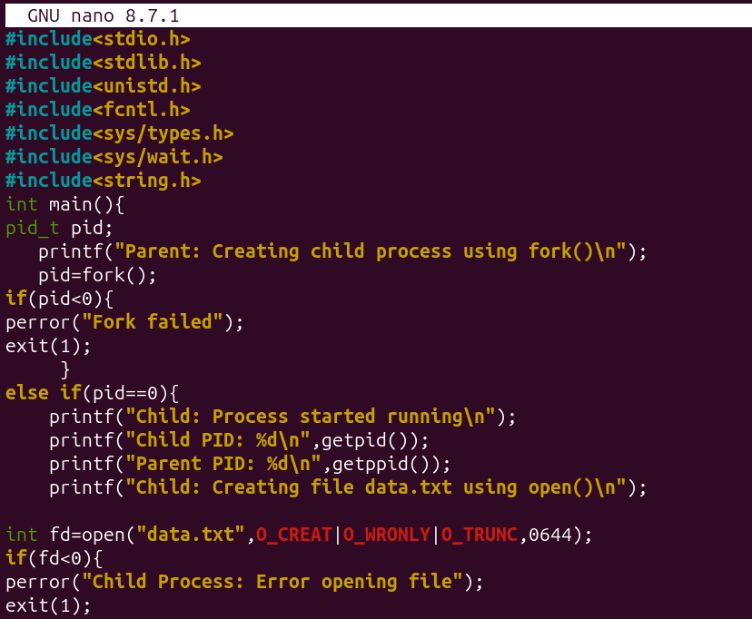
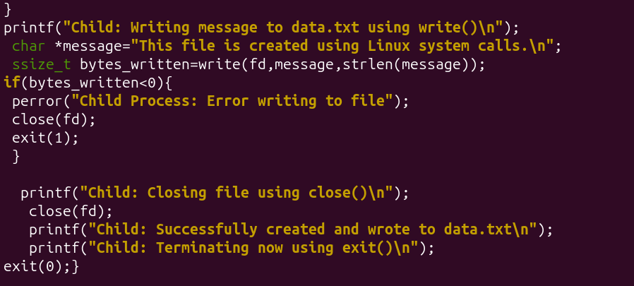
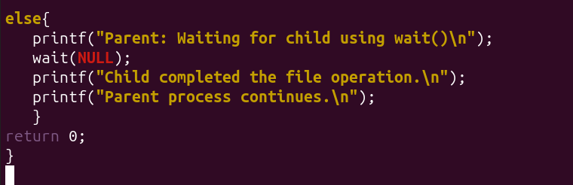

Terminal commands
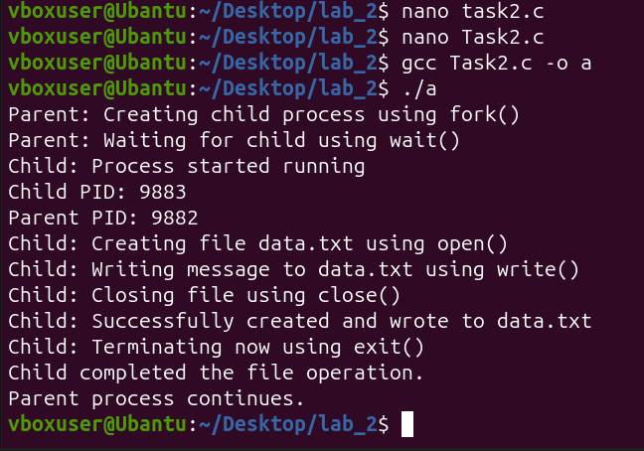

Conclusion:
This lab successfully showed how C programs communicate directly with the Linux operating system kernel. By using getpid() and getppid(), I learned how the system identifies and tracks different running programs using unique ID numbers. The fork() command showed me how a parent process can create a copy of itself to handle separate work. Using sleep() and wait() taught me process synchronization, proving how a parent can pause its own execution until its child process finishes running completely. Finally, using open(), write(), and close() demonstrated how to handle files at a low level without using standard high-level libraries. In conclusion, these tasks helped bridge the gap between textbook concepts and practical, hands-on terminal programming.

