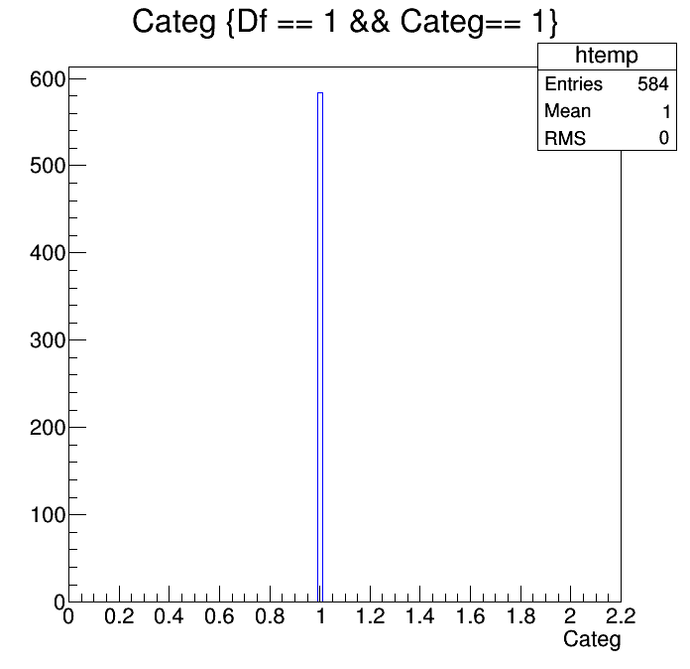
Signal
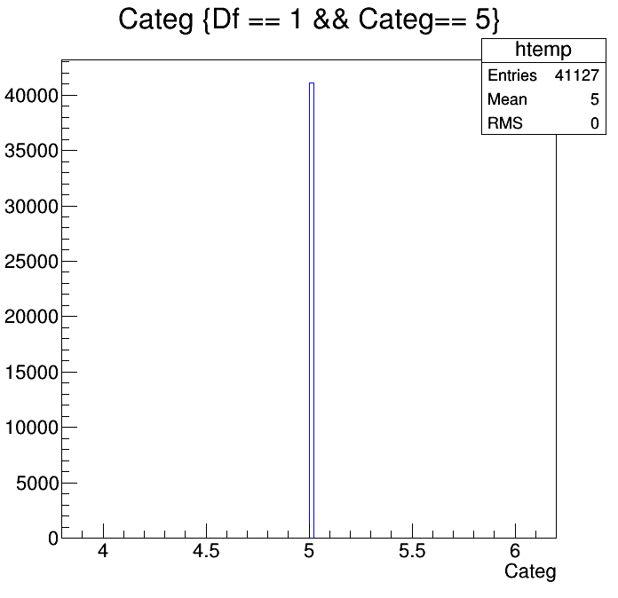

Category 1 Category 5
Background
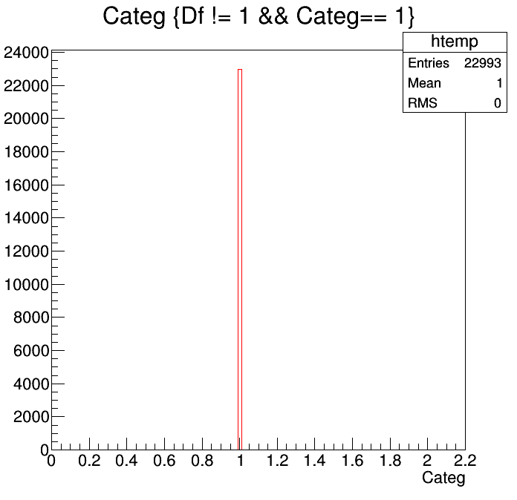
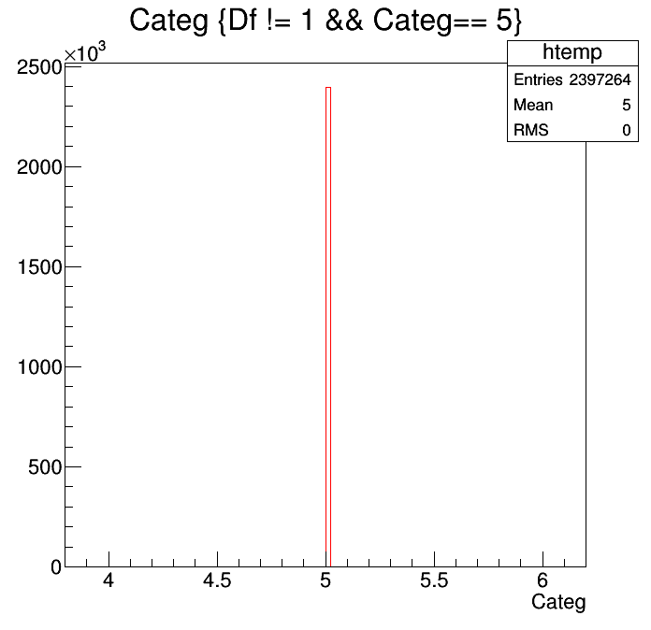

Category 1 Category 5

Expected improvement in sigma_Acp = sqrt(1+(584 / 41,127)) - 1
= 1.007 -1.0 = 0.007 (or 0.7%)

So including category-1 may not be worth the effort

