* Docker image is a software which is either locally stored or on the Docker hub
* A container is an instance of the docker image.
* An image can be run on multiple containers
* *Docker run “image-Name” –* this command tries to check if the image exists locally

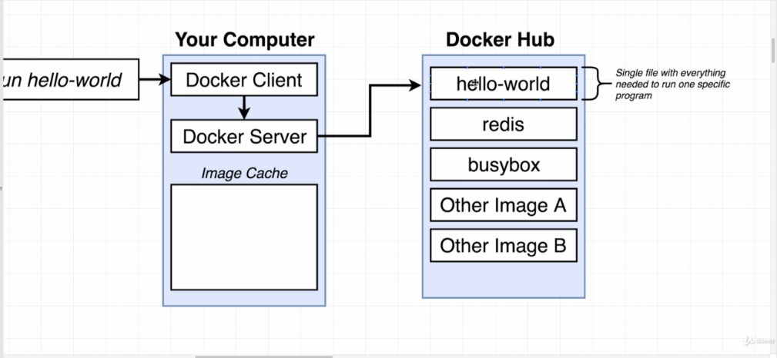

The docker CLI tries to find the image in the local cache, if not found, downloads it from docker hub and stores a copy in the local image cache.