**CSU Migration Factory (CMF):**

**Database Migration Service (DMS 2.0) Automation User Guide**

**For Script: CMF_DMS_SQLandSKUAssessmentsCombo_v1.2**



**Document Summary**

|  |  |
| --- | --- |
| **Document Item** | **Current Value** |
| Document Title | CMF Database Migration Service (DMS) Automation User Guide |
| Program | CSU Migration Factory |
| Date Last Modified | 23-Jul-2024 |
| Date Last Reviewed | 06-Sep-2023 |
| Current Document Known Issue | N/A |
| Status | Final |
| Document Description | This document provides automation details of how to automate the assessment of SQL Servers using DMS. |

**Revision History**

This section represents the change history of the document. Revisions of the document must be tracked by identifying a new version number, the date it was modified, the person making the change, and the reason for the change.

|  |  |  |  |  |
| --- | --- | --- | --- | --- |
| Date | Version | Change Description | Author | Reviewer |
| 06-Sep-2023 | 1.0 | Initial Version | Chethan, Mukesh, Lekshmy, Arun | Rackimuthu Kandaswamy |
| 23-Jul-2024 | 1.1 | Second Version | Arun, Lekshmy, Chethan | Rackimuthu Kandaswamy |

Contents

1. Executive Summary 5

1.1 Objective 5

1.2 Approach 5

1.3 Recommendations 5

2 Assessment Database Overview 6

2.1 DMS Assessments to migrate to Azure SQL Database(s) 6

3 Prerequisites for DMS Assessment - Execution 7

3.1 Non-Mission-Critical system 7

3.2 Operating System Requirements 7

3.3 Input Excel File 8

3.4 Windows User credentials 9

3.5 Storage Space & Folder read write permission 10

3.6 SQL User Credentials 10

3.7 Internet access to the below URLs: 10

3.8 Without Internet access to the URLs 10

3.8.1 Installing .NET Framework 4.8 11

3.8.2 Installing NET Core runtime 6.0.21 13

3.8.3 Installing Excel Import Module 16

3.8.4 Installing Az.DataMigration and Az.Accounts Modules 20

3.9 PowerShell Version, Modules & Execution policy 24

3.10 Connectivity 24

4 Copying Script 24

4.1 Folder Name 24

4.2 Script and Input file 25

5 Preparing the INPUT EXCEL file 26

6 Executing the Script 27

6.1 DMS assessment execution 27

6.2 DMS SKU assessment execution 35

7 Terminating/Stopping the Script SKU Execution 37

8 Azure Data Studio v1.45.1 manual installation (Optional step) 39

# Executive Summary

## Objective

This document is to provide detailed procedure/step to use the **Database Migration Service (DMS)** automation script (CMF_DMS_SQLandSKUAssessmentsCombo_v1.2) to detect/assess the following issues in on-premises SQL Servers:

* Migration blocking issues:
  + To discover compatibility issues that block migrating on-premises SQL Server database(s) to **Azure SQL Database**
  + To discover the compatibility issues that block migrating on-premises SQL Server database(s) to **Azure SQL Managed Instance**
  + To discover the compatibility issues that block migrating on-premises SQL Server database(s) to **SQL Server on Azure Virtual Machines**
* And to initiate & terminate the **data-collection** process for the **target** SKU assessment.

## Approach

This was devised to list the process to perform the SQL Server bulk assessment using DMS automation script which includes leveraging Microsoft Assessment and Planning Toolkit’s database discovery report along with additional SQL Server Connection parameters.

## Recommendations

Key recommendations are as follows:

1. Run the script on Non-Mission-Critical systems ONLY (i.e. **NOT** on any production server)
2. Operating System supported: System Windows Server 2019 & above, Windows Server 2016, Windows 10, Windows Server 2012, Windows Server 2008/2008 R2, Windows 7, Windows 8, Windows 8.1, Windows 7 64-bit and above
3. Ensure Connectivity exists to SQL Server for which the assessments are to be performed

**Note**: The values present in the Screenshots are demo values. Please change the values as Appropriate.

# Assessment Database Overview

## DMS Assessments to migrate to Azure SQL Database(s)

# Prerequisites for DMS Assessment - Execution

## Non-Mission-Critical system

* **Don't install and run the Database Migration Service directly on the SQL Server host machine or any mission-critical production server**
* **System will have been rebooted for the pre-requisites (like .NET Framework) as shown below**

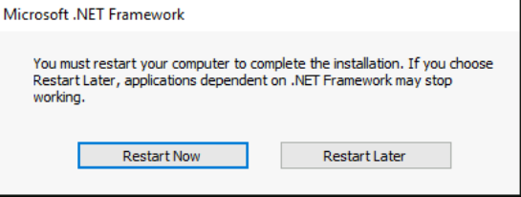

## Operating System Requirements

* Supported Operating System

Windows Server 2019, Windows Server 2016, Windows 10, Windows Server 2012, Windows Server 2008/2008 R2, Windows 7, Windows 8, Windows 8.1

Windows 7 64-bit and above

## Input Excel File

* **Important Notes:**
* This script is based on the worksheet named ‘input-to-DMS-for-assessment’ and following columns in worksheet of the Input Excel file:
* Worksheet name in the INPUT EXCEL FILE must be **input-to-DMS-for-assessment**
* **Column Name must be kept as shown below, change in names will result in errors**
* **Values in the column must be correct, incorrect values will also result in errors**
* If there is only one server/instance to be assessed using the script, please add a duplicate line with same server information to avoid an input related issue

|  |  |
| --- | --- |
| **Column Name** | **Note** |
| **Computer Name** | **SQL Server Name (e.g. 01SQLDEV001)** |
| **SQL Server Instance Name** | **SQL Server Instance Name (e.g. MSSQLSERVER)** |
| **Target SQL Server Version** | **Target SQL Server Version (e.g. Microsoft SQL Server 2016)** |
| **Authentication type** | **Authentication type (e.g. either Windows Authentication or SQL Server Authentication)** |
| **DBUserName** | **Database User Name (e.g. sa) in case of SQL Server Authentication. User must be member of the SQL Server sysadmin role** |
| **DBPassword** | **Database User Password in case of SQL Server Authentication** |
| **DBPort** | **Database Port (e.g. 1433)** |
| **KeyVaultSubscriptionId** | **Subscription ID to be entered** |
| **KeyVaultName** | **KeyVaultName to be entered** |
| **KeyVaultSecretName** | **KeyVaultSecretName to be entered** |

Note: If SQL Server is running on a cluster, “**Computer Name”** Column value should be updated with SQL Cluster name.

**“SQL Server Instance Name”** Column value should be updated with “**MSSQLSERVER”** fordefault SQL Instances

|  |  |  |
| --- | --- | --- |
| **Seq.No** | **File** | **Note** |
| 1 |  | Sample: DMS-INPUT-FILE |
| 2 |  | Sample: MAP (SQL Server) Discovery report where Database Instances Worksheet will have the SQL Server details. This may be used with additional four columns for the DMS assessment automation. |

## Windows User credentials

Windows user must have privileges to install the following software & PowerShell module:

* .NET Core 6.0.21
* .NET Framework 4.8
* ImportExcel Powershell Module
* Az.DataMigration and Az.Accounts Powershell Modules

## Storage Space & Folder read write permission

Windows user must have a privilege to create folder and write the assessment results to that folder

Minimum disk free space required is 200MB

## SQL User Credentials

SQL User must be member of the SQL Server **sysadmin** role in case of SQL Server Authentication

## Internet access to the below URLs:

|  |  |
| --- | --- |
| **URL** | **Note** |
| <https://go.microsoft.com/fwlink/?linkid=2088631> | .NET Framework 4.8 |
| <https://download.visualstudio.microsoft.com/download/pr/31949bf4-c9ef-4e57-9da2-d798ab8b8bbf/fb7a481d9381bb740223629422a006e0/dotnet-runtime-6.0.21-win-x64.exe> | .NET Core runtime 6.0.21 |
| <https://go.microsoft.com/fwlink/?linkid=2242848> | Azure Data Studio v1.45.1 (Optional step) |

## Without Internet access to the URLs

**Note:** Follow the instructions below to download all the software manually to a server where internet connectivity is enabled. Once all the software is downloaded, move all of them to the server where DMS automation script will be executed and install all of them one by one.

### Installing .NET Framework 4.8

1. Paste the download link in web - <https://go.microsoft.com/fwlink/?linkid=2088631>



1. Launch the downloaded offline installer **ndp48-x86-x64-allos-enu.exe,**

1. Read and accept the license terms.
2. Click on Install.

1. Once the installation is complete, restart the computer.

### Installing NET Core runtime 6.0.21

1. Paste the download link in web - <https://download.visualstudio.microsoft.com/download/pr/31949bf4-c9ef-4e57-9da2-d798ab8b8bbf/fb7a481d9381bb740223629422a006e0/dotnet-runtime-6.0.21-win-x64.exe>



1. Launch the downloaded offline installer **dotnet-runtime-6.0.21-win-x64**
2. Click on Install.

1. Once the installation is complete, click on close.

### Installing Excel Import Module

1. Open Browser and navigate to the link <https://www.powershellgallery.com/packages/ImportExcel/7.4.1>
2. Click On Manual Download

1. Now Click on Download the raw nupkg file.
2. The file will be downloaded to Downloads folder

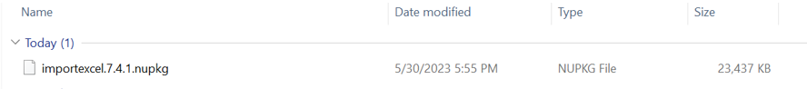

1. Right Click Properties-> and unblock the file -> Apply.

1. Rename the file as ImportExcel.zip.



1. Extract the zip RightClick-> Extract All

1. Goto Run Button -> Type Powershell and click on -> Windows PowerShell

1. Run the command. $env:PSModulePath which will list all the Environment variable paths for PowerShell Module



1. Navigate to the path which reflects with Program Files or ProgramFiles(X86) to the Respective modules Folder via FileExplorer and paste the extracted file (i.e. Step7)

Execute the below command from windows PowerShell as Administrator.

* **Import-Module ImportExcel**



### Installing Az.DataMigration and Az.Accounts Modules

1. Open Browser and navigate to the link

[PowerShell Gallery | Az.DataMigration 0.14.1](https://www.powershellgallery.com/packages/Az.DataMigration/0.14.1)

[PowerShell Gallery | Az.Accounts 1.1.0](https://www.powershellgallery.com/packages/Az.Accounts/1.1.0)

1. Click On Manual Download

1. Now Click on Download the raw nupkg file.
2. The file will be downloaded to Downloads folder

1. Rename the file as Az.DataMigration.zip

1. Right Click Properties-> and unblock the file -> Apply.

1. Extract the zip RightClick-> Extract All

1. Goto Run Button -> Type Powershell and click on -> Windows PowerShell

1. Run the command. $env:PSModulePath which will list all the Environment variable paths for PowerShell Module



1. Navigate to the path which reflects with Program Files or ProgramFiles(X86) to the Respective modules Folder via FileExplorer and paste the extracted file (i.e. Step7)

1. Similarly, follow the same steps for installing the Az.Accounts Module

Execute the below command from windows PowerShell as Administrator.

* **Import-Module Az.DataMigration**

* **Import-Module Az.Accounts**



## PowerShell Version, Modules & Execution policy

Execute the below commands from windows PowerShell as Administrator.

1. To find the PowerShell Version

* Get-Host

1. Set the PowerShell execution policy

* **Set-ExecutionPolicy Unrestricted -Scope CurrentUser**



## Connectivity

Connectivity must exist between the SYSTEM which runs the DMS assessment and SQL Servers which are to be assessed.

# Copying Script

## Folder Name

* Login into a Non-Mission-Critical system (i.e. **NOT** on any production server) from where the DMS assessment is to be run
* Create a folder C:\DMS(you may choose any available drive)

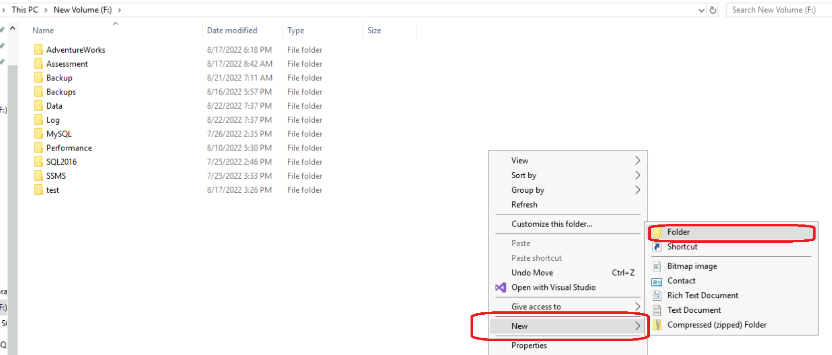

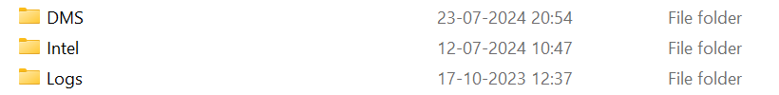

## Script and Input file

* Copy the folder named Validation_Scripts under the folder created in the previous step. For example: If DMS was the folder created in the previous step, then copy the Validation_Scripts under the DMS Folder.
* Copy the content to a file named CMF_DMS_SQLandSKUAssessmentsCombo_v1.2.ps1 under the folder created in the previous step. For example: If DMS was the folder created in the previous step, then copy the file named CMF_DMS_SQLandSKUAssessmentsCombo_v1.2.ps1 under the DMS Folder.



* Copy the content to a file named Terminate.ps1 under the folder created in the previous step.



# Preparing the INPUT EXCEL file

In Order to support the assessment process, INPUT EXCEL FILE has been driven from the Microsoft Assessment and Planning Toolkit Discover report.

**Each column will represent a SQL server instance to be assesses**

|  |  |  |  |  |  |  |  |  |  |
| --- | --- | --- | --- | --- | --- | --- | --- | --- | --- |
| **Computer Name** | **SQL Server Instance Name** | **Target**  **SQL Server Version** | **Authentication type** | **DBUserName** | **DBPassword** | **DBPort** | **KeyVaultSubscriptionId** | **KeyVaultName** | **KeyVaultSecretName** |

* Ensure the Computer Names are correct, and connectivity exists between the SYSTEM which runs the DMS assessment and Computer Name provided in the column
* Ensure the SQL SERVER Product Name is one of the below given values:
  + Microsoft SQL Server 2022
  + Microsoft SQL Server 2019
  + Microsoft SQL Server 2017
  + Microsoft SQL Server 2016
  + Microsoft SQL Server 2014
  + Microsoft SQL Server 2012
  + Microsoft SQL Server 2008 R2
  + Microsoft SQL Server 2008

Other values will result in incorrect assessment results

* Ensure that Authentication type is either **Windows Authentication** or **SQL Server Authentication** other values will result in errors
* Ensure that Database Username is correct and can connect to SQL Server instance to be assessed in case of SQL Server Authentication
* Ensure Database User Password is correct and can connect to SQL Server instance to be assessed in case of SQL Server Authentication
* Ensure Database ports are correct and can connect to SQL Server instance with this port
* Once the input file is prepared Copy the file (DMS-INPUT-FILE.xlsx) under the folder created in the previous step (C:\DMS)

# Executing the Script

## DMS assessment execution

* Open windows Command prompt as **Administrator**

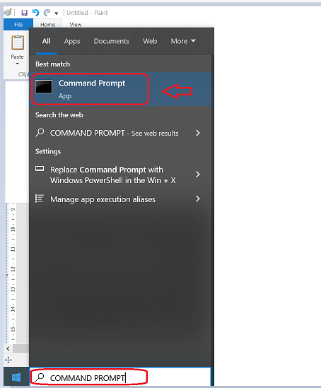

* Change the working directory/folder to the folder where you created/copied the script CMF_DMS_SQLandSKUAssessmentsCombo_v1.2ps1) in previous step

Note: The file size may change based on the current policies and bug fixes

* Enter the following command at the windows command prompt

Powershell.exe -ExecutionPolicy RemoteSigned -File .\CMF_DMS_SQLandSKUAssessmentsCombo_v1.2.ps1



* Enter assessment operation to perform by choosing values between 1 and 4

"1. Perform both SQL assessment and Performance data gathering"

"2. Perform SQL assessment only"

"3. Perform Performance data gathering only"

"4. Exit"

* If SQL Server Installation is detected, then the below screen will appear

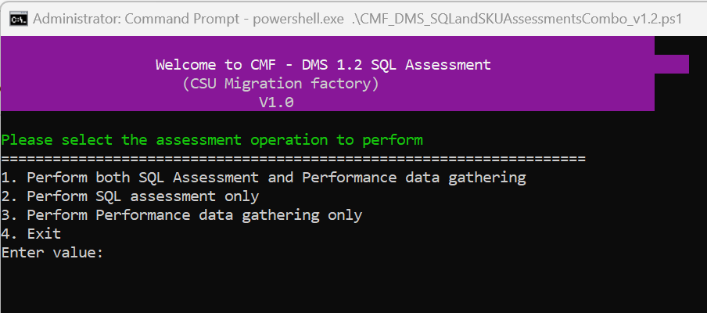

* After triggering the automation all the support folders (Archive , Output , Download etc. ) will be created automatically by the automation script in the C:\DMS folder

* + Enter Y to download & install the .net core

Ensure the internet connectivity exists to the blow URL and you have the permission to install:

<https://dotnet.microsoft.com/en-us/download/dotnet/thank-you/runtime-6.0.21-windows-x64-installer>

It will download and install **.NET core Runtime 6.0.21**

**Note: After Installation of .Net core Runtime, system needs a restart.**

* Pre-requisites Check for .Net Framework 4.8

Ensure the internet connectivity exists to the blow URL and you have the permission to install:

<https://go.microsoft.com/fwlink/?linkid=2088631>

It will download and install **.NET Framework 4.8**

* **Re-start the system**
* Enter the following command again to restart the DMS assessment process from the folder where the script is available

Powershell.exe -ExecutionPolicy RemoteSigned -File .\CMF_DMS_SQLandSKUAssessmentsCombo_v1.2.ps1



* Pre-requisites Check for PowerShell ImportExcel Module

Checks if ImportExcel Module is present, if not script automatically downloads.

* Pre-requisites Check for Az.DataMigration module

Checks if Az.DataMigration Module is present, if not script automatically downloads and also Az.Accounts Module along with it

In the Input file “DMS-INPUT-FILE.xlsx”, we have to fill in the necessary details like, “Hostname”, “SQL Server Instance Name”, “Target SQL Server Version”, “Authentication Type”, “DBUsername”,”DBPassword”,”DBPort”,”KeyVaultSubscriptionID”,”KeyVaultName” and “KeyVaultSecretName” like below:

In the above input file, if we are providing the Keyvault details, we don’t need to provide the credentials and vice versa.

Using the following method, we can get the Keyvault details (KeyvaultSubscriptionId, KeyVaultName, KeyvaultSecretName)

1. Login to Azure Portal
2. Search the KeyvaultName in the top search bar and click on the KeyvaultName

1. Click on the Secrets on the left side pane and find the KeyvaultSecretName

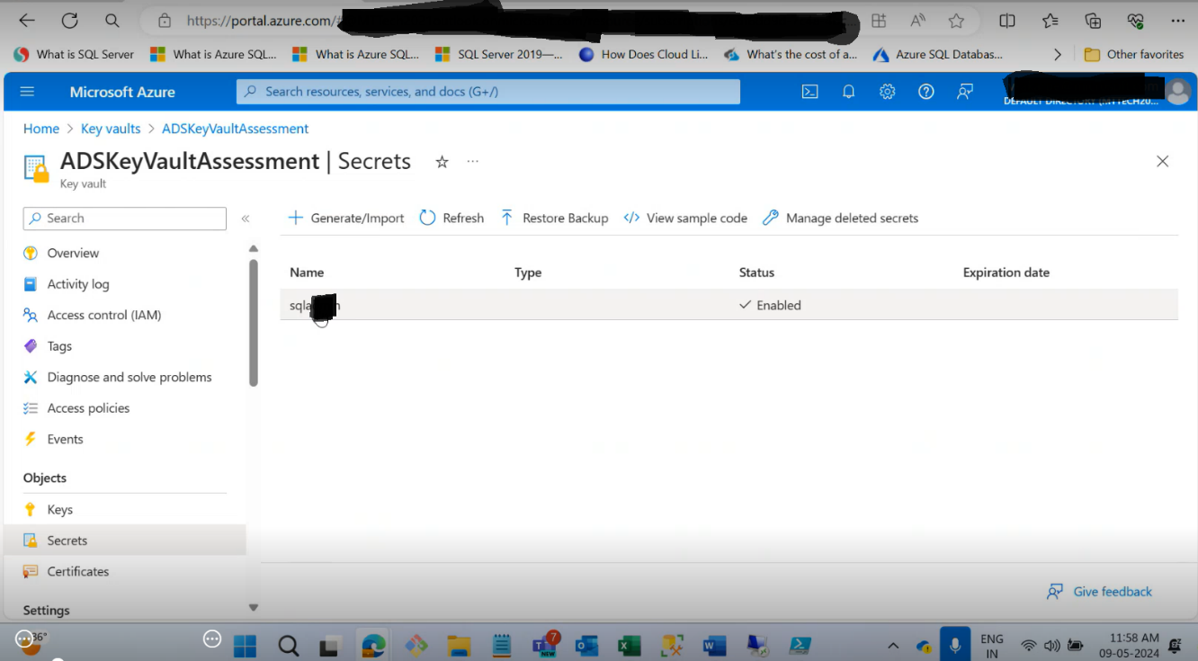

Execution of the DMS Assessment continues

## DMS SKU assessment execution

Upon pressing “Y” the console will ask for two additional parameters (Please Provide the Data Collection duration in Day/s) –

Here , please put any value between 0 to 15 .

**Note :** There might the situation user may want to run this below 24 hours , in that situation user should put 0 .

In the below example we put the day range as 2

Next the console will ask Hour value (Please Provide the Data Collection duration Hours) –

Here, please put any value between 0 to 23 . and press enter .

Note : If you put the Day value (as per 7.1) as 0 , please do not put the Hour value as 0 ( It should be anything between 1-23 )

After that the process will be initiated.

# Terminating/Stopping the Script SKU Execution

The process will continue to run as per the time range provided by the user in the last step and terminate automatically (Note – User also can terminate the process by pressing enter key.)

This will allow the performance data to be collected to select the best Azure SQL Database, SQL Managed Instance, or SQL Server on Azure VM **target** and SKU for your database. Database Migration Service (DMS) helps address these questions and make your database migration experience easier by providing these SKU recommendations. It is recommended that the performance data gathering is run for minimum four hours during the peak SQL Server workloads.

After running for a specific period, the process will stop executing on its own as per the Day/Hour values provided by the user, otherwise Press **Enter Key** in the window where the script is running.

Zip files will be created for the assessment & SKU processed, inside the Compressed folder. Share these files with CMF team to take it further for migrating on-premises databases to Azure cloud.

Press **Enter Key** to stop the execution

# Azure Data Studio v1.45.1 manual installation (Optional step)

|  |  |  |
| --- | --- | --- |
| File | Link | Note |
|  | <https://go.microsoft.com/fwlink/?linkid=2242848> | Azure Data Studio v1.45.1 (Optional step) |