**PROJECT REPORT TEMPLATE**

**INDRODUCTION:**

* We Are Five Members in A Team,

Team Lead: Susmitha R

Team Member 1:Babyshalini M V

Team Member 2: Priya s

Team Member 3: Vaishnavi V

Team Member 4: Sowmiya E

**PROJECT TITLE:**

* A CRM APPLICATIONS FOR SCHOOLS /COLLAGES

**PROJECT DESCRIPTION:**

* A CRM System helps you keep your customer’s contact details up to date, track every interaction they have with your business, and manage their accounts. Its designed to help you, improve your customer relationships, and in turn, customer lifetime value.

**DONE PROJECTS:**

* We Have done Empathy Map and Ideation & Brainstorming map,
* We Have Eight Milestone Projects and We Have Don this project.

**PURPOSE:**

* CRM software lets you store customer and prospect contact information, identify sales opportunities, record service issues, and manage marketing campaigns, all in one central location and make information about very customer interaction available to anyone at your company who might need it.

**PROBLEM DEFINITION & DESIGN THINKING:**

* **EMPATHY MAP**

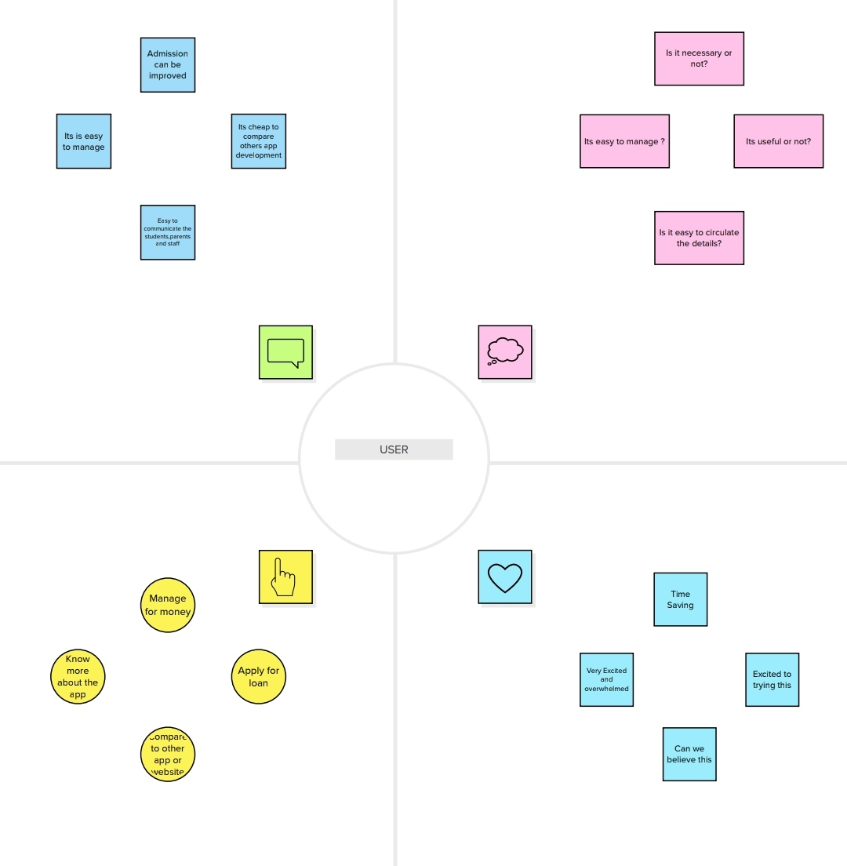

**IDEATION & BRAINSTROMING MAP:**

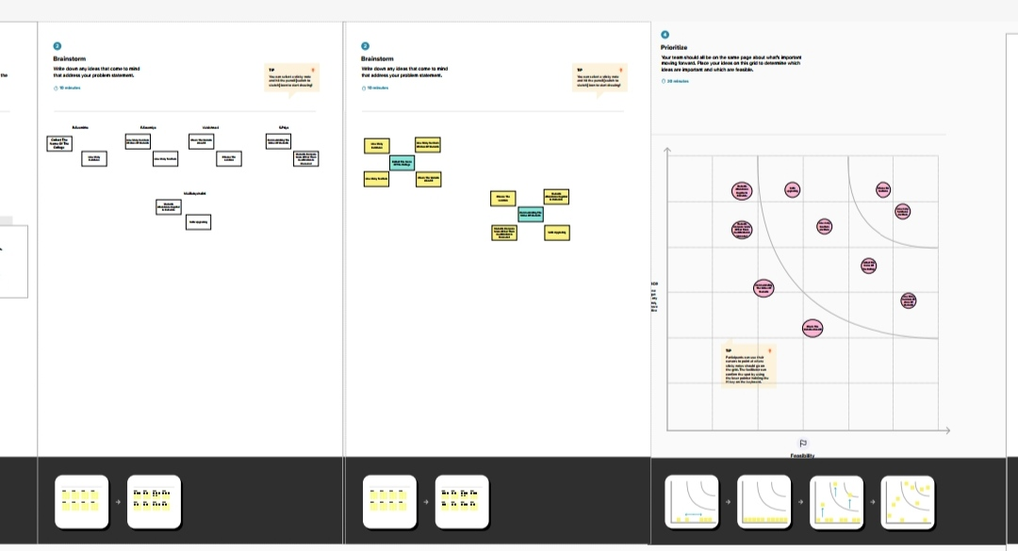

**RESULT:**

**DATA MODEL:**

|  |  |  |
| --- | --- | --- |
| **OBJECT NAME** | **FIELDS IN THE OBJECT** | |
| **OBJECT 1** | **FIELD LABLE** | **DATA TYPE** |
| **PARENT** | School Name | Text (80) |
| **OBJECT 2** | **FIELD LABLE** | **DATA TYPE** |
| **STUDENT** | School | Master-Detail (School) |
| **OBJECT 3** | **FIELD LABLE** | **DATA TYPE** |
| **SCHOOL** | Owner | Lookup (User, Group) |

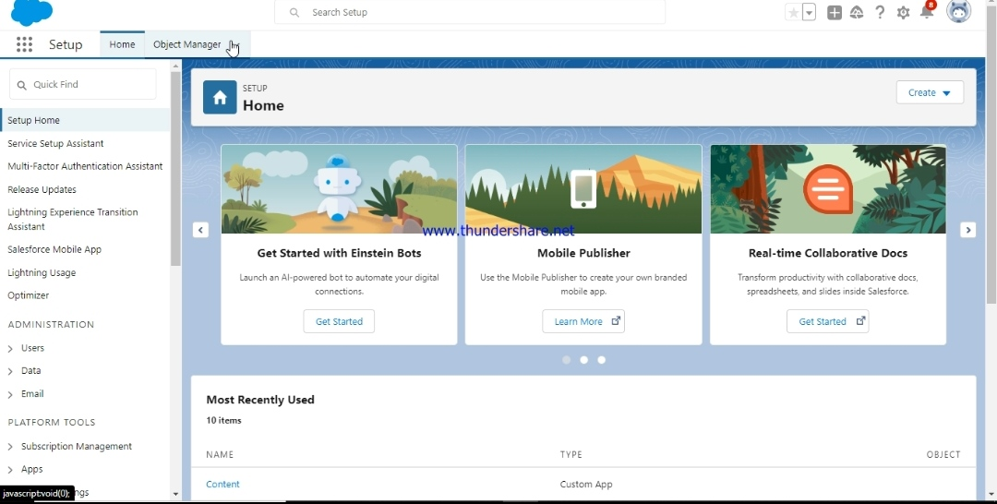

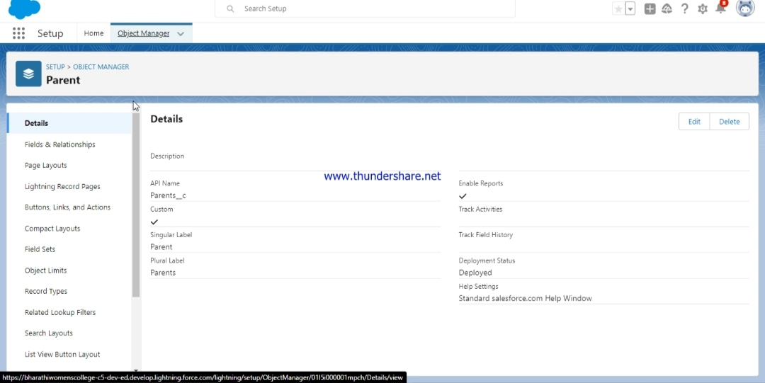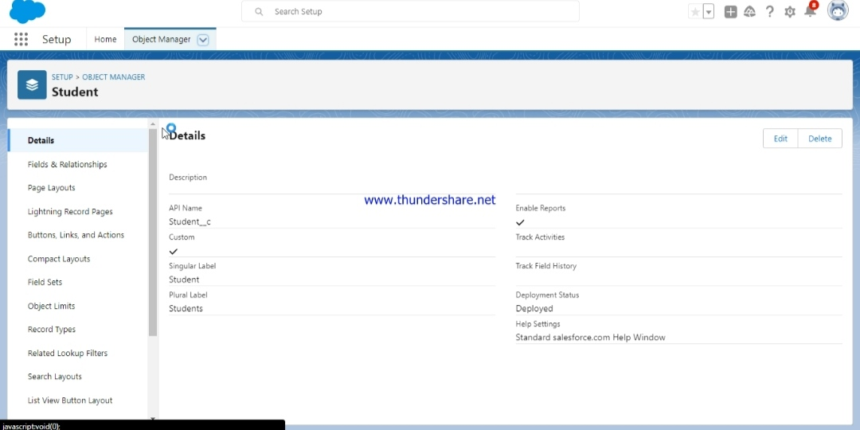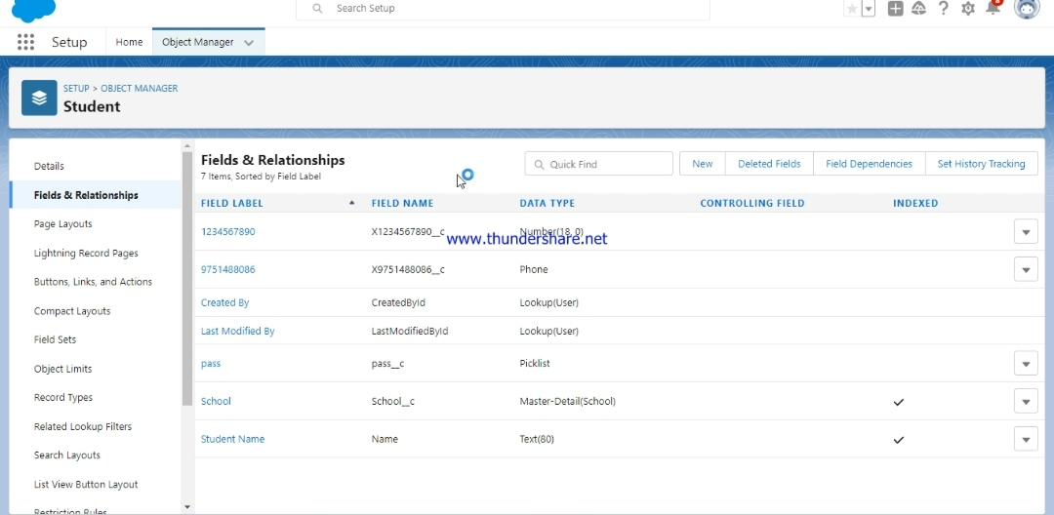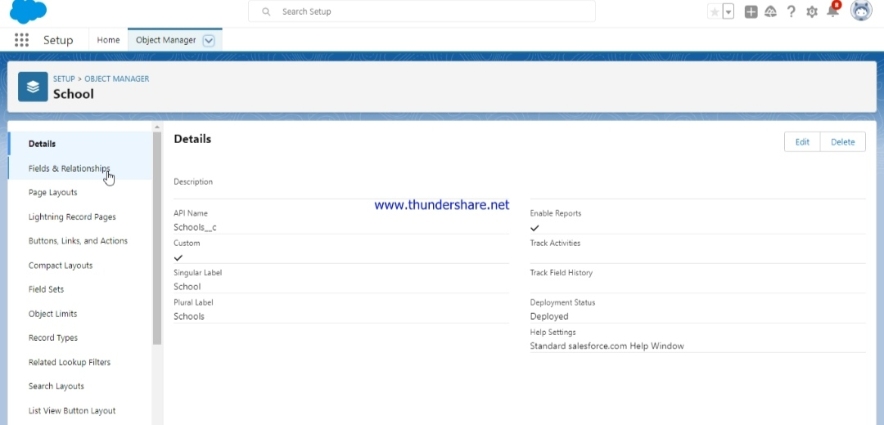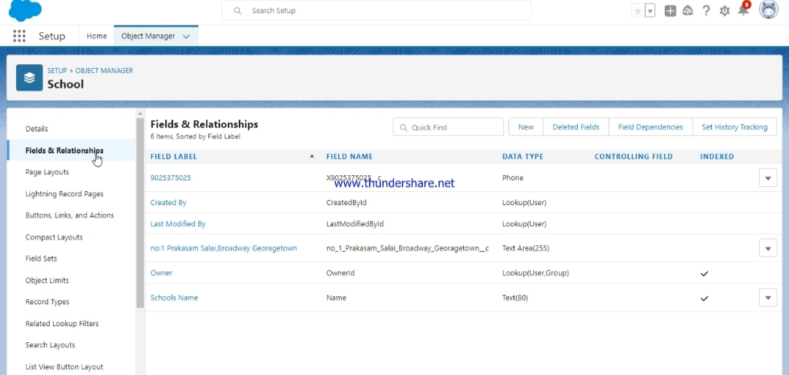

**TRAILHEAD PROFILE PUBLIC URL:**

**TEAM LEAD-**<http://trailblazer.me/id/susai20>

**TEAM MEMBER 1-** <https://trailblazer.me/id/ppriyas5>

**TEAM MEMBER 2-** <https://trailblazer.me/id/ssowmiya11>

**TEAM MEMBER 3-** <https://trailblazer.me/id/babmv>

**TEAM MEMBER 4-**<https://trailblazer.me/id/vrani39>

**ADVANTAGES & DISADVANTAGES:**

|  |  |
| --- | --- |
| **ADVANTAGE** | **DISADVANTAGE** |
| * Better Knowledge of Customers | * Costly |
| * Retain More customers | * Training |
| * Minimizes Cost | * Security Issues |
| * Increase Business Growth | * Eliminates Human Element |

**APPLICATIONS:**

* Customer relationship Management (CRM) is a set of Integrated, data-driven software solution that help manage, track, and store information related to your company’s current and potential customers.

**CONCLUSION:**

* In Conclusion, Sollid Performers CRM stands Out as the best CRM application for school and colleges due to its unique features and benefits. From streamlining the admissions and enrolment process to efficient student and faculty management, and a customizable and scalable solution, solid performers CRM offers a comprehensive solution to address the diverse needs of educational institutions.

**FUTURE SCOPE:**

* The future Of CRM is about which companies will be able to pivot to meet the changing needs and trends driven by customer expectations. Customers expect to organizations to know a lot about them and expect to have conversations.

**THANK YOU!**