- Exporting the Excel table isn't working.
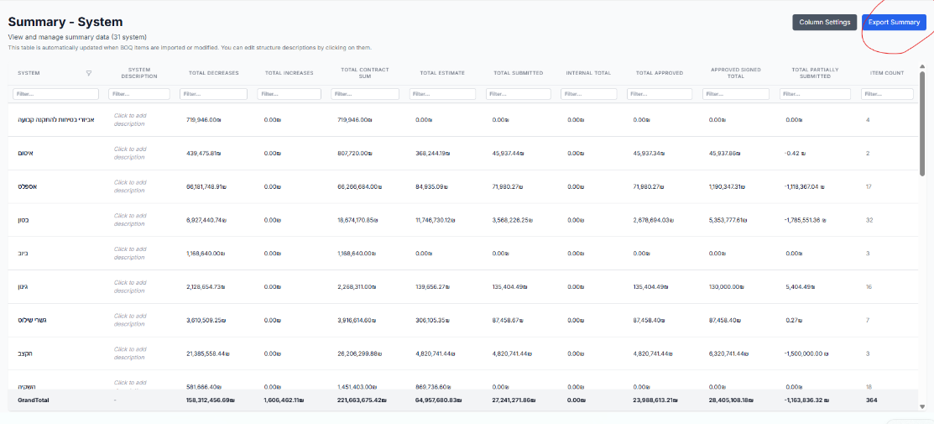

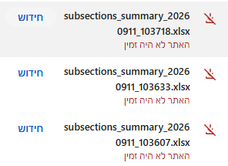

- OLD NOTE
When the system reads the signed, approved PDF,
Can it automatically update the data:
Invoice Date for Approved Signed QTY
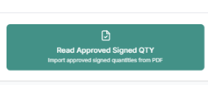

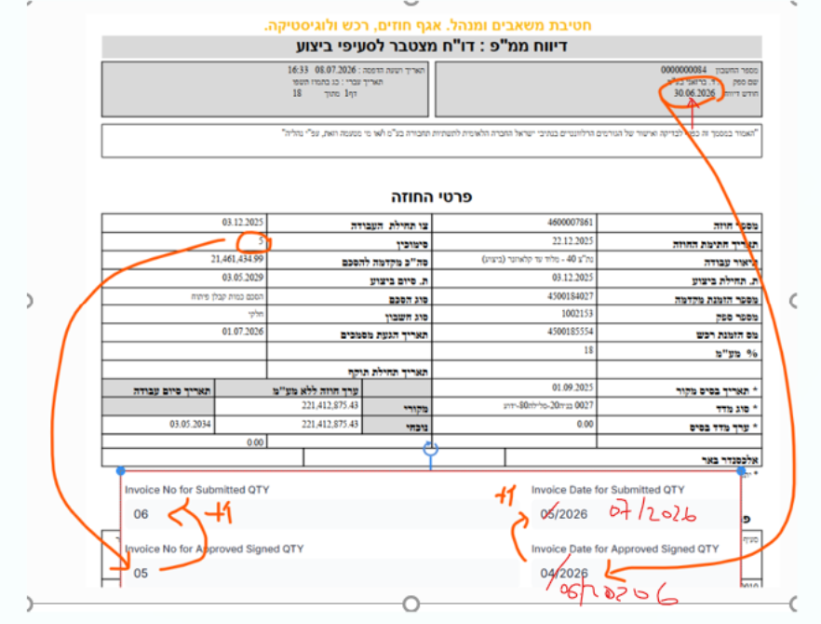

Let me know if it is possible !!

- Can The system allow me to navigate from the item no. in BOQ sheet to Concentration sheets of the items by clicking on the item
I know I have this option by clicking on the view sheet in actions column in BOQ sheet
can make it both ?

And also from Conc. Sheets to BOQ sheet via clicking on the item no. in Conc. sheets

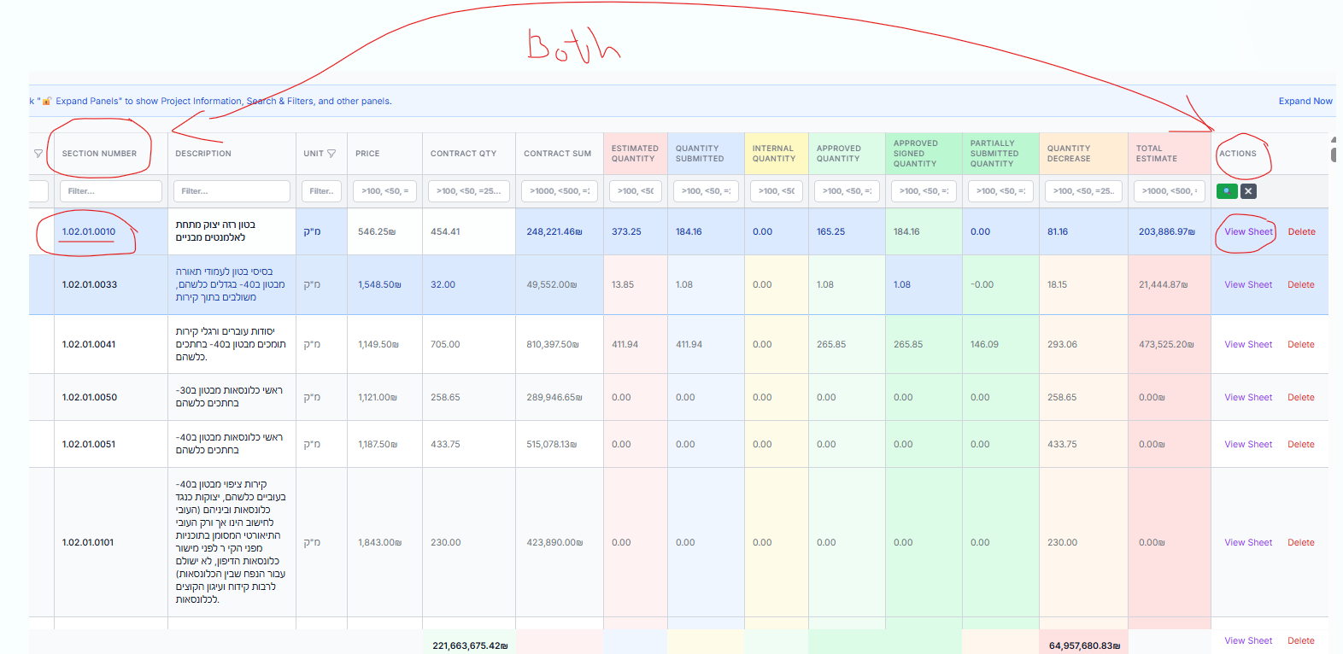

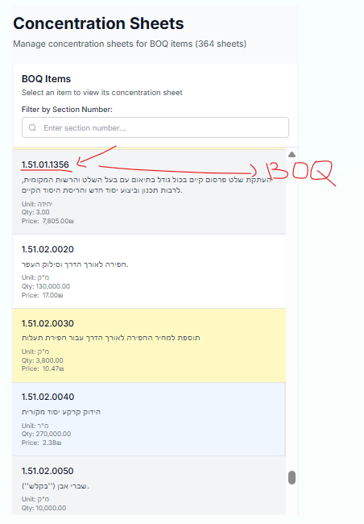

- NOTE 8 in previous NOTES you managed
the system outputs files to the FATINA folder based on the calculation sheet number and output them based on the invoice number in the same item folder !!
It creates a mess in the folder; it would be better to have two separate folders—for example, "FATINA" and "FATINA INVOICE."

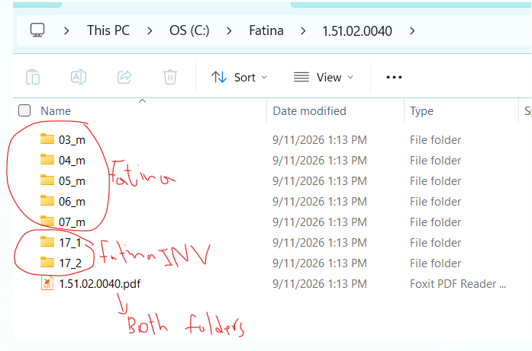

- On the Concentration sheets, color the text (e.g., red) for entries where the approved Qty does not match the submitted Qty.
approved Qty does not match the estimated Qty.

System gives two options that I choose
It makes it easier for me to track the unapproved quantities.

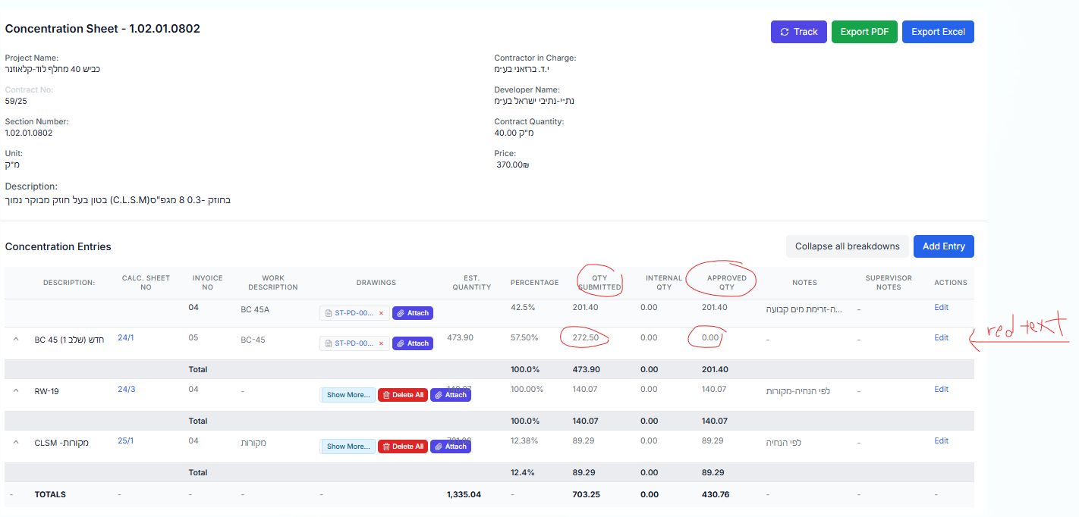

- Not necessary - but good to be
How can I go from Concentration sheets to Calculation sheet directly ?
As for now I can open it directly from conc. Sheets which is needed , but if I have to Track it I have to go to Calculation sheets and just then search the calc. sheet I need to track by right the calc. sheet number and then track it !!

- Filter by word in the Concentration Sheets

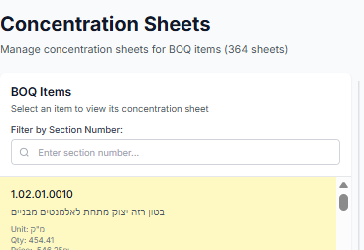

Is it possible to search also via words in the Work Description and Description
so system gives me all items has this word I’m searching for
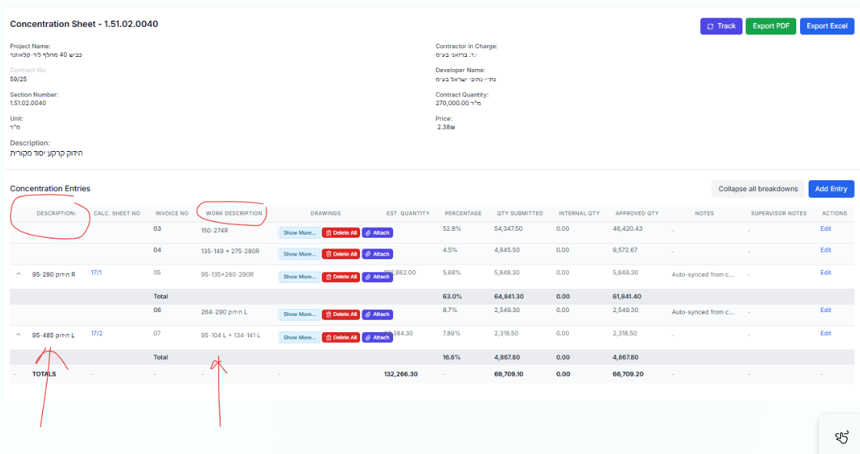
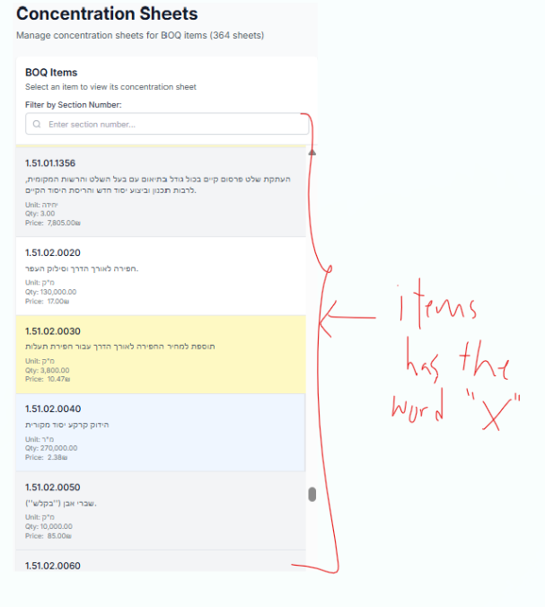

- Not necessary - but good to be
Hide columns in the Conc. Sheets for convenience


- Once I do the
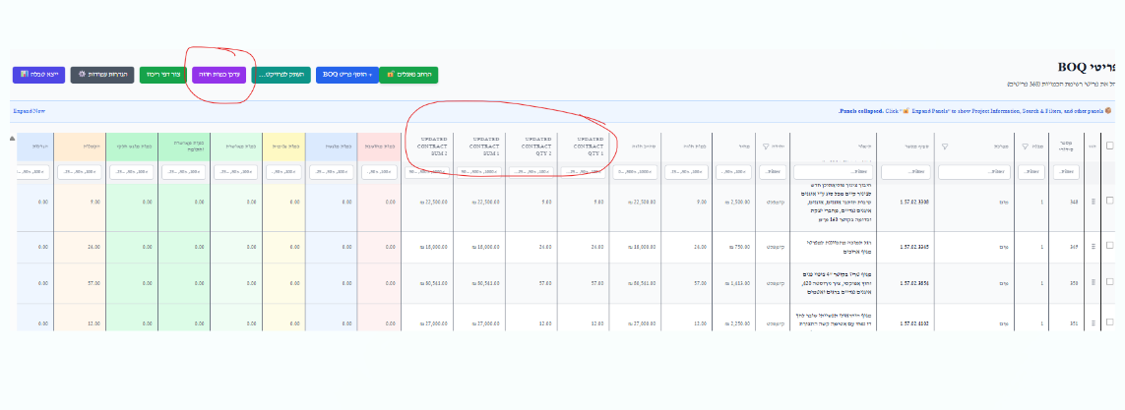
In the Hebrew version I get the titles in English not in Hebrew
Should be written in Hebrew
כמות חוזה מעודכנת מס' 1updated contract QTY 1
סה"כ חוזה מעודכן מס' 1updated contract sum 1
- Once I do the

I noticed that in the Conc. Sheets I get a mark that the original qty is changed which is great ( but needed just for the items quantities been changed from the quantity before not for all items !!! for now system gives for all items this note )
Means – item 01.02.01.0020 original quantity is 200
Updated quantity no. 1 is 250 ( system should give the sign)
Updated quantity no. 2 is 250 (system should not give the sign)
Means the Comparison should be between new and last old quantity !!
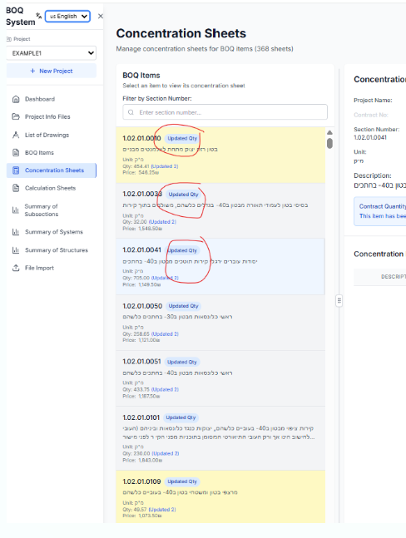

- Not necessary - but good to be

Calculator to be added in the side – so can open it where ever from any sheet in the system

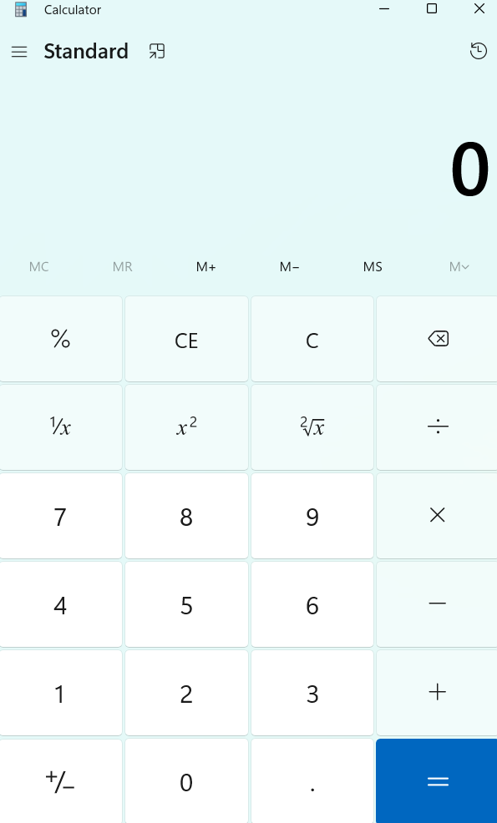

- OLD NOTE no. 2

Slider marker is needed in Concentration window and in all tables for all columns if possible (you did perfectly for the Concentration Sheets)
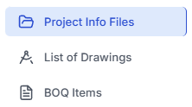

- I noticed that system gives an error while uploading Calc. sheets which in line 2 in is written an inscription with a specific sequence of letters or numbers.
System should give me the option for any Spontaneous caption
The error I got :
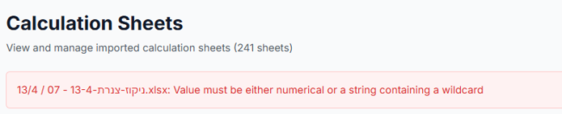

- VERY IMPORTANT
If the Calc. Sheet is set up for INVOICE 06, for example, and later on I changed to 07, the total will be incorrect.
I need to delete the entire calculation sheet and uploading again, which is not convenience!!
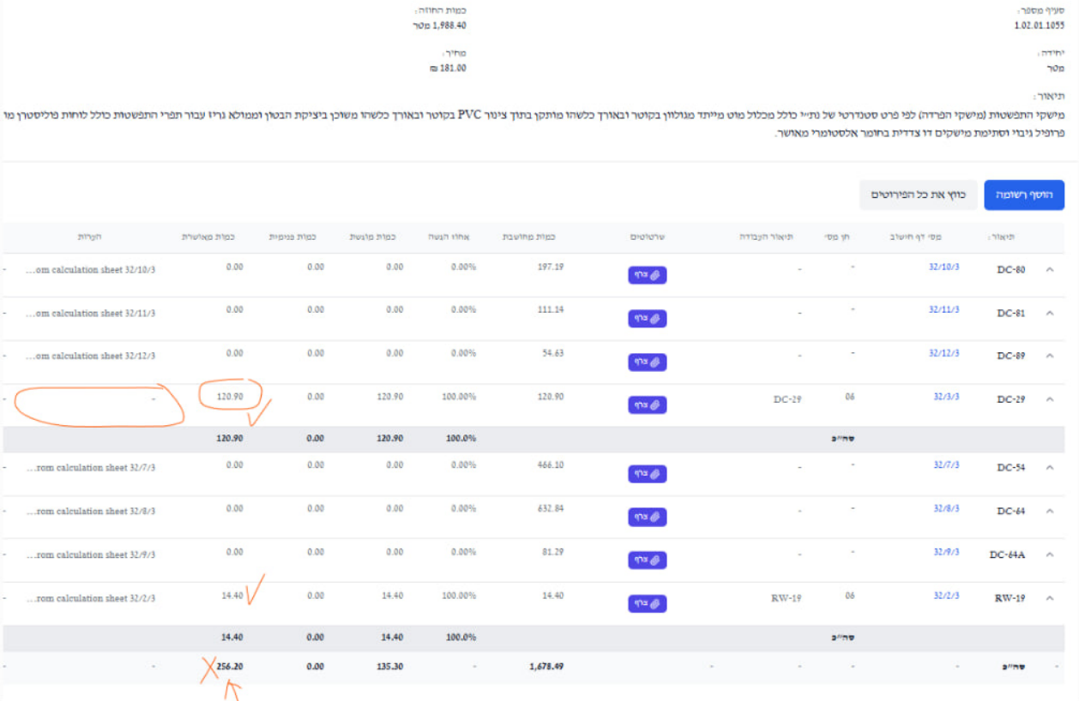

- VERY IMPORTANT
I noticed too that
If I have two or more items on a calculation sheet—for example:
item X is submitted as 'Invoice 07' and item Y is submitted as 'Invoice 06'
the FATINA file for Item Y gives me also 07_m !!!

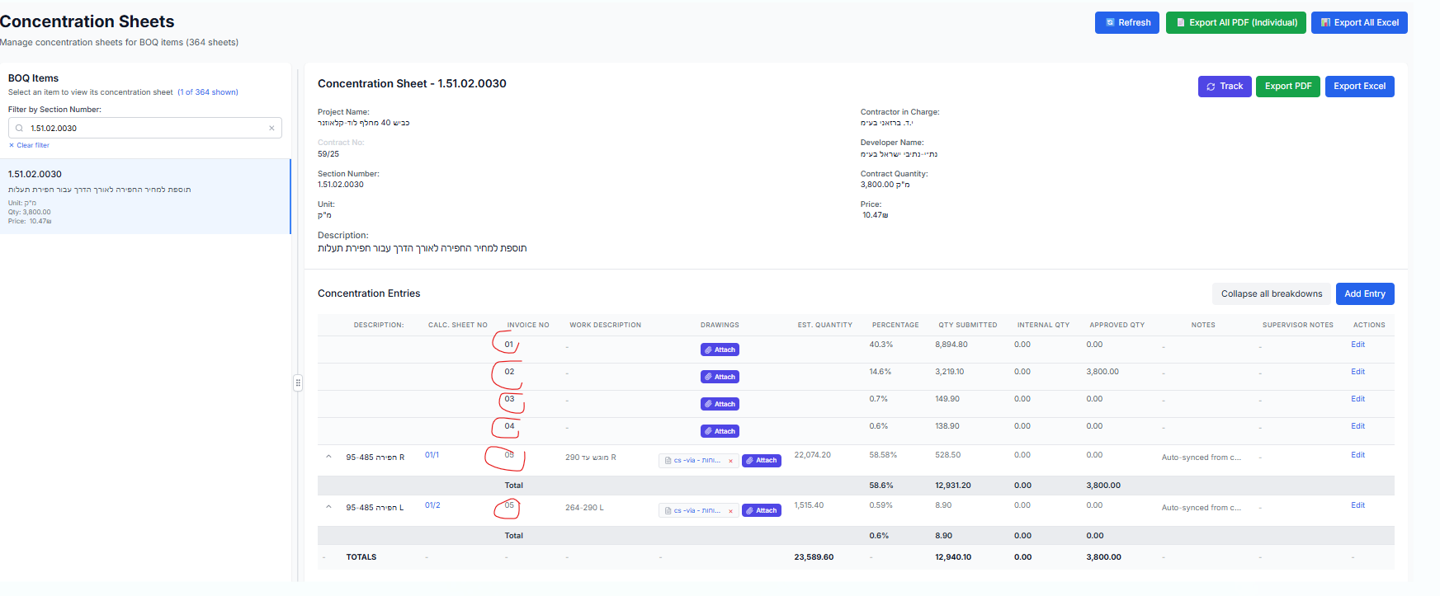

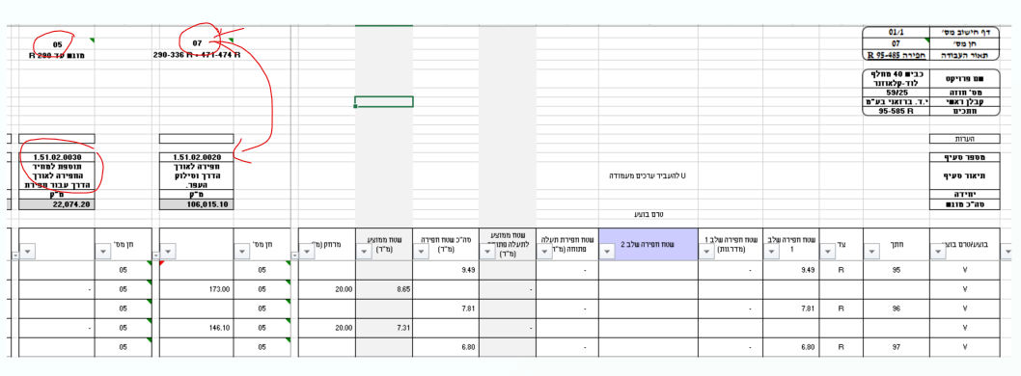

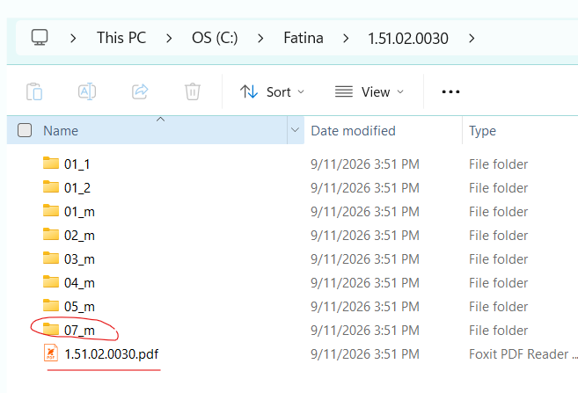

- VERY IMPORTANT
When I’m updating a calculation sheet that is already in the system—and which already has a PDF attached— all PDF’s get deleted.
The attachments should remain; I will delete them myself if necessary.

- I need three digits after the decimal point; right now, there are maybe 5 or more.
