Notes on the **source code** for

‘*In utero exposure to antiepileptic drugs impacts sleep dynamics and developmental outcomes in infants*’

**General description**

Function compute_PPC.m

1. Loads 19-channel EEG files (in .mat format).
2. Filters this EEG into N = 5 frequency bands: 0.4-1.5 Hz, 1.5-4 Hz, 4-8 Hz, 8-13 Hz, and 13-22 Hz.
3. Computes parcel signals using infant head model (see Tokariev et al., 2019, Cerebral Cortex).
4. Calculates phase-phase correlation (PPC) between parcel signals using debiased weighted phase lag index (Vinck et al., 2011, Neuroimage).
5. Corrects PPC connectivity matrix by removing 'non-reliable' edges (for more details see Supplementary Fig. S3 in Tokariev et al., 2019, Cerebral Cortex).
6. Saves frequency specific PPC connectivity matrices into PPC.mat file.

Script also contains a set of visualization functions that plot every step in the analytical pipeline.

**Input**

With this script we also provide an example of input data: infant_eeg.mat (folder 'Data example')

infant_eeg.mat contains a 19-channel EEG (Fs = 100 Hz, average montage, pre-filtered within 0.4-45 Hz).

Note, that the order of EEG channels should be the following:

Fp1, Fp2, F7, F3, Fz, F4, F8, T3, C3, Cz, C4, T4, T5, P3, Pz, P4, T6, O1, O2

We also provide pre-computed data needed for source modelling and parcellation (folder 'Head Model').

Folder 'Filters' contains band-pass filters: filters_eeg_5_bands.mat (low delta, high delta, theta, alpha, beta). Band-pass filters are implemented as a combination of high-pass (top row) and low-pass (bottom row) filters. We used Matlab function designfilt to generate all filters.

Important! Filters were designed for signals with Fs = 100 Hz! So, user have to a) re-sample input EEG data to Fs = 100 Hz or b) design new set of filters for different Fs (for example, using Matlab designfilt function).

**Output**

Functional connectivity (PPC) matrices [N of parcels x N of parcels] that were computed between all pairs of parcel signals and for each frequency band are stored to the variable PPC which is the cell array with dimensions [1 x N of EEG filters] and saved to the folder 'PPC_output' as PPC.mat.

Connectivity matrices computed with this script were further used in network-based statistics (Zalesky et al., 2010, Neuroimage). NBS toolbox can be found here: <https://www.nitrc.org/projects/nbs>. For the details on the statistical model that was used in our paper, please, see *Two-factor NBS design.pdf* file.

**System requirements**

This is stand-alone Matlab script. All data needed to run the script are provided with this package. The scripts were developed using Matlab (version R2019b) computing environment (developed by MathWorks). The script was tested with OS Windows 7 (64 bit), Windows 10. Any non-standard hardware is not needed.

**Installation**

The script does not require any special installation. To run the scripts, users need to install [Matlab](https://se.mathworks.com/) software on their computer and copy the whole folder with all files and sub-folders on their computer.

Add the main folder with the scripts to Matlab path (File > Set Path > Add Folder)

*Runtime*

(estimated using laptop with the following parameters: processor 2.60 GHz, 32 Gb RAM, Windows 10)

For the infant_eeg.m example file all computations take in average 41 seconds.

**Demo**

User just need to run compute_PPC.m script which will implement the following steps automatically:

1. Read (from the 'Data example' folder) and visualize input EEG data (infant_eeg.mat file):

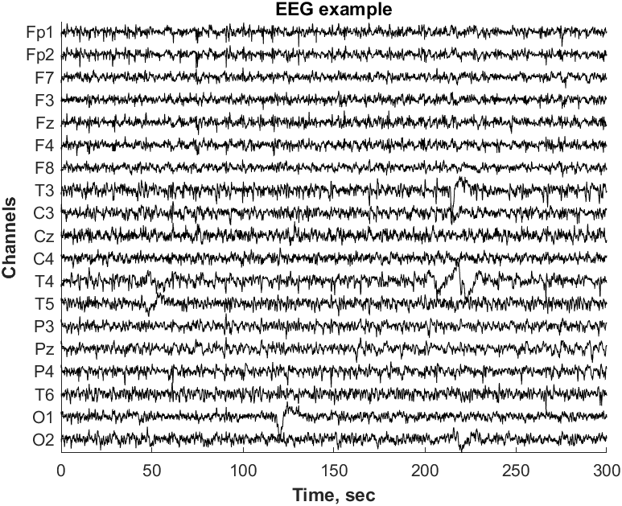

1. Filter EEG into N = 5 frequency bands and plot filtered signals:

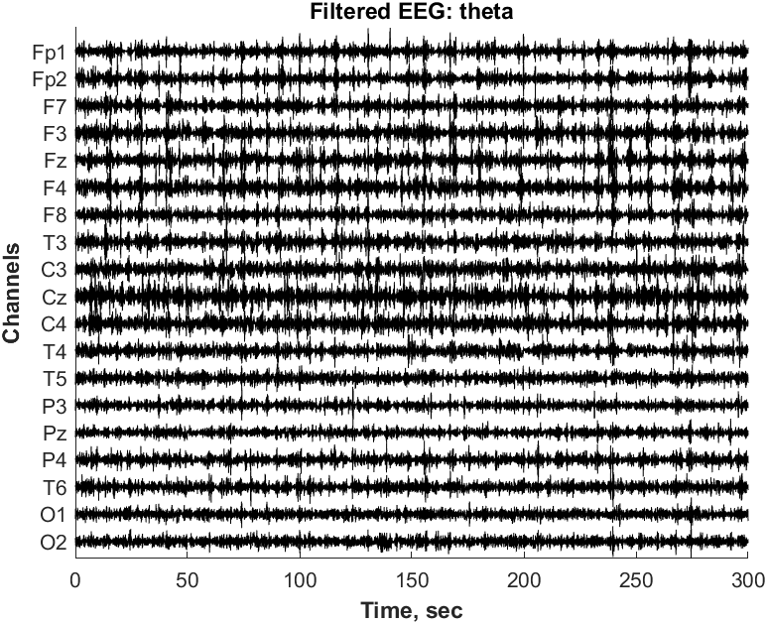

1. 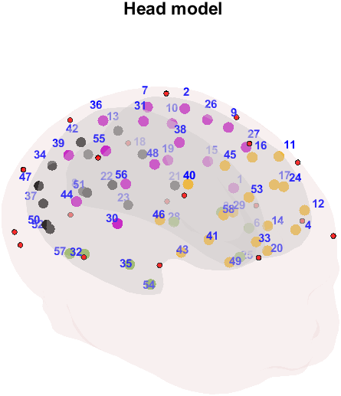Compute and visualize parcel signals and head model (parcel centroids and EEG electrodes):

Parcel color coding: Frontal – orange, Central – purple, Temporal – green, Occipital – black

Locations of recording EEG electrodes are shown with red circles.

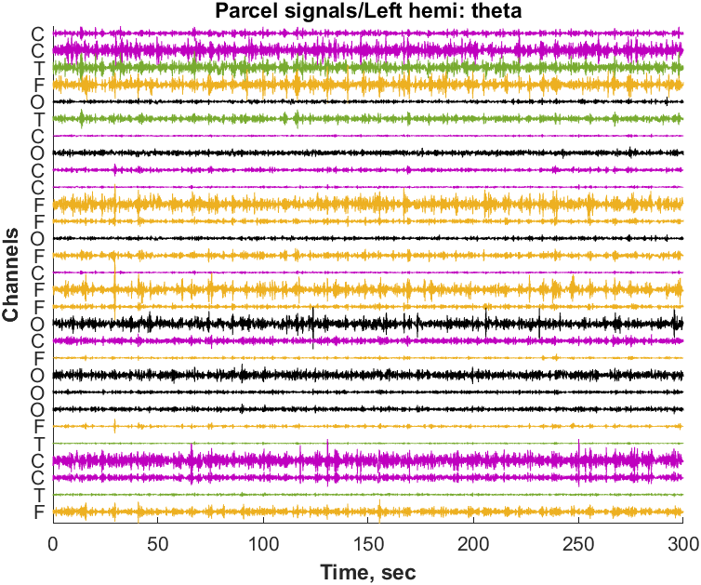

Corresponding parcel signals (Left hemisphere)

1. Calculate phase-phase correlation (PPC) and plot connectivity matrix:

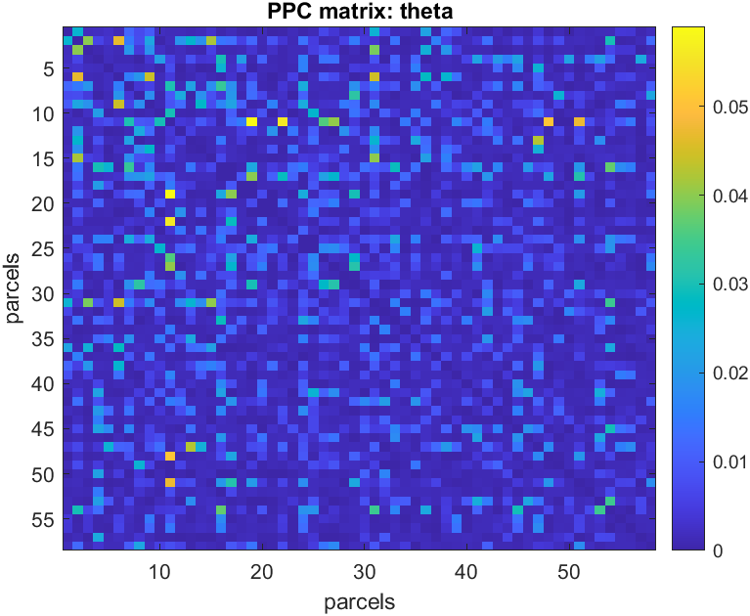

1. Correct connectivity matrix (remove non-reliable edges) and plot corrected matrix:

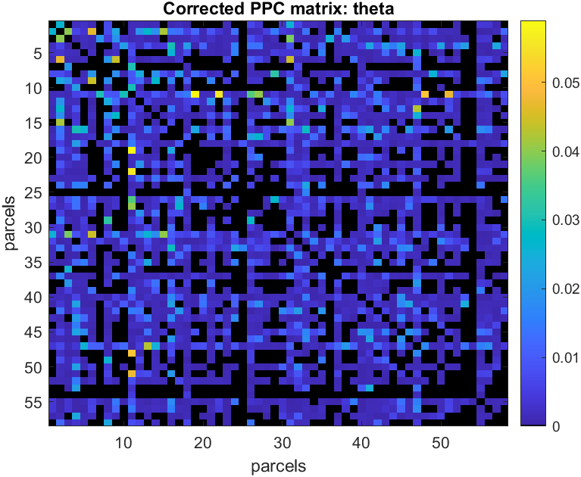

1. Save connectivity matrices (for all frequencies) to 'PPC_output' folder as PPC.mat file.