WEEK 6 DATA ANALYTICS ASSIGNMENT
E-commerce Sales Analysis and Business Intelligence Dashboard
Submitted by: V Baby Dora
Assignment: Week 6 – Data Analytics
Project Title: E-commerce Sales Analysis using Python and Power BI
Tools Used: Python, Jupyter Notebook, Pandas, NumPy, Matplotlib, Seaborn, Microsoft Power BI, GitHub
GitHub Repository: https://github.com/babydora99/Ecommerce-sales-analysis

1. Abstract
E-commerce businesses generate large amounts of data related to sales, customers, products, discounts, and profits. Analyzing this data helps businesses understand their performance, identify profitable products, and make better decisions.
This project focuses on analyzing the Sample Superstore dataset using Python and Power BI. Python libraries such as Pandas, NumPy, Matplotlib, and Seaborn are used for data inspection, cleaning, exploratory data analysis, and visualization. Microsoft Power BI is used to develop an interactive dashboard containing key performance indicators, charts, and filters.
The project aims to identify patterns in sales and profitability across product categories, sub-categories, customer segments, and geographical regions. The resulting analysis helps transform raw sales data into meaningful business insights and practical recommendations.
2. Introduction
Data analytics is an important part of modern business intelligence because it helps organizations understand historical performance and identify opportunities for improvement. In e-commerce and retail, sales data can reveal customer preferences, product demand, regional performance, and the impact of discounts on profitability.
In this project, the Sample Superstore dataset is analyzed using Python in Jupyter Notebook. The analysis includes data inspection, preprocessing, descriptive statistics, and graphical visualization. The results are then presented through a Power BI dashboard for easier interpretation.
This project provides practical experience in handling datasets, exploring business problems, creating visual reports, and communicating findings through data-driven insights.
3. Objectives
The main objectives of this project are:
- To understand and analyze a real-world retail sales dataset.
- To inspect the dataset for missing values, duplicate records, and data type issues.
- To clean and prepare the data for analysis.
- To perform exploratory data analysis (EDA) using Python.
- To analyze sales, profit, quantity, discounts, product categories, and customer segments.
- To create meaningful charts using Matplotlib and Seaborn.
- To develop an interactive Power BI dashboard with key performance indicators and filters.
- To identify business insights and suggest recommendations for improving sales and profitability.
- To document the project and maintain its files in a GitHub repository.
4. Dataset Description
The project uses the Sample Superstore dataset, which contains retail sales records and information about shipping, customers, products, sales, discounts, and profit.
The dataset contains the following important columns:
Column | Description
Ship mode | Shipping method used for an order
Segment | Customer segment
Country | Country associated with the record
City | City associated with the record
State | State associated with the record; the source column may be named Statre
Postal code | Postal code associated with the record
Region | Geographical sales region
Category | Main product category
Sub category | More specific product category
Sales | Sales amount
Quantity | Number of units sold
Discount | Discount applied to the sale
Profit | Profit or loss associated with the record

The dataset supports comparisons of sales and profitability across products, regions, and customer segments.
5. Tools and Technologies Used
Python: Used as the main programming language for data analysis and preprocessing.
Jupyter Notebook: Used to write and execute Python code interactively, inspect results, and document the analysis.
Pandas: Used for reading CSV files, inspecting records, handling missing values, checking duplicates, grouping data, and calculating summary statistics.
NumPy: Used for numerical operations and data analysis support.
Matplotlib: Used to create charts and graphical representations of sales and profitability.
Seaborn: Used to create statistical visualizations and explore relationships between numerical variables.
Microsoft Power BI Desktop: Used to create an interactive business intelligence dashboard with KPI cards, charts, and slicers.
GitHub: Used to store the project files, source notebook, documentation, and supporting materials.
6. Project Methodology
The project follows a structured data analytics workflow.
6.1 Data Collection
The Sample Superstore CSV dataset was obtained and stored in the project's data folder. It was loaded into a Pandas DataFrame for further analysis.
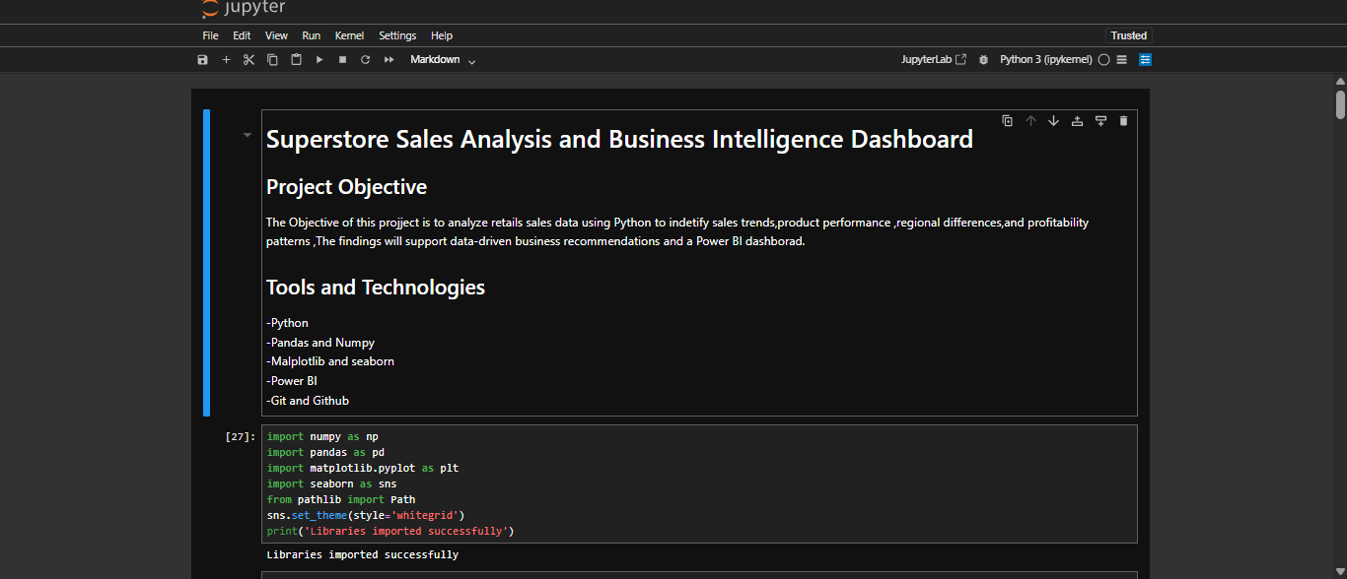
6.2 Data Inspection
The dataset was inspected to understand its structure, number of records, column names, data types, and numerical summaries. Missing values and duplicate records were checked to identify potential data quality issues. 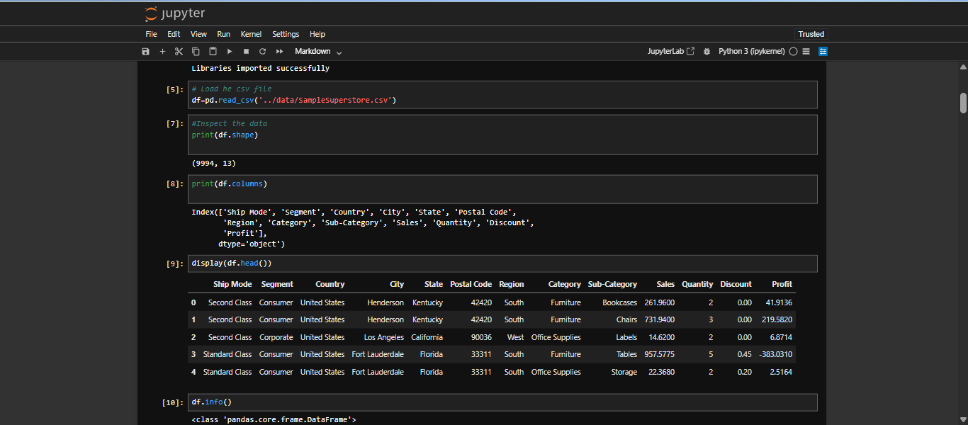
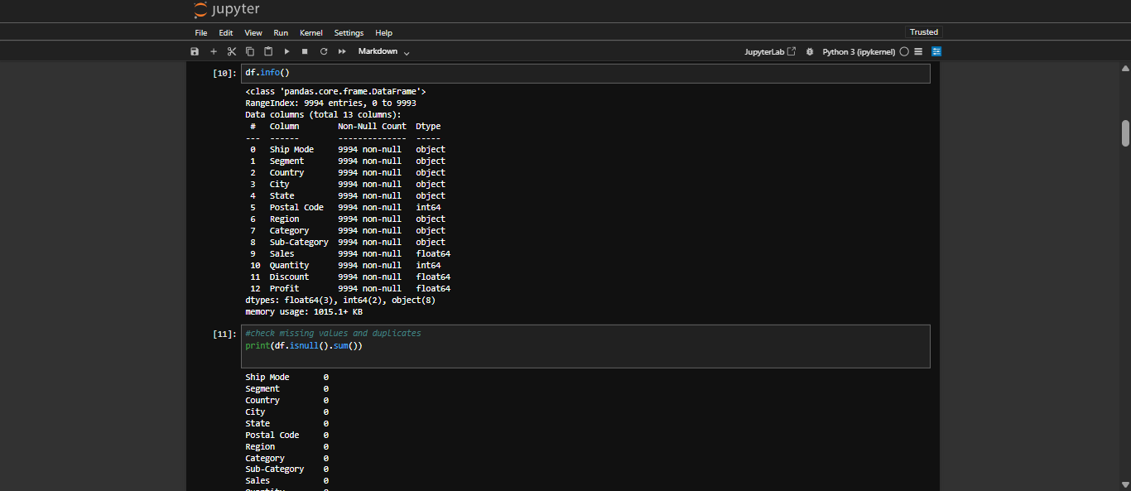
6.3 Data Cleaning and Preprocessing
The data preparation process included:
- Checking for missing values in each column.
- Identifying duplicate records.
- Reviewing data types for numerical columns.
- Removing exact duplicate rows if duplicates were present and removal was appropriate.
- Reviewing column names for consistency.
- Preparing a cleaned dataset for further analysis.
The original dataset was retained separately so that the processed data could be compared with the source data if required.
Since the available dataset does not include date columns, date conversion and time-based preprocessing were not applicable.
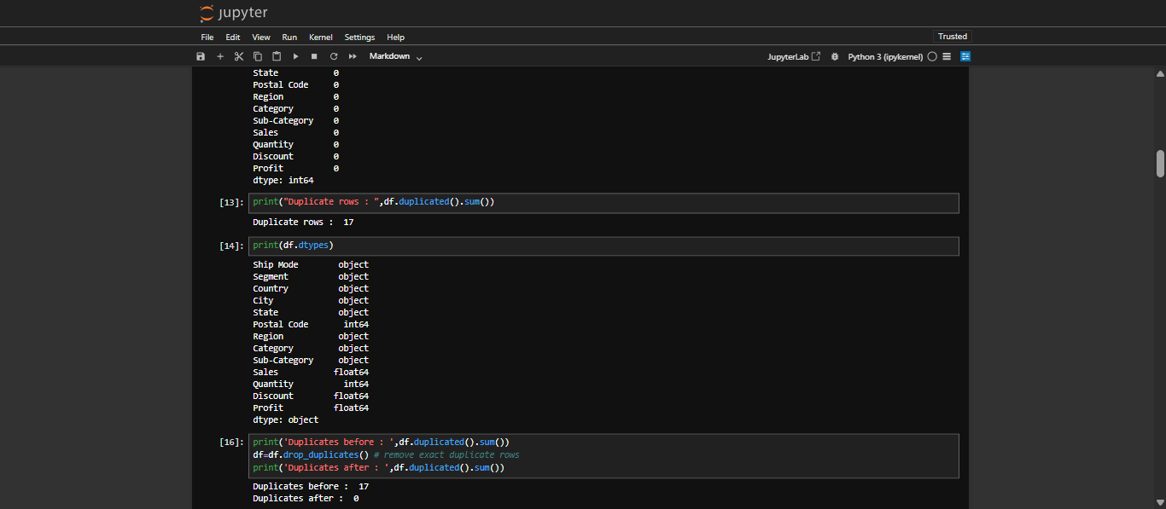
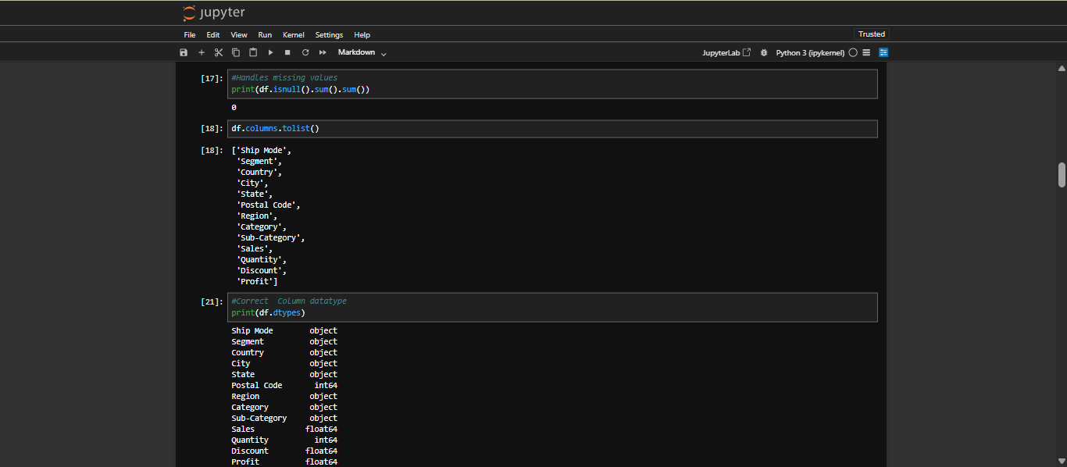
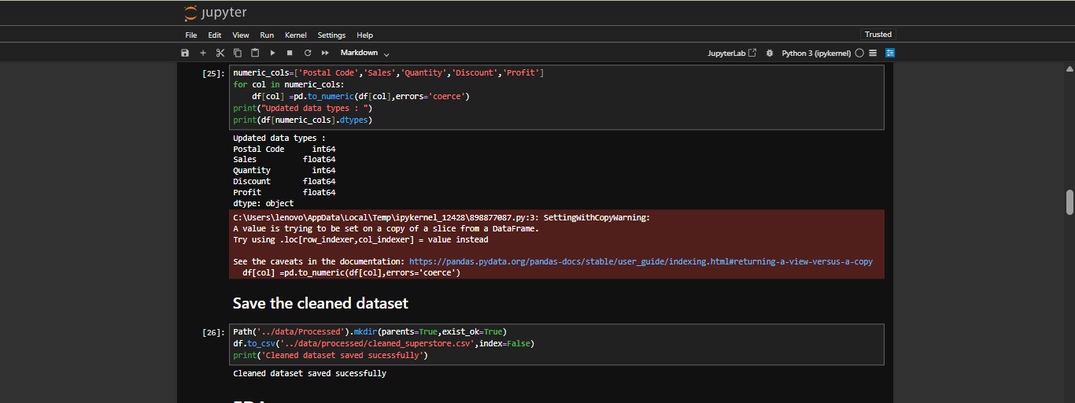
6.4 Exploratory Data Analysis
Exploratory data analysis was performed to understand the distribution and relationships of the main business variables.
The analysis examined:
- Overall sales, profit, and quantity.
- Sales across product categories and sub-categories.
- Profit across geographical regions.
- Sales across customer segments.
- The relationship between discount and profit.
Grouping and aggregation techniques were used to summarize the data and compare business performance across different dimensions.
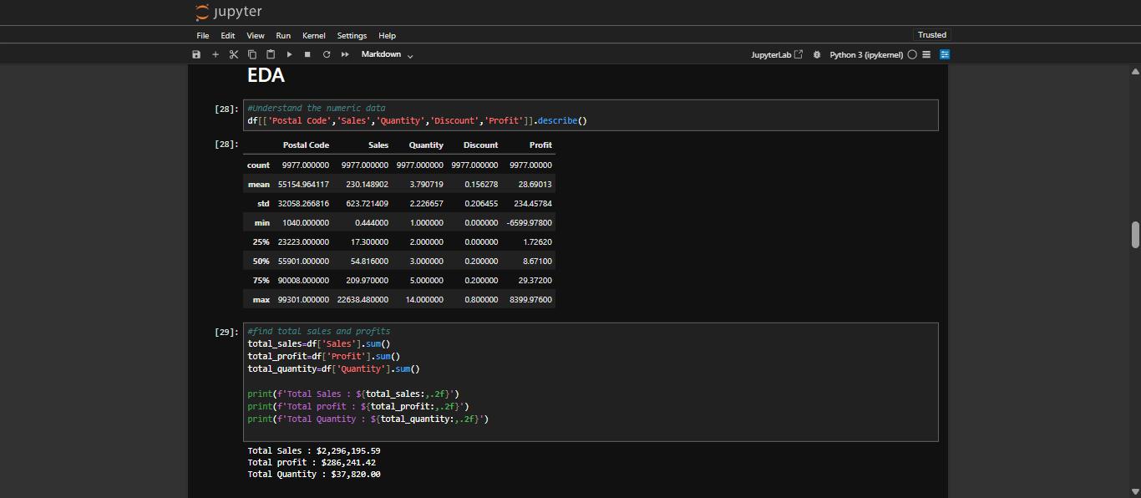
6.5 Data Visualization
Charts were created to make the analysis easier to understand. These visualizations help identify differences between categories, compare regional performance, and examine the relationship between discounts and profitability.
6.6 Power BI Dashboard Development
The cleaned dataset was imported into Power BI Desktop to create an interactive dashboard. KPI cards were used to display overall performance, while charts were used to compare categories, regions, customer segments, and sub-categories.
Slicers were included to allow users to filter the report by relevant dimensions, such as region, category, and segment, depending on the final dashboard configuration.
7. Python Implementation
Python was used in Jupyter Notebook to load, inspect, summarize, and visualize the dataset.
The following code illustrates the main analysis operations.
7.1 Importing Libraries and Loading Data
import pandas as pd
import numpy as np
import matplotlib.pyplot as plt
import seaborn as sns
sns.set_theme(style="whitegrid")
df = pd.read_csv("../data/SampleSuperstore.csv")
print(df.head())
print(df.shape)
print(df.info())
7.2 Checking Data Quality
print("Missing values:")
print(df.isnull().sum())

print("Duplicate rows:", df.duplicated().sum())
print("Dataset information:")
print(df.info())
print("Summary statistics:")
print(df.describe())
These commands help identify missing data, duplicate records, column data types, and numerical distributions.
7.3 Calculating Business Metrics
total_sales = df["Sales"].sum()
total_profit = df["Profit"].sum()
total_quantity = df["Quantity"].sum()
print("Total Sales:", total_sales)
print("Total Profit:", total_profit)
print("Total Quantity:", total_quantity)
These calculations summarize the overall sales amount, net profit, and quantity represented in the dataset.
7.4 Category-Wise Sales Analysis
category_sales = (
df.groupby("Category")["Sales"]
.sum()
.sort_values(ascending=False)
)
print(category_sales)
category_sales.plot(kind="bar", title="Sales by Category")
plt.xlabel("Category")
plt.ylabel("Sales")
plt.tight_layout()
plt.show()
This analysis compares total sales across product categories and helps identify the category generating the highest sales.
7.5 Regional Profit Analysis
region_profit = (
df.groupby("Region")["Profit"]
.sum()
.sort_values(ascending=False)
)
print(region_profit)
region_profit.plot(kind="bar", title="Profit by Region")
plt.xlabel("Region")
plt.ylabel("Profit")
plt.tight_layout()
plt.show()
This analysis compares profitability across geographical regions and highlights areas performing well or requiring further investigation.
7.6 Discount and Profit Analysis
plt.figure(figsize=(8, 5))
sns.scatterplot(
data=df,
x="Discount",
y="Profit"
)
plt.title("Discount vs Profit")
plt.xlabel("Discount")
plt.ylabel("Profit")
plt.tight_layout()
plt.show()
The scatter plot helps examine whether different discount levels are associated with higher or lower profits. The visualization shows association rather than proving that discounts directly cause a change in profit.
8. Exploratory Data Analysis and Visualizations
The following visualizations were used to explore the dataset. Insert the corresponding screenshots from your Jupyter Notebook under each subsection.
8.1 Sales by Category
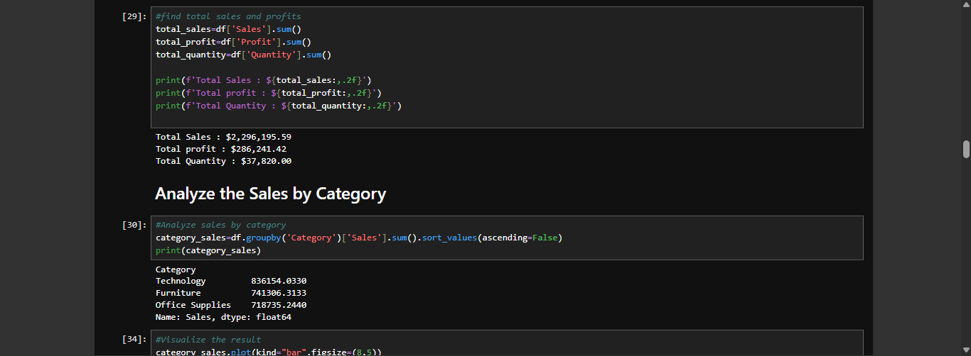
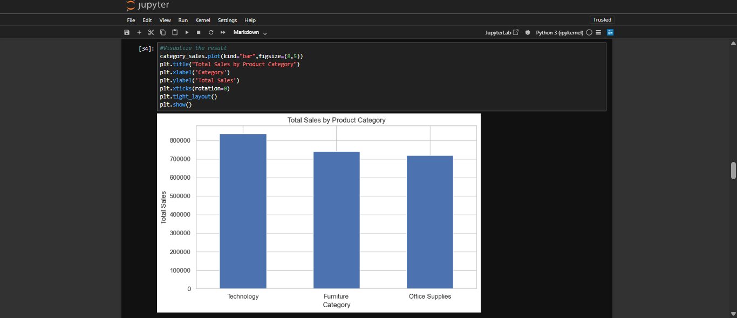
This chart compares total sales across the available product categories. It helps identify the strongest categories in terms of sales revenue and provides an overview of product demand.
8.2 Profit by Region
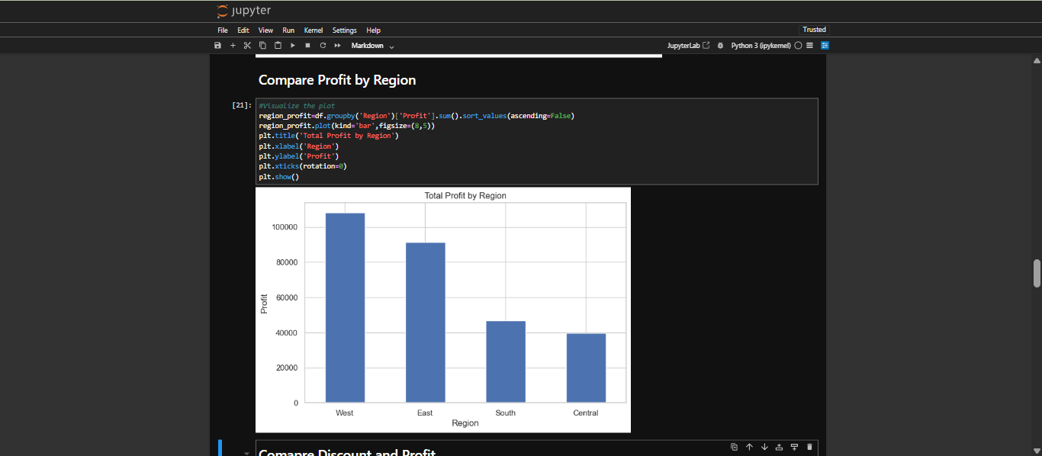
This visualization compares the profit generated by each region. It helps identify high-performing regions and regions that may require further investigation to understand their profitability.
8.3 Discount vs Profit
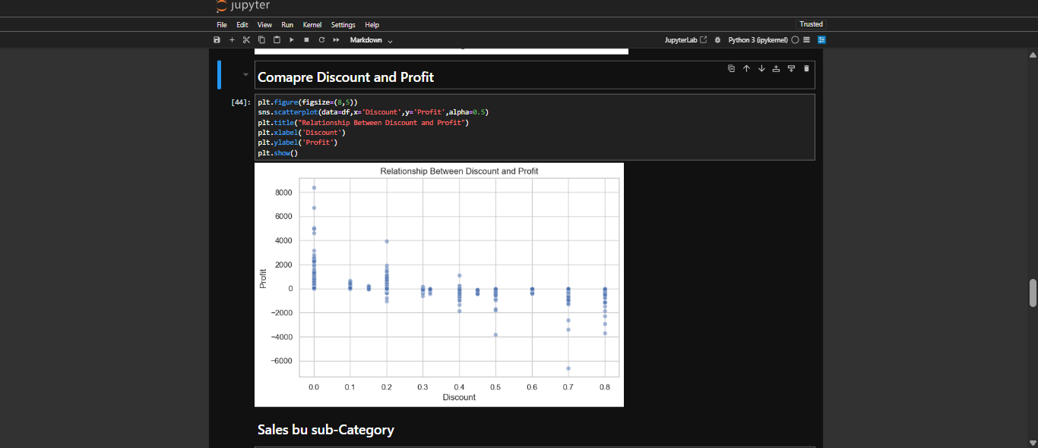The scatter plot displays individual records based on their discount and profit values. It helps examine whether higher discounts tend to occur alongside lower profits or losses and whether the relationship varies across transactions.
8.4 Sales by Sub-Category
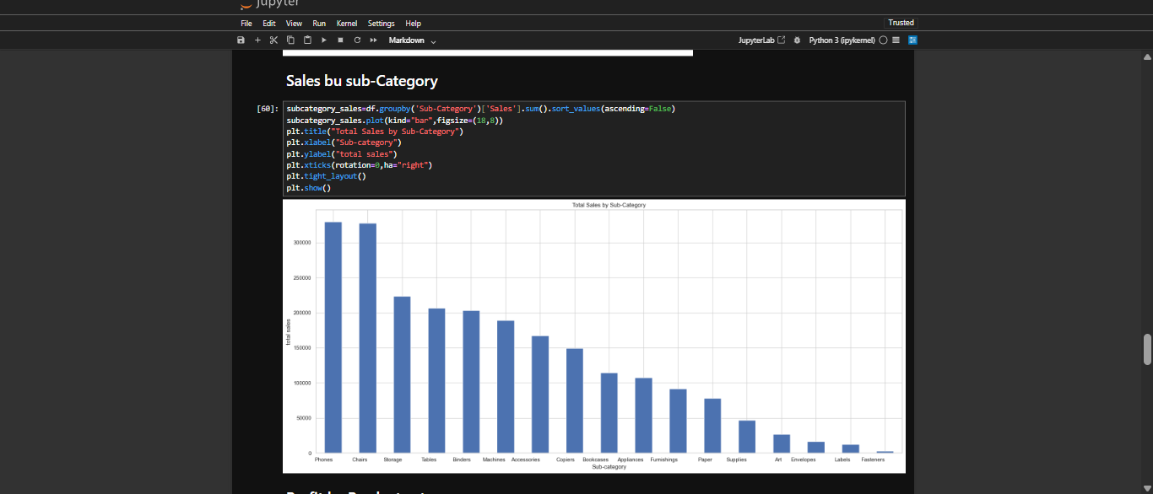This chart provides a more detailed view of product performance. It helps identify sub-categories with comparatively high or low sales and supports more focused product-level analysis.
8.5 Profit by Category
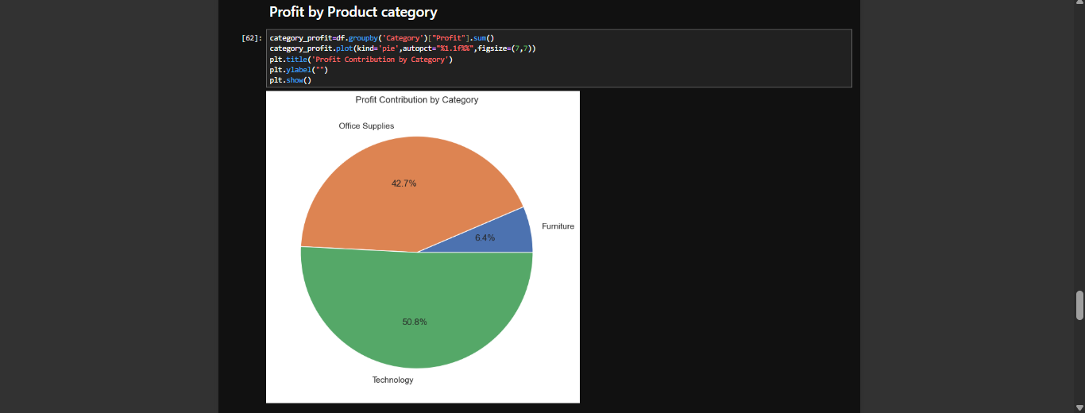This visualization compares profit across the main product categories. It complements the sales analysis because a category with high sales does not necessarily generate the highest profit.
A bar chart is suitable for this comparison because it can display positive and negative profit values clearly.
8.6 Sales by Customer Segment
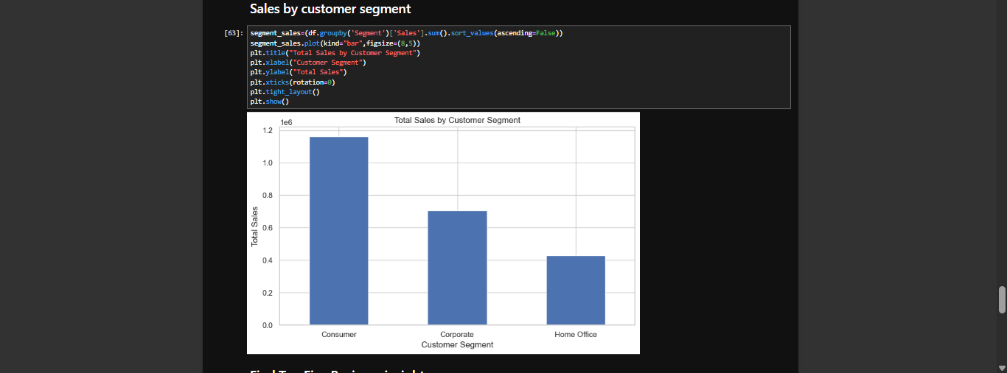This chart compares sales across customer segments. It helps show which segments contribute more to sales and can support decisions about customer engagement and marketing strategies.
Top 5 Business Insights are:
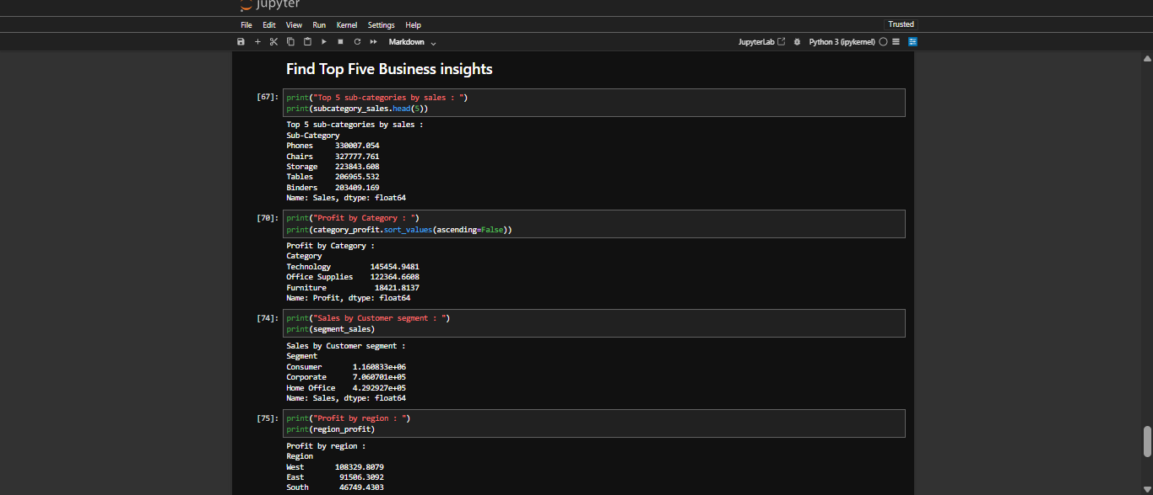
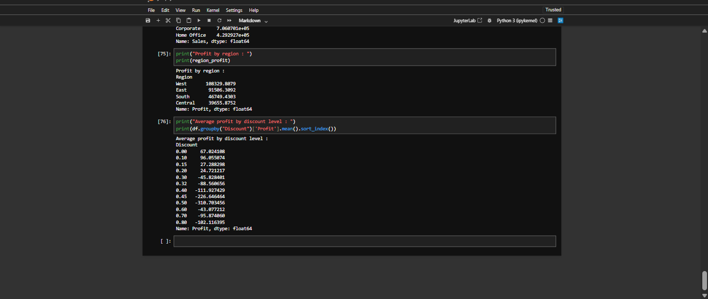
9. Power BI Dashboard
9.1 Dashboard Overview
Dashboard Title: Superstore Sales Analysis and Business Intelligence Dashboard
Microsoft Power BI Desktop was used to present the cleaned dataset through an interactive dashboard. The dashboard combines summary metrics and visual comparisons to make the results easier to interpret.
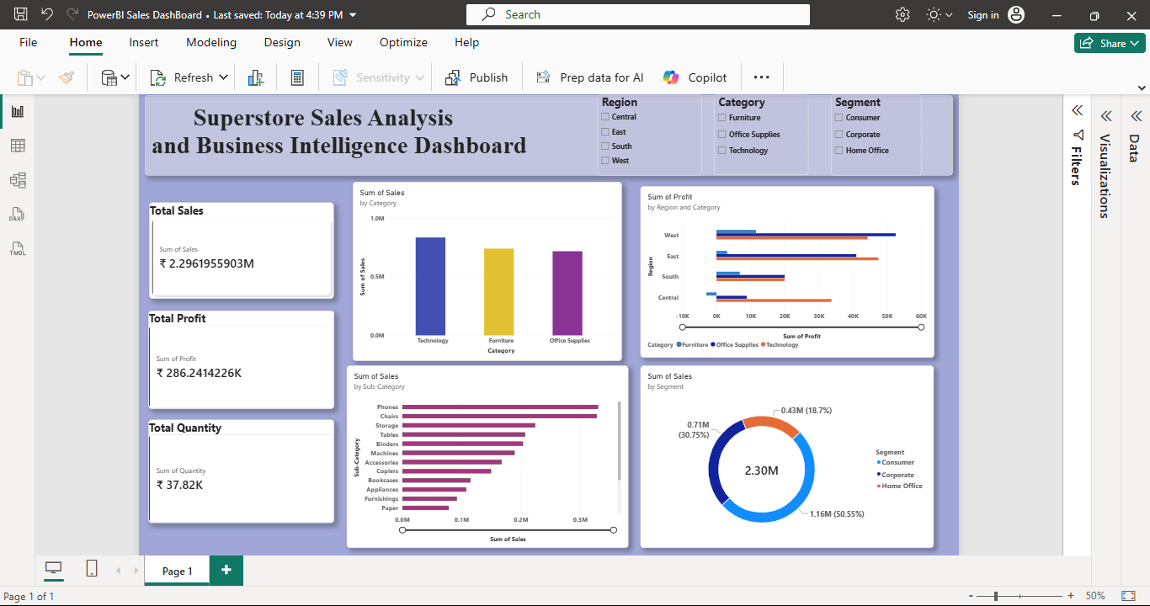9.2 Key Performance Indicators
The dashboard includes the following key performance indicators, subject to the final report configuration:
- Total Sales: The sum of the sales amounts in the dataset.
- Total Profit: The sum of the profit values, including losses.
- Total Quantity: The sum of the units sold.
These indicators provide a high-level overview of business performance.
9.3 Dashboard Visualizations
The dashboard uses charts to explore different aspects of retail performance:
- Sales by Category: Compares sales across product categories.
- Profit by Region: Compares profitability across geographical regions.
- Sales by Customer Segment: Shows the contribution of each customer segment to total sales.
- Sales by Sub-Category: Provides a detailed comparison of product-level sales.
- Discount vs Profit: Examines the relationship between discounts and profitability, if included in the final dashboard.
9.4 Interactive Filters
Slicers allow users to filter the displayed results by selected dimensions, such as region, category, or customer segment, where available.
These filters make the dashboard interactive and allow users to explore different parts of the dataset without modifying the source data.
10. Business Insights
The following insights should be completed using the actual values and rankings shown in the final charts and dashboard.
Insight 1: Product Category Performance
This indicates that the category contributes the largest share of sales revenue in the dataset.
Insight 2: Regional Profitability
The region with the highest total profit with a profit The region with the lowest with a profit . Comparing these regions can help identify differences in business performance.
Insight 3: Customer Segment Contribution
The customer segment generating the highest sales with sales This information can help the business understand which customer group contributes most to revenue.
Insight 4: Sub-Category Performance
The sub-category with the highest Sales. while the sub-category with the lowest sales .These differences help identify products that may require additional promotion, further analysis, or changes to the product strategy.
Insight 5: Discount and Profit Relationship
This suggests that the relationship between discount levels and profitability should be examined when evaluating pricing and promotional strategies.
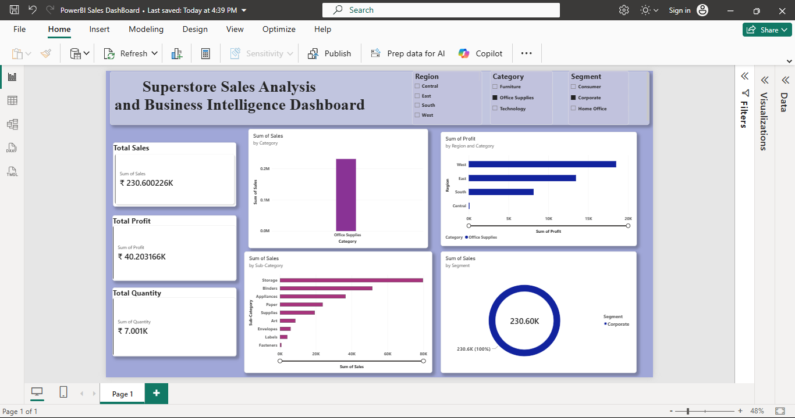The analysis should also consider other factors, including product category, sales volume, and individual transactions, before drawing conclusions about the effect of discounts.
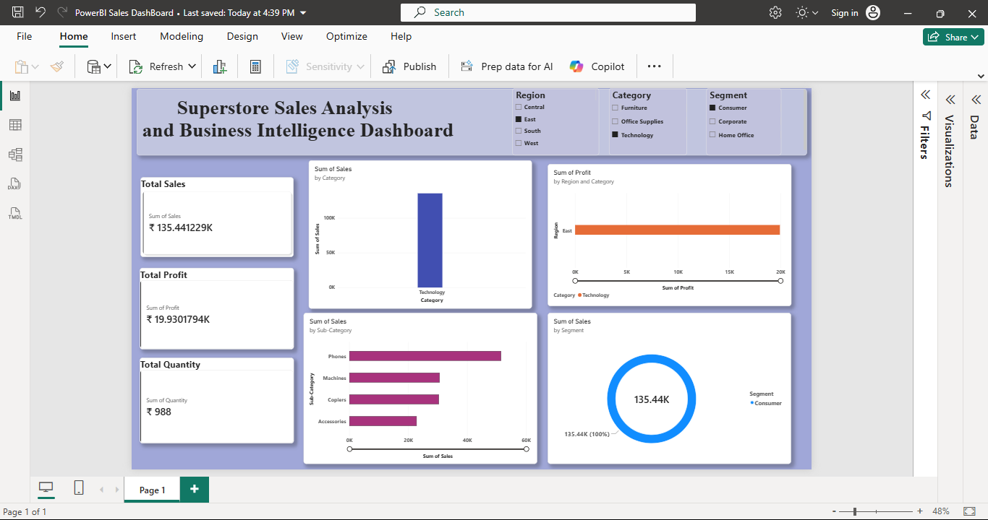11. Business Recommendations
Based on the results observed in the analysis, the following recommendations can be considered.
Recommendation 1: Improve Product-Level Performance
Review the sales and profitability of individual product sub-categories to identify products that perform well and products that require improvement. The business can investigate pricing, demand, product costs, and marketing effectiveness before deciding which products to promote or reassess.
Recommendation 2: Review Discount Strategies
Examine transactions with high discounts and low or negative profits. Evaluate whether discounts are improving sales enough to justify the reduction in profit. Consider adjusting promotional strategies based on product-level profitability and customer demand.
Recommendation 3: Learn from Regional Performance
Compare high-profit and low-profit regions to identify differences in product demand, sales volume, discount patterns, and operating conditions. Apply successful practices from stronger-performing regions where appropriate.
Recommendation 4: Strengthen Customer Segment Analysis
Use the segment-wise sales results to understand the contribution of different customer groups. Marketing campaigns and promotional activities can then be tailored to customer needs while considering profitability rather than sales alone.
12. Challenges Faced
During the project, several practical challenges were addressed:
- Understanding the structure and meaning of the dataset columns.
- Checking data quality before performing calculations.
- Selecting appropriate visualizations for different analytical questions.
- Interpreting sales and profit separately, since high sales do not always imply high profitability.
- Importing the cleaned dataset into Power BI and configuring KPI cards and charts.
- Organizing the notebook, dashboard, screenshots, and documentation for submission.
These activities helped develop a better understanding of the complete data analytics workflow, from raw data preparation to business reporting.
13. Learning Outcomes
Through this project, I gained practical experience in loading and inspecting CSV datasets using Pandas, checking missing values and duplicate records, and preparing data for analysis. I learned how grouping, aggregation, and descriptive statistics can be used to answer business questions.
I also improved my understanding of data visualization using Matplotlib and Seaborn. Creating charts helped me compare sales and profitability across product categories, sub-categories, regions, and customer segments.
Working with Power BI helped me understand how KPI cards, charts, and slicers can transform analytical results into an interactive business dashboard. Overall, this project improved my ability to organize data, explore business performance, interpret visualizations, and communicate findings through a structured report.
14. Conclusion
The E-commerce Sales Analysis project demonstrates how Python and Power BI can be combined to analyze retail sales data and present meaningful business information.
Python was used for data inspection, preprocessing, exploratory data analysis, and visualization. Power BI was used to create an interactive dashboard that summarizes important performance indicators and supports comparisons across categories, regions, and customer segments.
The project provides a foundation for data-driven decision-making by highlighting differences in sales and profitability and examining potential relationships between discounts and profit. The analysis also demonstrates the importance of validating findings against actual data before making business recommendations.
This project strengthened my practical skills in data analytics, Python programming, data visualization, and business intelligence reporting.
15. Project Files and References
GitHub Repository:
https://github.com/babydora99/Ecommerce-sales-analysis
Project files included:
- Jupyter Notebook containing the Python analysis.
- Original dataset, where permitted.
- Cleaned dataset.
- Power BI dashboard file (.pbix).
- EDA and dashboard screenshots.
- README documentation.
- Final project report.
References:
- Pandas documentation: https://pandas.pydata.org/docs/
- NumPy documentation: https://numpy.org/doc/
- Matplotlib documentation: https://matplotlib.org/stable/
- Seaborn documentation: https://seaborn.pydata.org/
- Microsoft Power BI documentation: https://learn.microsoft.com/power-bi/

